# Project Title: Artisanal E-Commerce Platform Development – PHASE 3

Introduction**:** The Artisanal E-Commerce Platform project aims to create a user-friendly online marketplace for artisanal products. This document outlines the initial steps of the project, including designing the platform layout and setting up a database to store product information.

## Platform Layout:

***INDEX.html***

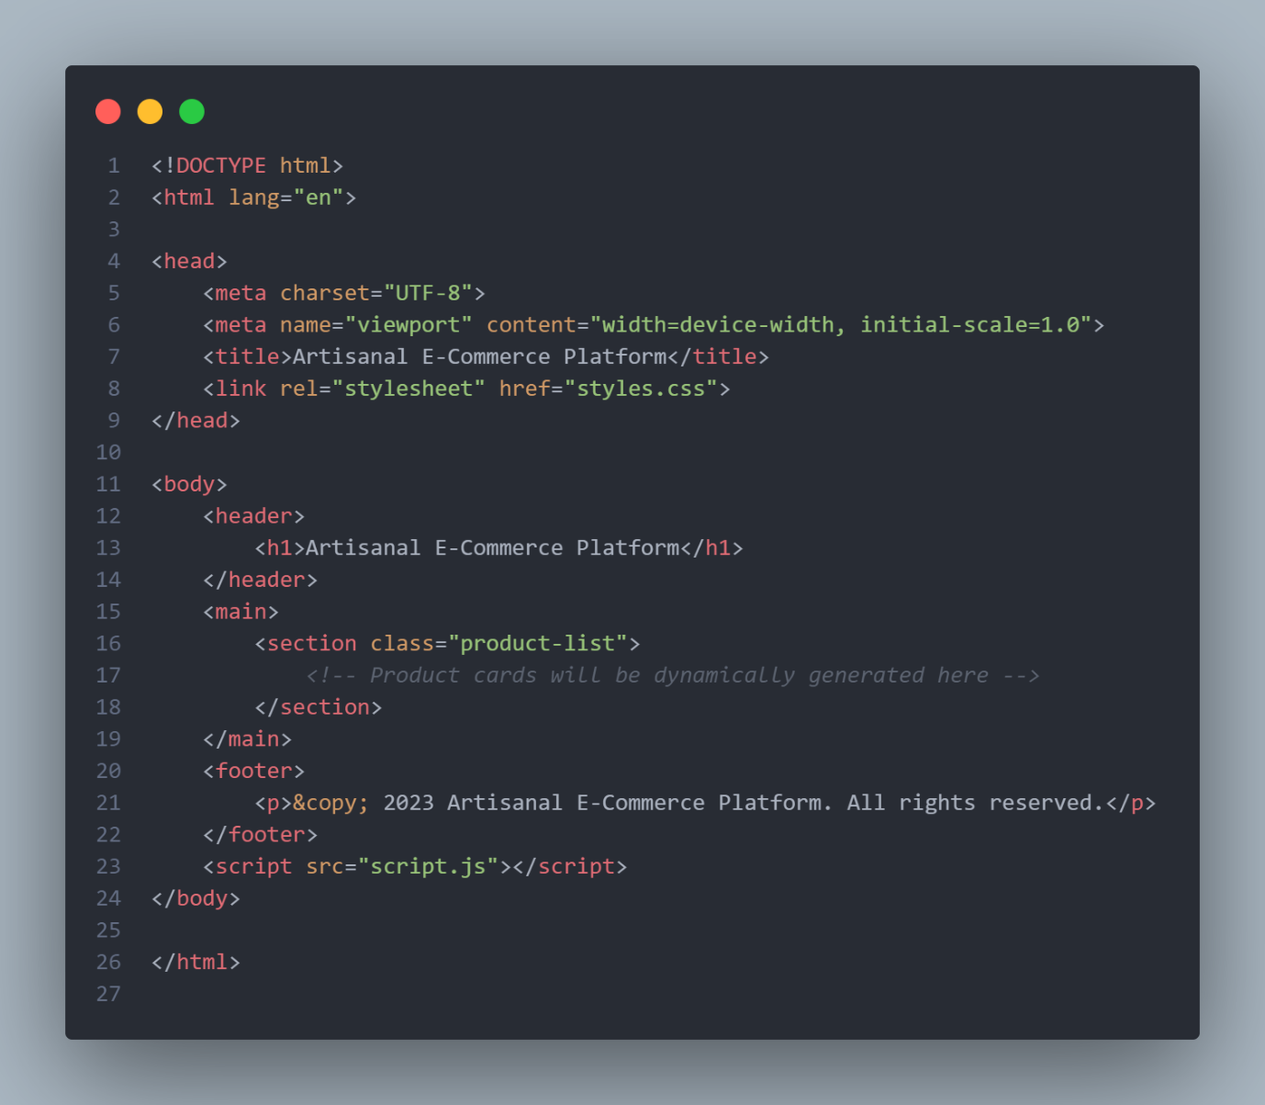

***Styles.css***

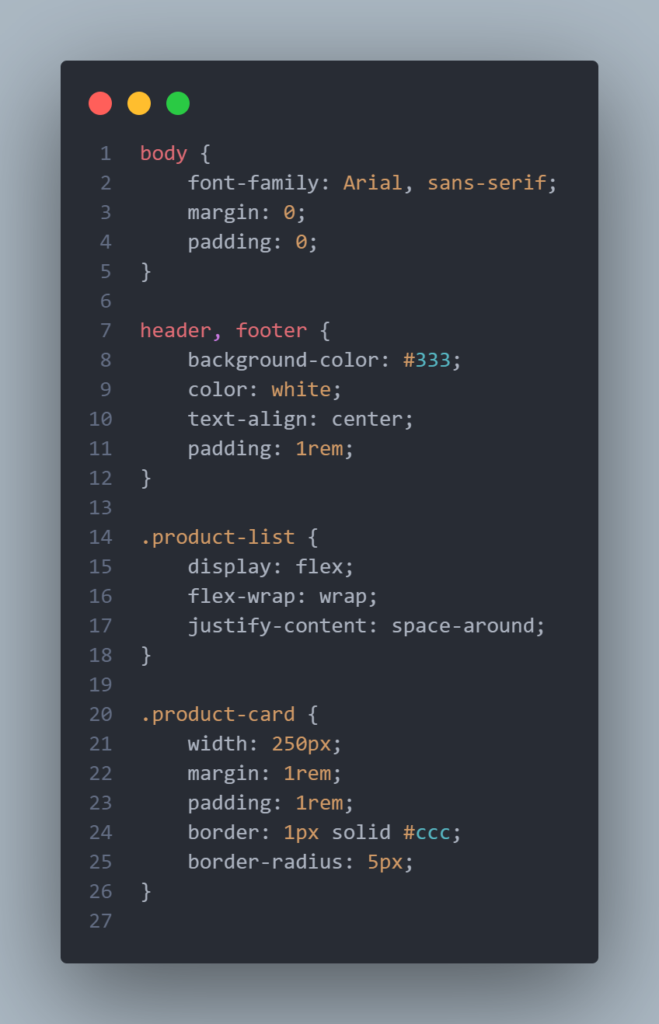

## Database Schema and Queries:

### Database: ecommercedb

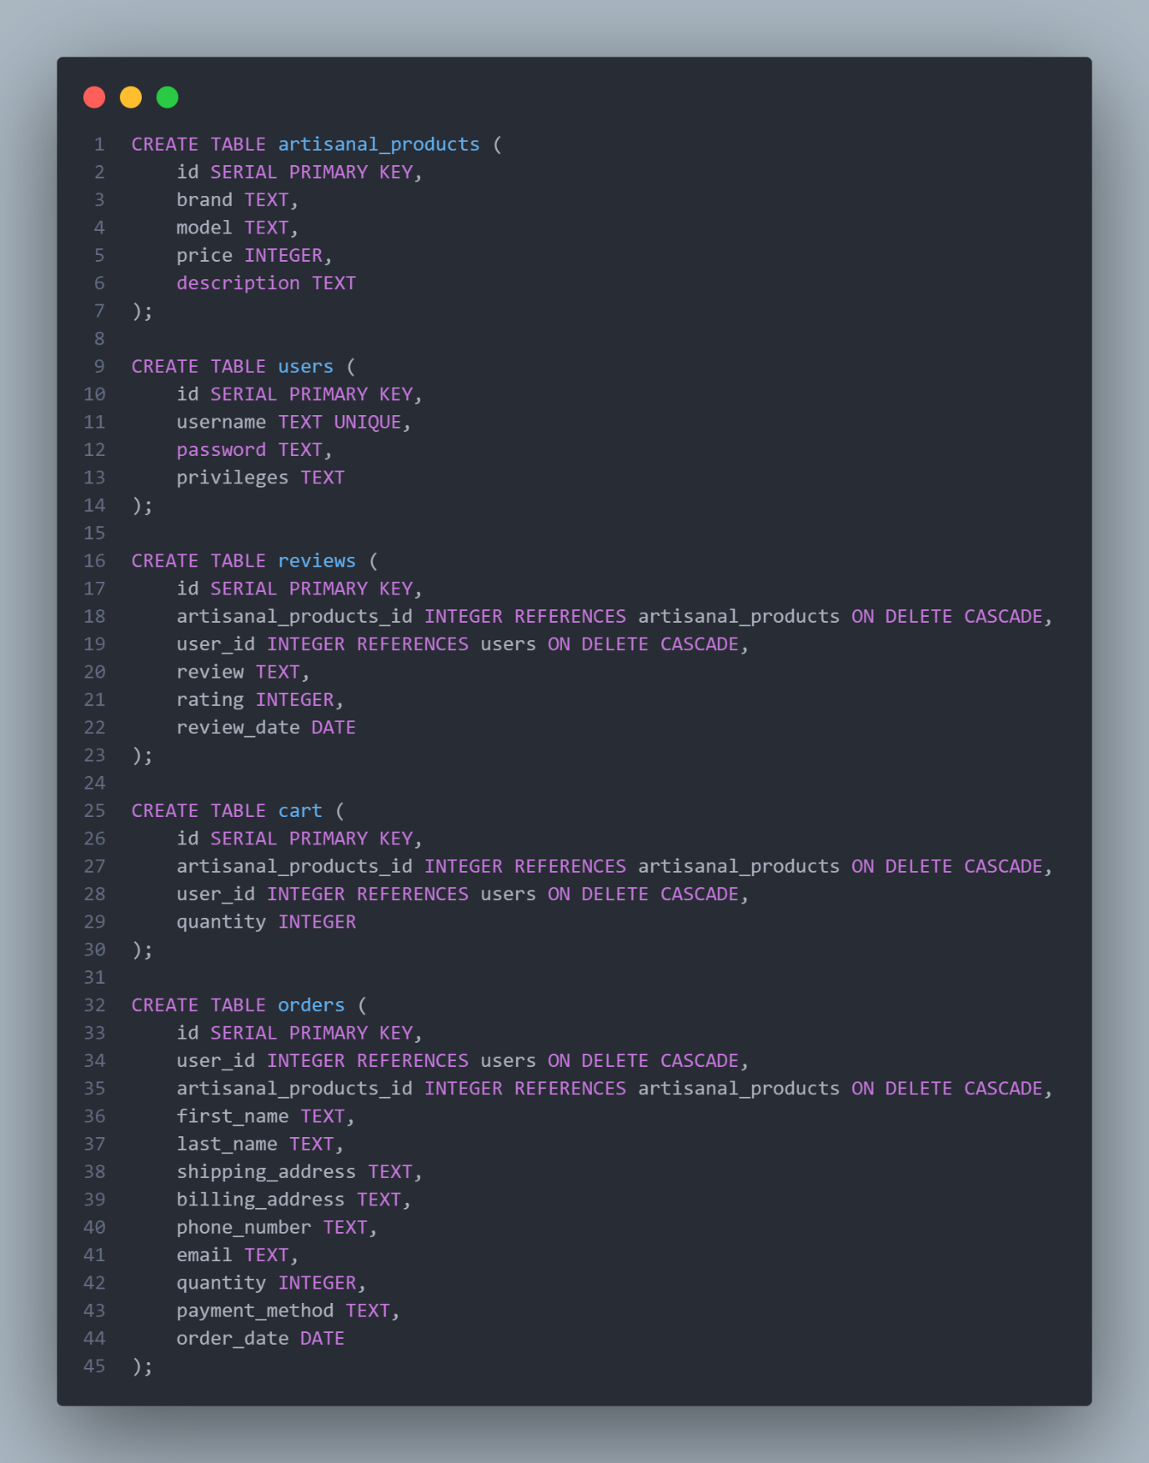

Conclusion:

The outlined platform layout and database schema provide a foundational structure for the Artisanal E-Commerce Platform. Further development will include dynamic generation of product cards using JavaScript and backend integration for database operations.