**Lab3 report**

Inhalt

Lab description 1

Step 1: define project files 1

Step 2 : C Startup code 2

Startup Summury: 2

Startup.s lab1 2

Startup functions: 2

Code: 3

Step 3: Linker script 3

Step 4: CHECK ENTRY POINT Validation 3

Step 5: QEMU Simulator 4

Lab description

1. Make file (automate build up process) [lab 2: create .o files then link according linker script.ld sections)
2. Debugging by gdb software

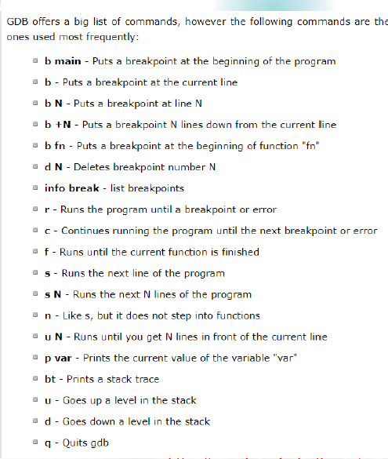

Step 1: debugging by GDB

1. CMD in project ordner QMEU window: qemu-system-arm -M versatilepb -m 128M -nographic -s -S -kernel learn-in-depth.bin
2. Anderes CMD Fenster: gdb und dann wird eine Verbindung zum server hergetellt
3. PC status angehalten (TAB für erweiterte funktionen)

MINGW instead of CMD export PATH:

To be done on installed cross tool chain bin folder then run cmd window from project file

|  |  |
| --- | --- |
| CMD | MINGW |
| set PATH=C:\Users\atta-es\Desktop\Embedded\Embedded_Github\ARM\10 2020-q4-major\bin | $ export PATH= C/Users/atta-es/Desktop\Embedded/Embedded_Github/Embedded_C/Lab_3 |

Step 2 : Make File

* Bild dependency tree :

#prepared by Essam Atta

CC=arm-none-eabi-

CFLAGS=-mcpu=arm926ej-s -g

INCS=-I .

LIBS=#linker_scrript libraries that may may be included

OBJ= uart.o app.o startup.o

SRC= $(wildcard *.c)#inculde all .c files in the directory to need for building

all : test.bin

@echo "========== Target binary build is done ============="

startup.o: startup.s

$(CC)as.exe $(CFLAGS) $< -o $@

%.o: %.c

$(CC)gcc.exe $(CFLAGS) $(INCS) -c $< -o $@

test.elf: uart.o app.o startup.o

$(CC)ld.exe -T linker_script.ld $(LIBS) $(OBJ) -o $@ -Map=Map_file.map

test.bin: test.elf

$(CC)objcopy.exe -O binary $< $@

clean:

rm -rf *.o *~

@echo "==========*.o and . elf have been succesfully removed=========="

clean_all:

rm *.o *.elf *.bin

@echo "==========*.o .elf and .bin files have been succesfully removed=========="

Startup Summury:

Startup.s lab1

Startup functions:

Code:

Step 3: Linker script

Step 4: CHECK ENTRY POINT Validation

Step 5: QEMU Simulator