**Collision Avoidance Report**

1. System description:

System designed to prevent or reduce the severity of a collision.  Sensor that is used an ultrasonic sensor for measuring the distance. The Distance is transmitted to the µc to be compared with threshold value and control the actuator (DC-Motor)

CA-System will be divided in to the following 3 blocks: US_Sensor, CA and DC_Motor

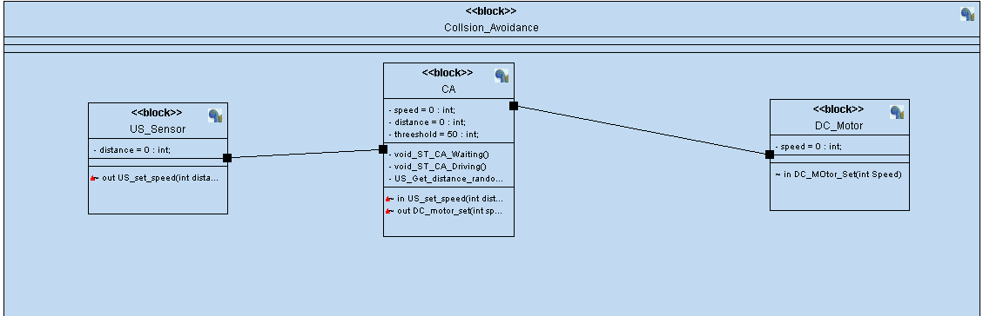

Figure 1UML_System_BLOCK

1. Sub-system:

* US_Sensor

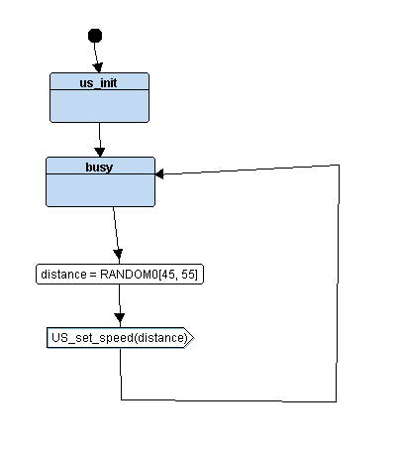

* CA

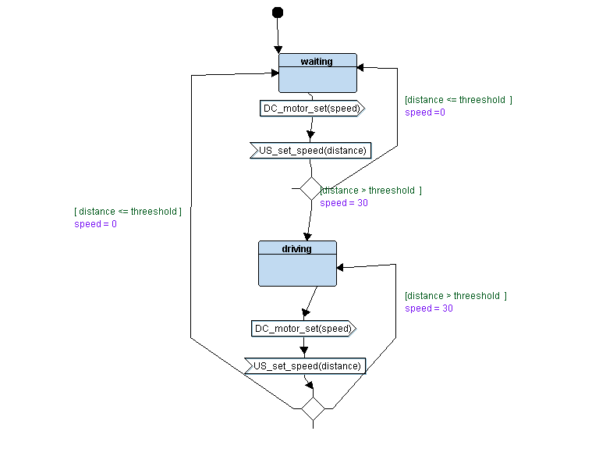

* DC_Motor

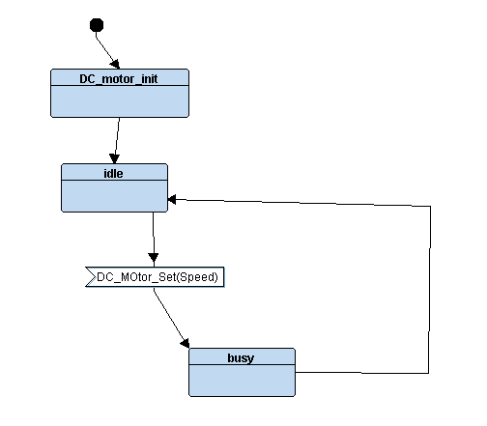

1. System simulation

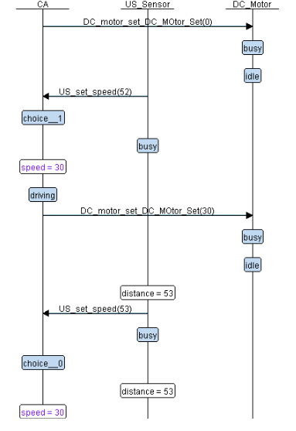

Figure 2 UML-System Simulation