400. Validation Error

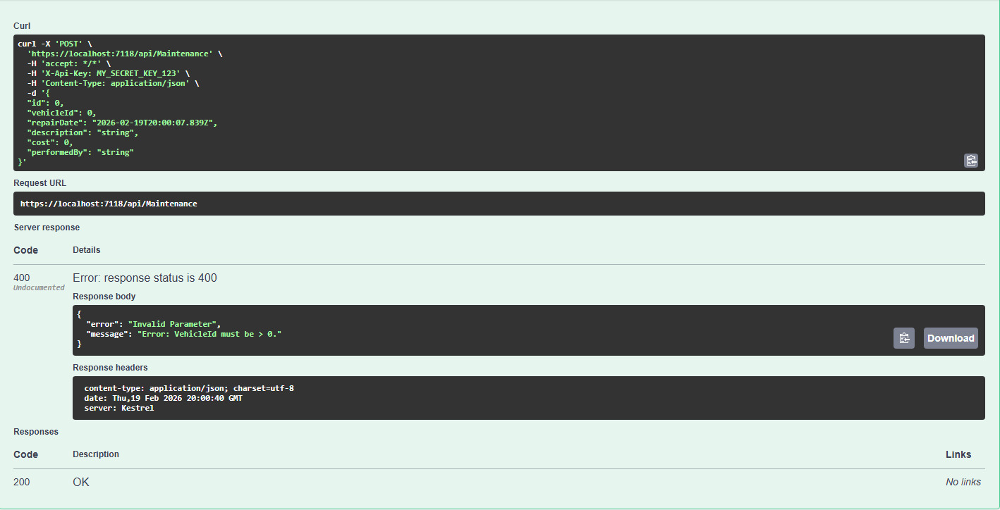

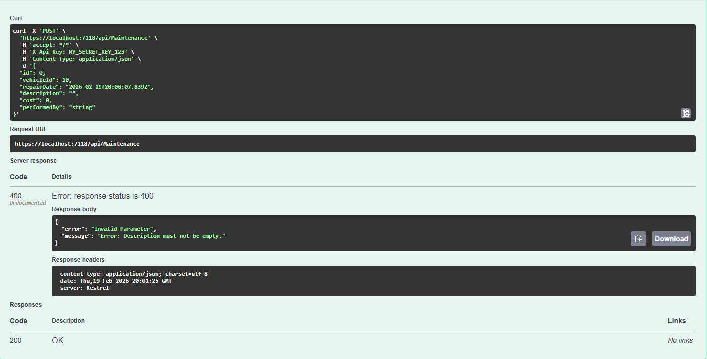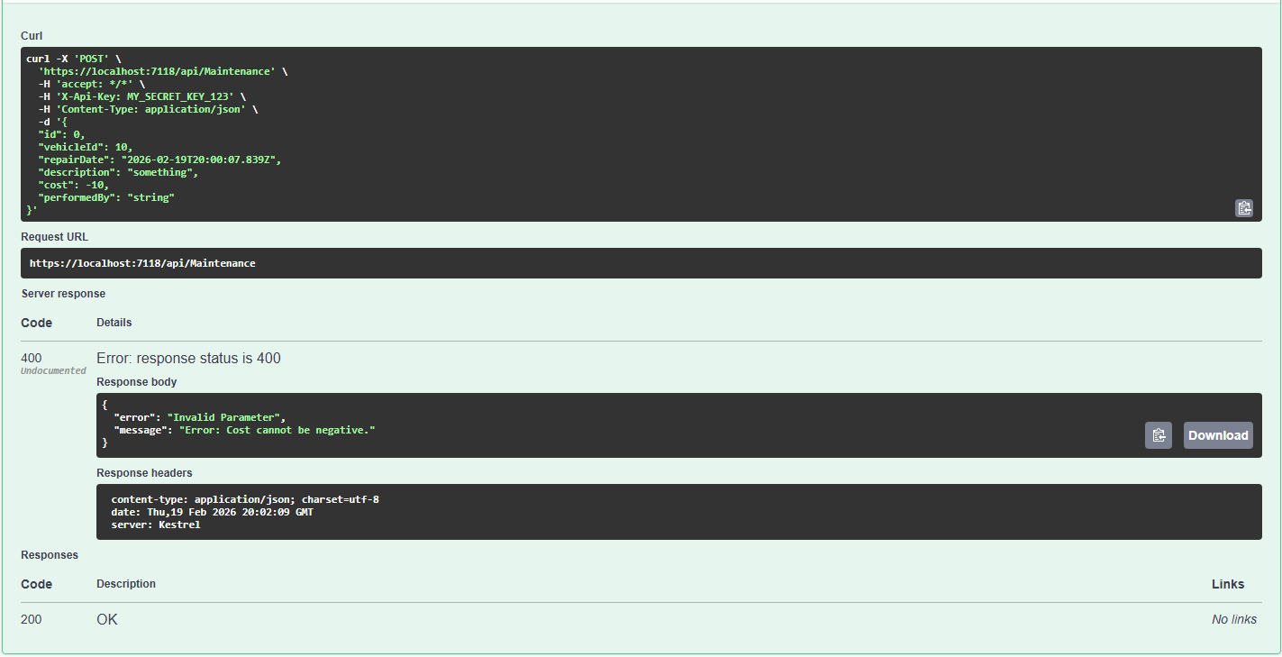

401. Unauthorized
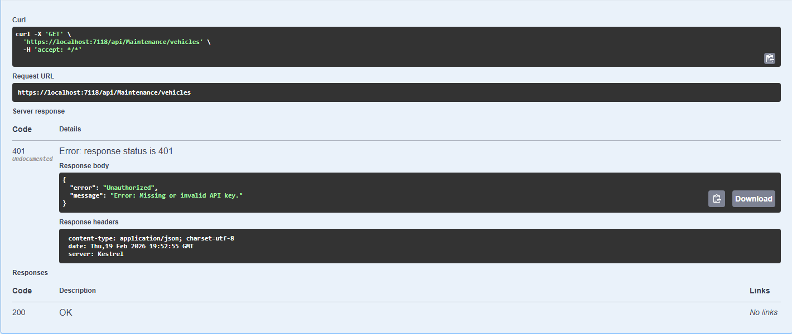

500. Server Error
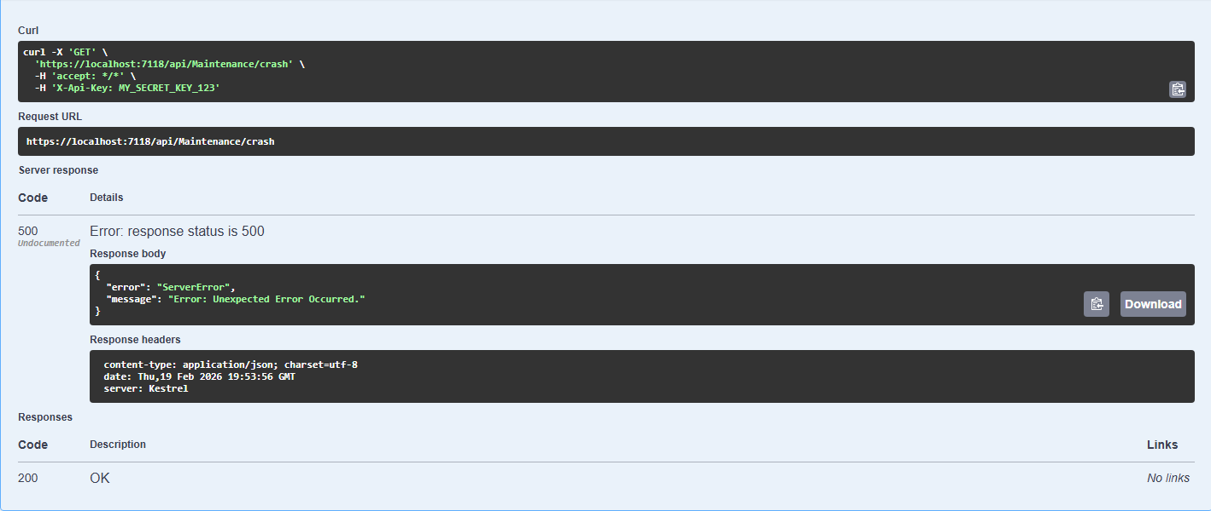

Usage Increment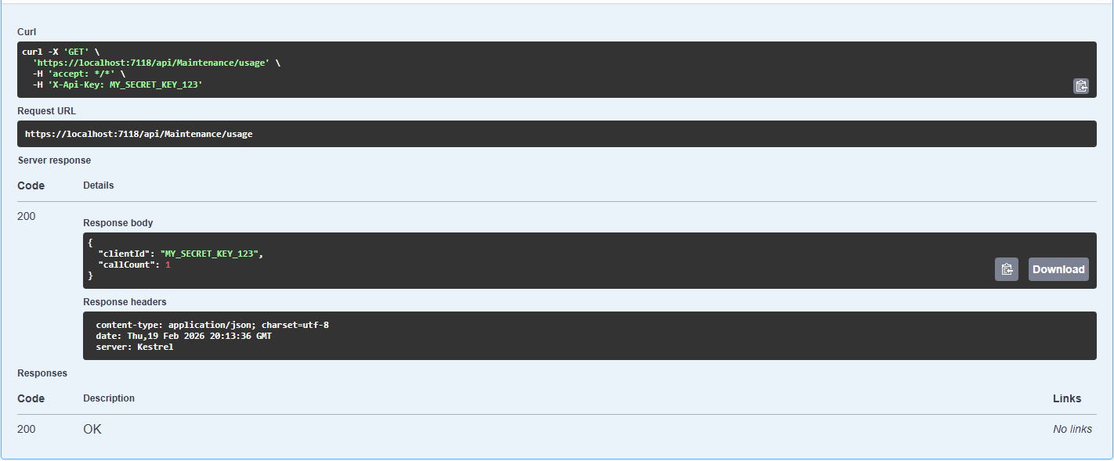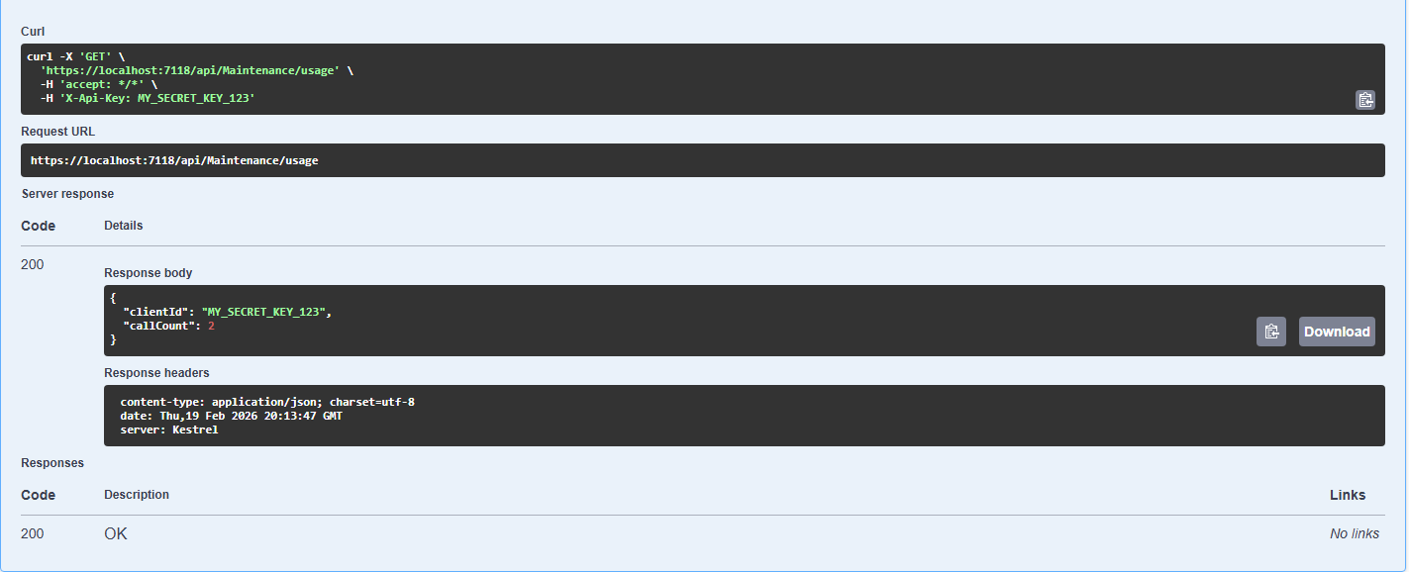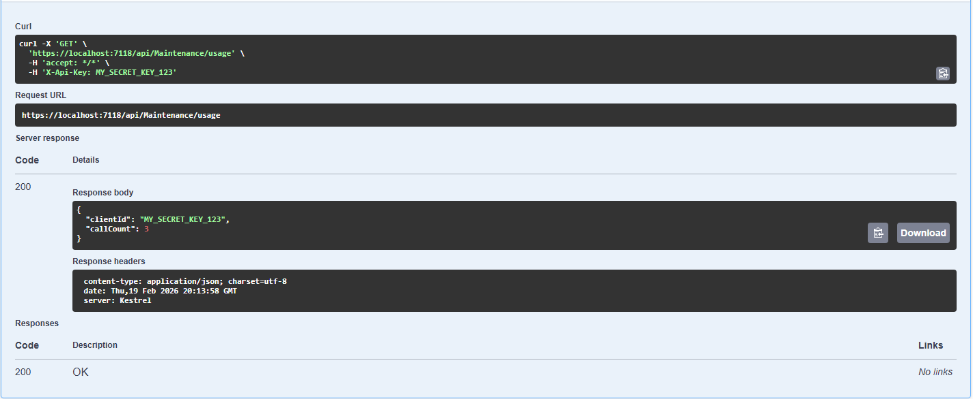

Middleware Security Enforcement
The middleware security is enforced by inserting code directly into the HTTP request, meaning every request passes through it before reaching the controller. In the lab, the API key acts as the middleware security and checks if the X-Api-Key header is entered. If the header is missing or invalid, it throws a 401 unauthorized JSON response back. If the correct X-Api-Key is provided, then it proceeds to the controller. This approach is more efficient and secure than checking for a key inside each controller.

In Memory State
When the application is started, a Dictionary<> is created in Program.cs and registered as a singleton. Making it a singleton forces it to create only one of that object for the application’s lifetime. When the usage endpoint is called, it calls that Dictionary and increments it. The count never resets unless the server process is restarted. This is the simplest in-memory state that doesn’t need a database or cache.

