IsolatedFootingRFT — Feature Spec
v1 — Wayfinder Complete. New extension in RFT-Tools (github.com/EssamKader/RFT-Tools), alongside ColumnRFT.extension and SimpleBeamRFT.extension. Diagrams below illustrate each section's logic.

1. Purpose
Automated isolated (pad) footing rebar detailing: bottom/top mesh, column dowels, and dowel stirrups — same tracer-bullet-verified approach as the existing tools.

2. Reused Components
- Dowel stirrup/tie shape generation — reuse the tie logic already built for ColumnRFT. Do not rebuild from scratch.

3. Naming & Geometry Conventions
Symbol | Meaning
a, b | Footing plan dimensions (a along X, b along Y)
Cw | Column width in the a-direction
X, Y | Clear offset, column face → footing edge, in a- and b-direction respectively (a = 2·X + Cw)
cover | Footing cover (top/bottom, per face)
Z | a − 2·cover — straight length of an a-direction bottom bar
N | footing_thickness − bottom_cover − top_cover — vertical hook leg of the first (lowest) mat
N2 | footing_thickness − bottom_cover − ⌀(first mat bar) − top_cover — hook leg of the mat stacked above the first one
LD | Required development/lap length = multiplier × bar diameter (e.g. 40·db) — multiplier is user input or code-table lookup
Primary Reinforcement | The bar direction with the larger offset/overhang beyond the column face (X or Y) — sits lowest within whichever mesh it's in
Secondary Reinforcement | The other bar direction — stacked above Primary Reinforcement, within that same mesh
mesh_bar_x | Bottom-mesh bars spanning the a-direction
mesh_bar_y | Bottom-mesh bars spanning the b-direction, stacked above mesh_bar_x

Confirmed: "if X > Y ⇒ Primary Reinforcement in X direction" compares the column-face offsets X (a-direction) vs. Y (b-direction) — whichever offset is larger, that direction's bars become the Primary Reinforcement.
Primary/Secondary is a per-mesh pairing, not a single global label: the bottom mesh has its own Primary Reinforcement (Bottom) / Secondary Reinforcement (Bottom), and — if the TOP + BTM option (Section 7) is chosen — the top mesh has its own Primary Reinforcement (Top) / Secondary Reinforcement (Top). The same X-vs-Y comparison decides the Primary direction identically for both meshes, since it's based on the fixed column offsets, not on which mesh it is.
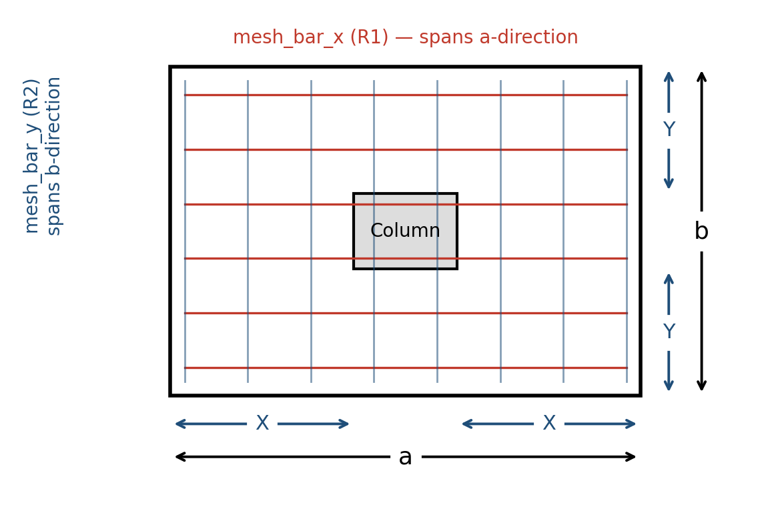
Diagram — isolated footing plan, X/Y offsets, and mesh_bar_x/mesh_bar_y layout

4. Bottom Mesh — Bar Length Formulas
mesh_bar_x = Z + 2·N
mesh_bar_y = Z2 + 2·N2
Z = a − 2·cover
Z2 = b − 2·cover
N = footing_thickness − bottom_cover − top_cover
N2 = footing_thickness − bottom_cover − ⌀mesh_bar_x − top_cover
Both mesh_bar_x and mesh_bar_y are L-shaped at each end by default (forming a U in elevation), unless the L-shape-alternating option (Section 6) is chosen.

5. Hook / Development-Length Decision (per bar end)
At each bar end, compare the straight length available outside the column footprint against LD:
- If LD > X → bend the bar up (hook) to add embedment via the vertical leg; total anchorage = straight X + hook.
- If X > LD → switch that bar from U-shape to L-shape — hook only the end(s) where LD > offset still applies; the end where offset > LD stays straight (no hook needed there).
Confirmed: the b-direction offset Y follows the identical rule (LD vs. Y) — the diagram below only shows the a-direction case, but the same comparison applies per-direction, per-end.
Note: here, as in Section 8, LD is not a flat length — it's LD = multiplier × db, where db is the diameter of the bar being checked (mesh_bar_x or mesh_bar_y) and the multiplier is a user input or code-table lookup.
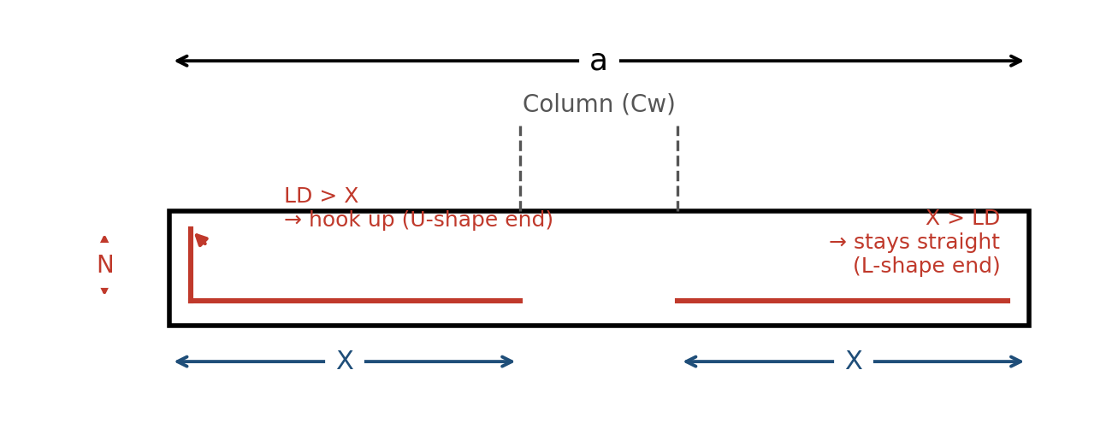
Diagram — development-length decision for U/L-shape bottom bars

6. U-Shape vs. L-Shape-Alternating — User Input, Set Separately for Bottom and Top
This is a direct user input, not a calculated result — and it's set independently for the bottom mat and the top mat (a footing could, e.g., run U-shape on the bottom and L-shape-alternating on top, or any other combination):
- U-Shape — every bar hooked at both ends. Safe default, more steel.
- L-Shape Alternative — each bar is L-shaped (one hook), and consecutive bars alternate which end is hooked, so the mat is still anchored at both edges overall, with less steel than full U-shape.
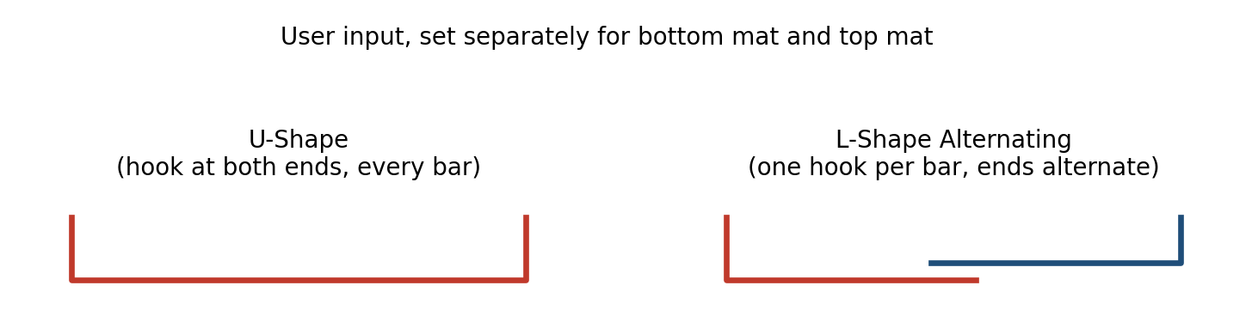
Diagram — U-shape vs. L-shape-alternating bar profiles
Whichever the user picks for a given mat overrides Section 5's per-end LD comparison for that mat — Section 5 only applies if/when the tool needs to decide the shape itself, which this input makes unnecessary.

7. Top Reinforcement Option
Do not infer whether a footing needs top steel from its thickness. Expose a user choice instead:
- BTM only
- TOP + BTM
If TOP + BTM is chosen, the top mat uses the same U-shape / L-shape choice (Section 6), closing top+bottom L-bars into a loop at the edge as an alternative to full U-shape bars top and bottom.
Confirmed: independent of Section 6 — the BTM-only/TOP+BTM toggle and the U-shape/L-shape toggle are set separately, not coupled.

8. Column Dowels (Vertical Starter Bars)
- Ls = lap/splice length — user input.
- dowel_bar = column vertical starter bar. Tied by dowel_tie (Section 9) and hooked horizontally at the bottom, resting on top of the bottom mesh.
Embedment inside the footing = a_dowel + b_dowel:
a_dowel = footing_thickness − bottom_cover − ⌀mesh_bar_x − ⌀mesh_bar_y
b_dowel = 200 mm (default)
LD (dowel development length) = user input, e.g. 55·db or 60·db (db = dowel_bar diameter). Compare LD to (a_dowel + b_dowel):
- If LD ≤ a_dowel + b_dowel → keep a_dowel and default b_dowel = 200mm.
- If LD > a_dowel + b_dowel → increase the hook: b_dowel = LD − a_dowel.
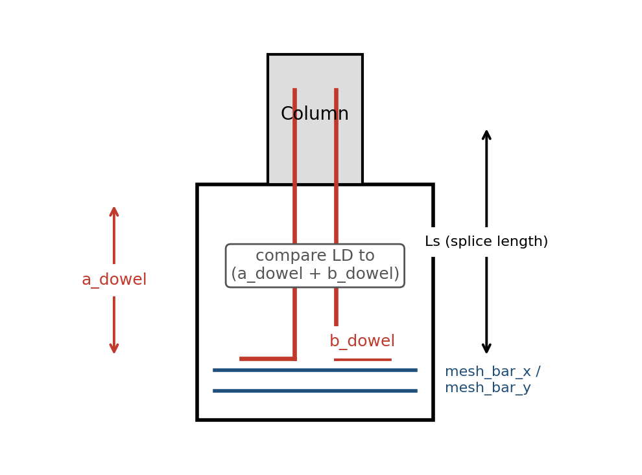
Diagram — column dowel embedment, a_dowel/b_dowel compared against LD

9. Dowel Stirrups (Ties)
- dowel_tie = the stirrup tying the dowel_bars together.
- Reuse ColumnRFT's tie/stirrup geometry logic for dowel_tie.
- Starter (first) dowel_tie: 50 mm from the bottom of the footing.
- End (last) dowel_tie: 50 mm below Top of Footing (T.O.F) — i.e. inside the footing depth. No dowel_tie is placed above T.O.F; the column's own ties take over there.
Confirmed: no default — tie diameter and spacing are both user inputs (matches the wall-automation/column-tool pattern of not hardcoding rebar sizes).
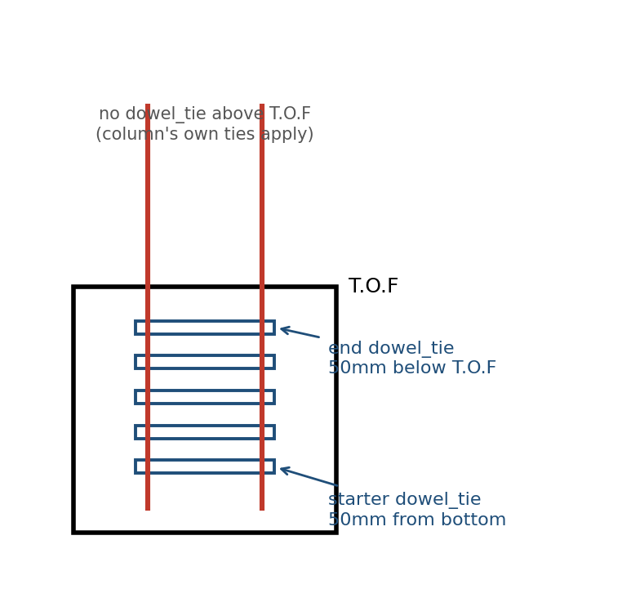
Diagram — dowel stirrup placement (starter/end offsets), reused from ColumnRFT

10. Perimeter Tie Bar (Footing-Level, Large Footings)
Separate from dowel_tie (Section 9, which only ties the column dowels).
- perimeter_tie = a bar that wraps around the footing's own perimeter, bundling/holding the footing's mesh bars (mesh_bar_x/mesh_bar_y, top and/or bottom) together — a binding element, not a structural one.
Geometry & length formula — closed rectangle, offset inward from all four faces by cover:
inner_a = a − 2·cover
inner_b = b − 2·cover
perimeter_tie_length = 2·(inner_a + inner_b)
Splice rule (12m stock length):
- If perimeter_tie_length ≤ 12m → one continuous bar.
- If perimeter_tie_length > 12m → split into two bars, overlapped by a lap length Ls at the joint. Because perimeter_tie is strictly a binding element (no direct tensile/compressive demand), the splice may be placed anywhere along the perimeter — no restricted zone.
The 12m threshold is hardcoded (standard stock length), not user input.
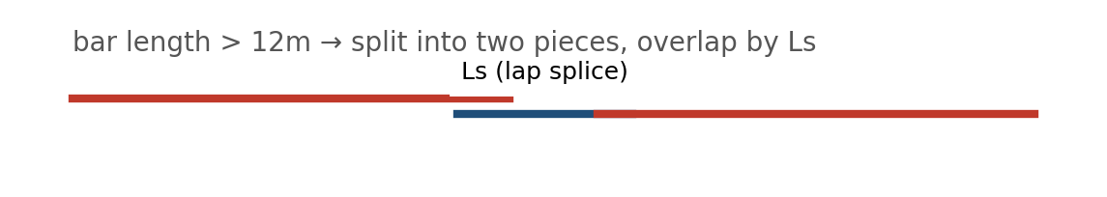
Diagram — 12m stock-length limit; splice with lap length Ls when exceeded
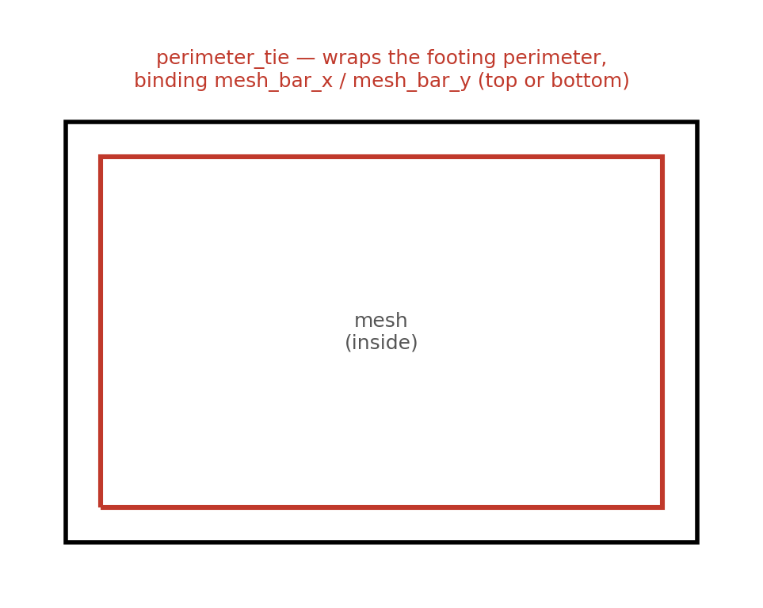
Diagram — perimeter_tie, plan view: wraps the footing perimeter, binding the mesh bars
Confirmed: diameter, spacing, and quantity of perimeter_tie are all direct user inputs — same pattern as beam side-face/crack reinforcement (e.g. the user can set one perimeter_tie loop every 200mm vertically up the footing thickness).

11. Suggested Implementation Order (tracer-bullet style)
- Tracer bullet: place one isolated footing + column dowels against a live Revit host over MCP; verify rebar-on-footing-host API behavior.
- Bottom mesh, straight case only (no hooks), single footing.
- Add hook/development-length logic (Section 5), U-shape default.
- Add L-shape-alternating option (Section 6).
- Add TOP + BTM option (Section 7).
- Column dowels + embedment logic (Section 8).
- Wire in ColumnRFT's stirrup/tie logic for dowel stirrups (Section 9).
- Multi-footing / batch support.

