⭐ 1. return_1y_pct
This is probably your MAIN performance metric.
Why it stands out:
- intuitive
- executive-friendly
- directly tied to performance
Use for:
- sector performance
- top/bottom performers
- trend comparisons

⭐ 2. volatility_1y_ann
This is your MAIN risk metric.
Why:
- pairs PERFECTLY with returns
- drives your quadrant chart

⭐ 3. sharpe_1y
🔥 VERY strong metric.
This is:
“risk-adjusted return”
Executives LOVE this because:
- high return alone isn’t enough
- Sharpe shows efficiency of return vs risk
This can differentiate you from junior analysts.

⭐ 4. composite_score
This screams:
executive KPI
Why:
- summarizes multiple signals
- easy ranking/filtering
- dashboard-friendly
Could be:
- top investment opportunities
- strongest sectors/assets

⭐ 5. momentum_score
VERY useful for:
- trend continuation
- market leadership
- high-growth sectors
Pairs nicely with:
- return
- volatility

⭐ 6. fear_greed_label
🔥 THIS is visually/storytelling GOLD.
Executives instantly understand:
- fear
- greed
- risk sentiment
This can create:
- segmentation
- color coding
- storytelling

⭐ 7. golden_cross
VERY nice supporting insight.
Why:
- simple bullish/bearish signal
- non-technical users recognize it quickly
Good for:
- filtering
- annotation
- “market momentum” stories

🚀 STRONGEST STORY COMBINATIONS
OPTION A (BEST)
Performance vs Risk
Use:
- return_1y_pct
- volatility_1y_ann
- sharpe_1y
This is your:
🔥 quadrant/scatter story

OPTION B
Market Momentum & Sentiment
Use:
- momentum_score
- fear_greed_label
- golden_cross
- composite_score
This is more:
- investor sentiment
- growth/risk narrative
---------------

Which sectors or assets are delivering the strongest performance relative to their level of risk?
Core business questions:
1) Which sectors/assets are performing the best?
2) Which sectors/assets carry the highest risk?
3) Which sectors provide the best balance of return versus risk?
4) Which sectors may require closer monitoring?
5) Are there emerging trends or momentum shifts?

Why Return vs Volatility is weaker here
The volatility chart is still good, BUT:
- volatility is harder for non-finance viewers
- the relationship is less clean visually
- Sharpe gives clearer quadrant interpretation
- Because Sharpe Ratio already incorporates risk-adjusted performance.
Your Sharpe chart already naturally separates:
- strong performers
- weak performers
- inefficient assets
VERY nicely.
scatter chart –
My dataset structure actually mirrors Yahoo Finance’s organization pretty well:

Yahoo Navigation
→ Market category
Your dataset
→ asset_class

That means:
- your dataset is intended for cross-market analysis
- not just stock-sector analysis
Which explains:
- why sector/industry are incomplete
- why asset_class is clean
Size mark: Market Cap Usd
Because my chart is about:
- long-term return
- risk-adjusted performance
- asset significance
Market cap fits that story better.

Market Cap USD
Represents:
- economic size, total market value, institutional importance
Question answered:
“How large/significant is this asset class financially?”
Very strategic/executive.

Average Volume
Represents:
- trading activity, liquidity, short-term participation
Question answered:
“How actively is this traded?”
More operational/trading-focused.
------
Strategic investment performance
NOT:
- trading behavior, liquidity analysis, transaction activity
So:
✅ Market Cap USD fits better conceptually.

Why volume might weaken the story
You already have:
- Return, Sharpe Ratio
Adding volume introduces a THIRD concept:
- trading activity
which doesn’t directly connect to:
- risk-adjusted efficiency
So the chart becomes slightly less coherent analytically.

- International and ETF markets exhibit the strongest risk-adjusted performance Crypto remained the weakest and most volatile asset class.
- Diversified global markets demonstrated stronger long-term efficiency and stability than higher-volatility assets.
- Market performance varied significantly across asset classes, indicating the importance of balancing return with volatility.
- Composite scoring and sentiment analysis exhibit stronger performance concentration withing diversified equity markets.
US Mega Cap and International asset markets remained strongest on Risk-adjusted performance.
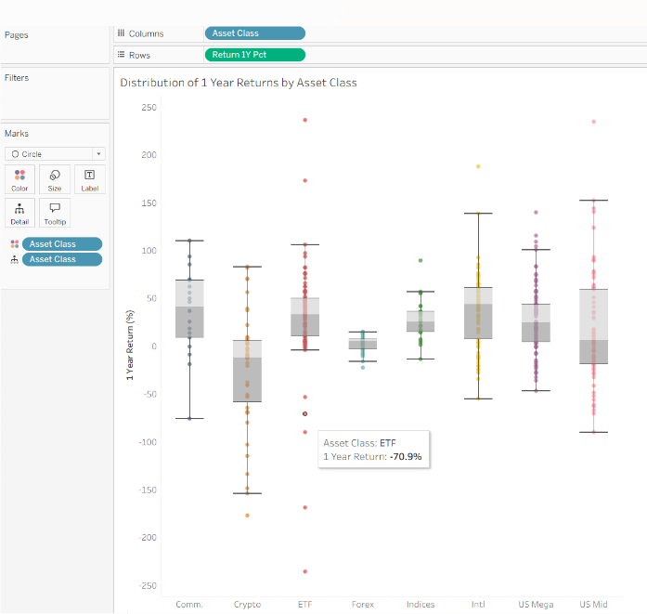

“Cryptocurrency assets demonstrated the greatest return volatility and the largest negative outliers, while forex assets showed the most stable return distribution.”
Crypto
- widest downside
- unstable returns
- largest negative outliers
Forex
- tightest/stablest spread
ETFs / Intl
- positive clustering
- strong upside potential
US Mid
- widest mixed dispersion
That’s excellent analytical value.

