Wenzhuo Wang (1562172)

**Program Structures & Algorithms**

**Fall 2021**

**Assignment No. 2**

* **Task (List down the tasks performed in the Assignment)**
* (Part 1) You are to implement three methods of a class called Timer.
* (Part 2) Implement InsertionSort(in the InsertionSort class) by simply looking up the insertion code used byArrays.sort.
* (Part 3) Implement a main program (or you could do it via your own unit tests) to actually run the following benchmarks: measure the running times of this sort, using four different initial array ordering situations: random, ordered, partially-ordered and reverse-ordered.
* **Relationship Conclusion:**
* With the exponential growth of N, the time of each operation decreases.
* The greater the randomness of array arrangement(Entropy increase), the longer the sorting time
* **Evidence to support the conclusion:**

1. **Output**

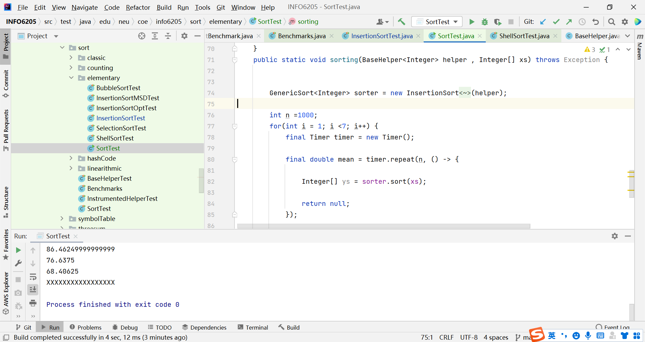

**Graphical Representation(Observations from experiments should be tabulated and analyzed by plotting graphs(usually in excel) to arrive on the relationship conclusion)**

**Part3:**

* **Unit tests result:**
* **Part1:**
* 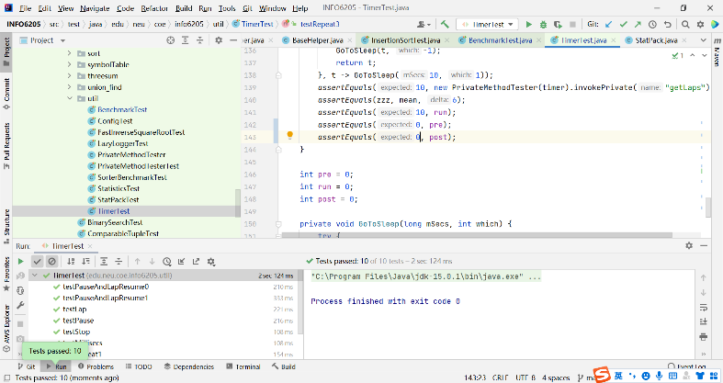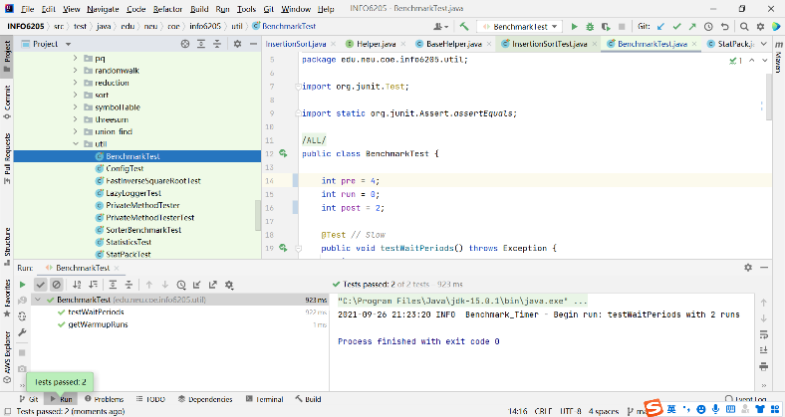

Part2:

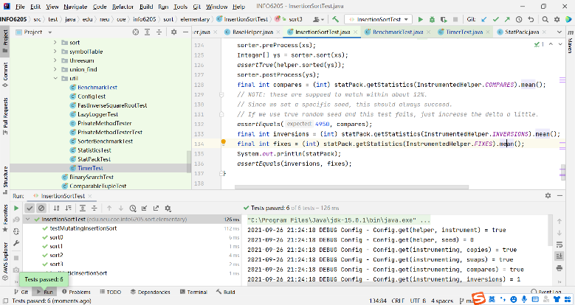

Part3:

Test/sort/elementary/SortTest.class

