Wenzhuo Wang (1562172)

**Program Structures & Algorithms**

**Fall 2021**

**Assignment No. 3**

* **Task (List down the tasks performed in the Assignment)**
* (Part 1) (a) Implement height-weighted Quick Union with Path Compression. For this, you will flesh out the class UF_HWQUPC. All you have to do is to fill in the sections marked with // TO BE IMPLEMENTED ... // ...END IMPLEMENTATION.
* (Part 2) Using your implementation of UF_HWQUPC, develop a UF ("union-find") client that takes an integer value n from the command line to determine the number of "sites." Then generates random pairs of integers between 0 and n-1, calling connected() to determine if they are connected and union() if not. Loop until all sites are connected then print the number of connections generated. Package your program as a static method count() that takes n as the argument and returns the number of connections; and a main() that takes n from the command line, calls count() and prints the returned value. If you prefer, you can create a main program that doesn't require any input and runs the experiment for a fixed set of n values. Show evidence of your run(s).
* (Part 3) Determine the relationship between the number of objects (n) and the number of pairs (m) generated to accomplish this (i.e. to reduce the number of components from n to 1). Justify your conclusion in terms of your observations and what you think might be going on.
* **Relationship Conclusion:**
* m = 4.9882n - 1710.2  
  R² = 0.9988
* **or**

m= n*log6.53n

R2=0.999909

* **Evidence to support the conclusion:**

1. **Output**

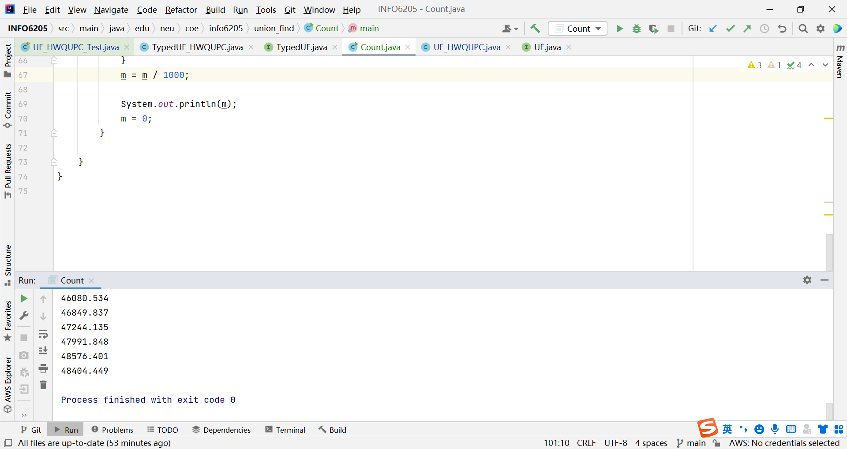

* The original data and fitting data are saved in file assignment3.xlsx

**Graphical Representation(Observations from experiments should be tabulated and analyzed by plotting graphs(usually in excel) to arrive on the relationship conclusion)**

**Part3:**

* **Unit tests result:**
* **Part1:**
* 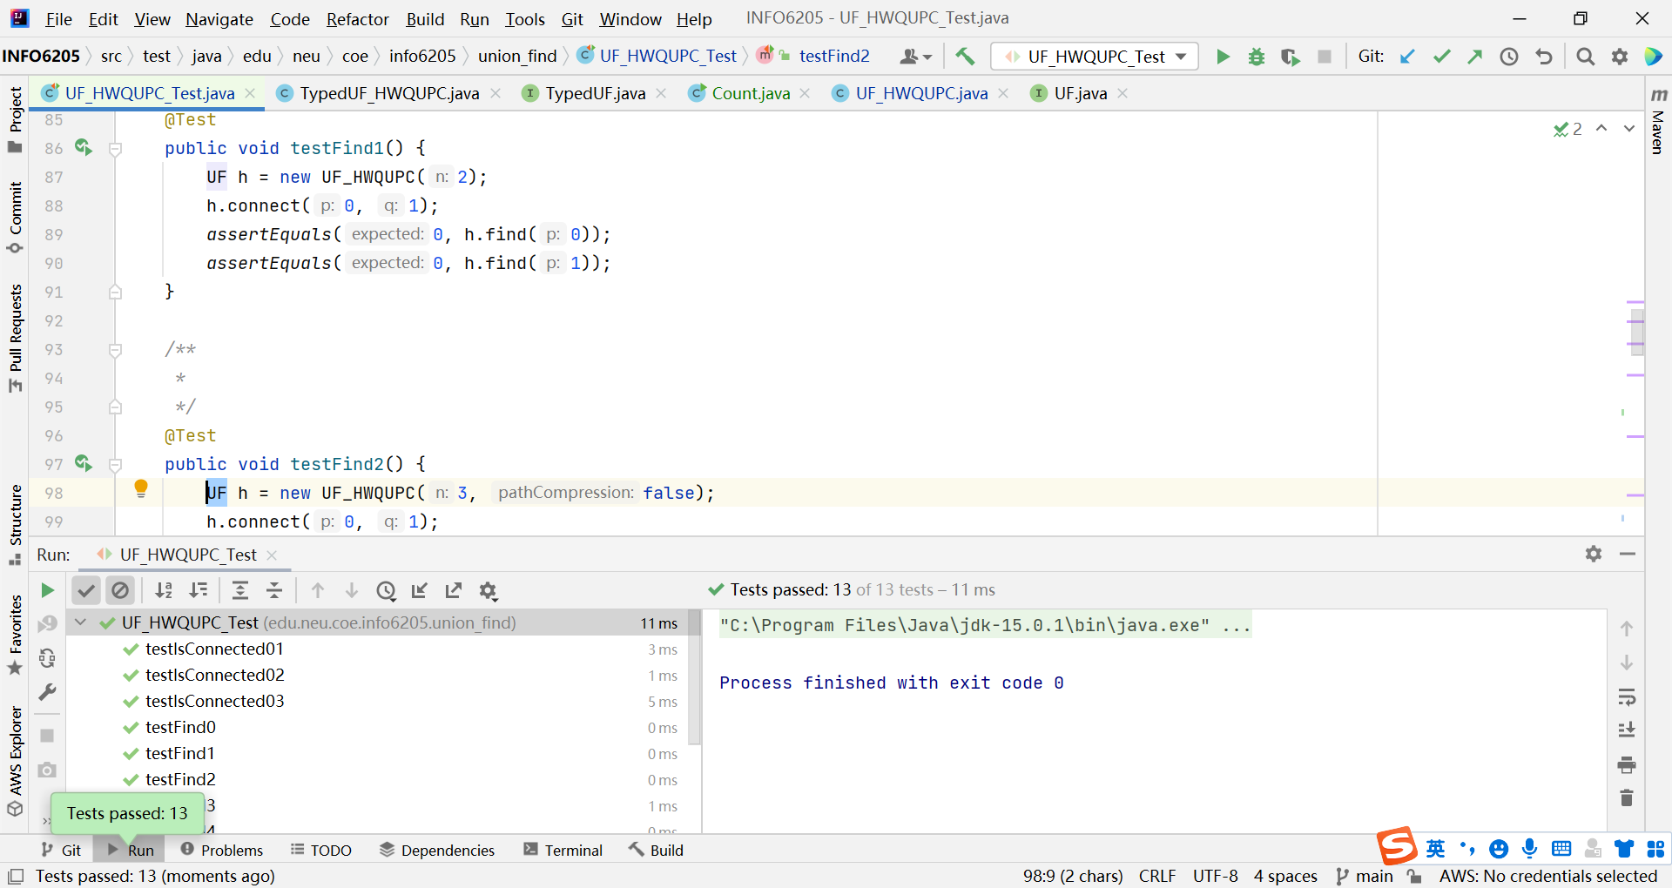
* **Part2,3:**

