Wenzhuo Wang – SEC fall(NUID 1562172)

Big Data System Engineering with Scala  
Fall 2021   
Assignment No. 5

https://github.com/Essexwwz/scala

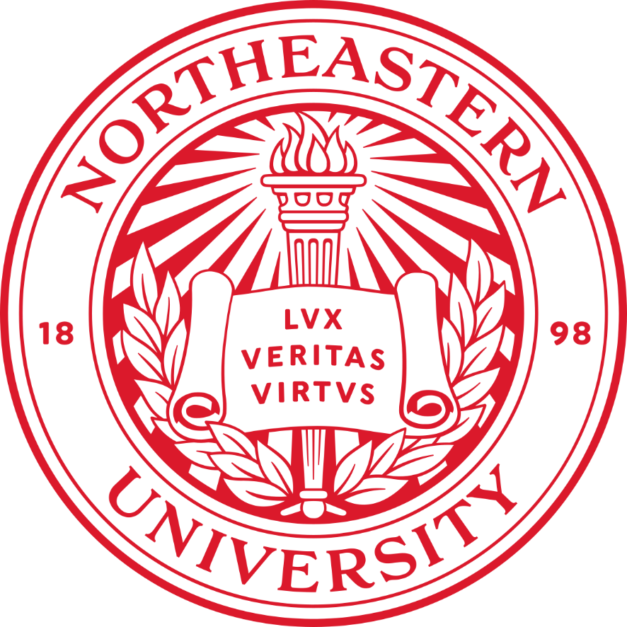

**Task**

**−** There are 13 TODOs in Function.scala and 2 TODOs in Movie.scala. You can get these from the class repo (see Course Material/Resources/Class Repository), the module name for this assignment is assignment-functional-composition.

**Solution:**

Function.scala:

* map2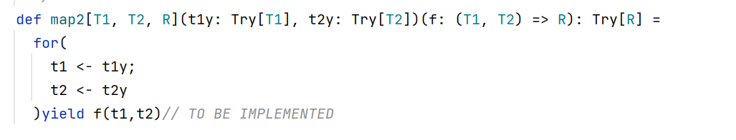
* map3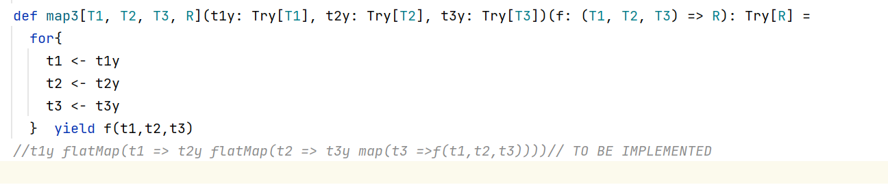
* map7

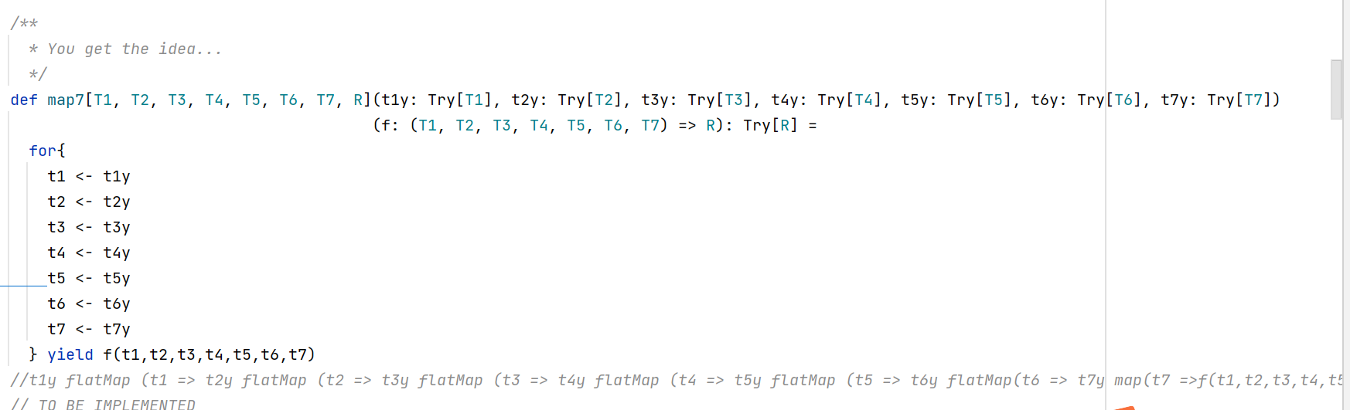

* lift

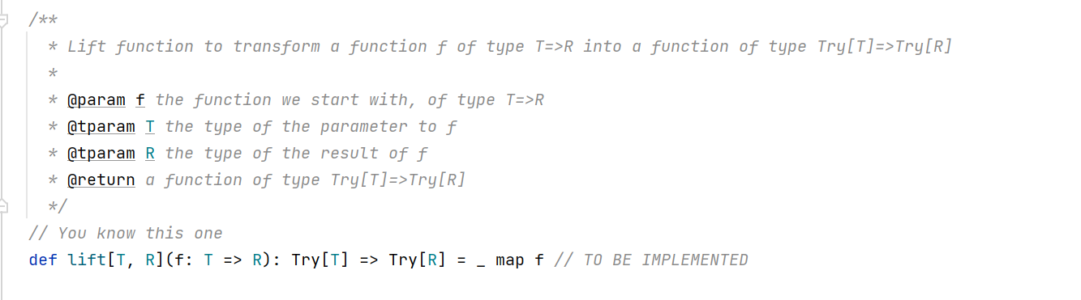

* lift2
* lift3
* lift7
* invert2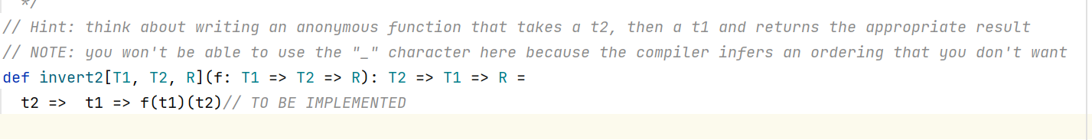
* invert3
* invert4



* uncurried2
* 
* uncurried3



* uncurried7
* 

Movie.scala:

* MoviesProtocol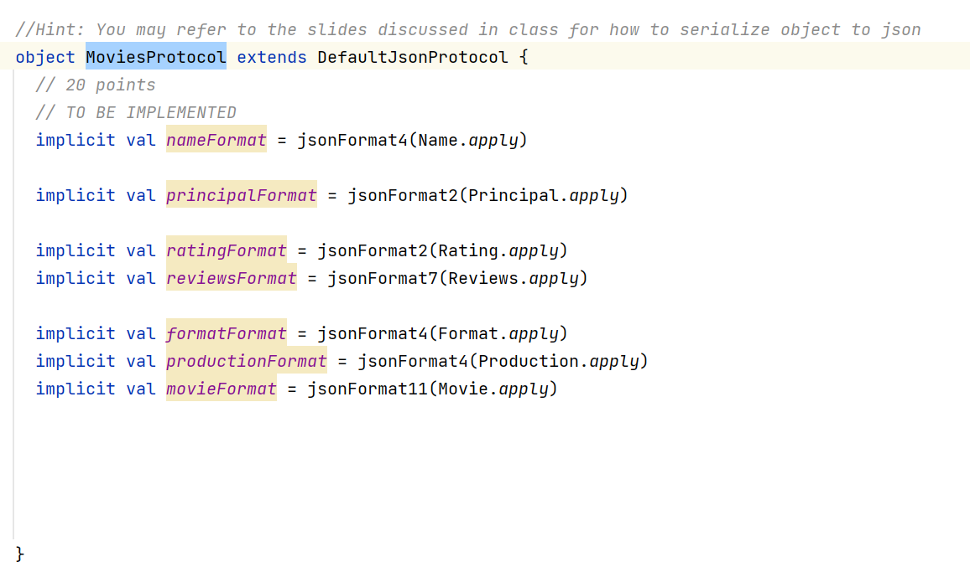
* testSerializationAndDeserialization

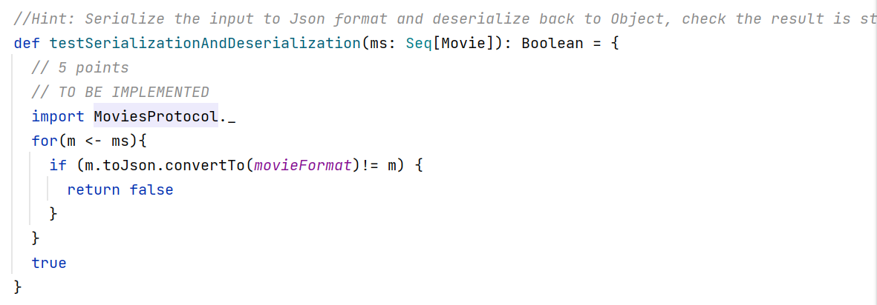

Unit test result:

FunctionSpec:

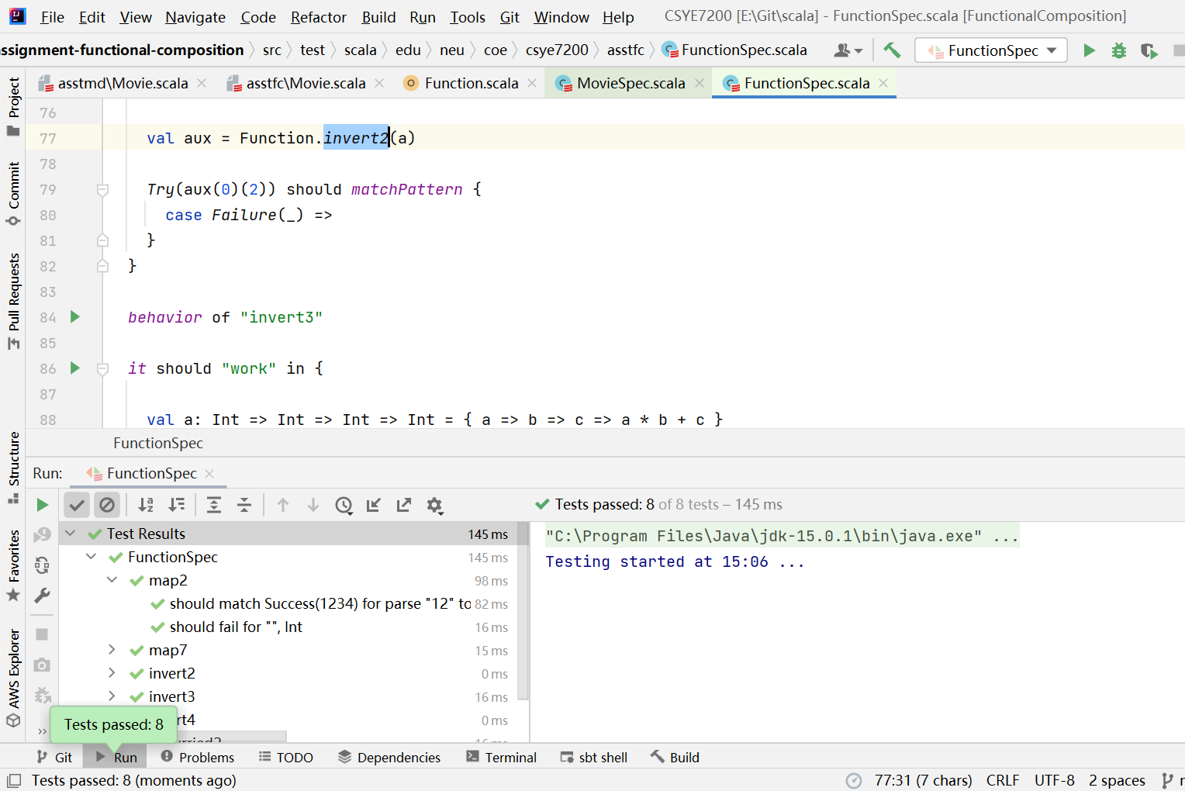

MovieSpec:

