Wenzhuo Wang – SEC fall(NUID 1562172)

Big Data System Engineering with Scala  
Fall 2021   
Assignment No. 4

https://github.com/Essexwwz/scala



**Task**

**−** Create a trait called RandomState which will have two obvious methods: next and get.

**−** Use implement map to map RandomState[T] into a RandomState[U], Use implement flatmap to flatmap RandomState[T] into a RandomState[U] **−** Implement the 6 TO BE IMPLEMENTED and run the tests.

**Solution:**

flatmap:

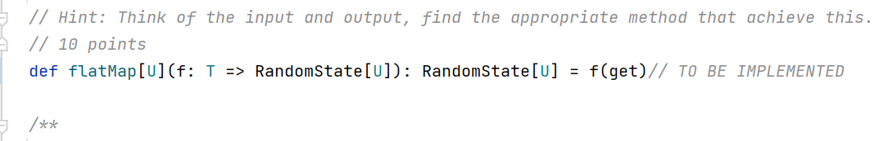

toStream:

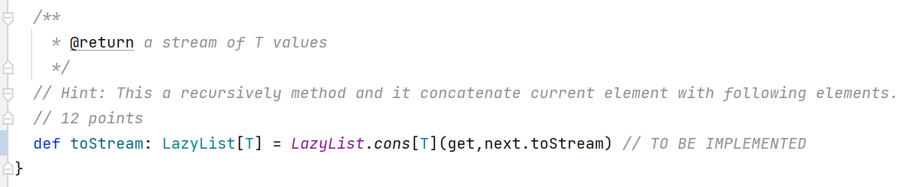

next:



get:

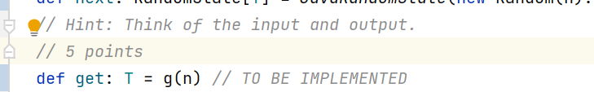

map:



longtoDouble:



Unit test result:

