**SYSTEM ANALYSIS AND DESIGN**

**Requirement Analysis**

**Functional Requirements**

**The system is able to:**

Message other people

Save and send data

Send email

**Non–functional Requirements**

**Availability**

**Usability**

**Compatibility**

**Functionality**

**Reliability**

**Portability**

**System Architecture**

The GSM and GPS sensors are used to send messages to using a cell network and generate real time location data in form of longitude and latitude respectively, they are activated using the push button. One connected, the microcontroller monitors the GPS receiver and GSM modem to receive and transmit the data to the phone as text message also the user can dial 1195 which is the hotline for Gender Based violence.

Once all the data is collected, it is stored on Firebase which will act as a source of data fir the Machine learning model.

The GSM and GPS sensors are used to send messages to using a cell network and generate real time location data in form of longitude and latitude respectively, they are activated using the push button. One connected, the microcontroller monitors the GPS receiver and GSM modem to receive and transmit the data to the phone as text message also the user can dial 1195 which is the hotline for Gender Based violence.

Once all the data is collected, it is stored on Firebase which will act as a source of data fir the Machine learning model.

### Machine Learning

Data recorded by the devices is sent to the Firebase from The data goes through Pre Processing where ‘cleaning’ will be performed like removing the empty spaces and peorm feature extraction of relevant columns.

Supervised learning is the technique used to map the data to the target variable (predicted output). Scikit-learn library will facilitate use packages like the numPY to enable data analysis. For the decision boundary technique to work the SVM algorithm is used, the inputs are divided into two classes, if results are above the decision boundary; it is match.

Figure 2. 2: Decision Boundary

□ □ □

□ □ □

■ ■ ■ ■ ■

■ ■ ■ ■

■ ■

PCA (Principal Component Analysis) will be used for prediction. A report will be generated based on the data, given that the Programming language used is Python.

The items will be connected using the breadboard having set different parameters, the board is connected to the computer using a USB cable. The Arduino code demo ought to be downloaded and unzipped into to the library before uploading the sample source code into the Arduino IDE.

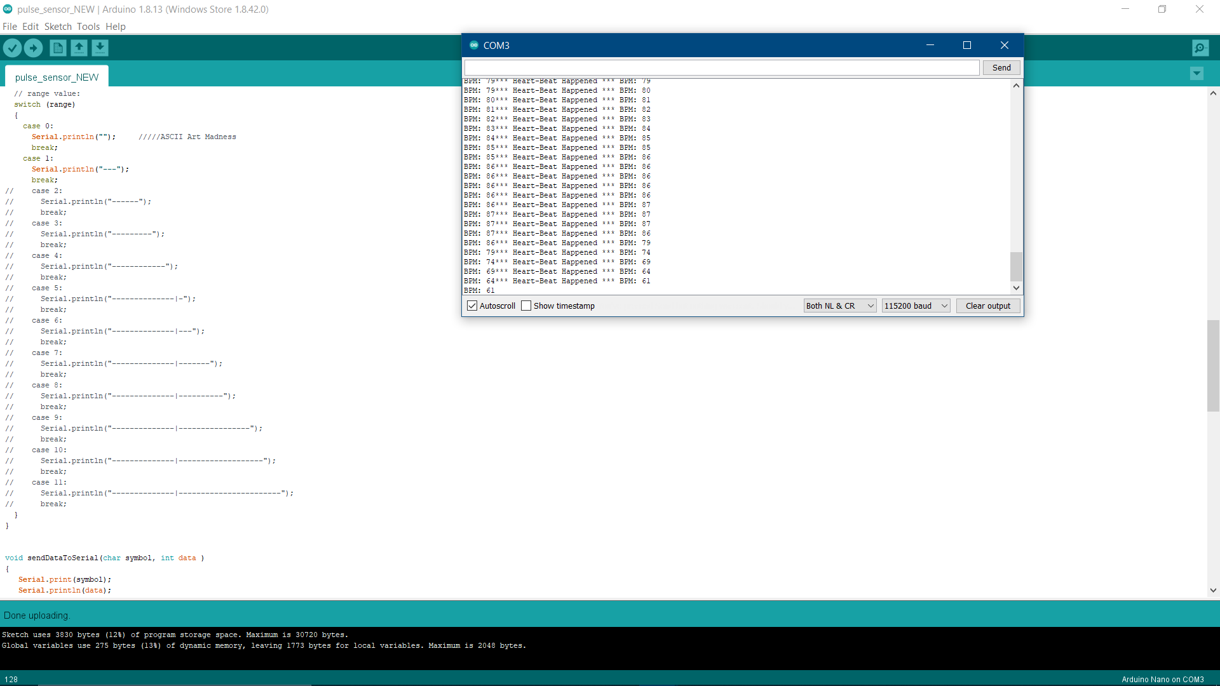

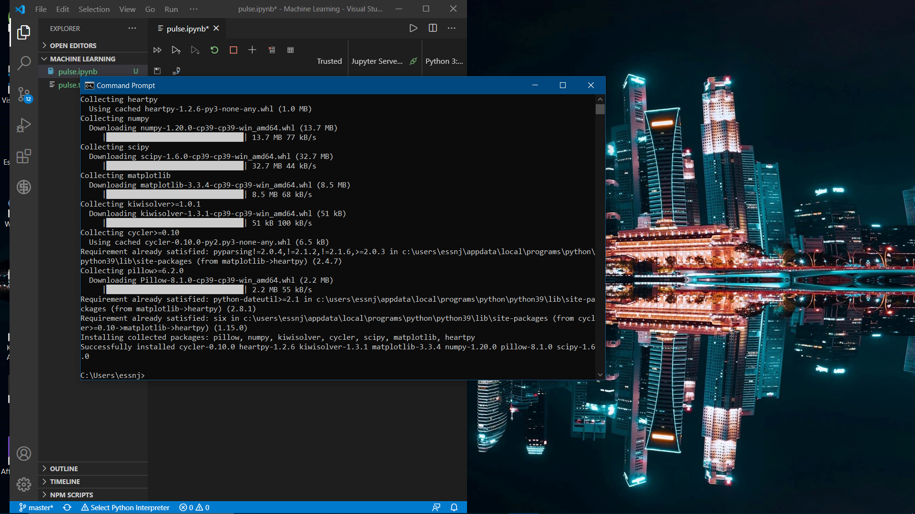

As much as this is a technical perspective of solving sexual violence, it is wise to understand that all this can be

