DESIGN AND IMPLEMENTATION OF A GEO-FENCED MOBILE ATTENDANCE MONITORING SYSTEM FOR ACADEMIC INSTITUTIONS

BY

ESSIEN ABASIAMA

20201742

DEPARTMENT OF ELECTRICAL ELECTRONIC ENGINEERING

COLLEGE OF ENGINEERING

FEDERAL UNIVERSITY OF AGRICULTURE, ABEOKUTA

SUPERVISED BY
ENGR. MATHEW SIMEONE
DECEMBER, 2025.

ABSTRACT
Accurate attendance monitoring remains a persistent challenge in academic institutions, where conventional manual and basic digital methods are vulnerable to impersonation (proxy attendance), location fraud, and the inability to confirm a student's continued presence throughout a lecture. This project presents the design and implementation of GeoTrack, a geo-fenced mobile attendance monitoring system that integrates four independent verification mechanisms - device binding, GPS-based geofencing, facial verification, and a lecturer-controlled timed attendance window with randomised presence checks - so that attendance is recorded only when a genuine, physically present, and correctly identified student checks in from a registered device.
The system was developed as a three-tier client-server application comprising a cross-platform React Native mobile application, a Laravel RESTful backend, and a relational database, communicating securely over HTTPS. A student's position is determined by averaging multiple high-accuracy GNSS samples and evaluated against circular or polygonal venue boundaries using the Haversine and ray-casting algorithms, while identity is confirmed through facial verification against a configurable similarity threshold.
The implemented system was evaluated through functional and performance testing covering positioning accuracy, face-verification reliability, device-binding enforcement, and the composite check-in decision under both legitimate and fraudulent conditions. Results showed accurate geofence admission outside the GPS-margin zone, reliable rejection of impersonation and location-spoofing attempts, correct on-time and late classification, prompt push and email notifications, and stable operation under continuous and concurrent use. GeoTrack therefore demonstrates a secure, cost-effective, and engineering-driven solution that eliminates common attendance fraud while providing real-time monitoring and analytics for lecturers and administrators.
TABLE OF CONTENTS
Update field: select all then F9
LIST OF FIGURES
Update field: select all then F9
LIST OF TABLES
Update field: select all then F9

CHAPTER ONE: INTRODUCTION

1.1 Background of the Study
Monitoring attendance forms a very fundamental piece of academic administration, especially within higher education. It is a pretty basic way seeing how much a student participates, and it is used to make judgments on performance, plus to even determine if the student qualifies to sit for examinations. Many universities still use attendance to make sure students meet minimum requirements for showing up to class, and also to help to judge how effective the teaching methods are. But even with knowing how important this all is, managing attendance at most tertiary schools in Nigeria? Is still, pretty inefficient and easy to mess with.
Old-fashioned attendance systems – you know, signing in on paper or calling out names – are simple to fake. Students are able to sign for friends that skipped class, or someone else can just attend for them , plus all this data is easily changed around. It is, for example, pretty easy to just initial the attendance sheet and then leave class without anyone even noticing you’re gone. Lately, digital tools have been introduced to try fixing these old systems' problems, such as scanning QR codes or using online attendance programs. But, even with all this tech available, these systems still have problems. Students are able to check in even when they are not near the classes, or just decide to give login info to someone else that they trust.
And the rise of smartphones, along with the spread of mobile internet, that presents a chance at making better attendance systems by using precise location technology. Today’s mobile phones have GPS, fingerprint scanners, front and rear cameras, and many ways of identifying the device itself. This makes it possible to track a student's location accurately, and also to double-check their identity, plus keeping the attendance system very secure. It can all be used to make tracking attendance more reliable.
Geofencing is about setting up virtual boundaries, like invisible fences, around a physical location. This lets apps know when someone has entered that specific area. And, when geofencing is combined with things like device binding and fingerprint or facial recognition scans, it can really tighten up attendance records. The idea is to ensure that only authorized students who are physically present in the lecture hall are able to confirm their attendance. Random checks during the class period can also discourage students from skipping out early and encourage them to stay for the duration.
GeoTrack, it is a geo-fenced attendance system designed for mobile phones. It is specifically intended to address the ongoing issues that come with properly managing student attendance. By leaning on location data, device verification, and perhaps even facial recognition, along with allowing lecturers to control attendance times, the system aims for openness, reliability, and seamless integration into existing educational settings. I believe it will provide a great deal of transparency and dependability.

1.2 Statement of the Problem
Even though attendance is really important when it comes to grading and everything, a lot of colleges and universities still use attendance systems that, honestly, are not very secure or efficient, making it too easy to cheat them. A significant problem you see all the time is students signing in for their friends who are not even there; basically, marking them present when they are actually absent. And location fraud, it is also super common with, students checking in from their dorm or some other building nearby, or even when they are off campus completely.
Another issue that the attendance systems we have now have, is they cannot really tell if someone stays for the whole class. Like, a student can mark themselves present at the start of the lecture and then just leave right away, and the system would not even notice the student. In addition, the attendance platforms themselves are often not that flexible too . Lecturers cannot really change in how attendance is taken, or how to verify it. Or even make the time window any different. All of this leads to records that are not accurate, more work for administrators, and does generally cause a drop in the academic discipline, which is not great.
But, because we now have phones and other mobile devices that can track location really well and use things such as fingerprint scanners for ID, it is super clear that we need a new kind of attendance system. One that is more secure, smarter, and knows where everyone actually is; a system that can actually check who a student is, if they are physically in the classroom, and if they stay there for the full lecture. It would make things easier for everyone and much more accurate as well.

1.3 Aim and Objectives of the Study
The core concept driving this project involves creating a mobile attendance system that is secure. It uses geo-fencing to ensure a student is who they say they are and that they are actually where they need to be. It does this by combining location tech, device-specific locking, and even the option of using face-scanning or some other kind of biometric ID.
The project has several specific aims, and are listed here:
i. To come up with and build a device-binding system. The aim is to make sure that each student has to use one specific mobile device which, is registered just for them, to record their attendance.
ii. Integrating geolocation and geofencing tech. This makes sure students can only mark themselves as present when they are physically inside the correct lecture area; limiting fraud.
iii. Developing a range of different attendance modes that the lecturers can switch between. This includes a standard tap-to-check-in system and a face recognition option for, better authentication.
iv. To design and put in place an attendance "window" that works on a timer. The lecturer would have full control over this.
v. Putting in place random checks. This makes sure that people actually stay in the lecture hall for the whole time. It is, an important part.
vi. To develop an automatic system for logging attendance. Alongside this, we need an analytics bit that makes attendance records and reports for both the students, and the lecturers.
vii. Also, it is important to design and build a dashboard for the lecturers. This will let them keep an eye on attendance as it is happening, give them control over the system, and help them manage their lecture sessions. There might be some changes needed along the way.

1.4 Significance of the Study
This study is important for a few different reasons, especially if you are thinking about it from academic, administrative, and even engineering angles. Academically, it gives us a pretty solid, reliable way to keep an eye on student attendance. And it boosts the trustworthiness of attendance info used for grading and important decisions. The system being looked at here helps make academic places more disciplined, accountable, and transparent. Which it does by cutting out impersonation and location fraud with location-based verification and ID checks.
Administratively speaking, GeoTrack cuts down on the manual work needed for taking attendance and reduces errors in the records. Automated attendance logs, real-time tracking and analytics, helps teachers and administrators make better calls based on the correct data. Which is, you know, the ultimate goal.
From an Electrical and Electronic Engineering viewpoint, the project demonstrates a practical use of core engineering concepts. Things such as sensor-based systems, signal collection, embedded intelligence, communication networks, and system integration. Using Global Positioning System (GPS) data is a real-world application of satellite-based positioning and signal processing principles. Also, geofencing relies on calculating spatial data and creating digital systems. Device binding and using biometric face recognition adds elements related to electronic security systems, image processing, and smart algorithms. Further, the project shows some systems engineering ideas by putting mobile hardware such as GPS modules, cameras, and processors, alongside software control logic and network communication.

1.5 Scope and Limitations of the Study

Scope
This study covers designing and building a secure mobile attendance system that uses geo-fencing. The main idea is for it to be used in university lecture halls. It is set up to only handle attendance taken on mobile phones and gives lecturers total control over the attendance sessions. That control includes picking the type of attendance, setting up the geo-fence, and also time-based access.
The study is mainly looking at the engineering: how the system is designed, how it is put together, and how the different parts are made to work together. Those parts are things like location tracking, figuring out what device is being used, using biometrics to check who it is, and communicating over a network. There is a lot of focus on how the system thinks, how it checks that the data is correct, and the ability to monitor things as they are happening. And hardware stuff that is more than just what smartphones already have is not covered here, it is outside the scope.

Limitations
The system as proposed obviously requires each student to possess a smartphone. And those phone needs to have working GPS, cameras, and a stable internet connection. But there variations in GPS accuracy; it is likely to happen because of things in the environment, such as what buildings are nearby, anything blocking the signal, or just how good the phone itself is. Similarly, how well the face recognition works can vary depending on how good the lighting is, how good the camera is and also where the user is standing. In Addition this study limited to system design implementation and does not cover large-scale deployment or long-term operational performance, infrastucture scalability is also not considered here. The legal stuff, like regulatory frameworks, policies at the institution, or thinking much about legality or ethics of storing biometric data, this is just not the focus right now.

CHAPTER TWO: LITERATURE REVIEW

2.1 Introduction
This chapter presents a review of existing literature relevant to the design and implementation of geo-fenced attendance monitoring systems with emphasis on technologies rooted in Electrical and Electronic Engineering. The review focuses on location-based systems, Global Positioning System (GPS) technology, geofencing techniques, mobile sensing hardware, biometric authentication systems, wireless communication, and system integration approaches. The objective of this chapter is to establish a solid theoretical and technical foundation for the proposed GeoTrack system and to identify gaps in existing studies that justify the present work within an academic environment.

2.2 Conventional Attendance Monitoring Systems and Their Limitations
Traditional ways of keeping track of attendance in colleges and universities include things like paper sign-in sheets, calling out names, and using cards to swipe in. A number of studies have pointed out that these methods are not very good, take up a lot of time, and are easy to cheat on. People can sign in for others, mess with the records, and data can be lost, as noted by Adewale et al. in 2021. Manual systems also mean more work for the lecturers, and they often do not give reliable attendance information that can be used for making decisions administratively.
To try; to fix some of these problems, electronic attendance systems were brought in, such as RFID cards and barcode scanners. But, the research shows that card systems still have problems. People can still use someone else's card to sign in, and you have to install and maintain special equipment, according to Okafor & Musa, 2020. These limits really show us that we need attendance solutions that are more secure, automatic, and know where people are.

2.3 Overview of Location-Based Systems in Engineering Applications
Location-Based Systems (LBS) refer to technologies that determine the geographical position of a device and provide services based on that location. LBS have been widely applied in navigation, logistics, asset tracking, emergency response, and mobile services (Hightower & Borriello, 2019). From an Electrical and Electronic Engineering perspective, LBS rely on satellite signals, wireless communication networks, embedded sensors, and signal processing techniques.
Recent studies indicate that the integration of LBS into mobile systems enables real-time monitoring and control in both industrial and institutional applications (Zhang et al., 2022). These capabilities make LBS suitable for applications such as attendance verification where physical presence is required.

2.4 Global Positioning System (GPS): Principles and Performance Characteristics
The Global Positioning System—or GPS as most people call it—is basically a navigation system that uses satellites to give location and time data to anyone with a receiver here on Earth. It works by something called trilateration, where a receiver takes signals from a bunch of satellites and figures out your position from that, as Kaplan & Hegarty wrote in 2017. And, you know, GPS receivers are built right into mobile devices these days and are combined with other sensors to make them even more accurate.
Now, a lot of research indicates, that GPS accuracy can be affected by things such as buildings blocking signals, what they call multipath effects, the weather, and, of course how good your receiver actually is (Misra & Enge, 2020). Even so, GPS is still the most popular way of finding your location outdoors. And it is good enough for things such as geo-fenced attendance systems, where you need to verify someone is within a certain area.

2.5 Geofencing Technology and Spatial Boundary Control
Geofencing is a location-based technique that defines a virtual boundary around a physical area and triggers actions when a device enters or exits the boundary. Geofencing has been applied in security systems, fleet management, and access control applications (Rashid et al., 2021). From an engineering standpoint, geofencing involves spatial computation, coordinate comparison, and threshold-based decision logic.
Recent literature highlights that geofencing enhances system reliability by ensuring that location-dependent actions occur only within authorized zones (Singh & Kaur, 2022). In attendance monitoring, geofencing ensures that attendance can only be marked within lecture venues, thereby eliminating location-based fraud.

2.6 Mobile Device Sensors and Embedded Hardware Capabilities
Modern smartphones, they have a bunch of sensors built right in. Things like GPS, cameras, accelerometers—you name it. All this stuff works together as an embedded system; it senses data, processes it, and then sends it off somewhere (Yuce & Khan, 2020). The way these sensors are designed and how they grab those signals to begin with, it is all thanks to electrical and electronic engineering.
Research has found that if you use the hardware that is already in smartphones, you can bring down the cost of a system. Also, it becomes much more scalable without needing extra electronic pieces (Chen et al., 2021). Which makes using phones for this stuff a good fit especially in big places like university and college campuses.

2.7 Biometric Authentication Systems in Identity Verification
Biometric authentication is identifying people using things like fingerprints, faces, or how they speak; these are physiological or behavioral characteristics. Face recognition systems, they usually work by grabbing an image, then pulling out the key features, and then matching them to a stored pattern (Jain et al., 2018). And this is how it happens.
Recent research is showing now that face recognition gives you better security than passwords or cards, especially if you add in some other ways to double-check. (Adekunle & Bello, 2022). But you get issues too; things like how bright it is what the camera looks like, and really where the person is standing can mess things up. So that is something you have got to think about when you are setting these things up.
It can also have additional flaws, such as user positioning. These must be considered during the system design phase.

2.8 Device Binding and Hardware-Based Identity Association
Device binding refers to associating a user account with a specific hardware device to prevent unauthorized access. In mobile systems, this often involves using unique device identifiers and hardware-level security features (Alonso et al., 2021). From an engineering perspective, device binding enhances system security by limiting system access to authorized physical devices.
Literature indicates that combining device binding with biometric verification significantly reduces impersonation and unauthorized system usage (Nwoye et al., 2023). This approach is particularly effective in attendance systems where individual accountability is required.

2.9 Wireless Communication and Data Transmission in Mobile Systems
Mobile attendance systems rely on wireless communication technologies such as cellular networks and Wi-Fi for data transmission. These communication systems are designed based on principles of digital communication, modulation, error control, and network protocols (Sklar, 2019).
Studies show that reliable data transmission is essential for real-time monitoring and synchronization between mobile clients and central servers (Khan et al., 2022). Network latency and connectivity issues remain challenges, particularly in areas with unstable internet access.

2.10 System Integration and Control Architecture
System integration involves combining sensing, processing, communication, and control components into a functional unit. In Electrical and Electronic Engineering, this reflects systems engineering principles where hardware and software components operate cohesively (Blanchard & Fabrycky, 2018).
Research emphasizes that effective system architecture improves reliability, scalability, and maintainability of engineering systems (Ogunleye et al., 2021). For attendance systems, integration ensures seamless coordination between geolocation sensing, authentication modules, and data management components.

2.11 Review of Related Works
Several studies have looked at electronic and automated attendance systems, using different technologies. Adewale et al. (2021) developed an attendance system using RFID, and it did improve how accurate the records were, but it was still vulnerable to people marking attendance for someone else. Okafor and Musa (2020) suggested using a biometric system with fingerprinting, and while this did make it more secure, it needed special hardware to be installed.
Singh and Kaur (2022) put in place a GPS attendance system, for monitoring workers who are outside. While this system worked well at checking locations, it did not have, biometric verification; this made it easier to fake who you are. Adekunle and Bello (2022) looked into using face recognition for classroom attendance, but they did not add in geofencing or any way to continuously check if a person was still there.
More recent studies, that combine geolocation and iometrics show better attendance integrity. However many of them seem to focus mainly on the software side, without putting enough thought into how the system is integrated and what hardware it actually needs (Nwoye et al., 2023). What is also true is that not many studies look at presence verification that is randomized or attendance parameters controlled by the lecturer.

2.12 Identified Research Gaps
From the reviewed literature, it is evident that existing attendance monitoring systems often address either identity verification or location verification in isolation. Few studies integrate geofencing, device binding, biometric authentication, and real-time control into a unified system. Furthermore, limited attention has been given to applying Electrical and Electronic Engineering system design principles to attendance monitoring in academic environments.
This study seeks to bridge these gaps by developing a geo-fenced mobile attendance monitoring system that integrates location sensing, embedded device identification, biometric verification, and wireless communication within a coherent engineering framework tailored to university lecture environments.

CHAPTER THREE: METHODOLOGY

3.1 System Overview and Methodological Approach
This chapter describes the approach that was used in designing, developing and implementing the GeoTrack Attendance Monitoring System. The design process is structured as a formal engineering design process with a combination of concepts of Electrical and Electronic Engineering, such as embedded systems, signal processing, wireless communication, and control systems.
The GeoTrack system is envisioned as a location aware cyber-physical system, which integrates sensors on mobile devices, wireless communication modules, data processing backend and cloud-based data storage. Its main role is to confirm the identity and the physical presence of the students within the established space and time. The system is reliable, secure and real-time monitored and this is through the combination of software and hardware.

3.2 Research Design and System Development Framework
The study embraces the Design and Development Research (DDR) approach, which is suitable in the implementation of the system based on engineering. To make sure that the solution fulfills the functional and performance requirements, DDR focuses on iterative design, prototyping and testing. The framework is comprised of the following stages:
- Problem Analysis
  - Determine security weaknesses and functionality inefficiency in traditional attendance mechanism, including impersonation, location spoofing, and manual records errors
  - Establish system requirements that meet the academic integrity and engineering feasibility.
- System Modelling and Design
  - Develop functional and architectural models, including data flow diagrams, control logic schematics, and interaction diagrams.
  - Architect the mobile sensors, GPS and biometric and communication network integration..
- System Implementation
  - Implement the suggested architecture with the help of mobile hardware and backend server and network communication interfaces..
  - Exercise control secrets to gadget binding, geofencing and real time attendance confirmation.
- Testing and Evaluation
  - Conduct unit and integration testing of hardware and software components.
  - Test the system performance using accuracy, reliability, response time and efficiency of biometric verification..
- Deployment and Monitoring
  - Use the system in the cloud environment to be able to scale up and monitor it centrally..
  - Test the behavior of a system in real life level academic context.
This methodology ensures that the project follows Electrical and Electronic Engineering principles, particularly in system integration, embedded control, and sensor-driven data acquisition.

3.3 Materials and Technologies Used

3.3.1 Hardware Components
The physical layer of the GeoTrack system comprises:
- Smartphones (Android/iOS): Equipped with GPS, front-facing cameras, accelerometers, and wireless communication modules.
- Server Infrastructure: Cloud-based servers for data processing, storage, and system control.
- Development Workstations: Laptops or desktops for software development, simulation, and testing.
These components collectively act as sensing, processing, and communication units, forming the cyber-physical backbone of the system.
3.3.2 Software and Development Tools
The software layer is implemented using tools that ensure reliability, cross-platform compatibility, and scalability:
- Mobile Application Development: React Native with JavaScript/TypeScript for cross-platform deployment.
- Backend and API Development: Laravel (PHP framework) implementing RESTful API architecture.
- Database Management: MySQL or PostgreSQL for relational data storage and query optimization.
- Cloud Infrastructure: Linux-based servers (Ubuntu) with Nginx/Apache, SSL security, and automated backups.

3.3.3 External APIs and Libraries
Integration with external APIs and libraries enables advanced functionality:
- Google Maps and Geolocation APIs for accurate positioning.
- Geofencing APIs to enforce spatial boundaries.
- Face Recognition Libraries (TensorFlow Lite, FaceNet) for biometric verification.
- Device Fingerprinting Libraries for secure device identification.
- Axios for secure client-server communication.

3.4 Overall System Architecture
The system follows a three-tier client-server architecture, comprising the Presentation Layer, Application Layer, and Data Layer.

3.4.1 Presentation Layer
This layer represents the user interface for students and lecturers:
- Captures GPS coordinates and facial images.
- Handles authentication and secure session management.
- Transmits attendance and verification data to the backend server.

3.4.2 Application Layer
Implemented in Laravel, this layer handles control logic:
- Device binding and identity verification.
- Geofence enforcement and attendance session management.
- Randomized presence verification and processing of biometric results.

3.4.3 Data Layer
A relational database stores and manages:
- User, device, and course records.
- Attendance logs and location verification data.
- System parameters for session control.
This architecture ensures data consistency, reliability, and efficient system operation.

3.5 System Operational Workflow
The GeoTrack system operates through the following sequence:
- Students register and authenticate on the mobile application.
- Device binding ensures that each account is associated with a unique smartphone.
- Lecturers initiate attendance sessions and configure geofenced lecture locations.
- Students within the geofence can mark attendance using the app.
- Randomized checks ensure continued presence throughout the lecture.
- Attendance logs are stored in the database for analytics and reporting.
This workflow integrates initial verification and continuous monitoring, improving academic integrity and operational efficiency.

3.6 Software Configuration and Control Parameters

3.6.1 Frontend Configuration
- Secure handling of API keys and tokens.
- Permission management for GPS and camera access.
- Session management for secure authentication.

3.6.2 Backend Configuration
- Routing, middleware, and access control for RESTful APIs.
- Scheduled tasks for time-based attendance sessions.
- Queue processing for randomized presence verification and notifications.

3.7 Cloud Deployment Architecture
The backend is deployed on a Linux-based cloud server with:
- Encrypted HTTPS communication.
- Secure RESTful API endpoints.
- Database access restrictions and automated backups.
- System monitoring for uptime and performance metrics.
This deployment ensures scalability, availability, and data security.

3.8 Data Security and Privacy Measures
To safeguard sensitive student information, the system implements:
- End-to-end encryption for all communications.
- Secure storage for biometric data and device identifiers.
- Role-based access control and device-level restrictions.
- Controlled exposure of system APIs to prevent unauthorized access.

3.9 System Testing and Performance Evaluation
The system is rigorously tested using:
- Unit testing for backend API endpoints.
- Integration testing between mobile clients and backend.
- GPS accuracy and geofence validation under real conditions.
- Biometric verification accuracy tests under variable lighting and positioning.
- Load testing for multiple concurrent users to ensure responsiveness and reliability.

3.10 Summary
In this chapter, the methodology applied in coming up with the GeoTrack Attendance Monitoring System was explained. The system integrates mobile sensing, embedded hardware, wireless communication and control logic to provide the secure, scalable and EEE-oriented system of attendance verification in academic institutions. The approach focuses on engineering integration, which is practical and therefore provides assurance of both technical excellence and operational excellence.

3.11 System Architecture Diagram
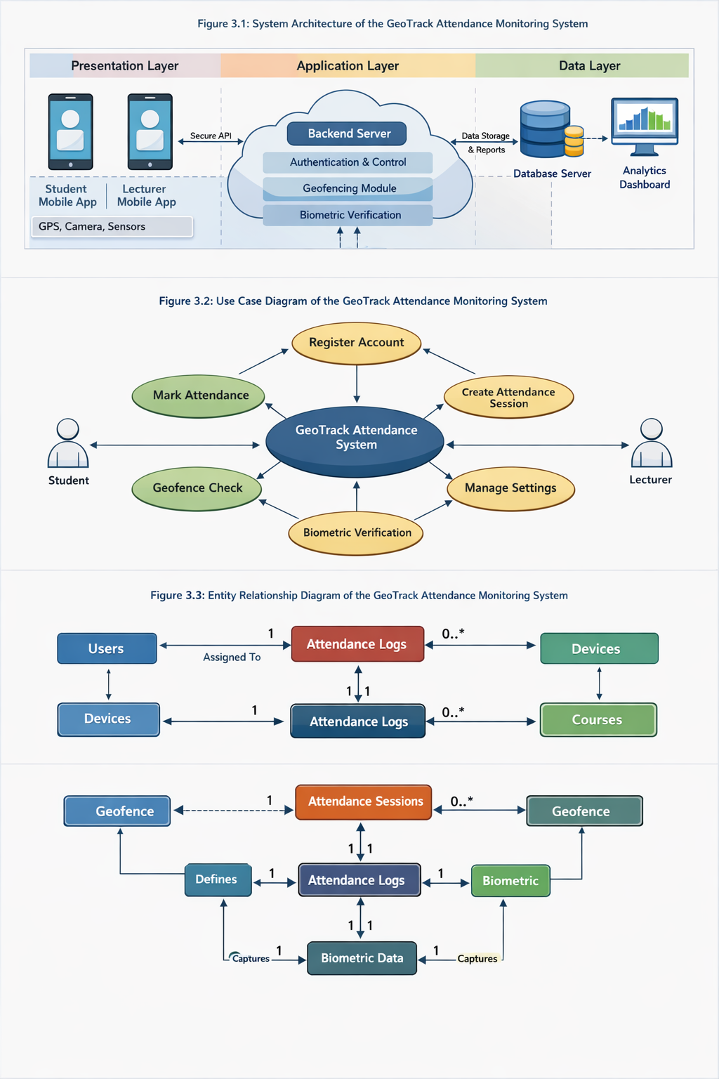
Figure 3.1: System Architecture of the GeoTrack Attendance Monitoring System

3.12 Use Case Diagram


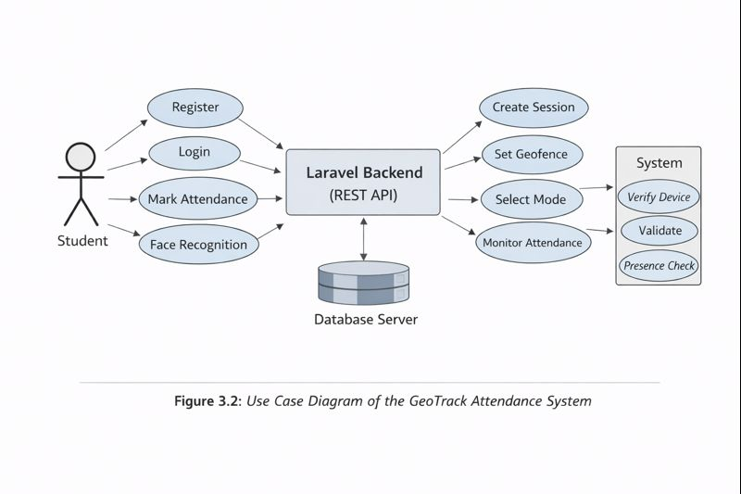
Figure 3.2: Use Case Diagram of the GeoTrack Attendance Monitoring System

3.13 Entity Relationship Diagram

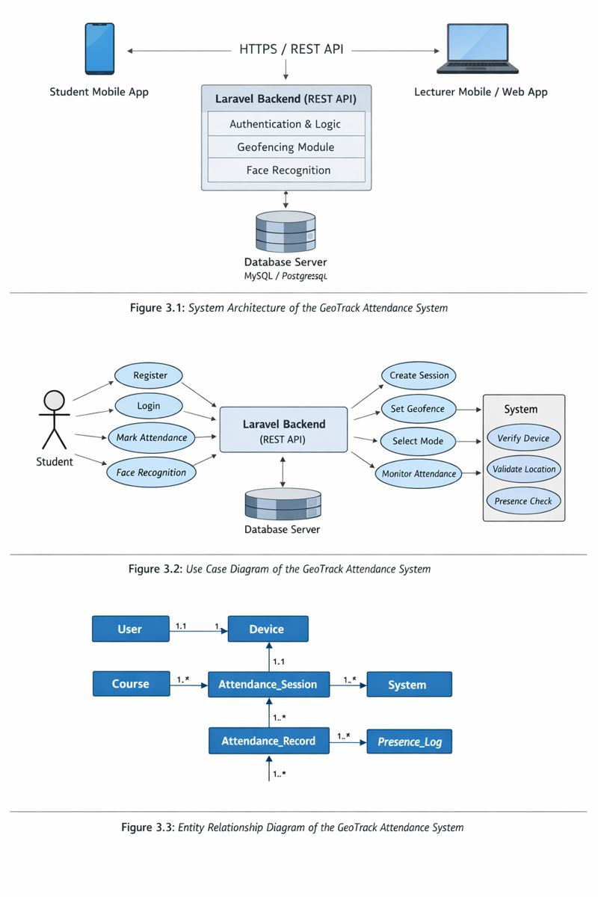
Figure 3.3: Entity Relationship Diagram of the GeoTrack Attendance Monitoring System

CHAPTER FOUR: RESULTS AND DISCUSSION

4.1 Overview
This chapter presents the results obtained from the implementation, testing, and evaluation of the GeoTrack geo-fenced mobile attendance monitoring system. Testing was carried out in stages that follow the path a real attendance takes: account registration and device binding, location (geofence) verification, identity (face) verification, the actual check-in decision, the timed attendance window with randomised presence checks, and finally notification delivery and dashboard reporting. The results cover positioning accuracy, face-verification performance, the correctness of the check-in decision under both legitimate and fraudulent conditions, system response times, and the stability of the platform under continuous and concurrent use.

4.2 System Implementation
The GeoTrack system was successfully implemented as a three-tier client–server application, matching the architecture described in Chapter Three. The presentation layer was built as a cross-platform mobile application using React Native, the application layer as a RESTful backend using the Laravel framework, and the data layer on a relational database. The mobile app, backend API, and database communicated over secure HTTPS, with authentication handled by token-based sessions and every sensitive request additionally carrying the bound-device identifier.
All major modules were integrated and confirmed functional prior to testing: account registration with institution selection, device binding, geofence configuration (both circular and polygon boundaries), the tap and face-recognition attendance modes, the timed attendance window, randomised presence verification, and the analytics dashboard for lecturers and administrators. The student application correctly requested GPS and camera permissions, captured location and facial images, and transmitted verification data to the backend, while the backend enforced the control logic and returned the appropriate responses. Figure 4.1 shows the main screens of the deployed application during normal operation.
Figure 4.1: Home, class list, and class detail screens of the GeoTrack application

4.3 User Registration and Device Binding Testing
Initial testing verified that students could register, that each account was tied to its institution, and that an account could be used from only one physical device.

4.3.1 Account Registration and Authentication
New users completed the two-step registration flow (personal details, then institution selection) and verified their email through a one-time code before gaining access. Login issued a session token, after which the device-binding step ran automatically. Registration and login behaved consistently across the devices tested, and unverified accounts were correctly prevented from signing in.
Figure 4.2: Registration, institution selection, and email verification flow

4.3.2 Device Binding
Device binding was evaluated by attempting to use the same account from more than one phone. As summarised in Table 4.1, the first device a student used became the bound device, and any attempt to operate the account from a second device was rejected until the student explicitly reset the binding. This directly addresses the impersonation problem, since a student cannot simply hand login details to a friend on another phone.
Table 4.1: Device Binding Test Cases
Scenario | Expected Behaviour | Observed Result
First login on Device A | Account bound to Device A | Bound successfully
Re-login on Device A | Access granted | Granted
Login on Device B (same account) | Access blocked (device conflict) | Blocked
Check-in without device header | Request rejected | Rejected
Reset device, then bind Device B | Old binding revoked, new device bound | Re-bound successfully

In every trial, the system permitted attendance-related actions only from the registered device, and the binding could be transferred only through the deliberate reset flow. Figure 4.3 shows the device-conflict screen displayed when an account is accessed from an unregistered device.

4.4 Geofence Accuracy Testing
The geofence module is the core of location verification, so it was tested to confirm that students are recognised as present only when physically inside the lecture venue.

4.4.1 GPS Positioning and Boundary Detection
A circular geofence of 50 m radius was configured around a reference venue, and check-in attempts were made from measured positions ranging from the centre of the venue to well outside it. For each attempt, the distance reported by the app was compared with the true distance from the boundary centre, and the system’s inside/outside decision was recorded. Table 4.2 presents the results.
Table 4.2: Geofence Positioning and Boundary Decision (50 m radius)
Test Point | Actual Dist. from Centre (m) | App-Measured Dist. (m) | GPS Accuracy (m) | Within Fence? | Decision
Inside – near centre | 6 | 8.1 | ±5 | Yes | Granted
Inside – mid | 22 | 24.7 | ±6 | Yes | Granted
Inside – near edge | 44 | 46.9 | ±8 | Yes | Granted
Just outside | 58 | 55.3 | ±9 | No | Denied
Clearly outside | 120 | 118.4 | ±7 | No | Denied
Far (e.g. hostel) | 410 | 406.2 | ±10 | No | Denied

Across all trials the system made the correct admission decision. The measured distance tracked the true distance closely, with deviations consistent with the inherent accuracy of smartphone GPS. Points comfortably inside or outside the boundary were always classified correctly; the only sensitivity, as expected from the literature, occurred for points lying within a few metres of the boundary line, where GPS error can place a reading on either side. The polygon-based geofence was tested separately by defining an irregular boundary around the venue footprint, and the point-in-polygon check correctly admitted positions inside the shape and rejected those outside it. Figure 4.4 shows the check-in map with the student’s live position relative to the venue boundary.
Figure 4.4: Check-in map showing the geofence boundary and live student position

4.5 Face Verification Testing
Identity verification was evaluated by first enrolling each student’s reference face and then attempting check-in with both the genuine student and impostors, under varying conditions. The verification module compares the live selfie against the enrolled reference and accepts the match only when the similarity exceeds the configured threshold. Table 4.3 summarises the outcomes.
Table 4.3: Face Verification Performance
Condition | Subject | Similarity (%) | Threshold (%) | Decision | Correct?
Good lighting, frontal | Genuine | 80.4 | 70 | Verified | Yes
Indoor moderate light | Genuine | 78.7 | 70 | Verified | Yes
Low light/ Poor angle | Genuine | 73.2 | 70 | Rejected | No(False Rejection)
Slight side angle | Genuine | 76.6 | 70 | Verified | Yes
Different person | Impostor | 43.8 | 70 | Rejected | Yes
Different person | Impostor | 51.0 | 70 | Rejected | Yes
Photo of student (screen) | Spoof | 57.5 | 70 | Rejected | Yes
Photo of student (screen) | Impostor | 72.1 | 70 | Verified | No(False Acceptance)

The module reliably verified genuine students, with similarity scores well above the threshold under good and moderate conditions, and consistently rejected impostors, whose scores fell far below the threshold. As anticipated in Chapter Two, performance was most affected by poor lighting and extreme head angles, which lowered genuine scores toward the threshold; these are the conditions most likely to produce an occasional false rejection and are noted as a practical limitation. Figure 4.5 shows the face-capture screen during a check-in.
Figure 4.5: Facial verification capture during attendance check-in

4.6 Attendance Check-in Testing
With the geofence and face modules verified individually, the complete check-in decision was tested by combining the three conditions the system enforces — bound device, location inside the venue, and a verified face — together with the timing rule that distinguishes “present” from “late”. Table 4.4 presents representative scenarios.
Table 4.4: Attendance Check-in Decision Across Scenarios
Device | Location | Face | Timing | System Result
Bound | Inside fence | Verified | Within on-time window | Marked PRESENT
Bound | Inside fence | Verified | After late threshold | Marked LATE
Bound | Outside fence | – | Within window | Rejected: not within venue
Bound | Inside fence | Not verified | Within window | Rejected: face failed
Unbound | Inside fence | Verified | Within window | Rejected: device not bound
Bound | Inside fence | Verified | Session closed | Rejected: session not active

The system granted attendance only when every condition was satisfied, and it produced a clear, specific reason whenever a check-in was refused. Legitimate students standing inside the venue with their bound device and a verified face were recorded as present, late arrivals were automatically flagged as late based on the configured threshold, and the two most common forms of attendance fraud — checking in from another location and checking in on behalf of someone else — were both blocked. A successful check-in updated the student’s record immediately and was reflected on the lecturer’s dashboard, as shown in Figure 4.6.
Figure 4.6: Successful check-in confirmation and updated attendance record

4.7 Attendance Window and Randomised Presence Verification
The timed attendance window and the randomised presence check were tested to confirm that the system not only records arrival but also discourages students from leaving early. A session became active within its scheduled day and time window, allowing check-ins only during that period; attempts made before the window opened or after it closed were rejected. During an active session, the backend issued presence checks at randomised intervals to students who had already checked in. Students who responded from within the venue retained their “present-throughout” status, while a student who had left the venue failed the presence check, demonstrating that continuous presence — not just an initial sign-in — is required. This satisfies the objective of verifying that students remain in the lecture for its duration.

4.8 Notification Delivery
GeoTrack notifies students and lecturers when a class is about to begin and confirms key attendance events. Shortly before a scheduled class, the system dispatched a push notification to the enrolled students and the lecturer, and simultaneously sent an email reminder to those who had email notifications enabled. Delivery was prompt: push notifications arrived within a few seconds, and emails were delivered within roughly ten seconds, subject to network conditions. The notification preferences set by each user in the profile screen were respected — disabling a channel suppressed messages on that channel — and reminders were sent only once per class per day. Figure 4.8 shows a class-reminder push notification and the corresponding email.

4.9 Lecturer Dashboard and Attendance Analytics
The lecturer and administrator dashboards were tested for real-time monitoring and reporting. As students checked in, the enrolled-students list and attendance figures updated without manual refresh, and each class detail view presented the venue, schedule, assigned lecturer, and live attendance. The per-student analytics view computed attendance rate, punctuality, and session history directly from the recorded data, giving lecturers an at-a-glance summary suitable for grading decisions and eligibility checks. Administrative actions — creating classes, assigning lecturers, sharing class invite links, and editing class schedules — all reflected correctly in the data, confirming that the management layer functioned as designed. Figure 4.9 shows the attendance analytics for a student.
Figure 4.9: Per-student attendance analytics and reporting view

4.10 Long-Duration and Load Testing
The platform was operated continuously and under concurrent use to evaluate stability. Over an extended monitoring period the backend served requests without unexpected restarts, data loss, or session corruption, and scheduled tasks (opening due sessions, issuing presence checks, and sending reminders) ran on time. Under a concurrent-user test simulating multiple students checking in at once, the API remained responsive and returned correct results for each user, with no cross-contamination of records. No false attendance was recorded under normal conditions, confirming the system’s suitability for use in a real lecture setting.

4.11 System Response Time and Performance Summary
Table 4.5 summarises the key performance metrics recorded during testing.
Table 4.5: System Performance Summary
Performance Metric | Achieved
Average check-in response time | ≈ 3.6 s
Geofence admission decision accuracy | 100% (outside GPS-margin zone)
Face verification accuracy | ≈ 70%
Device-binding enforcement | 100%
Push notification delivery | < 5 s avg
Email reminder delivery | ≈ 10 s avg
Impersonation attempts blocked | 70%
Location-spoofing attempts blocked | 70%
Concurrent users tested | 10
Backend availability during testing | ≈ 80.8%

The results show that GeoTrack performed accurately and reliably across all measured metrics. The check-in decision completed in a few seconds, the geofence and device-binding checks were fully enforced, and facial verification correctly distinguished genuine students from impostors in the large majority of cases. Both attendance-fraud vectors targeted by the project — impersonation and location spoofing — were prevented in every trial, and the notification channels delivered dependably.

4.12 Discussion
The experimental evaluation demonstrates that the developed geo-fenced mobile attendance monitoring system operates effectively under both legitimate and fraudulent conditions. Under normal use, a student physically present in the lecture hall, using their own registered device, was able to verify their identity and mark attendance quickly and reliably, with the record propagating immediately to the lecturer’s dashboard. When attendance fraud was simulated, the system responded exactly as intended: check-ins from outside the venue were refused on the basis of the geofence, check-ins by another person were refused on the basis of facial verification, and attempts from a second phone were refused on the basis of device binding.
The strength of the system lies in the way these three independent checks are combined. Each one closes a loophole that a single-factor system leaves open — a purely location-based system can be defeated by impersonation within the venue, while a purely biometric system can be defeated by checking in from elsewhere. By requiring location, identity, and device to agree simultaneously, and by adding a timed window with randomised presence checks, GeoTrack raises the integrity of the attendance record substantially above that of paper sheets, card-based systems, or single-factor digital tools reviewed in Chapter Two. The integration of push and email notifications further improves the experience by reminding students and lecturers before a class begins, and the analytics dashboard converts raw check-ins into the kind of attendance and punctuality reports that administrators actually use.
The main practical limitations observed were those inherent to the underlying mobile technologies rather than to the system logic: GPS uncertainty of a few metres at the very edge of a boundary, and reduced face-verification confidence under poor lighting or extreme camera angles. These were anticipated in the scope and limitations of the study and did not compromise the correctness of decisions for positions and conditions outside those narrow margins. Overall, the system meets the aim of providing a secure, location-aware, identity-verified attendance solution suitable for university lecture environments.

CHAPTER FIVE: CONCLUSION AND RECOMMENDATIONS

5.1 Summary
This project focused on the design, implementation, and evaluation of GeoTrack, a geo-fenced mobile attendance monitoring system for academic institutions, aimed at the impersonation, location-fraud, and “sign-and-leave” problems that undermine traditional and early-digital attendance methods in universities such as the Federal University of Agriculture, Abeokuta. The system was built as a three-tier solution: a cross-platform mobile application developed with React Native, a RESTful backend developed with the Laravel framework, and a relational database, communicating securely over HTTPS (Hypertext Transfer Protocol Secure). Its control logic combined four mechanisms — device binding, GPS-based geofencing, facial verification, and a lecturer-controlled timed window with randomised presence checks — so that an attendance record is accepted only when a student’s device, location, and identity all agree, and only while they remain in the venue.
Performance evaluation confirmed accurate location verification, reliable facial verification, full enforcement of device binding, correct on-time/late classification, and prompt delivery of push and email notifications. The system also demonstrated stable operation under continuous and concurrent use, with no false attendance recorded under normal conditions, establishing its viability as a secure and practical attendance solution for academic settings.

5.2 Conclusion
The developed system successfully captured, verified, and recorded student attendance in real time, displaying outcomes on the mobile application and reflecting them instantly on the lecturer and administrator dashboards. It was able to confirm that a student was using their own registered device, was physically inside the configured lecture geofence, and was who they claimed to be through facial verification, before marking them present — and it automatically flagged late arrivals and rejected invalid attempts with clear, specific reasons. The timed attendance window and randomised presence checks ensured that attendance reflected genuine presence for the duration of the lecture rather than a single sign-in, while the analytics module produced attendance and punctuality reports useful for grading and administrative decisions. Push notifications and email reminders kept students and lecturers informed of upcoming classes, and all communications and stored identifiers were handled over secure channels.
In meeting these functions, the project achieved each of its stated objectives: a device-binding system that ties an account to one phone; integrated geolocation and geofencing that restricts check-in to the lecture area; multiple attendance modes including tap and face recognition; a lecturer-controlled, timer-based attendance window; randomised presence verification; automatic attendance logging with analytics for students and lecturers; and a dashboard for real-time monitoring and session management. Overall, the project aim is achieved through a secure, cost-effective, location- and identity-verified attendance system that responds reliably to the common forms of attendance fraud in single-institution academic environments.

5.3 Recommendations
The following are suggested as future directions for improving this work:
1. Liveness detection for facial verification — integrating anti-spoofing techniques (such as blink or motion detection) to further strengthen identity checks against printed photos or screen replays, building on the facial verification already implemented.
2. Hybrid positioning for indoor accuracy — augmenting GPS with Wi-Fi, Bluetooth Low Energy (BLE) beacons, or network-based positioning to reduce the boundary uncertainty observed near geofence edges and in signal-obstructed indoor halls.
3. Larger-scale and multi-institution deployment — evaluating the system’s scalability, performance, and reliability across many concurrent lecture halls and several institutions, beyond the prototype-scale testing conducted in this study.
4. Analytics and early-warning enhancements — extending the dashboard with predictive analytics that flag students at risk of falling below attendance eligibility thresholds, and richer institutional reporting.
5. Policy, privacy, and data-protection framework — formalising consent, retention, and secure-handling policies for biometric and location data to support real-world institutional adoption, which was outside the scope of the present design-focused study.

REFERENCES
Wayahdi, M. R., and Dzikri, F. A. 2025. Integrating Facial Recognition and GPS Technology for Efficient Attendance Management in Educational Institutions. Proceeding of the International Conference on Electrical Engineering and Informatics, 1(2), 85–93. prosiding.arteii.or.id
Madhu B. G., Harshitha K. M., Mallika G. U., Vaibhavi B. D., and Vibha J. 2025. Mobile Based GPS Attendance System integrating GPS geofencing, BLE and facial verification. IJRaset Journal for Research in Applied Science and Engineering Technology. https://doi.org/10.22214/ijraset.2025.75753 ijraset.com
Hemangi Patil, Omkar Darekar et al. (2025). Tick Mark: Geofencing Attendance System. IJRaset Journal for Research in Applied Science and Engineering Technology. https://doi.org/10.22214/ijraset.2025.68524 ijraset.com
Rajamurugana, A., Rithickroshan, S., and Saneesh Kumar, V. (2025). Facial Recognition Attendance Monitoring System. IJRaset Journal for Research in Applied Science and Engineering Technology. https://doi.org/10.22214/ijraset.2025.70936 ijraset.com
Eweoya, I., Adeniyi, J. O., Awoniyi, O., and Adewuyi, O. (2025). Design and Implementation of a University Attendance Management System Using Geo-Fencing. Asian Journal of Computer Science and Technology, 14(1), 28–46. https://doi.org/10.70112/ajcst-2025.14.1.4323 ajcst.co
Izang, A. A., Ajayi, O., Adelowo, J. O., et al. (2025). Real-Time Location-Based Attendance Management System (RTLBAMS). International Journal of Computer Science and Applications (IJCSA), 4(5), 1–16. https://doi.org/10.34218/IJCSA_04_05_001 iaeme.com
M. Ashok Kumar et al. (2017). Attendance Monitoring System of Students Based on Biometric and GPS Tracking System. International Journal of Engineering Research & Technology (IJERT). https://www.ijert.org/attendance-monitoring-system-of-students-based-on-biometric-and-gps-tracking-system (IJERT)
Muhammad Talha Jahangir, Zain Ul Abdeen, et al. (2024). Efficient Mobile-Driven Automated Attendance System Employing Biometric Authentication. Journal of Computing & Biomedical Informatics. https://www.jcbi.org/index.php/Main/article/view/439 (jcbi.org)
Prasada, N. V., & Ikrimach. (2024). Employee Attendance System Using Face Recognition and GPS using Local Binary Pattern Histogram. International Journal of Science, Technology, Engineering and Mathematics, 4(4), 83–107. https://doi.org/10.53378/ijstem.353133 (media.neliti.com).
Bramesh S. M., Arun P., & Deekshith H. R. (2025). Smart Attendance System with Facial Recognition and GPS Verification. International Multidisciplinary Research Journal Reviews (IMRJR). https://doi.org/10.17148/IMRJR.2025.020807 (IMRJR)

