# Travel

You need to add 25 things to this document. (Make sure to number them just as I did in the example.) It may be helpful to copy and paste this list and then fill it in as you go along. All image names must start with your location, e.g yellowstone_sunset.jpg unless you are using a link from the internet.

[Link to Travel Files](https://drive.google.com/drive/folders/1q5vIvE3hqb4EL_0czgf-xbAWGyGAP2fc)

## Location:Vatican ,Europe

1. Vatican_Spiral_Staircase.jpg
2. Vatican_St_Peters_Square.jpg

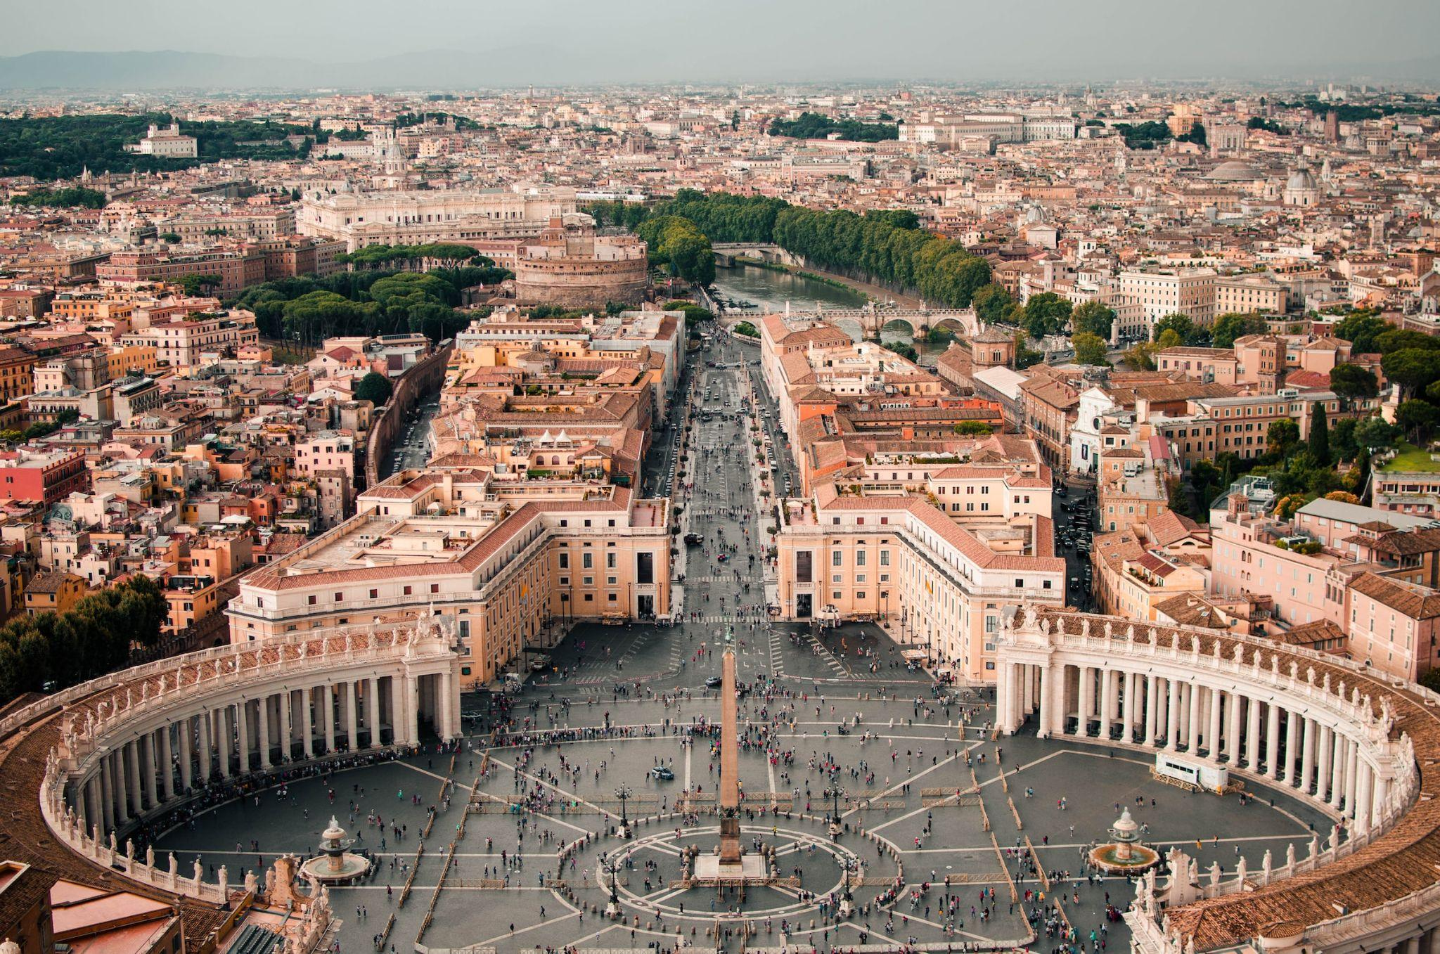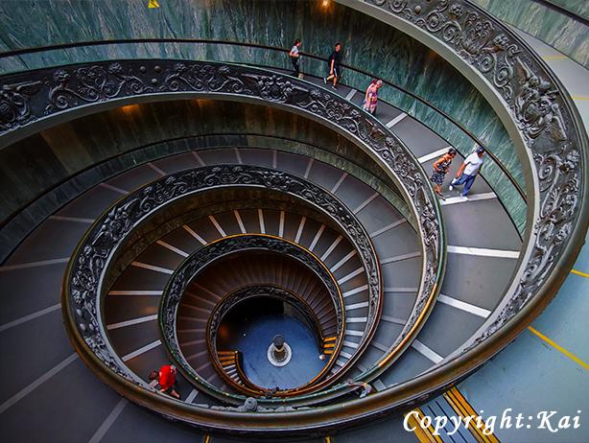

1. Geographical Location: Vatican City
2. Paragraph One about the location

Vatican City, a city-state surrounded by Rome, Italy, is the spiritual and administrative focal point of the Roman Catholic Church. Home to architectural and artistic marvels, it carries a history rich with spirituality and exquisite artistry. Visitors can start their journey at the St. Peter's Square, which stands as a testament to masterful architecture and the deep-rooted history of the church.

1. Paragraph Two about the location.

The Vatican boasts an array of stunning sites that captivate the eye and nourish the soul. From the iconic spiral staircase in the Vatican Museums to the breath-taking paintings in the Athenian academy, the heritage it harbors is indeed immense. Even a glimpse of the city from the waterfront offers a panoramic that encapsulates the spirit and grandeur of Vatican City, presenting an ethereal view that evokes a sense of tranquility and reverence.

1. **Photo Gallery – (Just write Photo Gallery)**
2. Vatican_Spiral_Staircase.jpg
3. The Vatican’s spiral staircase is a masterpiece of art and architecture, symbolizing the seamless blend of beauty and function.
4. Vatican_Athenian_Academy.jpg
5. The Athenian Academy showcases the art that inspired the emblem of the Polytechnic University of Milan, a portrayal of scholars engrossed in a deep discussion.
6. Vatican_St_Peters_Square.jpg
7. St. Peter's Square, the heart of the Vatican, a place where spirituality meets grandeur, standing testimony to the rich history of the Roman Catholic Church.
8. Vatican_City_from_Waterfront.jpg
9. A view of Vatican City from the waterfront, a perspective that offers a tranquil visual treat of this city-state’s majestic structures amidst the serene waters.
10. Name: Kai

**Name:Kai**