BASILICA
AI-Powered Parish Assistant Chatbot
Milestone 1: Project Planning & Architecture Design

1. Problem Statement & Justification
Many Catholic parishes rely on word-of-mouth, printed bulletins, or a single overworked church office line to answer routine questions from parishioners — e.g. "What time is Sunday Mass?", "How do I book a baptism?", "When is confession?", or requests for a specific scripture reading. This creates delays for parishioners and repetitive workload for parish staff, especially during high-traffic periods (Christmas, Holy Week, Ash Wednesday).
BASILICA addresses this with an AI-powered chatbot that instantly answers common parish questions (an NLP text-classification problem: mapping a parishioner's free-text question to the correct intent and response), available 24/7 through a simple web interface. This is real-world relevant because it reduces staff workload, improves parishioner access to information, and demonstrates a practical, deployable AI system rather than a purely academic exercise.

2. Objectives (Measurable AI Performance Targets)
- Achieve at least 85% intent-classification accuracy on a held-out test set of parishioner questions.
- Respond to a chatbot query in under 2 seconds end-to-end (API latency) on Cloud Run's free tier.
- Support at least 10 distinct intent categories at launch (mass times, sacraments, confession, events, donations, contact info, staff directory, scripture lookup, parish history, general FAQ).
- Keep monthly cloud cost at $0 by staying within GCP/Firebase free-tier quotas (scalability target: handle at least 100 concurrent users without breaching free-tier limits).
- Maintain system uptime of 99% during the demo/evaluation period, measured via Cloud Run monitoring.

3. Tools & Technology Stack Identification
Layer | Tool / Service | Justification
Frontend | HTML/CSS/JS (or Flutter later) hosted on Firebase Hosting | Free, fast global CDN, zero server management — ideal for a beginner-run parish site
Backend API | Python Flask, containerized with Docker, deployed on Cloud Run | Cloud Run scales to zero (no cost when idle) and has a generous always-free tier
AI / NLP | scikit-learn / spaCy (TF-IDF + classifier) for intent recognition, trained in Google Colab (free GPU) | Lightweight enough to train and explain as a beginner; no paid GPU needed
Database | Cloud Firestore (NoSQL) | Free tier, real-time sync, simple to query from Flask via Admin SDK
Auth | Firebase Authentication | Free, secures the admin panel used to update FAQ content
Storage | Google Cloud Storage bucket | Stores raw dataset and versioned trained model files
Version Control | Git + GitHub | Industry standard; free private/public repos

4. System Architecture Design
The diagram below shows data flow from the parishioner's browser through the chatbot API, the trained NLP model, and Firestore, back to the user.
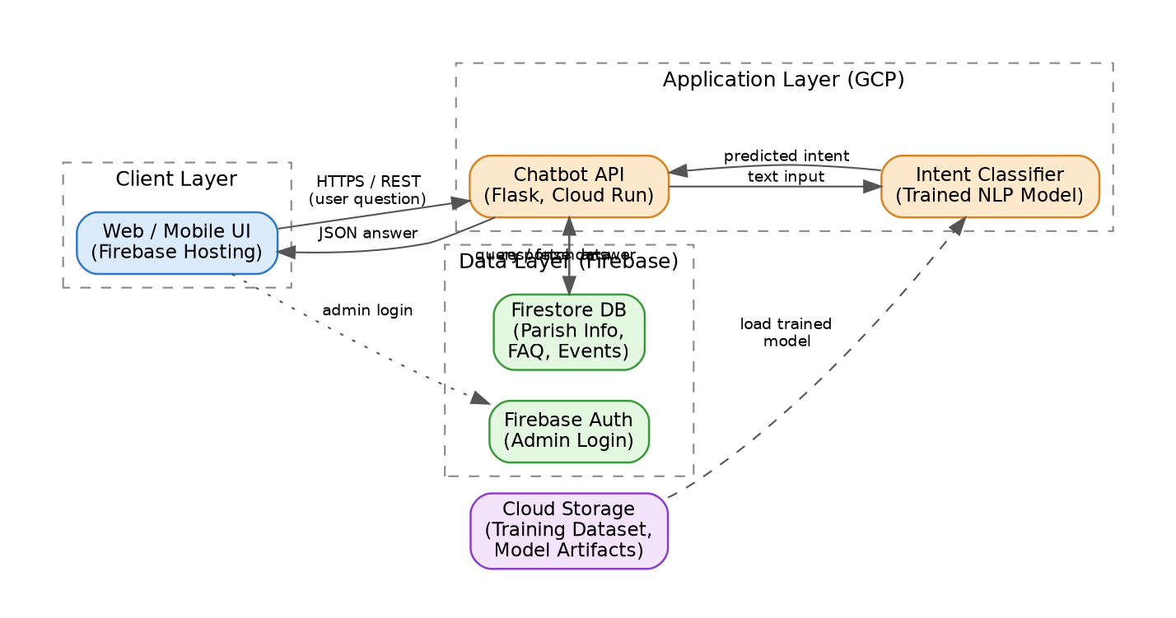
Flow summary:
- Parishioner types a question in the web UI (Firebase Hosting).
- The question is sent via HTTPS/REST to the Flask chatbot API running on Cloud Run.
- The API passes the text to the trained intent classifier, which predicts the closest matching intent.
- The API uses that intent to query Firestore for the correct, up-to-date answer (e.g. current Mass schedule).
- The answer is returned as JSON and displayed to the parishioner.
- An admin (parish secretary) can log in via Firebase Auth to update FAQ answers in Firestore without touching code.

5. Project Timeline & Justification
The 13-week schedule below is sequenced so each milestone's output feeds directly into the next: infrastructure must exist before data collection can be stored, data must be clean before a model can be trained, and a model must exist before it can be deployed. This mirrors the exact milestone order on the DAC Project Supervision Form.
Week | Task | Deliverable
1 | Problem definition, objectives, stakeholder interviews with parish office | Approved problem statement & objectives
2 | Tech stack selection, GCP/Firebase account setup, architecture design | Architecture diagram, justified tech stack
3-4 | Collect FAQ dataset (mass times, sacraments, scripture, parish info), provision Firestore | Raw dataset + cloud infra ready
5-6 | Clean data, label intents, split train/val/test, build preprocessing pipeline | Cleaned, split dataset + pipeline script
7-9 | Train intent classification model, tune hyperparameters, evaluate | Trained model + evaluation report
10-11 | Containerize with Docker, deploy Flask API to Cloud Run, connect frontend | Live chatbot API + working UI
12 | Load testing, bug fixing, monitoring setup, final metrics | Stable deployed system
13 | Write final report, prepare demo, rehearse presentation | Final report + live demo

6. Planned Extension (Post-Core, Weeks 10-13)
Once the core chatbot (Phase 1) is deployed and stable, BASILICA will be extended with a Sermon Transcription & Summarization feature: parish staff upload a homily audio recording, an AI speech-to-text model (Whisper) transcribes it, and a short auto-generated summary is published to the app for parishioners who missed Mass. This is documented here in advance as a scoped, sequenced extension — not core-project scope — so it does not put the Phase 1 deadline at risk. It will use its own dataset, its own model evaluation, and its own storage path (audio files in Cloud Storage), and will be presented as a scalability enhancement in Milestone 6.

Student Sign: ______________________ Date: ____________
Supervisor Sign: ______________________ Date: ____________

