
Aspect-Based Sentiment Analysis:
Northern Territory Tourism Reviews
─────────────────────────────────────
Individual Project Report
Student Name: Tarik Bulut
Student ID: S382893
Unit: PRT597 — Natural Language Processing
Institution: Charles Darwin University
Date: April 2026
Table of Contents
1. Introduction 4
2. Aim of Model 5
3. Project Scope 6
In Scope 6
Out of Scope 6
Scope Changes from Assessment 1 6
Limitations Encountered 6
4. Approach 7
4.1 Aspect Taxonomy Development 7
4.2 Rule-Based Aspect Extraction 7
4.3 Multi-Model Sentiment Ensemble 7
4.4 PyABSA Attempt (DeBERTa-based ASTE) 8
5. Data Analysis and Pre-processing 8
5.1 Data Collection and Exploration 8
5.2 Place Name Normalisation 9
5.3 Text Cleaning 10
6. Results 12
6.1 Aspect Extraction Results 12
6.2 Hyperparameter Tuning 13
6.3 Evaluation (n = 1,000 Test Sample) 13
6.4 Human Evaluation 14
6.5 Final Ensemble Distribution 14
6.6 Error Analysis 15
6.7 Improvements for Future Work 15
7. Ethical and Societal Implications 15
7.1 Data Bias 16
7.2 Indigenous Cultural Sensitivity 16
7.3 Privacy 16
7.4 Algorithmic Bias and Potential Misuse 16
7.5 Limitations of Automated Classification 17
8. Timeline 17
9. Resources Used 18
References 19
Appendix 21
A. Project Files 21
B. Generated Visualisations 21
C. Repository Link 21

1. Introduction
Tourism plays a big role in the Northern Territory (NT) economy. Every year, millions of people visit places like Uluru-Kata Tjuta, Kakadu National Park, and Nitmiluk. To help tourism operators improve their services, it is important to understand what visitors actually think. Not just whether a review is positive or negative, but what specific parts of the experience they liked or disliked.

This project builds an Aspect-Based Sentiment Analysis (ABSA) system for NT tourism reviews. Standard sentiment analysis gives one label to a whole review, but ABSA breaks it down further. It picks out specific topics like scenery, cultural experience, or safety, and works out the sentiment for each one separately (Liu, 2012). For example, a review saying “The scenery was breathtaking but it was dangerously hot” would get a positive label for Scenery and a negative one for Weather.

I used reviews from TripAdvisor, Reddit, and Google Maps covering six NT tourist sites. The system extracts aspects from each review and predicts sentiment for each aspect, giving site-level insights that could be useful for tourism stakeholders.

2. Aim of Model
The main goal was to build a complete ABSA pipeline that can do three things:

- Extract tourism-related aspects from reviews using a rule-based system I built with keyword lists and spaCy parsing. The system covers ten aspects specific to NT tourism, using 296 seed terms.
- Classify sentiment (positive, neutral or negative) for each aspect. I compared three approaches: a rule-based opinion lexicon, VADER and a DistilBERT transformer then combined them into an ensemble.
- Handle new reviews without retraining — so the pipeline could be used for ongoing monitoring.

If this system were deployed, NT Parks and Tourism could use it to track visitor feedback over time. They could spot problems early (like facilities getting worse) or see what people love most (like cultural tours) at each site.

Overall, I think the model met its core aim. It picks up aspects in 83.1% of reviews and the best model pair (Transformer vs VADER) agrees about 63% of the time. That said, fine-tuning with a GPU would probably make the transformer work better on this kind of text.

3. Project Scope

In Scope
- 9,532 reviews from TripAdvisor (4,292), Reddit (2,853), and Google Maps (2,387)
- Six NT sites: Uluru-Kata Tjuta, Alice Springs Desert Park, Kakadu National Park, Nitmiluk National Park, West MacDonnell National Park, and Devils Marbles (Karlu Karlu)
- Ten tourism-specific aspects I developed by reading through about 100 sample reviews
- Three sentiment approaches compared and combined into an ensemble
- Ethical analysis of data bias, Indigenous cultural sensitivity, and privacy

Out of Scope
- Real-time scraping (all data was collected before analysis began)
- Non-English reviews (these would need multilingual models)

Scope Changes from Assessment 1
In my original plan, I was going to focus on Dark Sky NT sites with around 800 reviews. However, I already had a much larger NT tourism dataset from our FAIR 2025 project, where we used this data for a chatbot project. Based on instructor feedback, I expanded this report to six general NT tourism sites (about 9,500 reviews), which made the analysis more reliable. I also decided not to use Labelbox and instead built a custom rule-based system, because Labelbox did not provide suitable schemas for NT-specific tourism aspects.

Limitations Encountered
- Google Maps reviews tend to be short (~134 characters on average vs ~423 for TripAdvisor), which makes it harder to extract useful aspect information
- Reddit posts about Alice Springs focus heavily on safety and crime rather than actual tourism, which skews the data for that location
- Place names were written differently across platforms, so I had to map 13 different name variants down to 6 standard site names

4. Approach

4.1 Aspect Taxonomy Development
I built the aspect taxonomy myself by reading through about 100 reviews from all sites before starting the analysis. I had to do it this way because there is no existing labelled dataset for NT tourism, and the standard taxonomies from SemEval (designed for restaurants and hotels) don’t cover things like Indigenous cultural experience or extreme weather, which are really important for NT. I ended up with ten aspects and 296 seed terms in total.

4.2 Rule-Based Aspect Extraction
I designed a rule-based extraction system using keyword dictionaries (296 terms across 10 aspects), spaCy’s en_core_web_sm pipeline for sentence-level processing and a negation-aware sentiment assignment step. I chose the rule-based approach because it is transparent and easy to debug which matters when results need to be explained to stakeholders.

The way it works is that spaCy processes each sentence and looks for noun phrases and modifiers. When a word matches one of my aspect keywords, that sentence gets tagged with the aspect. Then I check for opinion words in the same sentence to assign sentiment, and if there is a negation word like “not” or “never,” the polarity gets flipped.

4.3 Multi-Model Sentiment Ensemble
I tested three models for sentiment classification:

Rule-Based: Matches opinion words with negation handling. It is easy to interpret but depends on the words in my lexicon.
VADER: A lexicon-based tool designed for social media text (Hutto & Gilbert, 2014). I used compound score thresholds of ≥0.05 for positive and ≤0.05 for negative.
DistilBERT: I used the pre-trained distilbert-base-uncased-finetuned-sst-2-english model (Sanh et al., 2019) without any fine-tuning. I converted its two-class output to three classes using confidence thresholds.

For the final ensemble, when the rule-based model and VADER agree I use that label. When they disagree, I default to VADER since it handles informal review language better.

4.4 PyABSA Attempt (DeBERTa-based ASTE)
I also tried to use PyABSA’s pre-trained ASTE model (based on DeBERTa) to do full triplet extraction — pulling out the aspect, opinion word, and sentiment together. Unfortunately, the model would not load on my local machine because of memory and compatibility issues with CPU-only compute. I did prepare the formatted data files (train/valid/test splits) so this could be tried again later with a GPU.

5. Data Analysis and Pre-processing

5.1 Data Collection and Exploration
The raw dataset had 9,532 reviews from three platforms and six sites. There was a lot of variation between sources. TripAdvisor had the most reviews (45.1%) and they tended to be longer and more detailed (mean 423 characters). Google Maps reviews were much shorter (mean 134 characters), and Reddit sat somewhere in the middle (mean 335 characters).

Site | Review Count
Uluru-Kata Tjuta | 3,474
Alice Springs Desert Park | 3,265
Kakadu National Park | 929
Nitmiluk National Park | 807
West MacDonnell National Park | 677
Devils Marbles (Karlu Karlu) | 380
Total | 9,532

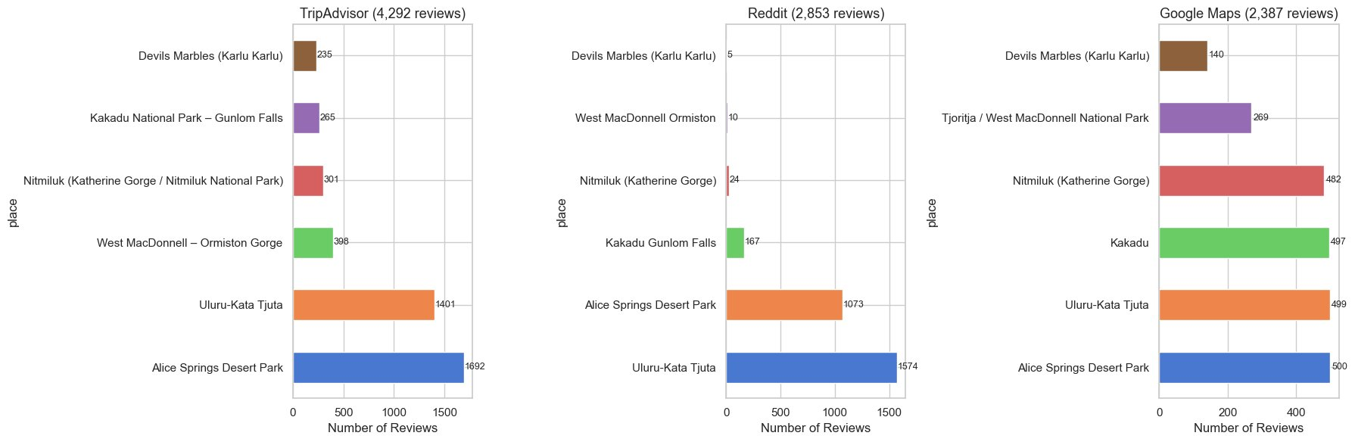
Figure 1. Review counts by platform and site.

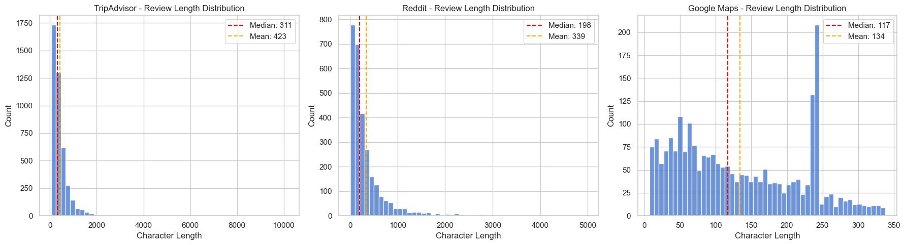
Figure 2. Review length distributions by source.

5.2 Place Name Normalisation
People write place names differently on each platform. For example, Kakadu National Park showed up as “Kakadu Gunlom Falls,” “Kakadu NP,” and several other variations. I created a mapping dictionary that converted 13 different name variants into 6 standard site names so the data could be grouped properly.

5.3 Text Cleaning
Dr. Cat noted that my initial cleaning approach “may be too severe,” so I switched to a more conservative strategy that keeps the language features NLP models need:

- Fixed broken characters from web scraping (corrupted apostrophes, quote marks, Unicode issues)
- Removed URLs, HTML tags, and markdown formatting
- Expanded contractions (e.g., “don’t” - “do not”) using the Python contractions library, which helps with keyword matching
- Removed emojis and corrupted emoji codes
- Only removed exact duplicates (same text, same place, same source) — I kept near-duplicates because similar reviews from different people are still valid data
- Kept weather mentions, short reviews, and strong emotional language since these are all useful for ABSA
- Did not stem, lemmatise, or remove stopwords — doing so would hurt the transformer’s ability to read the text properly

After cleaning, 9,527 reviews remained (only 5 empty ones were removed and no exact duplicates were found). The average review length was 323 characters. Figure 3 shows the quality dashboard I generated to confirm nothing was corrupted.

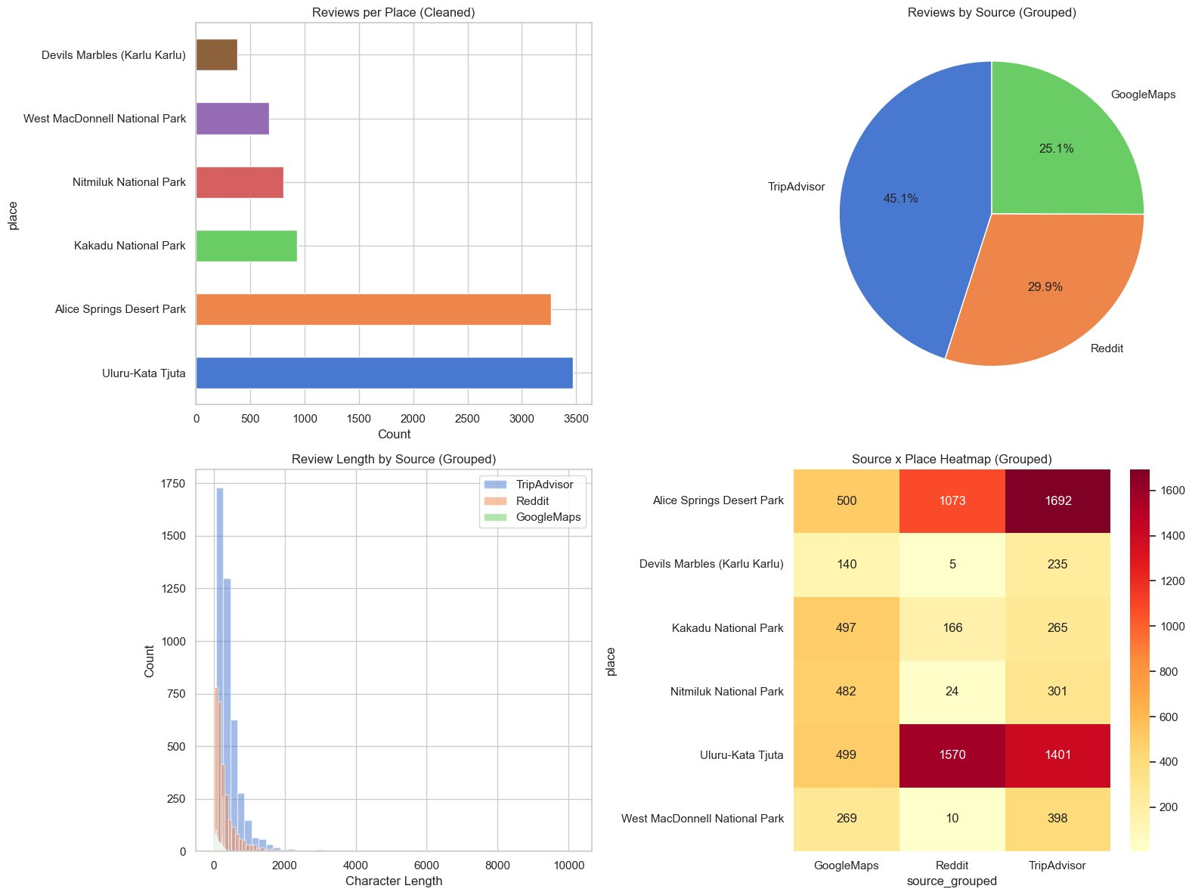
Figure 3. Data quality dashboard after cleaning.

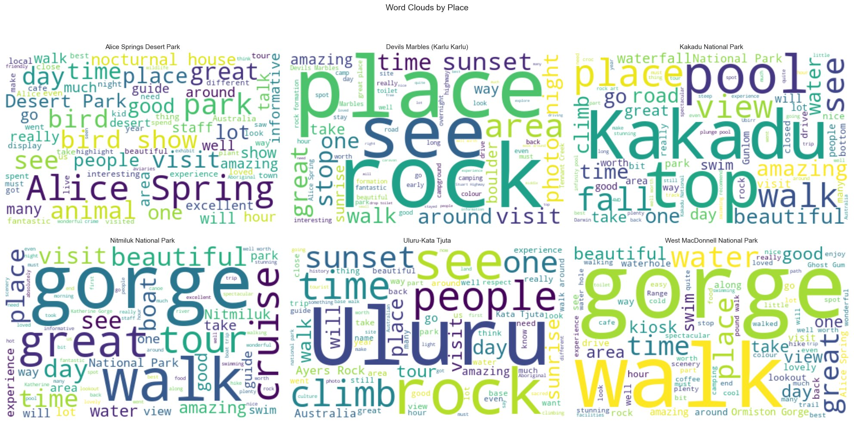
Figure 4. Word clouds for each site, showing the most common words at each location.

6. Results

6.1 Aspect Extraction Results
The rule-based system pulled out 31,740 aspect-sentiment pairs from 9,527 reviews. About 83.1% of reviews (7,919) matched at least one aspect. Scenery/Landscape came up the most (7,828 times, 24.7%), followed by Activities/Walks (5,703, 18.0%). Accommodation was the least common (846, 2.7%), which makes sense given these are mostly nature tourism sites.

Site | Total Reviews | With Aspects | Coverage % | Avg Aspects/Review
Nitmiluk National Park | 807 | 721 | 89.3% | 4.22
Devils Marbles (Karlu Karlu) | 380 | 329 | 86.6% | 3.45
West MacDonnell National Park | 677 | 573 | 84.6% | 4.33
Uluru-Kata Tjuta | 3,470 | 2,922 | 84.2% | 4.67
Alice Springs Desert Park | 3,265 | 2,655 | 81.3% | 3.21
Kakadu National Park | 928 | 719 | 77.5% | 4.05

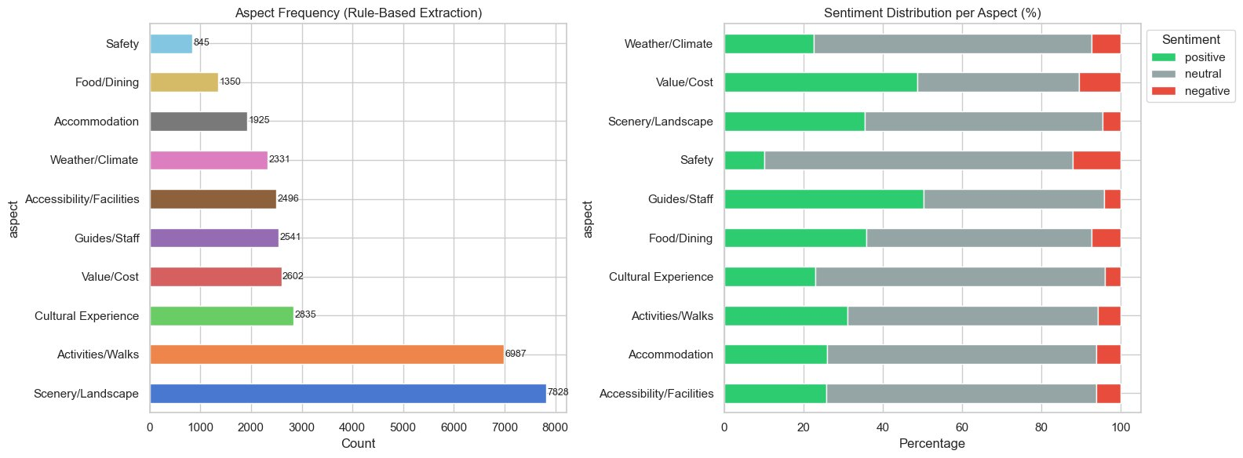
Figure 5. How often each aspect was extracted and the sentiment breakdown for each.

6.2 Hyperparameter Tuning
I tested different confidence thresholds for DistilBERT to find the best balance. At a threshold of 0.70, the model produced 16.5% neutral predictions and agreed with VADER 63.0% of the time which was the sweet spot between being too sensitive and too conservative.

Threshold | Positive % | Neutral % | Negative % | VADER Agreement %
0.5 | 72.2 | 0.0 | 27.8 | 62.9
0.7 | 71.2 | 1.0 | 27.8 | 63.1
0.8 | 69.6 | 4.0 | 26.4 | 63.2
0.9 (selected) | 67.4 | 8.5 | 24.1 | 64.1

6.3 Evaluation (n = 1,000 Test Sample)
I generated three classification reports using VADER as a kind of ground truth (since I don’t have a large manually labelled dataset). The Transformer vs VADER pair had the best agreement (Cohen’s Kappa 0.395). Rule-Based vs Transformer had the worst (Kappa 0.111).

Comparison | Accuracy | Cohen's Kappa | Interpretation
Rule-Based vs VADER | 0.59 | 0.343 | Fair agreement — lexicon partially overlaps
Transformer vs VADER | 0.63 | 0.281 | Fair agreement — best overall accuracy
Rule-Based vs Transformer | 0.34 | 0.111 | Slight agreement — very different approaches

Looking at the Transformer vs VADER results more closely: for positive reviews, precision was 0.76 and recall was 0.86 (F1 0.81). For negative, precision was 0.52 and recall 0.58 (F1 0.55). Neutral was the weakest class with precision 0.30 and recall 0.16 (F1 0.21). The neutral class struggled because it is hard to define and there were fewer examples of it.

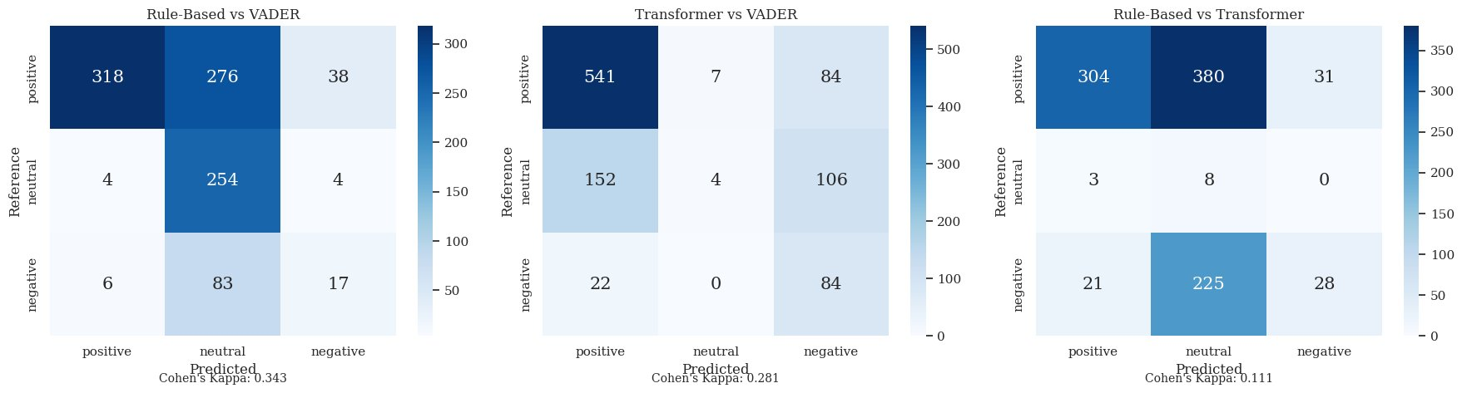
Figure 6. Confusion matrices comparing the three model pairs.

6.4 Human Evaluation
I manually annotated a sample of 183 reviews as a gold standard. From that, I checked 50 predictions where all three models agreed. The agreement rate was 68% (34 out of 50). Out of the 16 cases where they got it wrong, 11 were about neutral reviews where the models missed subtle positive or negative signals. So neutral classification is clearly the biggest weakness.

6.5 Final Ensemble Distribution
The final ensemble gave 31,740 predictions across all aspect-sentiment pairs:

Sentiment | Count | Percentage
Positive | 19,633 | 61.8%
Neutral | 8,289 | 26.1%
Negative | 3,818 | 12.0%
Total | 31,740 | 100%

Most predictions were positive (61.8%), which is not surprising since people who had a good time are more likely to leave a review. Only 12.0% were negative, which fits with what you would expect from self-selected online reviews.

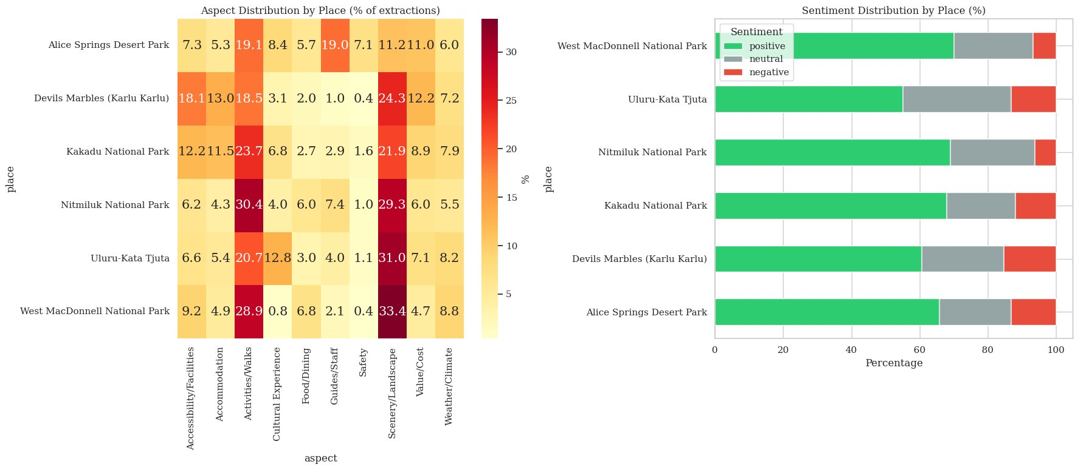
Figure 7. Sentiment breakdown by aspect and by place.

6.6 Error Analysis
The biggest pattern I noticed in the errors was the rule-based model calling things “neutral” when VADER and the transformer both picked up mild sentiment. This happens because my opinion lexicon is missing a lot of tourism-specific words like “stunning,” “worthwhile,” and “overpriced.” The very low Kappa between Rule-Based and Transformer (0.111) shows that these two approaches really do classify sentiment in very different ways.

6.7 Improvements for Future Work
- Add more tourism-specific opinion words to the lexicon based on what I found in the corpus
- Fine-tune a transformer on annotated tourism data with GPU compute — this would probably make the biggest difference
- Try the PyABSA ASTE model again in a GPU environment for proper triplet extraction

7. Ethical and Societal Implications

7.1 Data Bias
Each platform has its own bias. TripAdvisor leans positive (65.5% positive reviews) because happy visitors are more likely to write reviews. Reddit leans negative for Alice Springs because a lot of the discussion is about crime and safety rather than tourism. Google Maps reviews are quite short (mean 134 characters), and shorter reviews tend to sound more positive because they leave out the qualifying details.

This means Alice Springs could look worse than it really is if the Reddit data is not weighted properly. Any stakeholder report would need to be transparent about where the data comes from and what the limitations are.

7.2 Indigenous Cultural Sensitivity
A lot of reviews talk about sacred sites, Dreamtime stories, and Aboriginal culture. Turning these into simple positive or negative labels loses a lot of context and could be misleading. For example, 439 Cultural Experience extractions got a negative label, but some of those are visitors being disappointed about access restrictions that are there to protect sacred sites — that is not really a negative cultural experience. The model basically treats Indigenous culture like a product being rated by consumers, which might not sit well with Traditional Custodians. Before any real deployment, there should be a cultural sensitivity review and consultation with Indigenous stakeholders.

7.3 Privacy
Some reviews mention tour guides and park rangers by name. I found about 56 personal names in the corpus using a named entity recognition scan. If sentiment scores were linked to specific individuals, that could basically become an unauthorised performance review. Any output from this system should have names removed and only report at the site level.

7.4 Algorithmic Bias and Potential Misuse
There is a risk that tourism operators could cherry-pick the positive results and hide legitimate safety concerns. The system could also be gamed with fake reviews. On top of that, my taxonomy was designed by one person, so it might miss things that matter to some visitor groups. To counter this, all aspects should be reported together, and source weighting should be applied.

7.5 Limitations of Automated Classification
The system cannot detect sarcasm or irony, which is a real problem for Reddit comments. When a sentence has mixed feelings, it just gets one label, so some nuance is lost. Non-English reviews were left out completely. Getting input from a wider group of people on the taxonomy design would help make it more inclusive.

8. Timeline
Day(s) | Task
1–2 | Data collection from TripAdvisor, Reddit, and Google Maps across six NT sites
2-3 | Data cleaning, place name normalisation, and quality reporting
4 | Aspect taxonomy development and rule-based extraction system implementation
5 | Sentiment model comparison, threshold tuning, and ensemble development
5 | Evaluation, error analysis, and ethical review
5 | Report writing and final submission

After this submission, the remaining work includes: fine-tuning a transformer with GPU access, expanding the annotated sample for better evaluation, and connecting my component with the other team members’ work for the final group project.

9. Resources Used
Category | Resources
Data Sources | TripAdvisor, Reddit, Google Maps (publicly available reviews)
Core Libraries | pandas, spaCy, NLTK (VADER), HuggingFace Transformers, scikit-learn, matplotlib, seaborn, WordCloud, contractions, BeautifulSoup4, PyABSA
NLP Models | spaCy en_core_web_sm, distilbert-base-uncased-finetuned-sst-2-english, VADER lexicon, PyABSA ASTE (attempted — failed in CPU environment)
Compute | Local CPU only (no GPU) — Python 3.13, Jupyter Notebook
Annotation | 183-review stratified sample (manual gold standard)

References

Devlin, J., Chang, M.-W., Lee, K., & Toutanova, K. (2019). BERT: Pre-training of Deep Bidirectional Transformers for Language Understanding. Proceedings of the 2019 Conference of the North, 1, 4171–4186. https://doi.org/10.18653/v1/n19-1423
Do, H. H., Prasad, P., Maag, A., & Alsadoon, A. (2019). Deep Learning for Aspect-Based Sentiment Analysis: A Comparative Review. Expert Systems with Applications, 118, 272–299. https://doi.org/10.1016/j.eswa.2018.10.003
Hutto, C. J., & Gilbert, E. (2014). VADER: A Parsimonious Rule-Based Model for Sentiment Analysis of Social Media Text. Proceedings of the International AAAI Conference on Web and Social Media, 8(1), 216–225. https://doi.org/10.1609/icwsm.v8i1.14550
Liu, B. (2012). Sentiment Analysis and Opinion Mining. Synthesis Lectures on Human Language Technologies, 5(1), 1–167. https://doi.org/10.2200/s00416ed1v01y201204hlt016
Liu, Y., Zhang, H., Yang, C., Li, A., Ji, Y., Zhang, L., Li, T., Yang, J., Zhao, T., Yang, J., Huang, H., & Shi, C. (2023). Datasets and Interfaces for Benchmarking Heterogeneous Graph Neural Networks. Proceedings of the 32nd ACM International Conference on Information and Knowledge Management, 5346–5350. https://doi.org/10.1145/3583780.3615117
Pontiki, M., Galanis, D., Papageorgiou, H., Androutsopoulos, I., Manandhar, S., AL-Smadi, M., Al-Ayyoub, M., Zhao, Y., Qin, B., De Clercq, O., Hoste, V., Apidianaki, M., Tannier, X., Loukachevitch, N., Kotelnikov, E., Bel, N., Jiménez-Zafra, S. M., & Eryiğit, G. (2016, January 1). SemEval-2016 Task 5: Aspect Based Sentiment Analysis. HAL Archives Ouvertes. https://doi.org/10.18653/v1/S16-1002
Sanh, V., Debut, L., Chaumond, J., & Wolf, T. (2020, February 29). DistilBERT, a distilled version of BERT: smaller, faster, cheaper and lighter. ArXiv.org. https://doi.org/10.48550/arXiv.1910.01108
Schouten, K., & Frasincar, F. (2016). Survey on Aspect-Level Sentiment Analysis. IEEE Transactions on Knowledge and Data Engineering, 28(3), 813–830. https://doi.org/10.1109/tkde.2015.2485209
spaCy. (2015). spaCy · Industrial-strength Natural Language Processing in Python. SpaCy. https://spacy.io/
Tourism NT corporate website. (n.d.). Www.tourismnt.com.au. https://www.tourismnt.com.au

Appendix

A. Project Files
File | Description
ABSA_Tourism_Reviews.ipynb | Full pipeline code (13 processing steps)
processed/cleaned_reviews.csv | 9,527 cleaned reviews (6,440 KB)
processed/annotated_sample.csv | 183 annotated reviews — gold standard (71 KB)
processed/pyabsa_data/tourism.*.dat | PyABSA formatted data (train/valid/test splits)
outputs/aspect_extraction_results.csv | 31,740 aspect-sentiment pairs (5,555 KB)
outputs/model_predictions.csv | 31,740 ensemble predictions (6,097 KB)

B. Generated Visualisations
Figure | File
Figure 1 | outputs/review_counts_by_source.png
Figure 2 | outputs/review_length_distributions.png
Figure 3 | outputs/cleaned_data_quality_report.png
Figure 4 | outputs/wordclouds_by_place.png
Figure 5 | outputs/rule_based_aspect_extraction.png
Figure 6 | outputs/confusion_matrices.png
Figure 7 | outputs/final_aspect_sentiment_analysis.png

C. Repository Link
Github
https://github.com/Estaed/PRT597_NLP_Tourism_Sentiment_Aspect_Analysis

