**CS3354 Software Engineering**

**Final Project Deliverable 1**

Gateway

Chloe Lee

Hudson Apel

Hyrum Moses

Justin Tran

Noah Wohler

Dang Thien Nguyen

Esteban Kim

1. Final Project Draft Description

| Final Project Draft Description | A user-friendly website displaying the most common interview questions within a company depending on the role, level, and interview type (System Design, Behavioral, Technical, etc). The data within the website is completely provided by the users of the system. |
| --- | --- |
| Professor Feedback | A lovely topic!! Once complete, it will save a lot of time and effort for those who are part of the interviewer team. Please consider implementing it fully, if you can.  No pressure w.r.t. grade on implementation.  In the final report, please make sure to include comparison with similar applications -if any-, make sure that you differentiate your design from those, and explicitly specify how.  Fair delegation of tasks.  Please share this feedback with your group members.  You are good to go. Have fun with the project and hope everyone enjoys the collaboration. |
| Address Feedback | To differentiate our application to similar applications such as Glassdoor and Indeed, the group researched the similar websites and found ways to simplify our application for our customers. |
| GitHub URL | <https://github.com/EstebanKim11/3354-Gateway> |

2. Setting up a GitHub repository

| Each team member should create a GitHub account using UTDallas email. | Completed |
| --- | --- |
| Create GitHub repository with name 3354-teamName | Completed |
| Add all team members and the TA collaborators | EstebanKim11(EXK180009) is the repository creator so cannot be seen in the manage access section. |
| Make the first commit to the repository with README | Completed within the GitHub repository |
| Make another commit including a pdf/txt/doc file named “project_scope”. Need to discuss what needs to be added in here. | Completed within the GitHub repository |
| Keep all project related files in your repository. | Completed |

3. Delegation of tasks

| Group Member | Responsibilities |
| --- | --- |
| Chloe Lee | 1.4, Project scheduling, cost/effort/pricing estimation, Presentation Slides |
| Hudson Apel | Class Diagram |
| Hyrum Moses | Test Plan/Unit Test Code |
| Justin Tran | Sequence Diagram |
| Noah Wohler | Use case diagram, comparison w/ similar designs and conclusion |
| Dang Thien Nguyen | 1.5, Presentation Slides |
| Esteban Kim | Architectural Design, Management |

4. Which software process model is employed in the project and why?

In this project we are using the waterfall model because we plan to complete the implementation of the website in a single iteration using the five phases: communication, planning, modeling, construction, and deployment. Given the scope of the project, expected timeline, and size of the team, the waterfall model is the best software process model for our use case. We initially started with the requirements gathering by meeting in a group and discussed the functional and non-functional requirements of the website we plan to build. After a thorough review of the requirement specifications, we began planning the projected timeline to complete the website and deploy for people to use. After confirming with the team that the current timeline can be met, we began modeling the website by creating the use case, sequence and class diagrams as well as the architectural design. We completed a group discussion and review of the diagrams and plan to move onto the construction phase within the waterfall model. By the final deadline, we plan to complete the construction of the website with the necessary unit, regression, and system tests to validate that all requirement specifications were met and move onto the deployment phase.

5. Software requirements

* Functional requirements
  1. The user shall be able to log in and log out
  2. The user shall be able to search questions by company
  3. The user shall be able to filter questions by interview type, role, and level
  4. The user shall be able to add comments to an interview question through a thread if logged in
  5. The user shall be able to upvote and downvote questions if logged in
* Non-functional requirements
  1. **Usability** - The UI design should be user-friendly, providing easy access to all features of the website.
  2. **Performance** - The website should respond in a timely manner when provided with a stable high-speed internet connection.
  3. **Space** - The website’s data should be stored efficiently so as to not take up an excessive amount of storage space.
  4. **Dependability** - The website should be available nearly 24/7 with downtime no longer than fifteen minutes in any one day.
  5. **Security** - Users should only be able to create and interact with questions if logged in.
  6. **Environmental** - The system should be hosted on a server, allowing users to access it through a web browser.
  7. **Operational** - The user should feel confident that the information within the website is an accurate representation of the questions users may potentially be asked in an interview.
  8. **Development** - All changes to the website should be published and appropriately documented via GitHub.
  9. **Regulatory** - User information should be treated correctly according to privacy laws and regulations.
  10. **Ethical** - Questions with higher upvote scores should be shown first to filter out heavily downvoted questions, which may be inaccurate or harmful.
  11. **Accounting** - The website is non-profit but accepts donations, so proper documentation should be generated for donations in order to comply with the appropriate laws and regulations.
  12. **Safety/security** - Users should feel confident that they can post interview questions without being traced and stay anonymous if desired.

6. Use Case Diagram

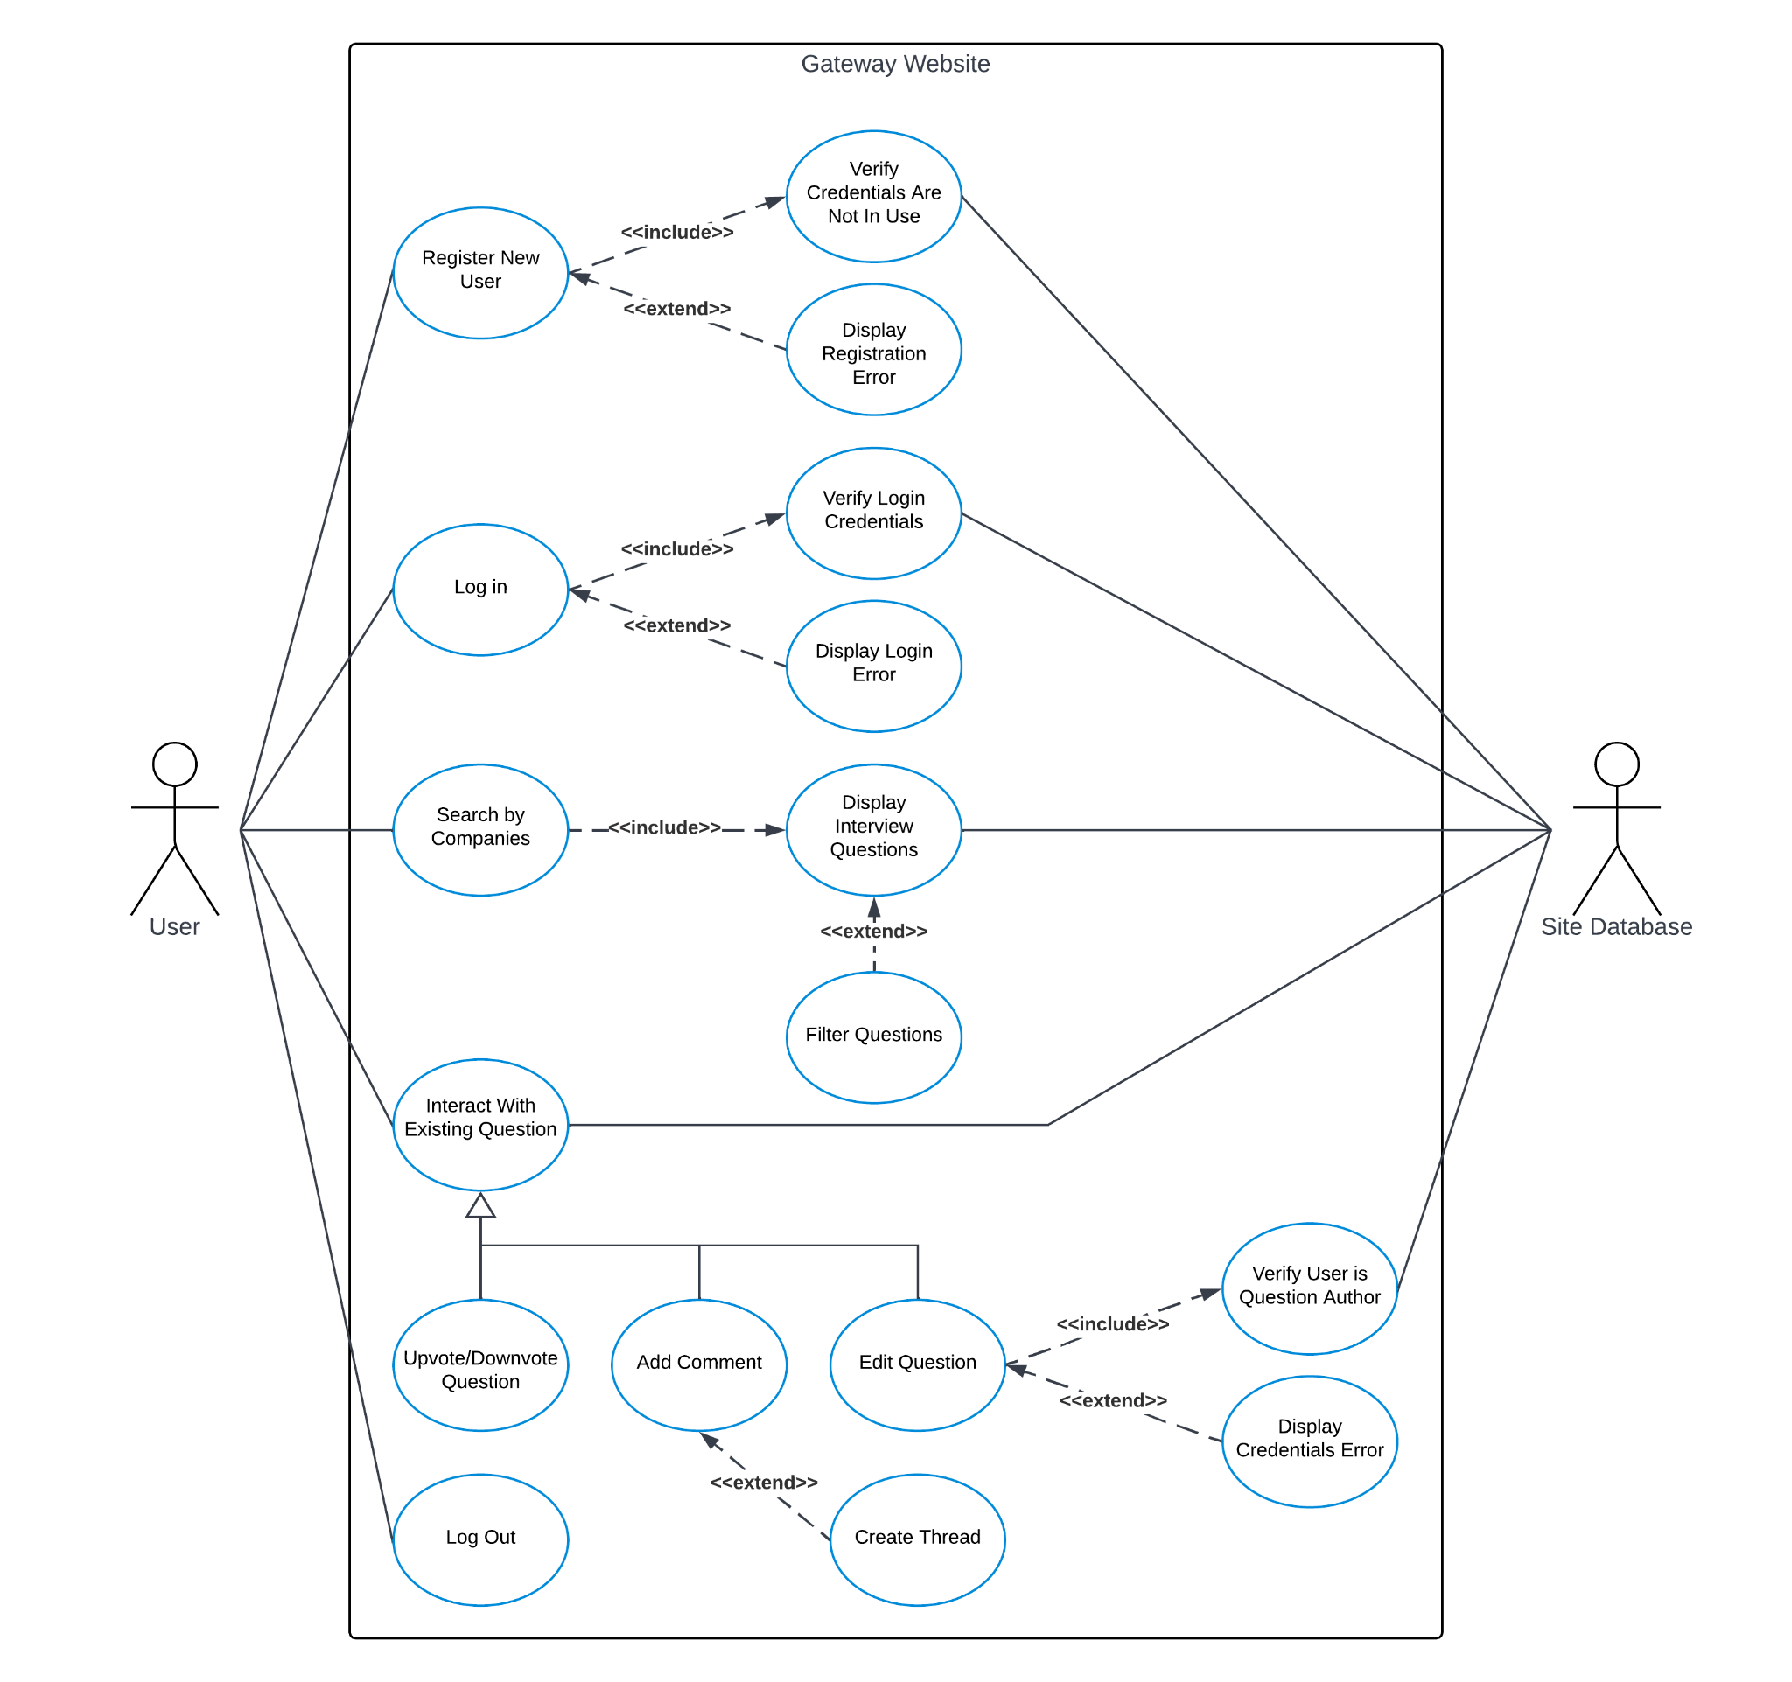

7. Sequence Diagrams

* + User Registration

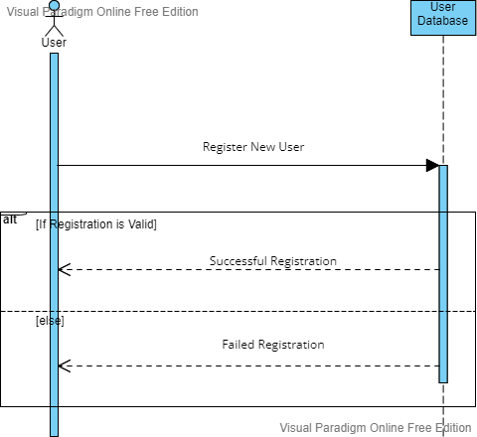

* Login

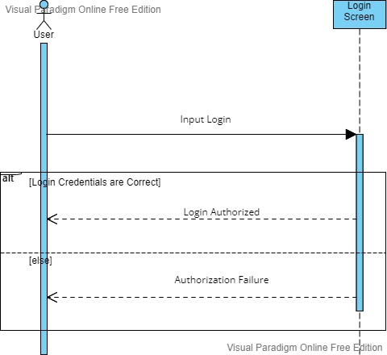

* Company Search

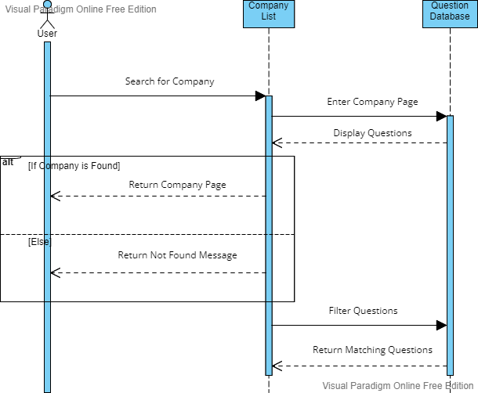

* Question Registration

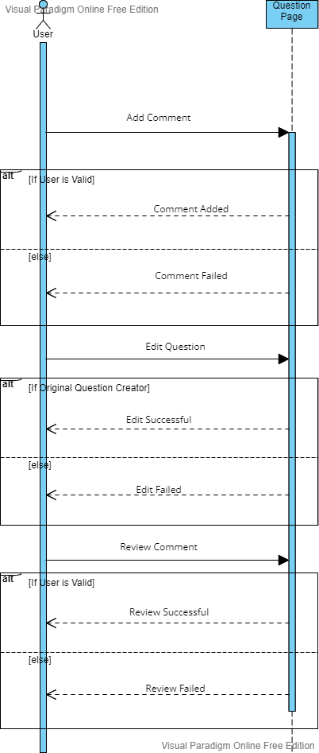

* Logout

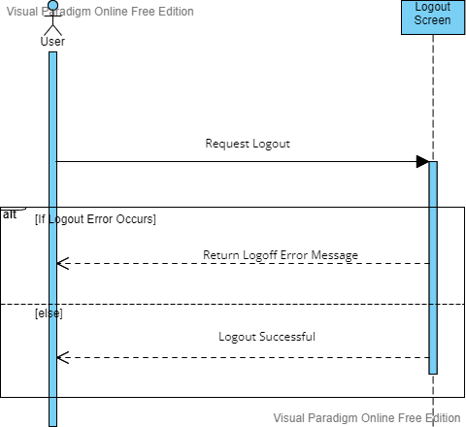

8. Class Diagram

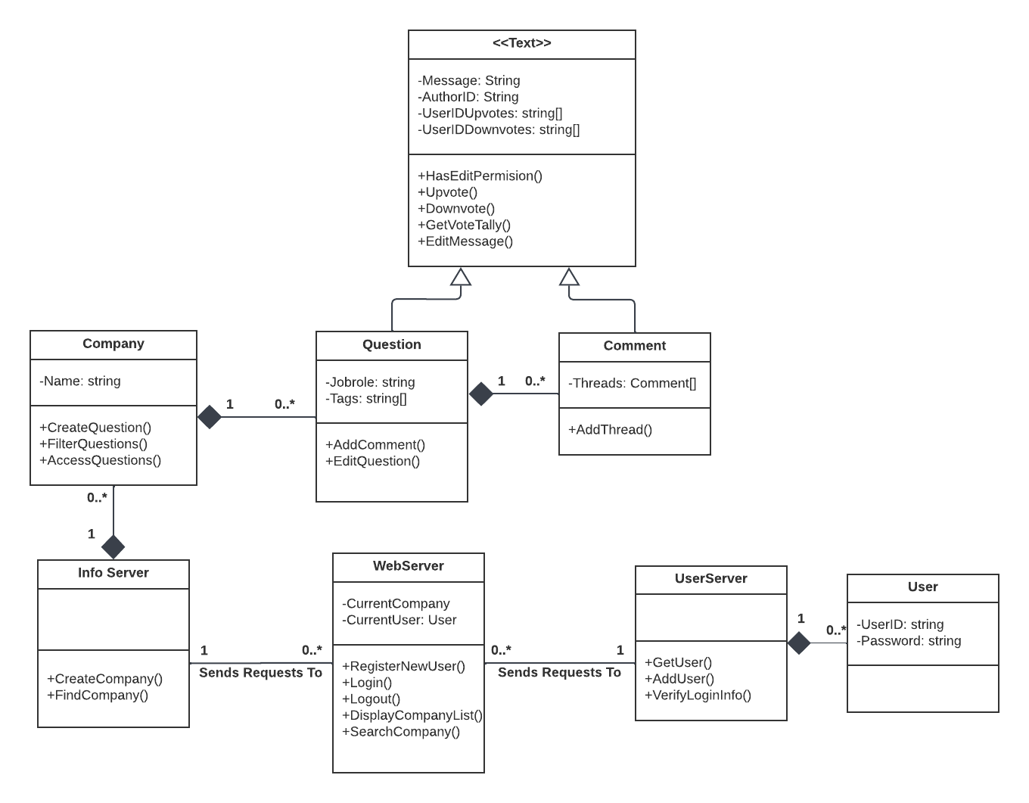

9. Architectural Design (Client-Server Pattern)

