**NAME: Guillermo Esteban Bernal Bonilla ________ DATE: _____09/February/2021_____**

**VERB TENSES – PRACTICE – 1T**

***Look at the following table and study the verb conjugations and the sentences’ structure for each verb tense.***

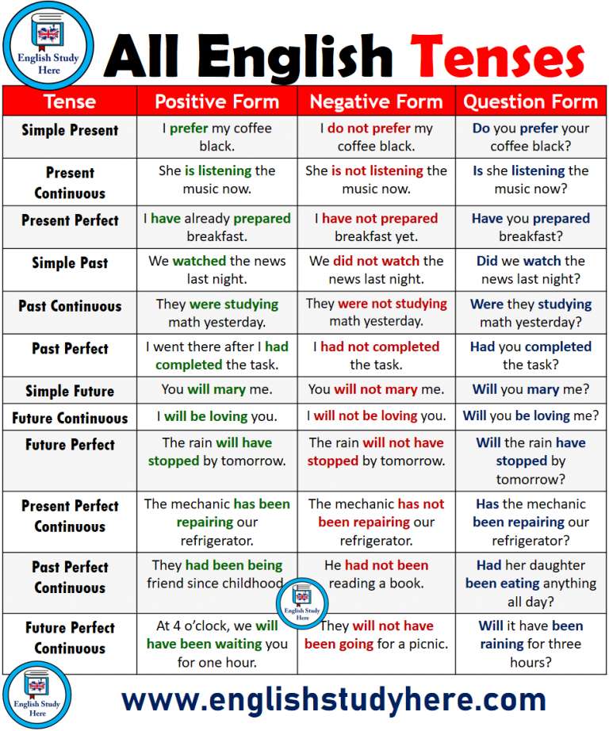

Image: [englishstudyhere.com](https://englishstudyhere.com/tenses/all-english-tenses/)

**SIMPLE**

**PAST – PRESENT – FUTURE**

***Use the verb in the box to create a sentence in the simple past, simple present and simple future. Conjugate the verb according to each tense and its form.***

|  |  |  |  |  |
| --- | --- | --- | --- | --- |
| **VERB** | **VERB TENSE** | **FORM** | **SENTENSE** | **CONTRACTION** |
| Prefer | S. Present | **e.g. (+)** | I prefer my coffee black. |  |
| **e.g. (-)** | I do not prefer my coffee black. / I don’t prefer my coffee black. | Don’t |
| **e.g. (?)** | Do you prefer your coffee black? |  |
| **DRY** | Simple  Present | **+** | My shirt is already dry |  |
| **-** | My shoes do not dry | Don’t |
| **?** | Are your pants dry? |  |
| **GIVE** | Simple  Past | **+** | I gave you a glass of water |  |
| **-** | I did not give you the money | Didn’t |
| **?** | Did you give lunch to your son? |  |
| **IMPROVE** | Simple  Future | **+** | I will improve my grades |  |
| **-** | I will not improve my breathing | Won’t |
| **?** | Will you improve your endurance? |  |

***Complete de table with the correct structure for this tense.***

***Use S for subject, V for verb, AV for auxiliary verb, MV for main verb and QW for question words.***

|  |  |  |
| --- | --- | --- |
| **+** | **-** | **?** |

**PERFECT**

**PAST – PRESENT – FUTURE**

***Use the verb in the box to create a sentence in the past perfect, present perfect and future perfect. Conjugate the verb according to each tense and its form. Use the words: already, since, just, for, yet and already.*** ***i had not liked already your food***

|  |  |  |  |  |  |
| --- | --- | --- | --- | --- | --- |
| **VERB** | **VERB TENSE** | **FORM** | **SENTENSE** | **TIME**  Since, just, for, yet and already | **CONTRACTION** |
| Prepare | Present Perfect | **e.g. (+)** | I have already prepared breakfast. | already | I’ve |
| **e.g. (-)** | I have not prepared my breakfast yet / I haven’t prepare my breakfast yet. | yet | Haven’t |
| **e.g. (?)** | Have you prepared your breakfast already? | already |  |
| **KISS** | Present Perfect | **+** | I have already kissed your cheeks | already | I’ve |
| **-** | I haven't kissed your lips yet | yet | Haven’t |
| **?** | have you kissed your mom just now? | just |  |
| **LIKE** | Past Perfect | **+** | I had liked your shirt for the beach | for | I’d |
| **-** | I had not liked already your food | already | Hadn’t |
| **?** | Had you liked my coat for the winter? | for |  |
| **MIX** | Future Perfect | **+** | I will have already mixed the foods | already |  |
| **-** | I will haven´t mixed the drinks yet | yet | Haven’t |
| **?** | Will you have mixed the music for the party? | for |  |

***Complete de table with the correct structure for this tense.***

***Use S for subject, V for verb, AV for auxiliary verb, MV for main verb and QW for question words.***

|  |  |  |
| --- | --- | --- |
| **+** | **-** | **?** |

**CONTINUOUS**

**PAST – PRESENT – FUTURE**

***Use the verb in the box to create a sentence in the past continuous, present continuous and future continuous. Conjugate the verb according to each tense and its form.***

|  |  |  |  |  |
| --- | --- | --- | --- | --- |
| **VERB** | **VERB TENSE** | **FORM** | **SENTENSE** | **CONTRACTION** |
| Listen | Present Continuous | **e.g. (+)** | She is listening to music. / She’s listening to music. | She’s |
| **e.g. (-)** | She is not listening to music. / She isn’t listening to music. | Isn’t |
| **e.g. (?)** | Is she listening to music? |  |
| **ORDER** | Present Continuous | **+** | I am ordering my schedule | I’m |
| **-** | She is not ordering her room | Isn’t |
| **?** | Are you ordering your diet? |  |
| **PRACTICE** | Past Continuous | **+** | He was practicing soccer |  |
| **-** | I was not practicing English | Wasn’t |
| **?** | Were you practicing taekwondo? |  |
| **REPLACE** | Future Continuous | **+** | I will be practicing martial arts |  |
| **-** | She will not be practicing languages | Won’t |
| **?** | Will they be practicing for the exam? |  |

***Complete de table with the correct structure for this tense.***

***Use S for subject, V for verb, AV for auxiliary verb, MV for main verb and QW for question words.***

|  |  |  |
| --- | --- | --- |
| **+**  Present Continuous =  Past Continuous =  Future Continuous= | **-** | **?** |