Communication protocols used to interface Embedded Systems and Cloud Computing structures

Instituto Tecnologico de Costa Rica
Escuela de Ingenieria Electronica
Maestria en Electronica
MP6122- Sistemas Empotrados de Alto Desempeno

Avence Articulo de Investigacion.

Tema: Cloud Computing

Grupo 2:

Ing. Fernando Paris
Ing. Esteban Rivera
Ing. Kevin Gomez

Paper Structure
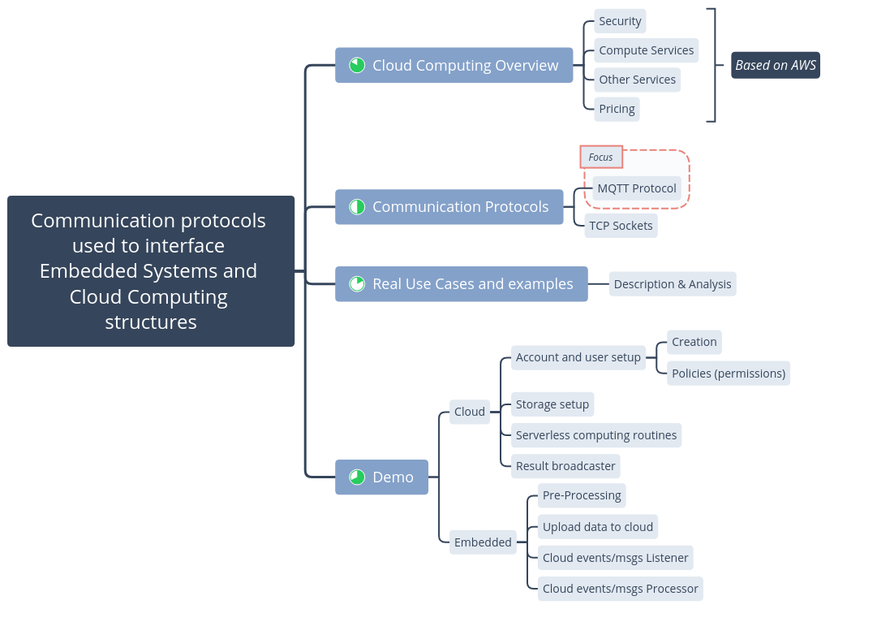

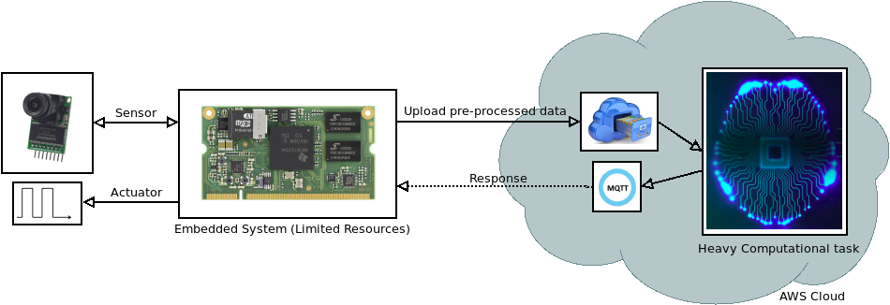
DEMO

References

[1]N. Nikolov, "Research of the Communication Protocols between the IoT Embedded System and the Cloud Structure", Faculty of Computer Systems and Technologies Technical University of Sofia, Sozopol, Bulgaria, 2018.

[2]B. Rong Chang, H. Tsai, C. Chen and C. Huang, "Access Control of Cloud Computing Using Rapid Face and Fingerprint Identification", Sue-Te University, National University of National University of Kaohsiung, Taiwan Taiwan, 2011.

[3]K. An, "Strategies for Reliable, Cloud-based Distributed Real-time and Embedded Systems", Department of Electrical Engineering and Computer Science Vanderbilt University, Nashville, TN, 2015.

[4]A. Toosi, J. Son and R. Buyya, "A Low-Cost Raspberry-Pi-Based Micro Datacenter for Software- Defined Cloud Computing", University of Melbourne, Melbourne, Australia, 2018.

[5]"AWS IoT Core Overview - Amazon Web Services", Amazon Web Services, Inc., 2019. [Online]. Available: https://aws.amazon.com/iot-core/?nc1=h_ls. [Accessed: 26- Jul- 2019].

[6]"AWS IoT Partner Solutions Overview - Amazon Web Services", Amazon Web Services, Inc., 2019. [Online]. Available: https://aws.amazon.com/iot/partner-solutions/. [Accessed: 26- Jul- 2019].

[7]R. Bryce, T. Shaw and G. Srivastava, "MQTT-G: A Publish/Subscribe Protocol with Geolocation", IEEE, Athens, Greece, 2018.

[8]S. Nuratch, "Applying the MQTT Protocol on Embedded System for Smart Sensors/Actuators and IoT Applications", IEEE, Chiang Rai, Thailand, Thailand, 2018.

[9]P. Peniak and M. Franeková, "Extended Model of Secure Communication for Embedded Systems with IoT and MQTT", IEEE, Pilsen, Czech Republic, 2018.

