Delta Sparse Integration (SDI)…

Esteban Rivera¹, Charlie Démené¹, Mickael Tanter¹

¹ Physics for Medicine Paris, INSERM U1273, ESPCI Paris, PSL University, CNRS, Paris, France

Correspondence: Mickael Tanter

Introduction
Accurate and reproducible simulation of ultrasound image formation is essential for designing transducers, testing beamforming strategies, and evaluating new imaging methods. Two broad classes of models are widely used. Full-wave solvers (for example, finite-difference and k-space pseudospectral methods) numerically solve the acoustic wave equations and can handle heterogeneous media and nonlinear propagation [1,2]., and on the other hand we have the Spatial impulse response (SIR) or linear-systems methods that assumes linear acoustics and compute fields by superposing elementary source responses from the transducer aperture making it in general fast and efficient.[3,4].
The SIR idea is rooted in classical results for baffled pistons (Tupholme; Stepanishen), which express transient radiation as an integral of geometry-dependent impulse responses convolved with the source excitation [5,6]. Building on this foundation, Jensen & Svendsen (1992) proposed a practical algorithm that discretizes the radiating surface into small rectangles and sums their time-shifted contributions; this approach underpins the Field II simulator [7].
Field II is a widely used MATLAB toolbox that implements Jensen’s SIR methodology and supports arbitrary transducer geometries, dynamic focusing, apodization, and pulse-echo simulations [7,8]. The Field II distribution and user guide describe implementation details and provide canonical examples for validation [8]. Because it is based on linear acoustics, Field II is computationally efficient for large apertures and long simulated times, but it does not model nonlinear propagation or complex multiple-scattering in heterogeneous media; such effects are handled by full-wave tools such as k-Wave [2,9].
So far, Field II is distributed from the author’s site as MATLAB source together with compiled components. A commercial parallel version, Field IIPro, is also offered, which includes a Python interface but is not open-source and requires licensing. As a result, there is currently no free Python version of Field II, limiting options for researchers who wish to modify or accelerate the low-level engine algorithm, or integrate the simulations to other python libraries [8].
Python has become a dominant language for scientific computing, machine learning, and data analysis. Its ecosystem drove the create of PyTorch, a fully featured framework for building deep learning models which provides an imperative, GPU-capable framework with automatic differentiation used for optimization via gradient descent, that could be use in inverse-problems research [10]. In addition, community projects such as Nilearn and the BrainGlobe initiative illustrate Python’s strong adoption in neuroimaging and computational neuroanatomy, providing several Python-based software tools to access, analyze and visualize anatomical data [11,12] that one could be interested to integrate with ultrasound simulations when working in neuroscience.
In this paper we present TorchField, an open-source, PyTorch-based implementation of the far-field Tupholme–Stepanishen SIR method. TorchField reformulates the trapezoidal impulse from a piecewise description to a double integration of Dirac delta distributions, allowing a vectorized tensor formulation suited for GPU execution and automatic differentiation in PyTorch. Key features are: (i) a fast, differentiable SIR engine with optional GPU acceleration; (ii) support for arbitrary patch-defined transducers; (iii) a reproducible, unit-tested codebase with examples that mirror Field II for validation; (iv) integration with gradient-based optimization workflows; and (v) compatibility with neuroanatomy datasets provided by projects such as BrainGlobe. TorchField is intended as a Python-native, open alternative for rapid prototyping and model-based research within the linear-acoustic regime, particularly in the neurosciences.
In addition, we introduce PyField, an open-source and freely available simulator that closely follows the Field II methodology. PyField provides a Python platform with transparent source code for calculating SIR and monochromatic pressure fields.

Theory
This section describes the simulation method used with the far-field Tupholme–Stepanishen SIR [] method used in FIELDII [] and PyField, and how it could be then used to compute monochromatic pressure fields. The development presented here is based on [6], however, for the sake of completeness, a detailed development of the approach is presented.

Basic theory
Consider the problem of determining the time-dependent pressure in the half-space $z≥0$, resulting from the velocity of the aperture. The aperture is assumed to vibrate with a specified normal velocity $v_{n}(\vec{r},t)$ which may be nonsinusoidal and/or pulsed, and the medium in the half-space is assumed to be isotropic with a constant velocity of propagation. In addition, the aperture delimited by the area $S$ is assumed to be mounted in an infinite planar baffle, so that the normal velocity vanishes outside $S$ {Fig. system showing the assumptions}.
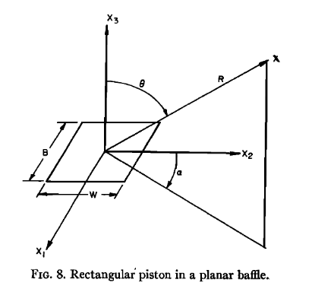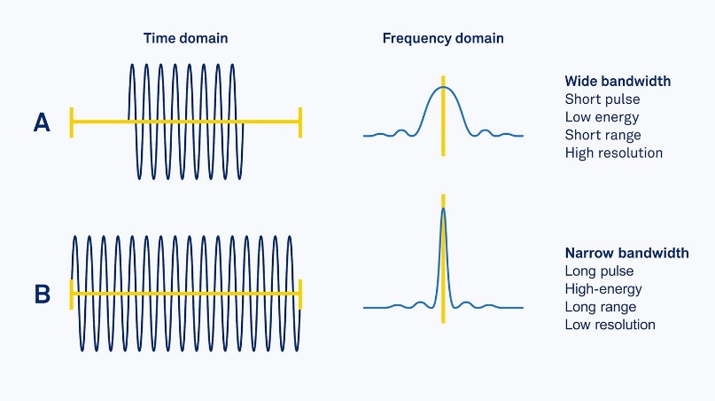
TO SHOW THE ASSUMPTIONS THAT ARE MADE.

The problem is formulated as a classical boundary value problem in the wave-equation of velocity potential $Φ\left(\vec{r},t\right)$, which satisfies the homogeneous wave equation:

$$∇^{2}Φ\left(\vec{r},t\right)-\frac{1}{c_{0}^{2}}\frac{∂^{2}Φ\left(\vec{r},t\right)}{∂t^{2}}=0, \vec{r}∈B [1]$$
Where $c_{0}$ is the speed of sound in the medium, and $B$ is the half-space $z≥0$ ($B=\left\{\left(x,y,z\right)∈R^{3} \right| z≥0\}$).
The boundary condition of the normal velocity on the aperture surface and the system initial conditions yields to
$$\frac{∂Φ}{∂z}=v_{n}\left(\vec{r},t\right), \vec{r}∈S, t>0 [2]$$
And
$$Φ\left(\vec{r},t\right){\left.​\right|}_{t=0}=\frac{∂}{∂t}Φ\left(\vec{r},t\right){\left.​\right|}_{t=0}=0 [3]$$
The solution of this system can be obtained using a Green’s function representation. The velocity potential may then be expressed as
$$Φ\left(\vec{r},t\right)=\int_{0}^{t}{\int_{S}{v_{n}\left({\vec{r}}_{a}, t_{0}\right)g\left(\vec{r},t\right|{\vec{r}}_{a},t_{0})} dS dt_{0}} [4]$$
Where $g\left(\vec{r},t\right|{\vec{r}}_{a},t_{0})$ is the time-dependent green’s function for the problem, $v_{n}\left(\vec{r}, t\right)$ is the normal velocity, and the ${\vec{r}}_{a}$ denotes source coordinates on the aperture. Using the method of images, the Green’s function for a baffled piston is given by [Morse & Ingard, Blackstock]:
$$g\left(\vec{r},t | {\vec{r}}_{a},t_{0}\right)=\frac{δ(t-t_{0}-\left|\vec{r}-{\vec{r}}_{a}\right|/c_{0}) }{2π\left|\vec{r}-{\vec{r}}_{a}\right| } [5]$$
Substituting Eq 5 intro Eq. 6, gives
$$Φ\left(\vec{r},t\right)=\int_{0}^{t}{v_{n}\left(t_{0}\right)\int_{S}{ \frac{δ(t-t_{0}-\left|\vec{r}-{\vec{r}}_{a}\right|/c_{0}) }{2π\left|\vec{r}-{\vec{r}}_{a}\right| }}dS dt_{0}}[6]$$
Where since the aperture is rigid the velocity is independent of the spatial position on the aperture, i.e. $v_{n}\left(\vec{r},t\right)=v_{n}\left(t\right)$ for $\vec{r}∈S$. We now define the Spatial Impulse Response (SIR) as
$$h\left(\vec{r},t\right)=\int_{S}{ \frac{δ(t-\left|\vec{r}-{\vec{r}}_{a}\right|/c) }{2π\left|\vec{r}-{\vec{r}}_{a}\right| }}dS [7]$$
With this definition, Eq. (7) becomes the convolution
$$Φ\left(\vec{r},t\right)=\int_{0}^{t}{v_{n}\left(t_{0}\right)h\left(\vec{r},t-t_{0}\right) dt_{0}}=v_{n}\left(t\right)*h\left(\vec{r},t\right) [8]$$
Where * denotes the convolution in time. From the velocity potential, the acoustic pressure field is obtained as
$$p\left(\vec{r},t\right)=ρ_{0}\frac{∂Φ\left(\vec{r},t\right)}{∂t} [7]$$
Which yields
$$p\left(\vec{r},t\right)=ρ_{0}\frac{∂v_{n}\left(t\right)}{∂t}*h\left(\vec{r},t\right) [8]$$
Thus, the pressure field is computed as the convolution of the SIR - which encodes the spatial contribution or geometric features of the aperture - with the velocity $v_{n}\left(t\right)$​​, which encodes the temporal information of the excitation.
Note that by computing the temporal Fourier transformation of this expression, one gets to
$$P\left(\vec{r},ω\right)=iωρ_{0}V\left(ω\right)H\left(\vec{r},ω\right) [9]$$
Where $P\left(\vec{r},ω\right)=F\left\{p\left(\vec{r},t\right)\right\}, V\left(\vec{r},ω\right)=F\left\{v\left(t\right)\right\}$, and $H\left(\vec{r},ω\right)=F\{h\left(\vec{r},t\right)\}$.
Although a more accurate treatment of transient responses, including bandwidth filtering for specific transducers, is possible and it’s what FIELDII does, this lies beyond the scope of the present work. Here, we focus on computing the pressure distributions of transducers intended for brain stimulation. Since these typically operate with long bursts at nearly constant frequency, the spectral information narrows to an almost monochromatic case [Fig. of an example burst and its spectral information].
In the special case of a monochromatic excitation at the transducer’s central frequency $f_{c}$ ​, the pressure amplitude is
$$p_{f_{c}}\left(\vec{r}\right)=\left|P\left(\vec{r},ω_{c}\right)\right|=2πf_{c}ρ_{0}\left|V\left(ω_{c}\right)\right|\left|H\left(\vec{r},ω_{c}\right)\right| [10]$$
which shows explicitly that
$$p_{f_{c}}\left(\vec{r}\right)∝\left|H\left(\vec{r},ω_{c}\right)\right| [11]$$
Hence, in the monochromatic regime, the spatial pressure distribution is proportional to the Fourier transform of the SIR at the operating frequency.

The Far-Field SIR for a rectangular aperture
In the previous section, we derived how the pressure field can be computed from the Spatial Impulse Response (SIR), following the classical Tupholme–Stepanishen formulation that underlies Field II [ref]. Equation (7), which defines the SIR, is a direct expression of Huygens’ principle: the acoustic field at a point $\vec{r}$ is obtained by summing the spherical wavelets radiated from each infinitesimal element of the aperture surface, evaluated at the appropriate retarded time.
This formulation can be recast using acoustic reciprocity. Instead of viewing the aperture as the emitter of secondary sources, one can equivalently consider a spherical wave origina ting at the field point and propagating backward toward the aperture. The problem then reduces to finding the intersection of this backward-projected spherical wave with the aperture surface. Geometrically, the field point is projected onto the aperture plane, and the expanding spherical wave appears as a circle whose overlap with the aperture determines the contribution to the SIR. For instance, rewriting the integral in polar coordinates leads to the alternative formulation [Jensen]:
$$h\left(\vec{r},t\right)=\int_{θ_{1}}^{θ_{2}}{\int_{d_{1}}^{d_{2}}{\frac{δ(t-R/c_{0})}{2πR}}}rdrdθ [12]$$
where $r$ is the projected radial coordinate, $R^{2}=r^{2}+z_{p}^{2}$ is the distance from the field point to the aperture, and $z_{p}$ is the field point height above the aperture plane. The integration limits $d_{1}, d_{2}$, and $θ_{1},θ_{2}$ are set by the aperture boundaries.
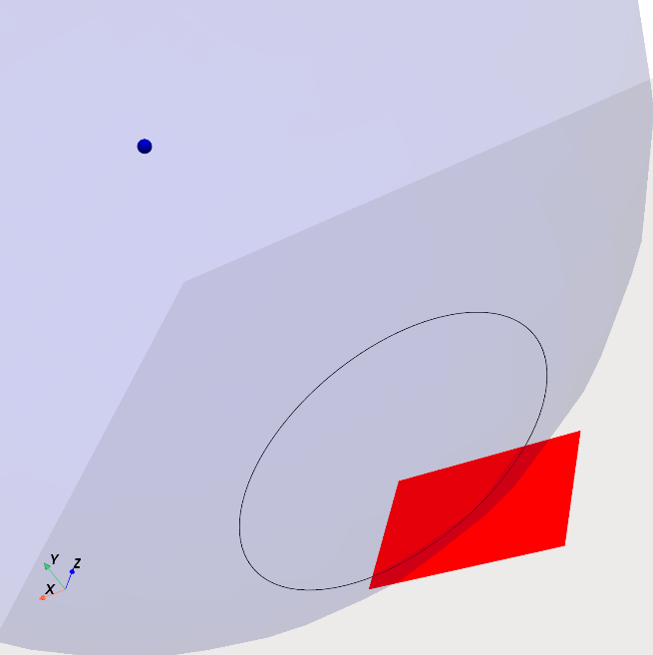
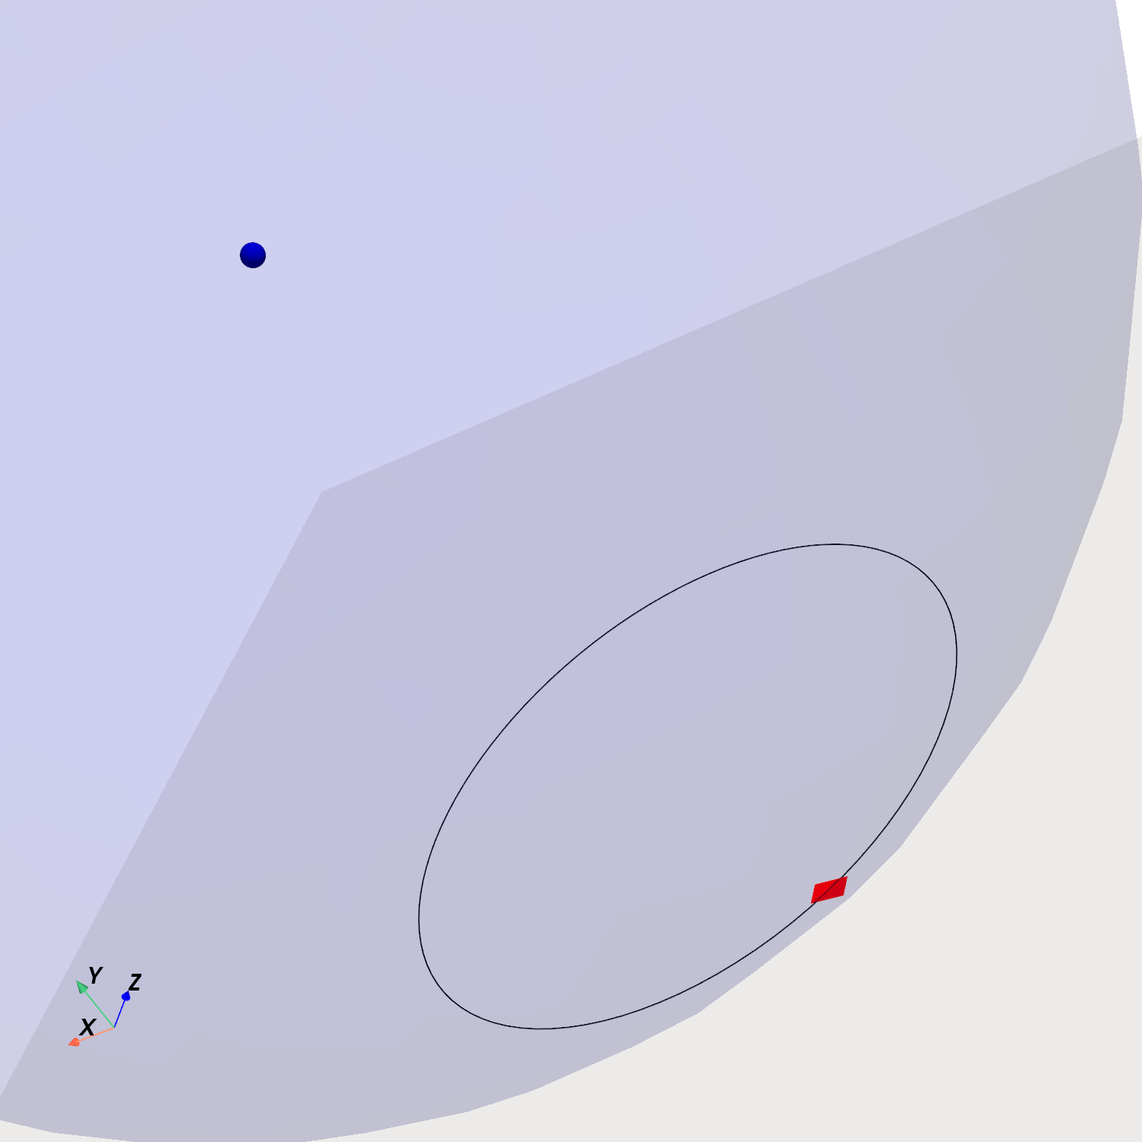
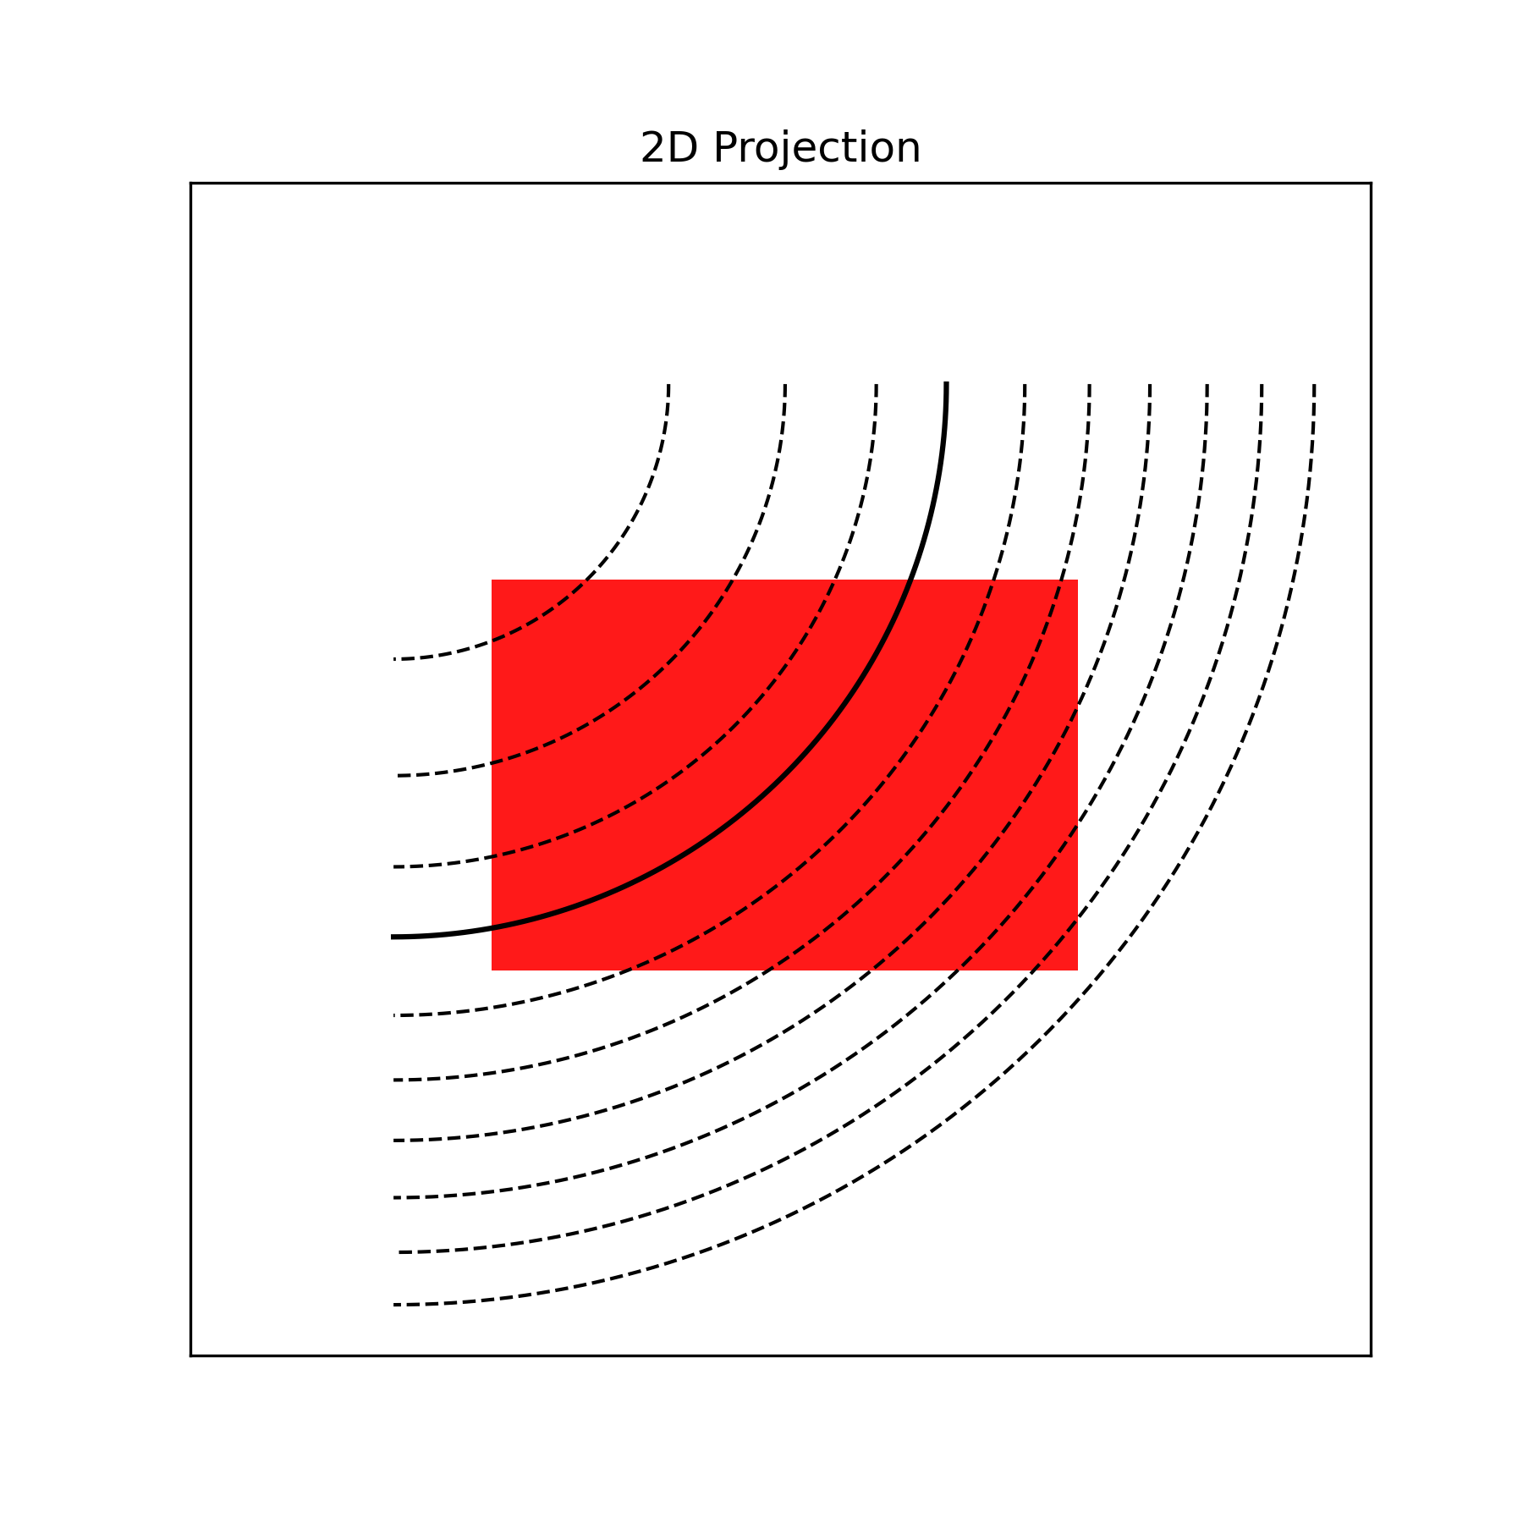
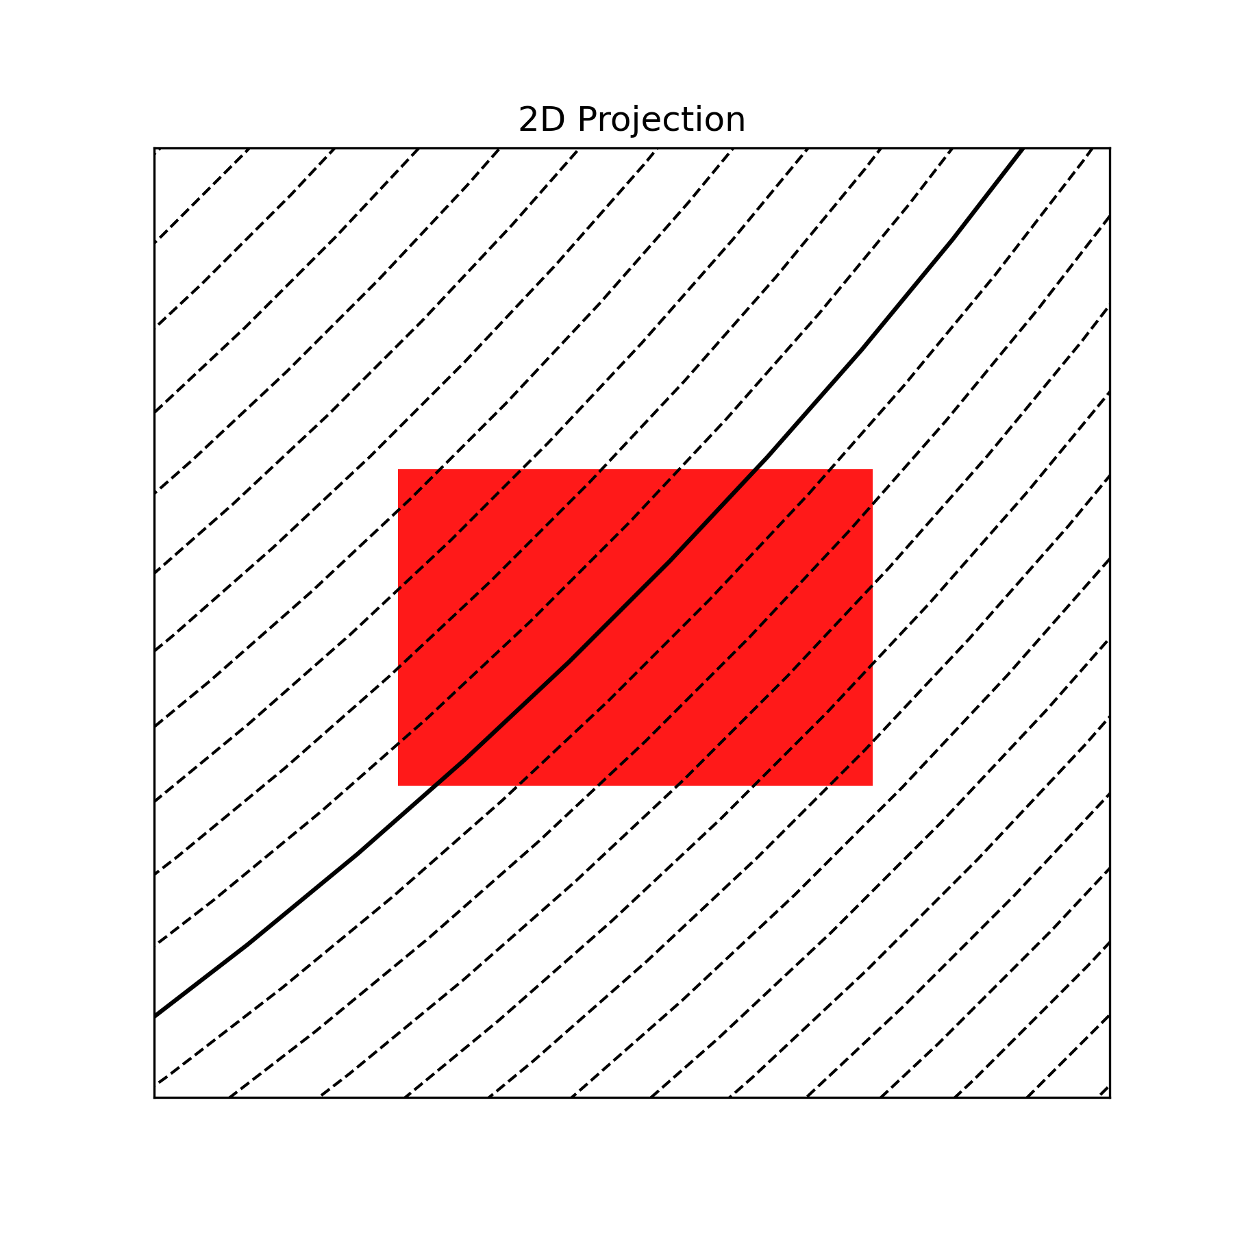
NOT SURE IF SOMETHING LIKE THIS. STILL NEED TO ADD THE CORRESPONDING SIR SHAPE.

For rectangular apertures, an exact solution to this integral has been derived in [6]. To build intuition, it is helpful to consider the problem geometrically. The impulse response at a given time corresponds to the fraction of the aperture that contributes coherently at that instant. Thus, the SIR can be understood in terms of isodistance curves from the field point. In the near field, these curves appear as rounded contours [Fig. circle contours], whereas in the far field, they approximate straight lines [Fig. Straight lines].

In general, under the assumption of the far-field, the SIR of a rectangular aperture tends to a trapezoidal shape [Fig. trapezoid]. This shape can be constructed by convolving two rectangular pulses whose widths correspond to the projections of the aperture’s length and width onto the line connecting the aperture center to the field point. Consequently, the trapezoidal SIR can be fully described by five parameters:
- $t_{1}$​: time-of-flight (TOF) from the nearest aperture corner,
- $t_{2}, t_{3}$​: TOFs from the second and third nearest corners, which define the onset and end of the plateau,
- $t_{4}$​: TOF from the farthest corner,
- $h_{max}$​: the plateau height,
Placing the rectangular aperture $m$ of width and height of $w_{mx},w_{my}$ in the $x-y$ plane with its center at the coordinate ${\vec{r}}_{m}$, the field point position vector -coming from the $m$-th rectangle to the $p$-th field point- is ${\vec{r}}_{m,p}={\vec{r}}_{p}-{\vec{r}}_{m}$, where ${\vec{r}}_{p}$ are the coordinates of the field point. This vector can be further decomposed into a distance $l_{m,p}=\left|\left|{\vec{r}}_{m,p}\right|\right|$ and an unit vector ${\vec{u}}_{m,p}=\frac{{\vec{r}}_{m,p}}{ \left|\left|{\vec{r}}_{m,p}\right|\right|}=(x_{u},y_{u},z_{u})$​. Using this description, one can get the following equations
$$t_{1}=\frac{l_{m,p}}{c_{0}}-\frac{Δt_{1}+Δt_{2}}{2}$$
$$t_{2}=t_{1}+Δt_{1}$$
$$t_{3}=t_{1}+Δt_{2}$$
$$t_{4}=t_{1}+Δt_{1}+Δt_{2} [13]$$
Where $Δt_{1}$ and $Δt_{2}$, correspond to the min and max TOF for the side lengths of the rectangle
$$Δt_{1}=\min\left(\frac{w_{my} y_{u}}{c_{0}},\frac{w_{mx} x_{u}}{c_{0}}\right) [14]$$
$$Δt_{2}=\max\left(\frac{w_{my} y_{u}}{c_{0}},\frac{w_{mx} x_{u}}{c_{0}}\right) [15]$$
Note that $t_{2}-t_{1}=t_{4}-t_{3}=Δt_{1}$ and $t_{3}-t_{2}=Δt_{2}-Δt_{1}$, and that there are some cases where some of the $t$’s are identical and thus have $Δt_{1}$ and/or $Δt_{2}$ equal to zero.
The shape of the trapezoid is a function of $Δt_{1}$ and $Δt_{2}$ and so is its amplitude, but the area of the trapezoid integrated over the whole-time interval is always equal to [Jensen]
$$a_{rec}\left(l\right)=\frac{w_{mx} w_{my}}{2πl_{m,p}} [16]$$
Geometrically, the area can also be expressed as
$$a_{rec}=h_{max}Δt_{2} [17]$$
Combining (16) and (17) gives the trapezoid amplitude
$$h_{m,p}^{plateau}=\frac{w_{mx} w_{my}}{2πΔt_{2}l_{m,p}} [18]$$
Therefore, the far-field trapezoidal SIR for a $m$-th rectangular aperture is
$$h_{m}\left({\vec{r}}_{p},t\right)=h\left({\vec{u}}_{m,p},l_{m,p},w_{mx},w_{my},t\right)=\left\{\begin{matrix}\begin{matrix}s_{m,p}\left(t-t_{1}\right), t_{1}<t<t_{2} \\ h_{m,p}^{plateau}, t_{2}<t<t_{3}\end{matrix} \\ \begin{matrix}s_{m,p}\left(t_{4}-t\right), t_{3}<t<t_{4} \\ 0, elsewhere\end{matrix}\end{matrix}\right. [19]$$
With
$$s_{m,p}=\frac{h_{m,p}^{plateau}}{Δt_{1}} [20]$$

The SIR for any transducer geometry

Naïve method:
When simulating arbitrary transducer geometries, it is rarely guaranteed that an entire piezoelectric element will satisfy the far-field condition. To resolve this, each element is subdivided into smaller rectangular patches. Each subdivision is assumed to operate in the far-field regime, and the total aperture response is then obtained by summing contributions from all subdivisions.
To ensure validity, the patch dimensions must satisfy [Jensen]:
$$w≪\sqrt{\frac{4lc_{0}}{f}} [21]$$
Where $l$ is the distance to the field point, $w$ the largest dimension of the rectangle and $f$ is the highest frequency in the response simulated.
Moreover, real ultrasound transducers rarely behave like ideal pistons. Their vibration profile may be modified by boundary conditions at the edges or intentionally shaped to suppress sidelobes. For instance, applying a Gaussian apodization reduces sidelobes by weighting the active aperture [CITE]. Apodization can be incorporated into Eq. (19) by scaling the SIR of each element with a factor $a_{e}$​, where $a_{e}=1$denotes a fully active element and $a_{e}=0$ an inactive one. Similarly, delays can be introduced as a temporal translation of the SIR, and can be further used to steer or focus the beam.
Therefore, the general expression for an ultrasound transducer composed by $M$ rectangular patches is,
$$h_{tx}\left({\vec{r}}_{p}, t\right)≈\sum_{m=1}^{M}{a_{m}h_{m}\left({\vec{r}}_{p},t-τ_{m}\right)}[22]$$
Where $h_{m}$ was previously defined in eq[19]. Note that for an element $e$ of this transducer, there is a subset of patches $m$ such that $a_{m}=a_{e}$ and $τ_{m}=τ_{e}$. That is to say, the patches over an element will have the same value of apodization and delay. Finally, the overall impulse response of a transducer with $E$ elements, each divided into $M$ subdivisions, is:
$$h_{tx}\left({\vec{r}}_{p}, t\right)≈\sum_{e}^{E}{h_{e}\left({\vec{r}}_{p}, t\right)}=\sum_{e}^{E}{\sum_{m_{e}}^{M}{a_{e}h_{e,m}({\vec{r}}_{p},t-τ_{e})}} [23]$$
An example of the influence of transducer geometry, and elements apodization and delays can be seen in {FIG. TRANSDUCER WITH DELAYS AND APODIZATION}.
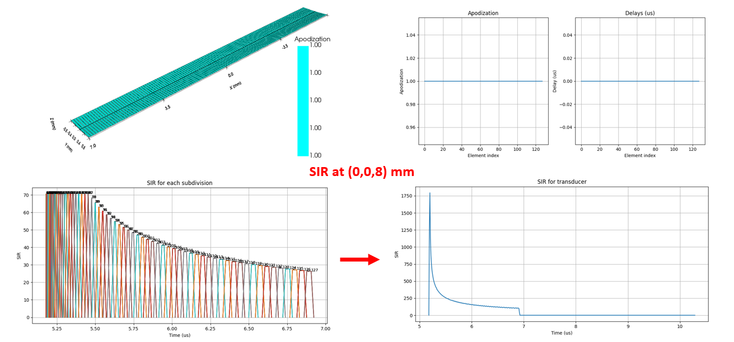
SOMETHING SIMILAR TO THIS BUT WAY BETTER AND PRETTIER.

A new approach: Sparse Delta Method (SDM).
From the derivation on the equation [19], we can see that the first derivative of the trapezoid piecewise function can be written as follows
$$\frac{∂h_{m}\left({\vec{r}}_{p},t\right)}{∂t}=\left\{\begin{aligned}s_{m,p}, t_{1}<t<t_{2} \\ -s_{m,p}, t_{3}<t<t_{4} \\ 0, elsewhere\end{aligned}\right.$$
$$=s_{m,p}∙\left(u\left(t-t_{1}\right)-u\left(t-t_{2}\right)-u\left(t-t_{3}\right)+u\left(t-t_{4}\right)\right) [24]$$
Where$s_{m,p}$ is function of the $m$-patch geometry and the point field $p$ as depicted in equation 20, and $u(t)$ is the Heaviside step function, defined as
$$u\left(t\right)=\left\{\begin{aligned}1, t≥0 \\ 0, t<0\end{aligned}\right.$$
If we continue with furthe derivation, we can get to the next expression
$$\frac{∂^{2}h_{m}\left({\vec{r}}_{p},t\right)}{∂t^{2}}=s_{m,p}∙\left(δ\left(t-t_{1}\right)-δ\left(t-t_{2}\right)-δ\left(t-t_{3}\right)+δ\left(t-t_{4}\right)\right)=s_{m,p}Δδ\left(t\right) [25]$$
Where $δ\left(t\right)$ stands for the unit impulse or unit Dirac delta distribution, defined as
$$δ\left(t\right)=\left\{\begin{aligned}1, t=0 \\ 0, t≠0\end{aligned}\right.$$
Thus, we can rewrite the piecewise function shown in [19] as
$$h_{e,m}\left({\vec{r}}_{p},t\right)=\int_{-∞}^{t}{\int_{-∞}^{t'}{s_{m,p}Δδ\left(t^{''}\right)}dt^{''}dt'} [26]$$
Where,
$$Δδ\left(t\right)=δ\left(t-t_{1}\right)-δ\left(t-t_{2}\right)-δ\left(t-t_{3}\right)+δ\left(t-t_{4}\right) [27]$$
Thanks to the additive property of the integrals, the SIR for a transducer composed by $M$ patches becomes,
$$h_{tx}\left({\vec{r}}_{p}, t\right)≈\sum_{m}^{M}{a_{m}h_{e,m}({\vec{r}}_{p},t-τ_{m})}=\int_{-∞}^{t}{\int_{-∞}^{t}{\sum_{m}^{M}{a_{m}s_{m,p}Δδ\left(t-τ_{m}\right)}}dtdt} [28]$$

Overview of the programs
Building on the above formulation, we developed two open-source Python simulators—PyField and TorchField—that compute the monochromatic pressure fields of arbitrary transducer geometries. PyField reproduces the Field II method with transparent, open code suitable for teaching and validation. TorchField extends the approach by leveraging PyTorch, providing GPU acceleration, automatic differentiation, and integration into optimization workflows. In the following subsections, we detail the logic underlying these implementations.

PyField
So far, the derivation has been expressed in terms of continuous time. For implementation, however, we must discretize the temporal axis. The continuous variable $t$ is replaced by its sampled version $\left\{t_{k}\right\}$, a vector of $T$ samples defined as:
$$t_{k}=t_{0}+kΔt, k=0, 1, 2,…T-1. [24]$$
with sampling step $Δt=1/f_{sampling}$, where $f_{sampling}$ is the sampling frequency, and $t_{0}$ is the initial time.
Let’s assume we have a set of $P$ field points, stored in a matrix $R_{P}∈R^{P×3}$ containing the 3 spatial coordinates, and a transducer composed by $E$elements, each divided with $M$ rectangular patches. In PyField algorithm, we first compute the five trapezoid parameters (eq. 13 and 18) for every patch-point combination. Each of these combinations is referred to as an Event. The events are stored in a tensor $C∈R^{P×M×5}$.
From the event tensor $C$, the smallest $t_{1}$ value across all events sets the starting time $t_{0}$ of the temporal grid, while the larges $t_{4}$ defines its final time $t_{f}$. The number of samples is then chosen to satisfy:
$$T≥\left(t_{f}-t_{0}\right)f_{sampling}=Δt_{span}f_{sampling} [23]$$
We now allocate the output tensor $h∈R^{P×T}$, which will store the impulse response for each field point across time.
The PyField’s naïve algorithm proceeds as follows:
- Loop over field points $\left(p=1,…, P\right)$.
  - For each point, retrieve the trapezoid parameters of all patch–point events from tensor $C$.
- For each point, loop over events $\left(p, m=1,…,M\right)$:
  - Compute the time interval indices $(k_{start},k_{end})$ that correspond to the trapezoid boundaries on the discrete time grid.
- For each event, loop each event time interval $\left(p, m, k=\left(k_{start}, k_{end}\right)\right)$:
  - Within this index range, evaluate the trapezoidal SIR contribution $h_{m}\left({\vec{r}}_{p},t_{k}\right)$ using the piecewise definition (Eq. 19).
- Accumulate contributions in the temporal grid:
  - Add the computed trapezoid values into the output tensor:
$h\left(p, k_{start}:k_{end}\right) +=h_{m}\left({\vec{r}}_{p},t_{k_{start}:k_{end}}\right)$
Where $b +=a$ means $b=b+a$. That is to say, $b$ is reassigned with its previous value plus $a$. By repeating this process, the contributions of all patches are accumulated for each point, producing the final tensor $h$, which contains the SIR at every field point. As shown in Eq. (11), this SIR tensor can be then used to compute the pressure field distribution.

TorchField:
For implementation, the temporal axis must be discretized, which requires careful handling of the delta function contributions. The continuous variable $t$ is replaced by its sampled version $\left\{t_{k}\right\}$, a vector of $T$ samples as defined in Eq. [24]. Unlike the piecewise trapezoidal function defined by the four times $(t_{1}, t_{2}, t_{3},t_{4})$, the reformulated method uses delta functions located exactly at these times. Since $t_{1},…,t_{4}$ do not necessarily coincide with the discrete grid $\left\{t_{k}\right\}$, their contributions must be distributed to the closest discrete samples.
Intuitively, this means that instead of placing a delta “between samples” (which would be lost on the grid), we split its wight between the two nearest time samples. This ensures that the total contribution is preserved while being consistent with the discrete representation.
Formally, given a continuous time $t^{'}∈R$, its index position in the sampled grid is,
$$k_{t'}=\frac{t^{'}-t_{0}}{dt} [35]$$
Here $k_{t^{'}}∈R$, while $k∈Z^{+}$ represents valid discrete indices. Thus, instead of assigning the delta exactly at $t'$. Its amplitude is distributed between the two nearest discrete grid points, using linear weight:
$$w^{f}\left(t^{'}\right)=k_{t'}-\left\lfloor k_{t^{'}}\right\rfloor , w^{c}\left(t^{'}\right)=\left\lceil k_{t^{'}}\right\rceil -k_{t^{'}}=w^{f}\left(t^{'}\right)+1 [36]$$
Where now $\left\lfloor k_{t^{'}}\right\rfloor ∈Z^{+}$ and $\left\lceil k_{t'}\right\rceil ∈Z^{+}$, and corresponds to the floor and ceil value of the number $k_{t'}$ that can be now used as index. Then, for taking the lower and higher value between $\{t_{k}\}$ closest to $t'$ we define
$$t^{f}=t_{\left\lfloor k_{t}\right\rfloor }, t^{c}=t_{\left\lceil k_{t}\right\rceil } [37]$$
Where $t_{\left\lfloor k_{t^{'}}\right\rfloor , }$ means that we are evaluating our time vector at the index $\left\lfloor k_{t^{'}}\right\rfloor$, and the same for $\left\lceil k_{t}\right\rceil$. With this interpolation, the discrete version of the deltas defined in equation [29] becomes
$$Δδ\left(t_{k}\right)=Δδ{\left(t_{k}\right)}^{ceil}+Δδ{\left(t_{k}\right)}^{floor} [38]$$
With,
$$Δδ{\left(t_{k}\right)}^{floor}=w^{f}\left(t_{1}\right)δ\left(t_{k}-t_{1}^{f}\right)-w^{f}\left(t_{2}\right)δ\left(t_{k}-t_{2}^{f}\right)-w^{f}\left(t_{3}\right)δ\left(t_{k}-t_{3}^{f}\right)+w^{f}\left(t_{4}\right)δ\left(t_{k}-t_{4}^{f}\right) [39]$$
$$Δδ{\left(t_{k}\right)}^{ceil}=w^{c}\left(t_{1}\right)δ\left(t-t_{1}^{c}\right)-w^{c}\left(t_{2}\right)δ\left(t-t_{2}^{c}\right)-w^{c}\left(t_{3}\right)δ\left(t-t_{3}^{c}\right)+w^{c}\left(t_{4}\right)δ\left(t-t_{4}^{c}\right) [40]$$
This weighting ensures that the delta contributions are properly mapped onto the discrete time grid, by adding four more deltas. A schematic illustration of this interpolation strategy is shown in Figure X (middle-point positioning).
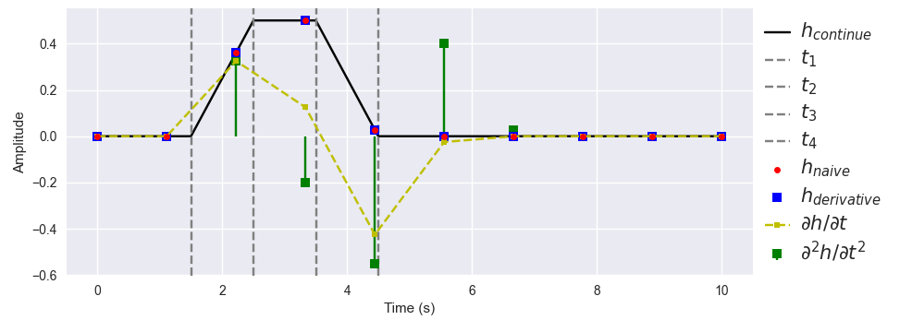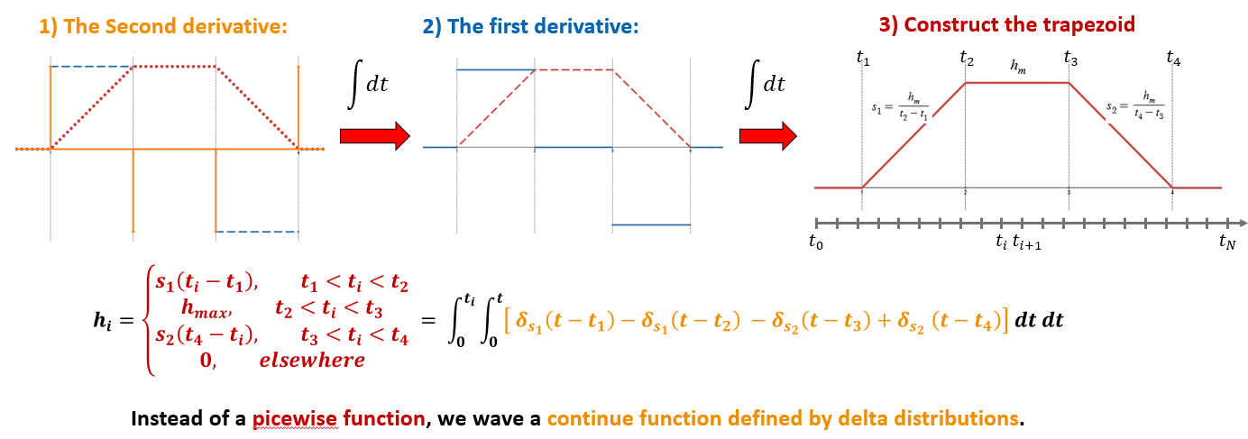
SOMETHING SIMILAR TO THIS

This approach was implemented in PyTorch, a Python package that provides a Tensor computation with strong GPU-ready acceleration.

Performance analysis:

During computation, the number of trapezoids is equal to the combinations of field points and patches on the transducer. In the naive method, each patch $m$ is evaluated by filling the trapezoid over all its nonzero time samples. Then, If on average a trapezoid spans a number $\overline{Δk}$ of sample times out of a temporal grid with $T$ samples, for $P$ field points the computation time ($CT$) becomes of the order of
$$CT\left(Naive\right)\sim O\left(P∙M∙\overline{Δk}\right) [29]$$
For clarity, consider the case of a single field point $\left( P=1\right):$
$$CT\left(Naive_{(P=1)}\right)\sim O\left(M∙\overline{Δk}\right) [30]$$
In contrast, the Sparse Delta Method (SDM) proposed in Eq. [24] avoids filling entire trapezoids. Instead, each patch contributes only four Dirac deltas (or four samples), requiring $CT\left(\sum_{m}^{M}{S_{m,p}\left(t\right)}\right)\sim O\left(4M\right),$at the expense of adding the cost of the two integrations over time each with $\sim O(T)$. Hence,
$$CT\left(SDM_{(P=1)}\right)\sim O\left(4M+2T\right)\sim O\left(M+T\right) [31]$$
In general, the naive algorithm will be faster only if,
$$M∙\overline{Δk}≪ M+T [32]$$
Which leads to
$$\overline{Δk}≪1+\frac{T}{M} [33]$$
In the regime of $M≫T$, this inequality requires $\overline{Δk}≪1$. In general, the sampling frequency is chosen as most trapezoids are well sampled, thus $\overline{Δk}≫1$ so this means that in most cases the SDM is going to be faster than the naïve one. Conversely, for the naïve method to be competitive, one must have, $T≫M$.
For calculation, the range of time $Δt_{span}$ for the SIR is compute as $Δt_{span}=\frac{T}{f_{s}}$, where $f_{s}$ corresponds to the sampling frequency. To not lose any trapezoid event, the minimum range of time when no delay is applied, is
$$Δt_{span}^{min}=\left(d^{max}-d^{min}\right)/c_{0} [35]$$
Where $d^{max}=\max\left(\left|{\vec{r}}_{m,p}\right|\right)$ and $d^{min}=\min\left(\left|{\vec{r}}_{m,p}\right|\right)$ refers to the maximum and minimum distance between the center of the patches and the field-points, and $c_{0}$ stands for the speed of sound in the medium. Thus,
$$Δt_{span}^{min}>d^{max}$$
For simplicity, let’s consider a linear aperture of value $A$. To compute the SIR of this aperture, we must divide it in $M$ patches of length $w$ that fall in far-field, that is
$$A=Mw$$
Such that,
$$d^{max}≫\frac{w^{2}}{4λ}⇒d^{max}≫\frac{A^{2}}{4M^{2}λ}$$
From [35] we get the next inequation
$$Δt_{span}^{min}>\frac{d^{max}}{c_{0}}⇒\frac{T}{f_{s}}>\frac{d^{max}}{c_{0}}$$
And with [36] and [37] we find,
$$T>\frac{f_{s}A^{2}}{4M^{2}c_{0}λ}$$
array placed in the $x-y$ plane centered in the axis, with an aperture of $A$ (so spanned from $\left[-\frac{A}{2},\frac{A}{2}\right]$) , and a set of points located on the space under the transducer until a maximum depth of $z_{f}$, so $\left(x_{p},z_{p}\right)=\left\{\left(x,z\right)∈R^{2} | x∈\left[\frac{A}{2},\frac{A}{2}\right] ∧z∈\left(0,z_{f}\right]\right\}$. Under this configuration the maximum distance becomes
$$d^{max}=\sqrt{z_{f}^{2}+A^{2}} [36]$$
This shows that for most practical apertures and imaging depths, TorchField will be faster than the naïve PyField-style approach.

Comparison of TorchField and FIELDII.

Linear array probe.

Calibration data?

Matrix probe.

Discussion.

Conclusion

References

- Treeby BE, Cox BT. k-Wave: MATLAB toolbox for the simulation and reconstruction of photoacoustic wave fields. J Biomed Opt. 2010;15(2):021314.
- Cohen JB, et al. (example ref) — (Replace with specific FD/FDTD or k-space pseudospectral reference as needed).
- Jensen JA. Calculation of pressure fields from arbitrarily shaped, apodized, and excited ultrasound transducers. IEEE Trans Ultrason Ferroelectr Freq Control. 1992;39(2):262–267.
- Jensen JA. A new calculation procedure for spatial impulse responses in ultrasound. J Acoust Soc Am. 1999;105(6):3266–3274.
- Tupholme GE. Generation of acoustic pulses by baffled plane pistons. Mathematika. 1969;16(2):209–224.
- Stepanishen PR. Transient radiation from pistons in an infinite planar baffle. J Acoust Soc Am. 1971;49(5B):1629–1638.
- Jensen JA, Svendsen NB. (1992) — same as [3]; Field II implementation described in Jensen J.A.: "FIELD: A program for simulating ultrasound systems" and user guide.
- Jensen JA. FIELD: A program for simulating ultrasound systems — User’s guide and project pages (Field II distribution).
- Treeby BE, Cox BT. (same as [1]) — full-wave vs SIR comparison discussions.
- Paszke A, et al. PyTorch: An imperative style, high-performance deep learning library. NeurIPS. 2019.
- Abraham A, et al. Nilearn: a Python module for fast and easy statistical learning on neuroimaging data. NeuroImage. 2014; (or project website/docs).
- Tyson AR, et al. BrainGlobe: an open source toolkit for computational neuroanatomy (project website/docs).

[9] A. D. Pierce. Acoustics, An Introduction to Physical Principles and Applications. Acoustical Society of America, New York, 1989.

