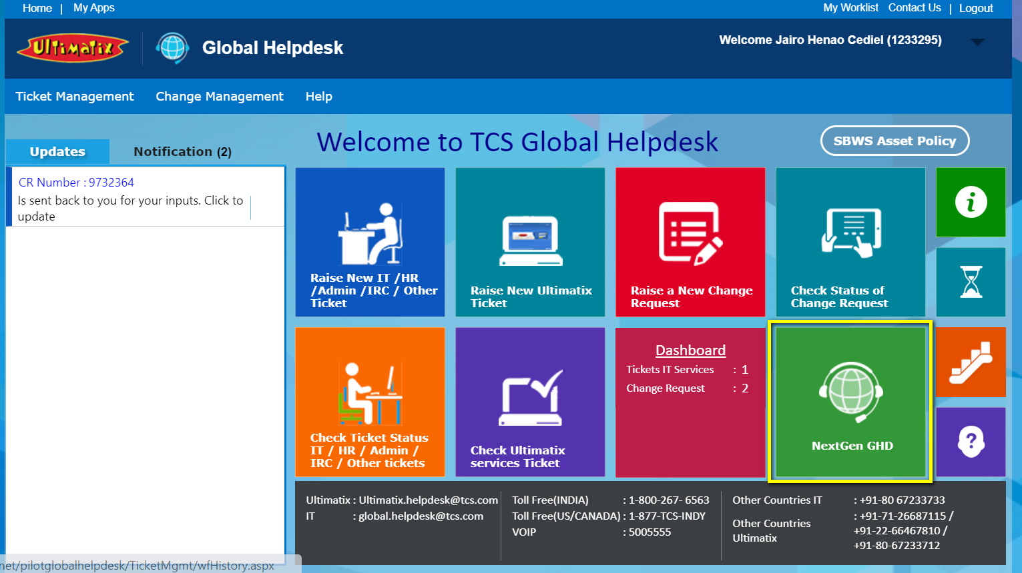

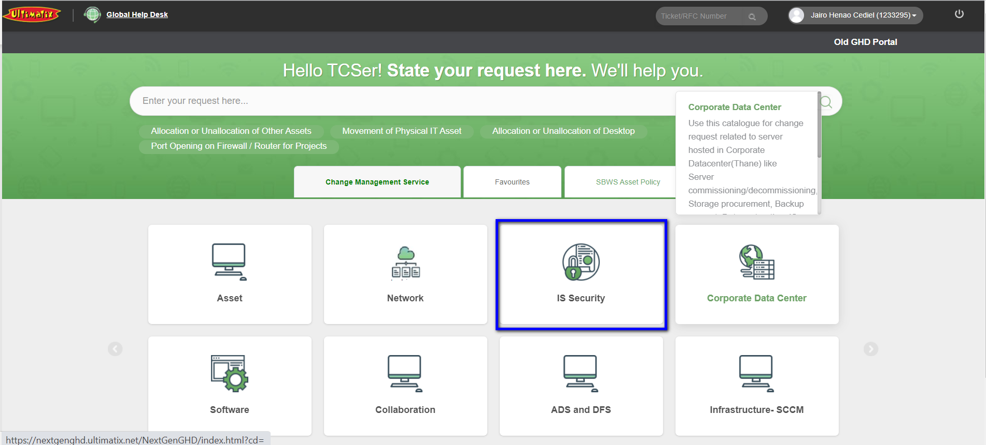

Admin Rigth (1233295) Jairo Alberto Henao Cediel Bancolombia ADM - ID Laptop 50HW016651

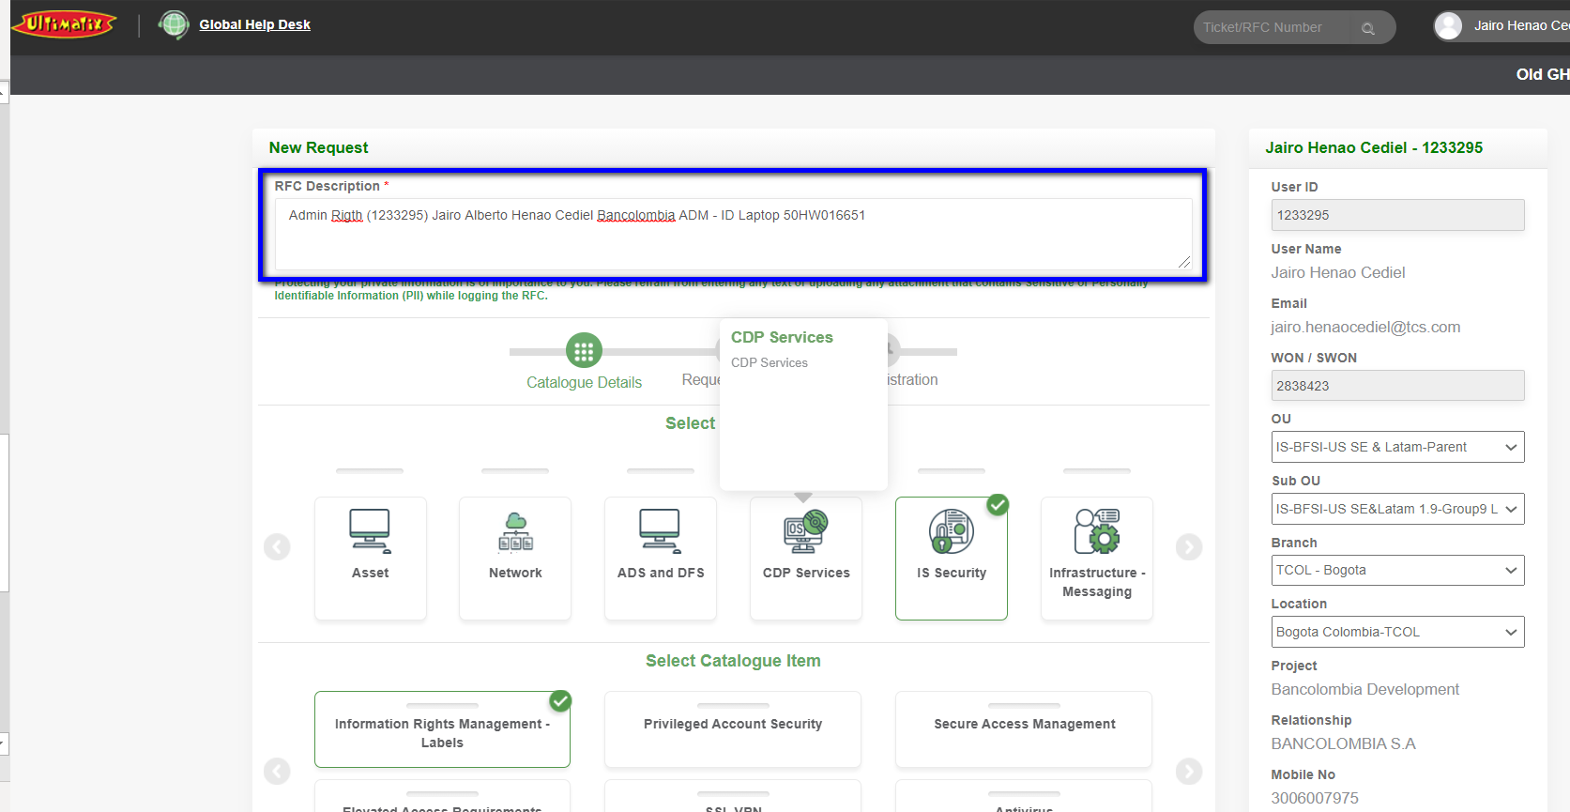

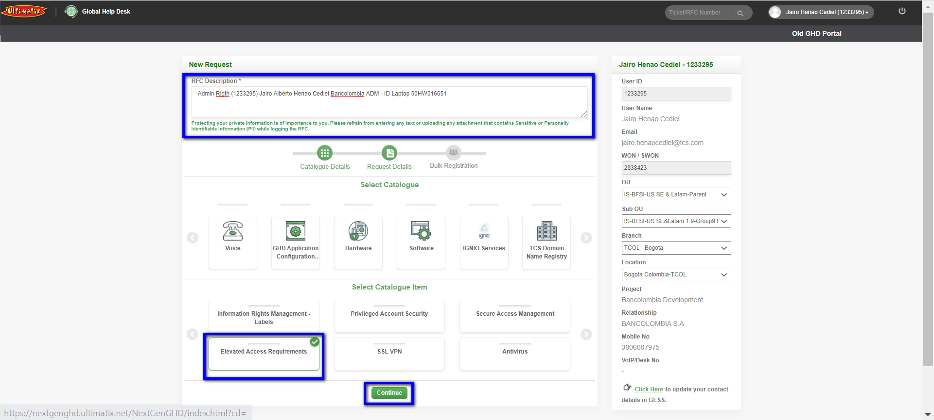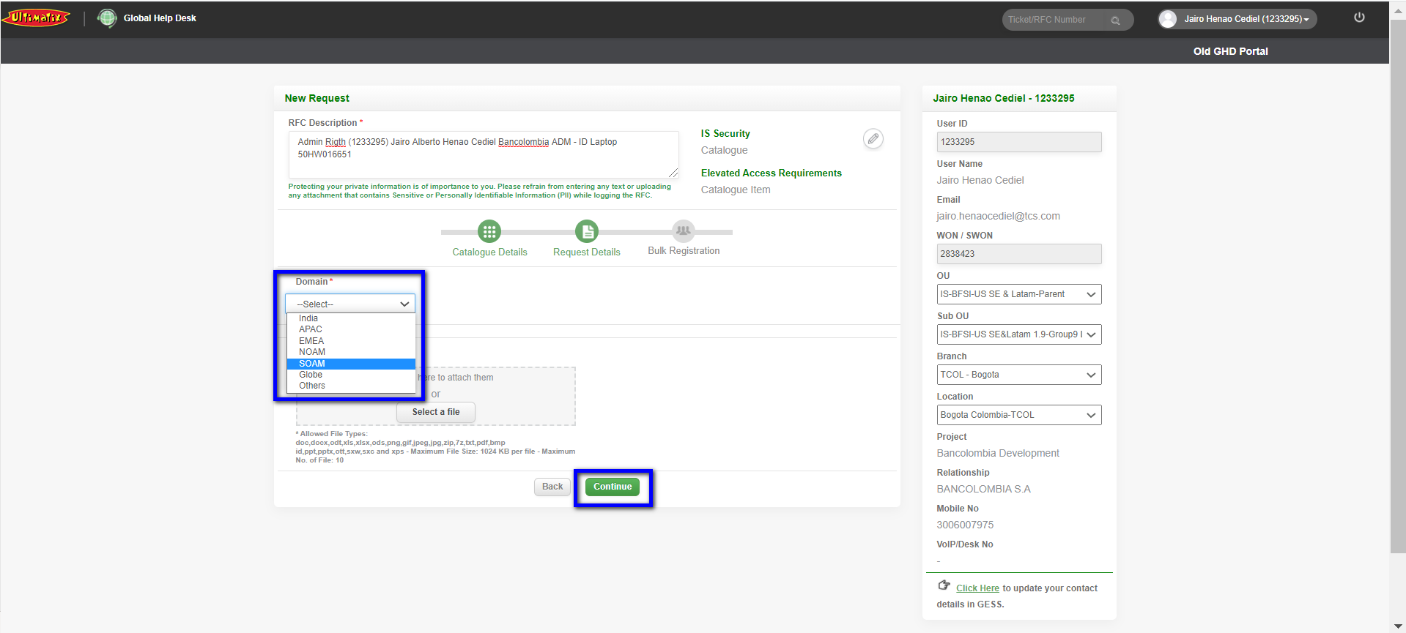

Please Provide Admin Rigth Privileges to: NAME Jairo Alberto Henao Cediel ID:1233295 ASSET ID: 50HW016651 WON NUMBER: 2838423 Bancolombia ADM, Administrator permissions are required to use the following aplications in cliente development environments Quality Center/ALM iSeries - client access Software It is required to use client applications Bancolombia it Would not be possible to use client applications Bancolombia.

