|  |  |
| --- | --- |
| Description: aulaDepartment of Civil Engineering  Technologiepark 904  B-9052 Zwijnaarde | Tim Verbrugghe  +32 9 264 5567  [timl.verbrugghe@ugent.be](mailto:timl.verbrugghe@ugent.be) |

|  |
| --- |
| * openWEC Manual - |

|  |  |  |
| --- | --- | --- |
| **Revision** | **Date** | **Author** |
| **2.0** | 07/06/2016 | Tim Verbrugghe |

Contents

1 Introduction 1

2 Installation & Getting Started 1

3 Choosing a simulator 2

4 Pre Processing 2

4.1 Mesh Tool 2

5 Frequency domain modelling 6

5.1 Nemoh 6

6 Time domain modelling 8

6.1 Simulation 8

7 Post-Processing 9

8 Theoretical Background 9

# Introduction

openWEC is an open-source tool to simulate the hydrodynamic behaviour and energy yield from single body wave energy converters. It is based on the linear wave theory and assumes potential flow. Two software packages are coupled:

* Frequency domain solver Nemoh, developed by Ecole Centrale de Nantes
* Time domain solver, developed in-house

Additional to these 2 solvers, a preprocessing meshing tool and a postprocessing visualisation tool are part of the package.

# Installation & Getting Started

There are two ways to run openWEC on your computer. You can choose to run the python source code directly, or install a compiled windows executable. Both the source code and executable are accessible through the projects github page:

<https://github.com/tverbrug/openWEC>

In order to run the source code directly, the following prerequisites are needed:

* Python 2.7
* Numpy
* Scipy
* Matplotlib
* VTK (only when importing .stl meshes)

When you choose to install the pre-compiled executable, download the setup_openWEC.exe file and follow the installation instructions.

# Choosing a simulator

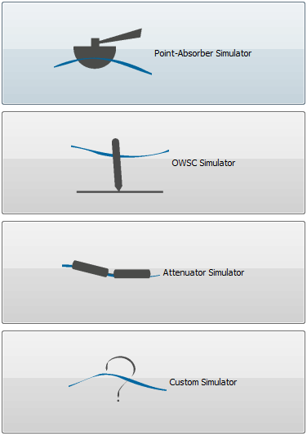

First, you can select the type of WEC simulator you want to use. There are three typical WEC types available, with limited but easy-to-understand functionality:

* Point-Absorber Simulator: a heaving hemispherical buoy floating in the water.
* OWSC Simulator: a pitching flap-type device, anchored to the sea bottom
* Attenuator Simulator: a pitching floating snake-type device, consisting of two rigid body elements

Also, a custom simulator is provided, in which all functionality is available and a custom mesh can be created or imported.

# Pre Processing

## Mesh Tool

First, a mesh needs to be created. This is done with the Mesh Tool. In the first 3 simulators, you only need to fill in the dimensions of the device, the water depth, the density and the approximate number of meshing panels you want the mesher to create.

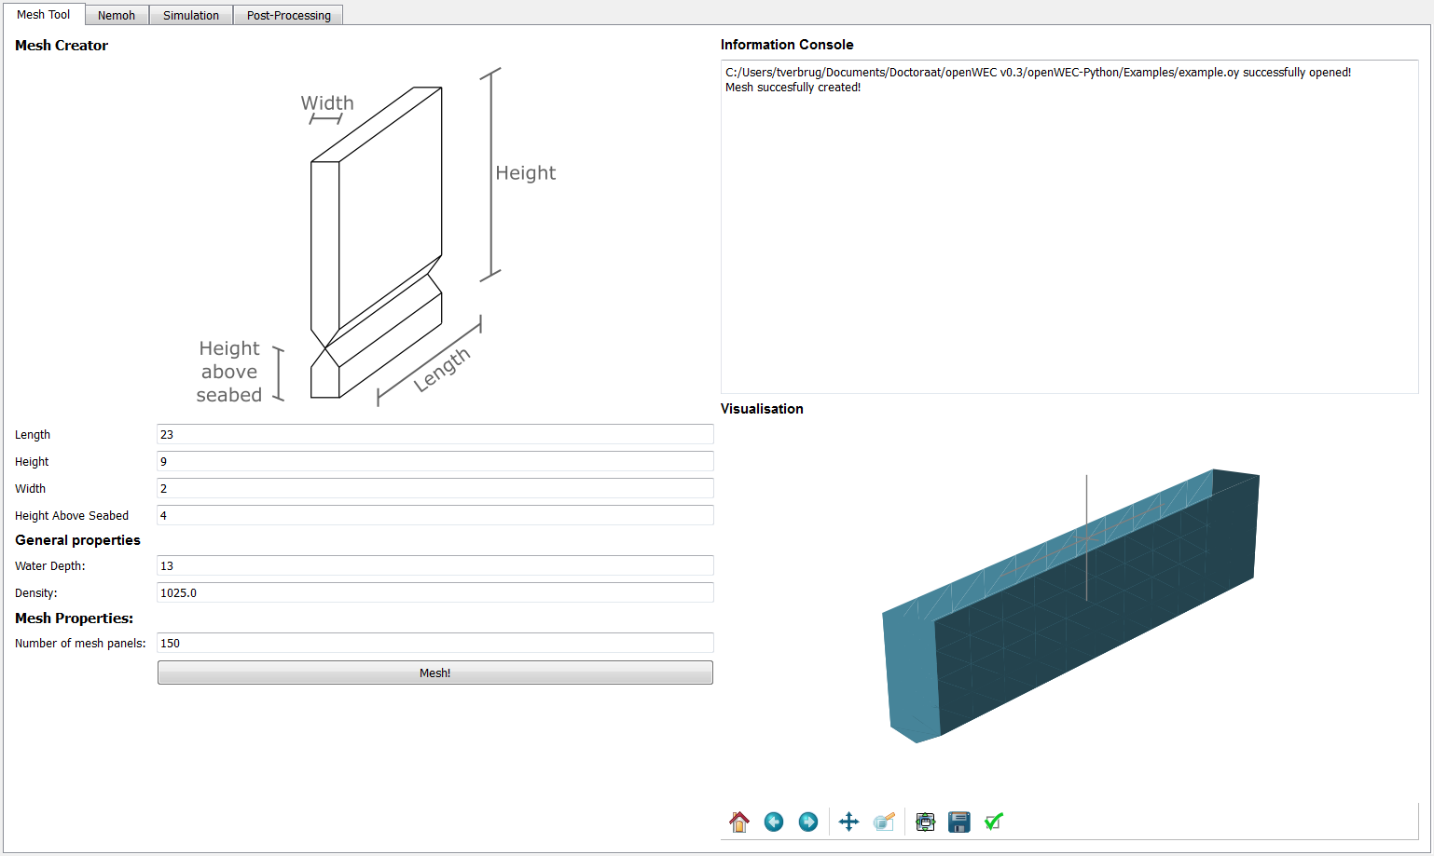

In the Custom Simulator, the options are far more diverse:

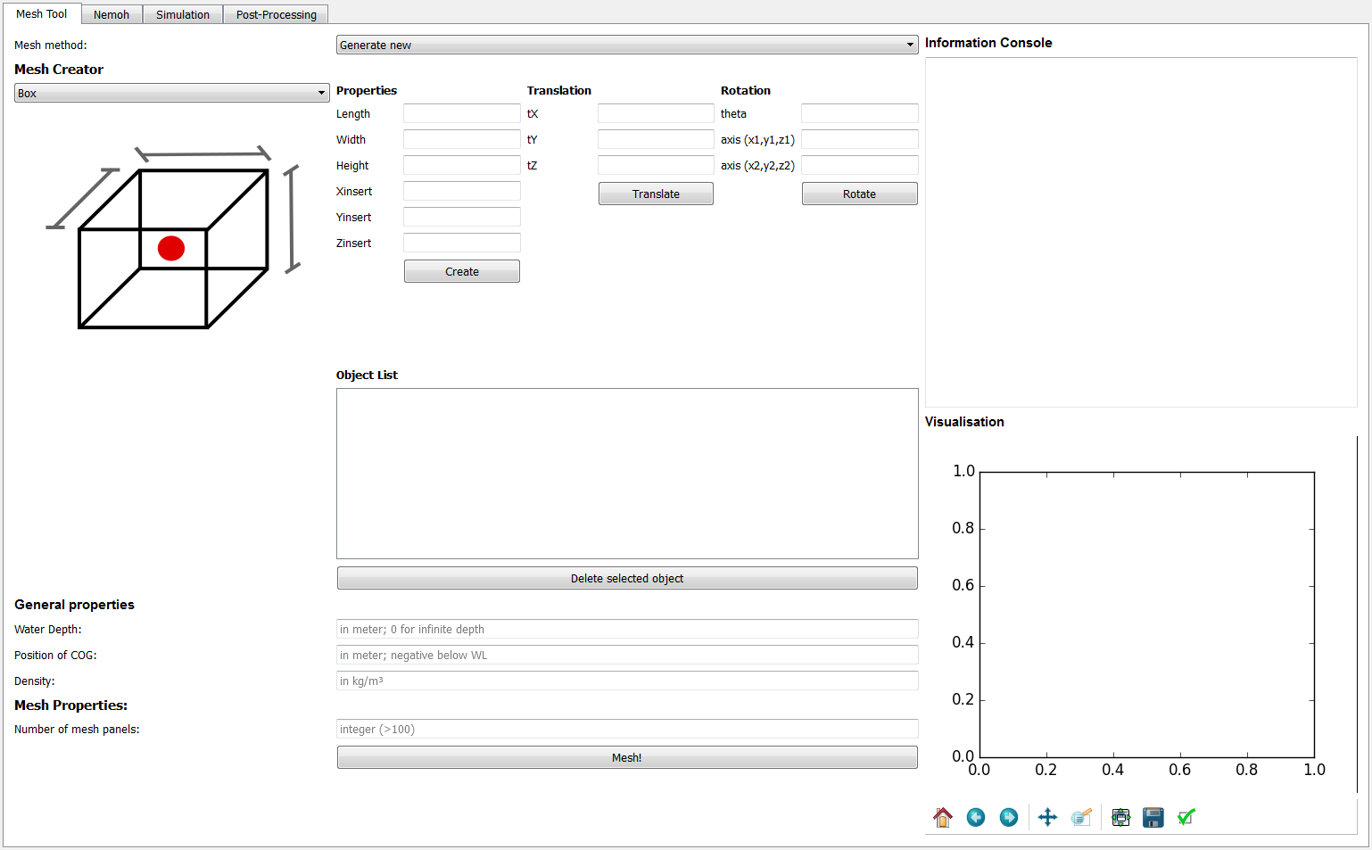

There are 4 different ways to create a mesh:

* **Generate a new mesh** based on predescribed shapes: a floating buoy with a conical or spherical bottom, and a cylindrical top.
* **Import a Nemoh mesh** from a previous simulation
* **Convert a .stl mesh** you have created with other software like MeshLab

Depending on what option you have selected, you must fill in some of the parameters below the WEC shapes. If you have selected anything else than ‘Generate new’, the information console will display what options need to be filled. When selecting ‘Generate new’, you can create a new Mesh with the Mesh Creator. You can add the following basic shapes to the mesh project:

* Box
* Cylinder
* Cone
* Sphere
* Pyramid
* Wedge
* Hemisphere
* Hemicylinder
* Torus

The GUI will show the geometry of the selected object, together with a red dot explaining what the point of insertion will be. E.g. for the cone, the insertion point is at the center of the base circle, and the cone tip is pointed downwards.

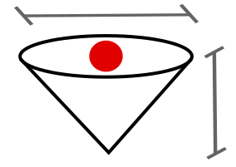

Several mesh elements can be added to the project, and will be added to the Object List. Alle elements in the list are subject to the following manipulations:

* Translation
* Rotation
* Delete

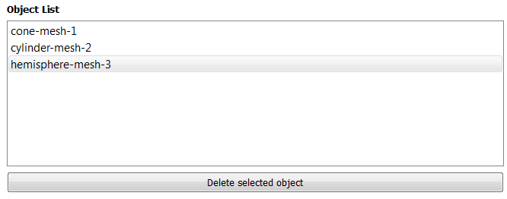 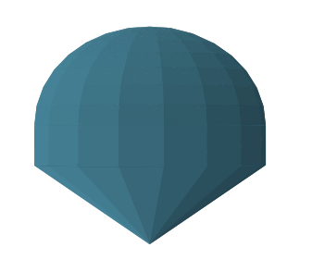

When the complete mesh object is assembled. The general properties should be filled in:

* **Water Depth**: positive values for a finite depth, negative or zero for infinite depth
* **Position of COG**: relative to the water surface, important for rotational movements
* **Water Density**: salt/fresh/… water
* **Number of mesh panels**: refinement of the mesh

Once every required option is filled, the refined mesh is created by pressing the ‘Mesh!’ button. In the shell window you will see the code is running. Once finished, the created mesh is displayed in the plotting window. When creating a mesh from a .stl file, make sure you visually check the mesh for inconsistencies. The .stl mesh must be correctly created to result in a good Nemoh mesh!

The result files of the mesh are found in the ‘./Calculation/mesh’ folder in the main program directory.

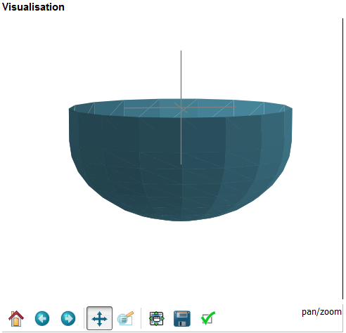

# Frequency domain modelling

The frequency domain modelling is performed with the Nemoh BEM Solver. It is based on the linear wave theory and thus assumes potential flow. For each panel of a mesh, the hydrodynamic parameters are calculated for a certain frequency range.

## Nemoh

Next, the BEM solver can be run to calculate the hydrodynamic parameters:

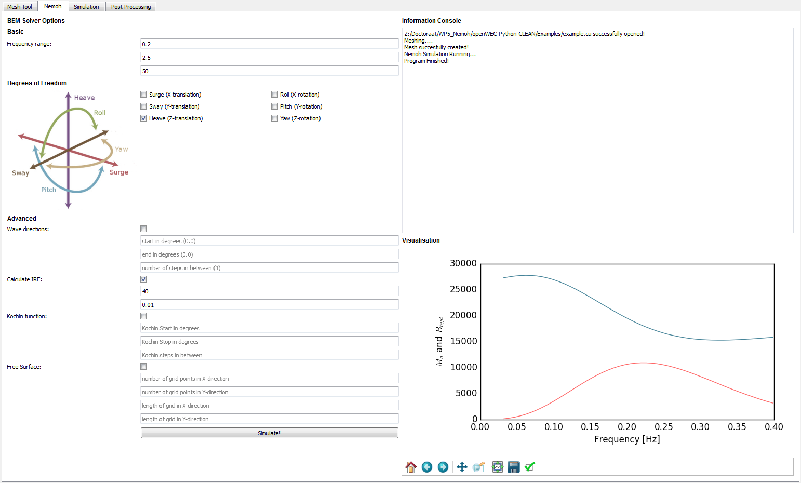

The solver can be run with only the basic options, or you can choose to include several advanced options. Within the basic options you are required to give a frequency range for the calculations by entering three values:

* **The starting frequency** in rad/s (e.g. 0.2 rad/s)
* **The ending frequency** in rad/s (e.g. 2.5 rad/s)
* **The number of frequency steps** (preferably >50)

The degrees of freedom can be selected. All combinations are possible

The advance functions can be enabled or disable with the different check boxes:

* **Wave directions**: only applicable for non-axisymmetric shapes, otherwise you will get the same results for every wave direction.
* **Calculate IRF**: When selected, the impulse response function is calculated. This option is needed if you want to use irregular waves in the time-domain.
* **Kochin function**: calculates the kochin function for each solved problem
* **Free Surface**: calculates the free surface elevation around the WEC for all solved problems, for a given grid.

The calculation will start when pressing the ‘Simulate!’ button. In the shell window you can follow the calculations. Once finished the Added Mass and Hydrodynamic damping will be plotted in the visualisation window.

# Time domain modelling

Once the frequency domain modelling is finished, the time-domain solver can be used. Here the WEC heaving response and energy absorption is calculated for regular or irregular waves.

## Simulation

The time-domain solver can be accessed through the tab ‘Simulation’:

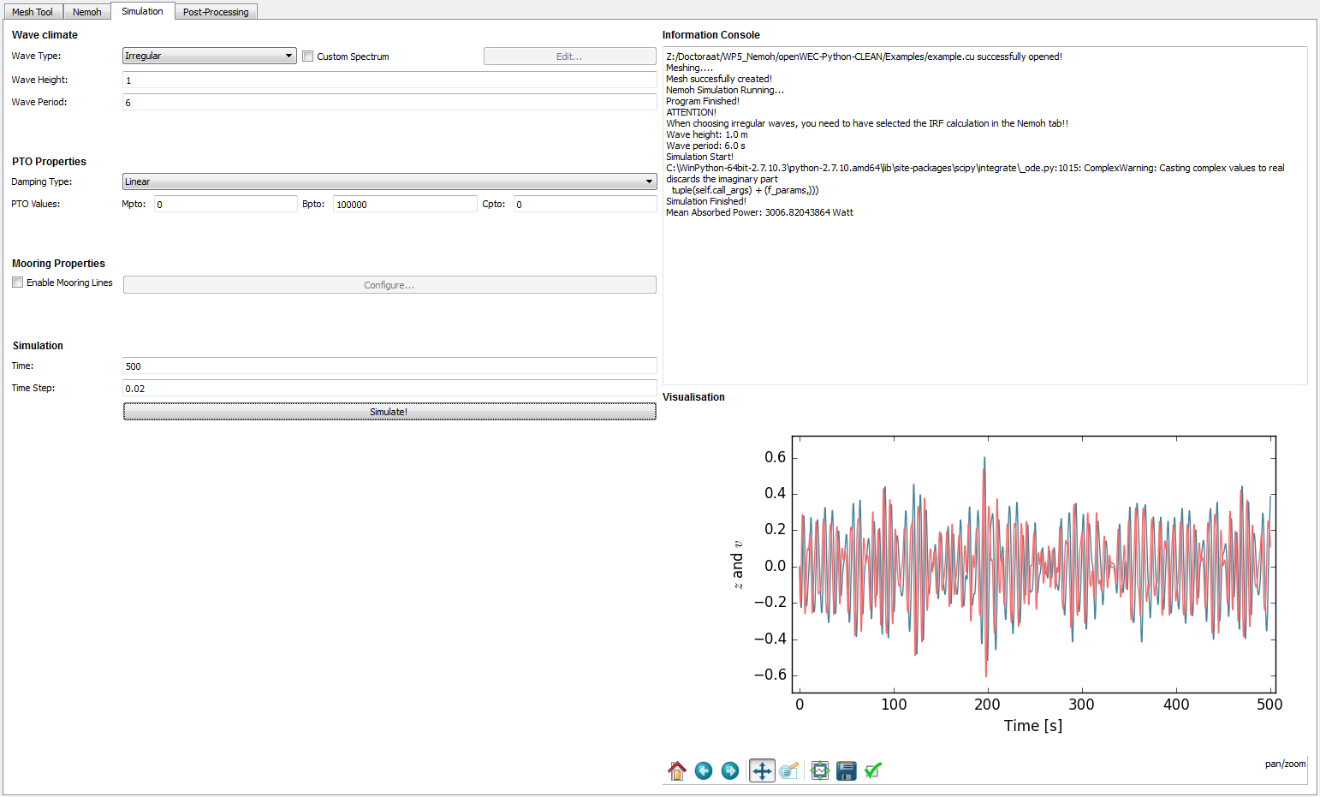

Options are split up into three sections: wave climate, PTO properties and Simulation. All option boxes need to be filled in to be able to simulate.

* **Wave Type**: select between irregular or regular waves. When irregular waves are chosen, you have the option to apply a custom wave spectrum.
* **Wave Height**: enter the wave height in meters
* **Wave Period**: enter the wave period in seconds
* **Damping type**: set the damping type, choosing between two options:
  + **Linear:** set fixed PTO parameters resulting in forces proportional to the device’s acceleration (Mpto), velocity (Bpto), or position (Cpto)
  + **Coulomb:** set a fixed PTO forces which is fully applied when the device has a positive velocity
* **Mooring:** you have the option to couple the time domain solver with the mooring line simulation package MoorDyn. The configure button needs to be pushed to edit the mooring line parameters.
* **Time**: simulation duration
* **Time Step**: time step for each iteration

# Post-Processing

The final tab allows the user to postprocess the results:

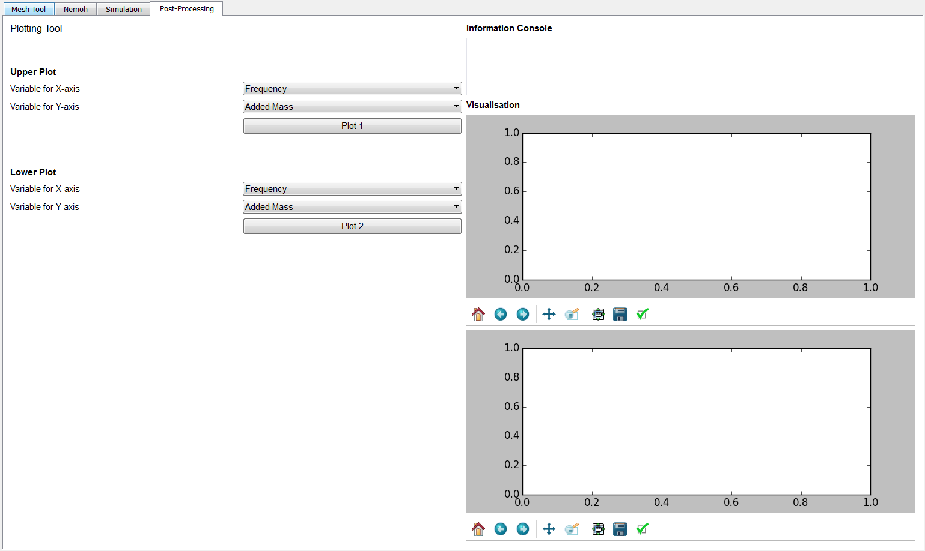

In the plotting tool, you have two visualisation windows at your disposal. For each plot you can select a variable to plot on the x-axis and one on the y-axis. The options for the Y-axis variable will automatically change according to the selected x-axis variable.

# Theoretical Background