Group C – Anomalies Detection in IoT

Project Proposal
The primary objective is to identify unusual patterns that indicate security breaches, technical failures, or unexpected device behavior. By combining edge computing on a Raspberry Pi 5 with sensor nodes based on the ESP32, the system provides a holistic approach to IoT reliability.
The architecture follows a tiered approach to security and data processing:
- Perception Layer (ESP32): A microcontroller equipped with a DHT22 sensor captures real-time temperature and humidity telemetry. Data is encapsulated in JSON format and transmitted via MQTT to a local broker.
- Edge Intelligence Layer (Raspberry Pi 5): This central node acts as the Anomaly Detector. Also, it hosts a local MQTT Broker (Port 1883)
- Cloud Visualization Layer (ThingsBoard): Verified telemetry and security alerts are forwarded to the srv-iot.diatel.upm.es server using a secure MQTTS connection (Port 8883).
To meet the specific requirements of Topic 9, the system integrates three core methodologies:
- Machine Learning (Isolation Forest): An AI model is used to detect statistical outliers in sensor data.
- Markov Chain Analysis: The system monitors transitions between combined temperature/humidity states. By utilizing a transition probability matrix, it identifies "impossible jumps" that indicate logic errors or process tampering.
- Mining Process: Event logs are analyzed to discover the actual process flow.
A critical component of this work is the development of a Security Testing Suite. Dedicated scripts within the Raspberry Pi environment simulate real-world threats:
- Flooding Attack: Rapid transmission of messages to saturate the broker.
- Replay Attack: Injection of previously captured valid packets with outdated sequence IDs.
- Data Injection: Forcing extreme or incoherent sensor values to trigger AI alerts.
- Markov Anomaly: Forcing invalid state transitions to test process logic.

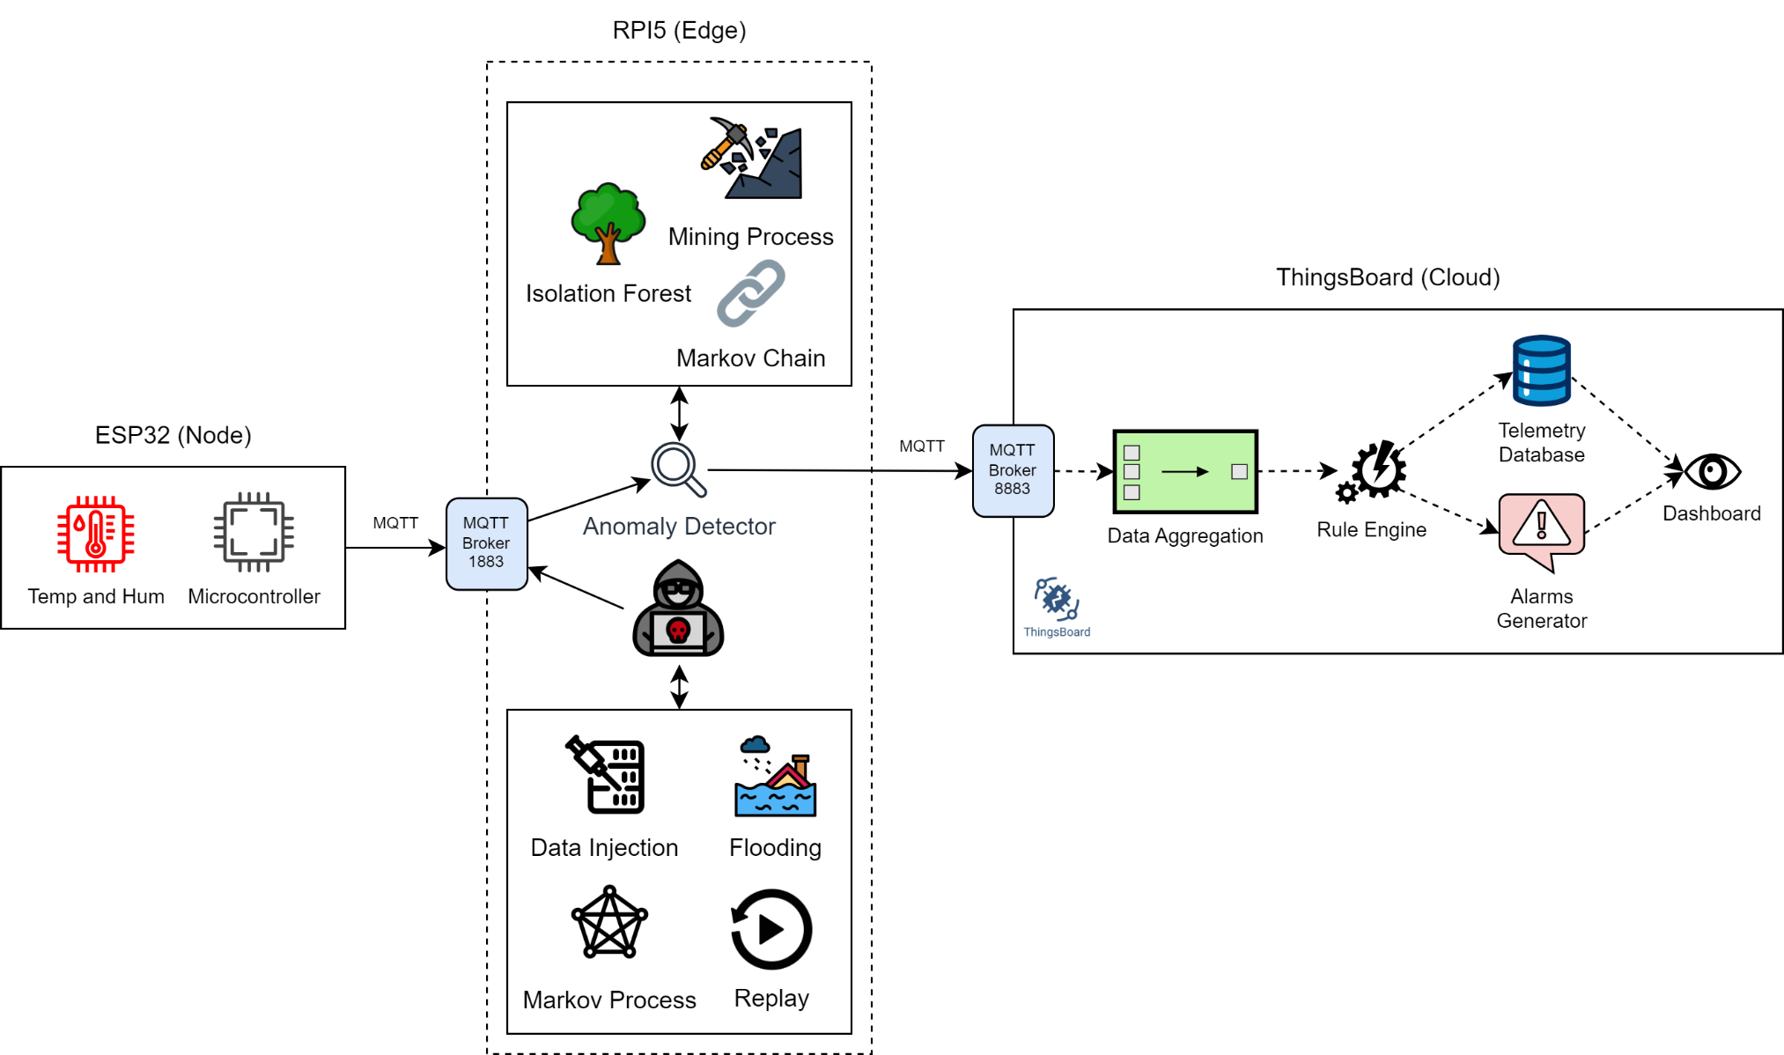
Figure 1: System Proposal

