Academic Performance of Engineering Students:
A Case Study of Educational and Socioeconomic Differences

Yanjun Yang

MSSP 6070

September 29, 2026

Executive Summary
This case study examines differences in academic performance among 12,411 engineering students using academic, demographic, and socioeconomic information from the data_academic_performance dataset. The analysis focuses on parental education, socioeconomic stratum, gender, and SISBEN classification in relation to students’ global assessment scores. The results show substantial descriptive differences across socioeconomic strata and parental education levels. Average global scores ranged from 152.35 in Stratum 1 to 181.51 in Stratum 6, while differences of approximately 20 points were observed between selected lower and higher parental education categories. In comparison, the difference between female and male students was relatively small, at approximately 2.41 points. Academic performance also varied across SISBEN classifications, although limited documentation restricts further interpretation of these categories. Based on these findings, further assessment and targeted academic support should be considered for groups showing larger performance gaps, while additional multivariable analysis is recommended before implementing broader educational policies. Because the analysis is descriptive, the observed relationships should not be interpreted as causal effects.

Introduction
This case study examines the academic performance of 12,411 engineering students using the data_academic_performance dataset (Delahoz-Dominguez et al.). The dataset contains academic, demographic, and socioeconomic information about the students, including academic performance in the final year of high school and the final year of their professional engineering programs. It also includes characteristics such as gender, parental education, socioeconomic stratum, and SISBEN classification. The purpose of this analysis is to examine differences in academic outcomes across student groups, with particular attention to parental education, socioeconomic stratum, gender, and SISBEN classification. The findings are intended to identify patterns that may help inform educational decision-making and student support.

Current Situation Analysis
The dataset contains 12,411 engineering students, including 5,043 female students and 7,368 male students. The mean global assessment score (G_SC) is 162.71, with a standard deviation of 23.11 and a median of 163. Scores range from 37 to 247. Students are distributed across six identified strata, with the largest groups in Stratum 2 and Stratum 3. The dataset also includes variation in parental education and SISBEN classification, allowing academic performance to be compared across different demographic and socioeconomic groups.

Key Issues and Goals
The main issue in this case study is whether academic performance differs across demographic and socioeconomic groups. The analysis focuses on four questions: whether parental education is associated with student outcomes, how academic performance differs across socioeconomic strata, whether global assessment scores differ by gender, and whether performance varies across SISBEN classifications. The goal is to identify notable differences in academic performance and provide information that may help the Department of Education better understand where additional attention or student support may be needed.

Decision Criteria
The primary criterion used to compare student groups is the average global assessment score$\text{(}{\text{G}}_{\text{S}}\text{C}\text{)}$. Differences in mean scores are used to identify patterns in academic performance across parental education levels, socioeconomic strata, gender, and SISBEN classifications. Group size is also considered when interpreting the results because some categories contain substantially fewer students than others. Larger differences in average scores receive greater attention, while results from smaller or unclear categories are interpreted cautiously.

Assumptions
Several assumptions were made in preparing the data for comparison. Values coded as 0 were excluded from the final Stratum and SISBEN visualizations because their meaning was not defined in the available categorical documentation and these groups contained relatively few observations. For the ordered parental education visualizations, 0, Not sure, and Ninguno were excluded because the available documentation did not provide enough information to place these categories confidently within the education hierarchy. The analysis therefore focuses on categories that can be clearly interpreted and ordered. All comparisons are treated as descriptive associations rather than evidence of causal relationships. The dataset also includes a socioeconomic level variable (SEL) ranging from 1 to 4. Following the course clarification, Level 1 is assumed to represent a lower socioeconomic level and Level 4 a higher socioeconomic level because the original article does not provide a more detailed definition of this ranking.

Data Analysis
Parental Education and Academic Performance
Parental education shows a clear association with students’ global assessment scores. For fathers, students whose fathers had completed primary education had an average G_SC of 155.20, compared with 176.99 among students whose fathers had postgraduate education, a difference of approximately 21.79 points. A similar pattern appears for maternal education. Students whose mothers had completed primary education averaged 155.34, while those whose mothers had postgraduate education averaged 175.64, a difference of approximately 20.30 points.
Across the ordered education categories, average scores generally increased as parental education increased. The relationship was not perfectly linear for every adjacent category, particularly for paternal education, but the overall pattern was similar for both parents. These findings indicate that parental educational background is associated with meaningful differences in academic outcomes in this sample. However, the analysis does not establish that parental education itself causes the score differences, because other socioeconomic and educational factors may also contribute to the observed pattern.
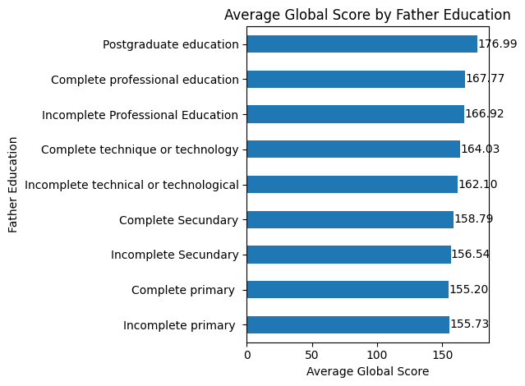
Fig. 1. Average Global Score by Father Education.
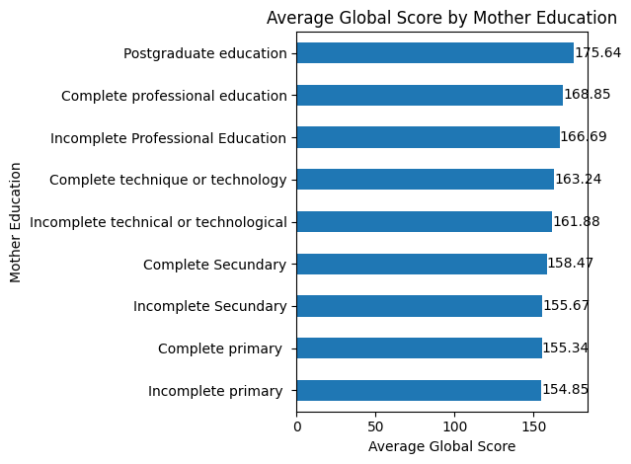
Fig. 2. Average Global Score by Mother Education.
Performance by Stratum
Academic performance differed substantially across socioeconomic strata. The average global assessment score increased from 152.35 in Stratum 1 to 158.20 in Stratum 2, 163.82 in Stratum 3, 172.00 in Stratum 4, 177.39 in Stratum 5, and 181.51 in Stratum 6. Among the six identified strata, Stratum 6 had the highest average score and Stratum 1 had the lowest, resulting in a difference of approximately 29.16 points.
The pattern was consistent across the six identified strata, with higher-numbered strata corresponding to higher average global scores in this dataset. However, the group sizes were unequal. Strata 2 and 3 contained most of the students, while Strata 5 and 6 were substantially smaller. Therefore, the differences in average scores should be interpreted together with differences in group size.
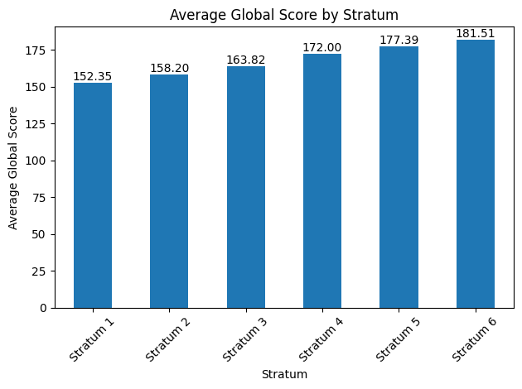
Fig. 3. Average Global Score by Stratum.

Gender and Global Assessment
The gender comparison showed a much smaller difference than the differences observed across parental education levels and socioeconomic strata. Female students had an average global assessment score of 161.28, while male students had an average score of 163.69, resulting in a difference of approximately 2.41 points. The median scores were also similar, at 162 for female students and 164 for male students. Although male students had a slightly higher average score in this dataset, the descriptive gender difference was relatively small compared with the differences observed across socioeconomic strata and parental education categories.
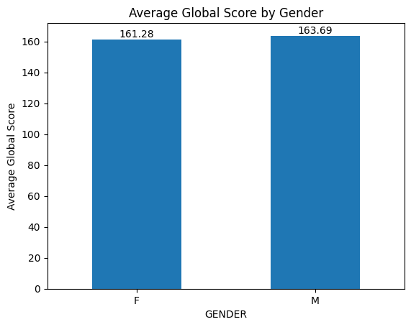
Fig. 4. Average Global Score by Gender.
SISBEN Classification and Academic Performance
Academic performance also varied across SISBEN classifications. Students in Level 1 had an average global assessment score of 152.68, compared with 155.89 in Level 2 and 160.99 in Level 3. Students who were not classified by SISBEN had an average score of 167.47, while students classified in another SISBEN level averaged 166.05.
These results show differences in academic performance across SISBEN categories. However, the available categorical documentation does not provide sufficient information about the substantive meaning of each SISBEN level. Therefore, the results are presented as descriptive differences without assigning additional socioeconomic interpretations to the categories.
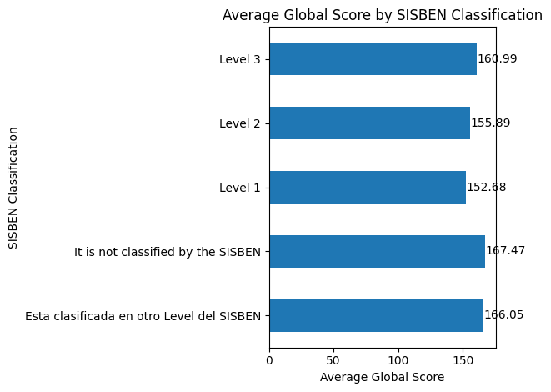
Fig. 5. Average Global Score by SISBEN Classification.

Limitations
This analysis has several limitations. First, it is descriptive and does not control for potential confounding variables, so the observed differences across groups should not be interpreted as causal effects. Second, group sizes are unequal, particularly across socioeconomic strata and some parental education categories. Third, several categorical variables contain values that are unclear or insufficiently documented, including 0, Not sure, and Ninguno. In addition, the original article provides limited explanation of the socioeconomic variables. For example, SEL is reported on a scale from 1 to 4, but the article does not provide a detailed definition of the individual levels. Finally, the dataset consists of engineering students, so the findings may not generalize to students in other academic fields or to the broader student population.

Preferred Alternative with Rationale
Based on the descriptive findings, the preferred approach is to prioritize further assessment and targeted academic support for students in lower socioeconomic strata and those from lower parental-education backgrounds. These groups showed larger differences in average global assessment scores than those observed by gender. For example, the average score differed by approximately 29.16 points between Stratum 1 and Stratum 6, while the difference between female and male students was approximately 2.41 points. Differences associated with parental education were also substantial, with gaps of approximately 21.79 points for paternal education and 20.30 points for maternal education when comparing complete primary education with postgraduate education. Therefore, socioeconomic stratum and parental education may provide useful areas for further investigation when considering where additional educational support is needed.

Recommendations and Predicted Outcomes
Based on the findings, the Department of Education should consider evaluating additional academic support for students in lower socioeconomic strata and those from lower parental-education backgrounds. Possible forms of support could include tutoring, academic advising, mentoring, and other educational resources. These efforts should be designed to support students based on demonstrated academic needs rather than assuming that all students within a demographic group require the same assistance.
Before implementing large-scale policies, further analysis is recommended. Multivariable statistical models could be used to examine whether the observed differences remain after accounting for related characteristics such as parental education, socioeconomic stratum, SISBEN classification, school background, and other available variables. Future data collection and analysis should also improve the documentation and consistency of categorical variables, particularly unclear values such as 0. If targeted support is evaluated and implemented effectively, the expected outcome would be improved academic support for groups showing larger performance gaps and better evidence for future educational decision-making.

Conclusion
This case study identified meaningful differences in global academic performance across several student characteristics. The largest descriptive differences were associated with socioeconomic stratum and parental education. Students in higher strata and those with more highly educated parents generally had higher average global assessment scores, while the difference between female and male students was comparatively small. Academic performance also varied across SISBEN classifications, although the available documentation limits further interpretation of these categories. Overall, the findings suggest that socioeconomic and family educational backgrounds are important factors to consider when examining differences in student outcomes. However, because the analysis is descriptive, these patterns should not be interpreted as evidence of causation. Further analysis is needed to better understand the factors associated with these performance differences and to evaluate appropriate forms of educational support.

References
Delahoz-Dominguez, Enrique, Rohemi Zuluaga, and Tomas Fontalvo-Herrera. “Dataset of Academic Performance Evolution for Engineering Students.” Data in Brief, vol. 30, 2020, article 105537. https://doi.org/10.1016/j.dib.2020.105537

