Case Study Report 2

Adventure Works Internet Sales Analysis and Growth Strategy

Yanjun Yang

October 27, 2026

Executive Summary
This report evaluates Adventure Works Bicycle Company’s Internet sales to inform a practical growth strategy. The dataset contains 60,398 sales-line records across six country regions from December 2010 through January 2014. Annual comparisons emphasize the three complete years, 2011–2013. The United States ($9.36 million) and Australia ($9.03 million) were the largest markets during those years. Across the full dataset, Bikes generated $28.32 million, representing 96.46% of recorded Internet sales, with an average unit price of $1,862.42. Homeowners spent an average of $1,630.57 per customer, compared with $1,500.05 among non-homeowners; this descriptive difference does not establish causation.
Leadership should protect the core bicycle business in the United States and Australia while piloting complementary accessory offers, initially in Australia. The pilot should be evaluated using accessory attachment rates, average order value, and gross profit per order before expansion. No numerical sales uplift is projected because the descriptive evidence is insufficient for a defensible forecast.

Introduction
Adventure Works Bicycle Company seeks to understand its Internet business and identify opportunities for growth. Using a course-provided extract of the fictional Adventure Works sales data, this report examines sales by year and country region, customer yearly income and gender, product category performance, and the relationship between homeownership and customer spending. Analysis was conducted in Python using pandas and visualizations. Summary findings appear in the body; supporting tables and charts are presented in the appendices ("Internet Sales Dataset").

Body

Key Issues / Goals / Problems
The central management question is how to direct limited marketing and merchandising resources toward promising Internet sales opportunities. The analysis therefore seeks to identify the strongest existing markets, the product category generating the most revenue, relevant customer differences, and possible opportunities to increase sales per customer.

Decision Criteria
Alternatives are assessed against three criteria: (1) historical revenue contribution, (2) plausible incremental sales opportunities supported by observed patterns, and (3) feasibility of running a limited, measurable pilot. Revenue is not treated as equivalent to profit; an initiative should be scaled only after its effect on gross profit and customer experience is assessed.

Assumptions
SalesAmount is treated as recorded Internet sales revenue, without adding TaxAmt or Freight. Because the dataset includes only December 29–31, 2010 and January 1–28, 2014, full-year comparisons focus on 2011–2013. Customer-level demographic statistics use one observation per CustomerKey, and spending comparisons aggregate all sales lines per customer. Product categories (Bikes, Accessories, Clothing) were inferred from product names because the extract does not include a category variable; this classification should be validated against an official product lookup before operational use. All figures describe this fictional dataset, not real company outcomes. Observational differences do not prove causality.

Data Analysis

Internet Sales by Year and Country Region
Across 2011–2013, the United States generated $9,357,412.76 in Internet sales, followed by Australia with $9,031,583.08. The United Kingdom ranked third ($3,387,299.47), followed by Germany ($2,891,034.51), France ($2,637,422.66), and Canada ($1,964,808.97). All six markets recorded higher sales in 2013 than the last year. In 2013 alone, the United States generated $5,462,078.86 and Australia $4,339,443.38. These figures establish the two countries as the leading revenue markets, but they do not by themselves indicate comparative profit margins (see Appendix A, Table A1 and Figure A1).

Yearly Income and Gender by Country Region
After deduplicating customer records, the analysis included 18,484 unique customers. Australia had the highest mean yearly income ($64,338.62), narrowly exceeding the United States ($63,616.83); France had the lowest ($35,762.43). The United Kingdom exhibited the highest standard deviation ($48,431.99), with mean income of $52,169.37 versus median income of $30,000, indicating a substantial difference between these two measures. Across countries, women represented approximately 48.82%–49.73% of customers and men 50.27%–51.18%. Thus, gender composition was relatively balanced, whereas income levels and dispersion varied materially. These statistics describe Adventure Works customers, not national populations (Appendix B, Tables B1–B2).

Product Category Sales and Average Price
Across the full observation period, Bikes produced $28,318,144.65, or 96.46% of total recorded Internet sales ($29,358,677.22). Accessories generated $700,759.96 (2.39%), and Clothing generated $339,772.61 (1.16%). The mean recorded UnitPrice for Bikes was $1,862.42; the calculated sales revenue per unit was also $1,862.42. Although Accessories had more sales lines, Bikes dominated sales value (Appendix C, Table C1 and Figure C1). The dominance of bicycle revenue supports a bicycle-led growth strategy but does not establish relative category profitability.

Homeownership and Sales
The dataset includes 12,502 homeowner customers and 5,982 non-homeowner customers. Homeowners generated $20,385,349.80 in cumulative sales, versus $8,973,327.42 for non-homeowners. Because the groups differ in size, average cumulative spending per customer is more informative: $1,630.57 for homeowners compared with $1,500.05 for non-homeowners, an 8.7% difference. The corresponding medians were $342.00 and $209.96. These results show an association, not an effect of owning a home; income, household composition, and other factors may account for some of the difference (Appendix D, Table D1 and Figure D1).

Preferred Alternative with Rationale
The preferred alternative is a bicycle-centered strategy in the United States and Australia, paired with a limited accessory cross-selling pilot in Australia. These countries contributed the most revenue during the three complete years and each generated more than $8.8 million in bicycle sales. However, Australia generated $133,337.20 in accessory sales versus $245,035.82 in the United States, despite comparable bicycle revenue (Appendix E, Table E1). This gap suggests a testable opportunity, not proof of unmet demand: customer mix, assortment, and purchasing patterns could explain the difference.

Justification / Predicted Outcome or Recommendations
Adventure Works should test relevant accessory suggestions—such as helmets, bottles, or maintenance supplies—alongside bicycle product pages and at checkout in the Australian market. A randomized or otherwise carefully matched pilot could compare the offer against existing merchandising. Management should monitor accessory attachment rate (orders containing an accessory divided by bicycle orders), average order value, incremental gross profit per order, and return or cancellation rates. Any discounting should be evaluated against margin rather than revenue alone.
A successful pilot would demonstrate measurable incremental profit without unacceptable customer or operational costs. If results are favorable, the company could expand to the United States and then consider other regions. No specific percentage increase in sales is asserted: the available data are descriptive and cannot support a reliable causal or predictive estimate of the intervention’s impact.

Conclusion
Adventure Works’ Internet revenue is heavily concentrated in bicycles, with the United States and Australia leading regional sales. Customer income varies by country, gender representation is relatively balanced, and homeowners exhibit modestly higher cumulative spending per customer. These findings support a focused, test-and-learn approach: reinforce the bicycle business in established markets and evaluate accessory cross-selling before committing to wider rollout. The proposed strategy aligns investment with observed sales patterns while recognizing the limits of the fictional, observational dataset.

References
“Internet Sales Dataset.” MSSP 6070 course-provided CSV dataset, University of Pennsylvania, n.d.
Microsoft. “AdventureWorks Sample Databases.” Microsoft Learn, learn.microsoft.com/en-us/sql/samples/adventureworks-install-configure. Accessed 27 Oct. 2026.

Appendices

Appendix A. Internet Sales by Country Region
Table A1. Annual Internet Sales by Country Region (USD), 2010–2014
Country | 2010 | 2011 | 2012 | 2013 | 2014
Australia | 20,910 | 2,563,732 | 2,128,407 | 4,339,443 | 8,508
Canada | 3,578 | 571,572 | 307,605 | 1,085,633 | 9,458
France | 3,400 | 410,845 | 648,066 | 1,578,512 | 3,195
Germany | 0 | 520,500 | 608,658 | 1,761,876 | 3,278
United Kingdom | 699 | 550,591 | 712,701 | 2,124,007 | 3,714
United States | 14,834 | 2,458,285 | 1,437,049 | 5,462,079 | 17,543

Note. Dollar amounts are rounded to the nearest whole dollar for display; 2010 and 2014 are partial years.
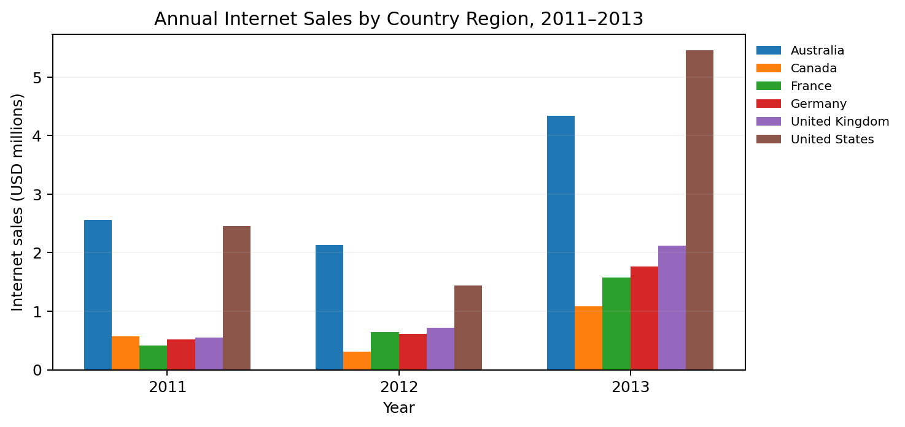
Figure A1. Annual Internet Sales by Country Region, 2011–2013.

Appendix B. Customer Demographics
Table B1. Yearly Income Summary Statistics by Country Region (USD)
Country | N | Min | Max | Mean | Median | SD
Australia | 3,591 | 10,000 | 170,000 | 64,339 | 70,000 | 31,830
Canada | 1,571 | 10,000 | 170,000 | 57,167 | 60,000 | 20,252
France | 1,810 | 10,000 | 110,000 | 35,762 | 30,000 | 27,277
Germany | 1,780 | 10,000 | 130,000 | 42,944 | 30,000 | 35,494
United Kingdom | 1,913 | 10,000 | 170,000 | 52,169 | 30,000 | 48,432
United States | 7,819 | 10,000 | 170,000 | 63,617 | 60,000 | 25,706

Note. One record per unique CustomerKey. Income statistics are rounded to whole dollars for display.
Table B2. Customer Gender by Country Region
Country | Female N | Male N | Female % | Male %
Australia | 1777 | 1814 | 49.48 | 50.52
Canada | 767 | 804 | 48.82 | 51.18
France | 893 | 917 | 49.34 | 50.66
Germany | 874 | 906 | 49.10 | 50.90
United Kingdom | 934 | 979 | 48.82 | 51.18
United States | 3888 | 3931 | 49.73 | 50.27

Appendix C. Product Category Sales
Table C1. Total Internet Sales by Product Category, Full Dataset
Product category | Sales lines | Sales (USD) | Sales share
Bikes | 15,205 | $28,318,144.65 | 96.46%
Accessories | 36,092 | $700,759.96 | 2.39%
Clothing | 9,101 | $339,772.61 | 1.16%

Note. Categories were inferred from product names and should be checked against the source product taxonomy. Shares are rounded.
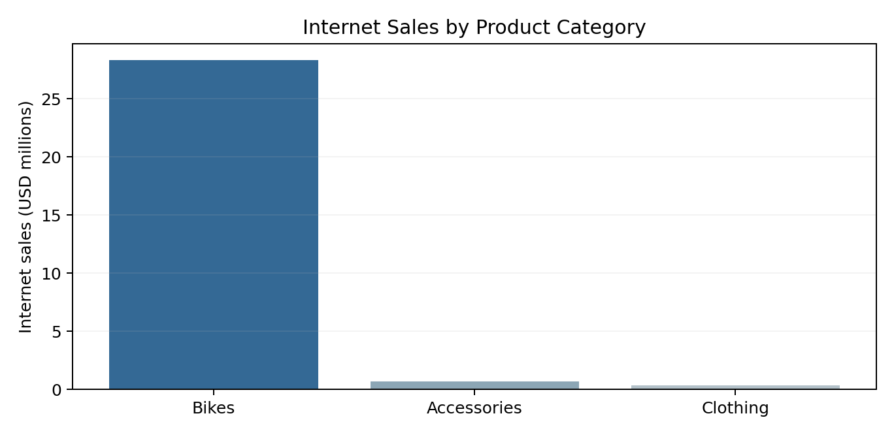
Figure C1. Total Internet Sales by Product Category.

Appendix D. Homeownership and Sales
Table D1. Cumulative Spending per Customer by Homeownership Status
Group | Customers | Total sales | Mean | Median | SD
Non-homeowners | 5,982 | $8,973,327 | $1,500 | $210 | $2,047
Homeowners | 12,502 | $20,385,350 | $1,631 | $342 | $2,159

Note. Amounts rounded to whole dollars for display; the body reports exact values to two decimal places.
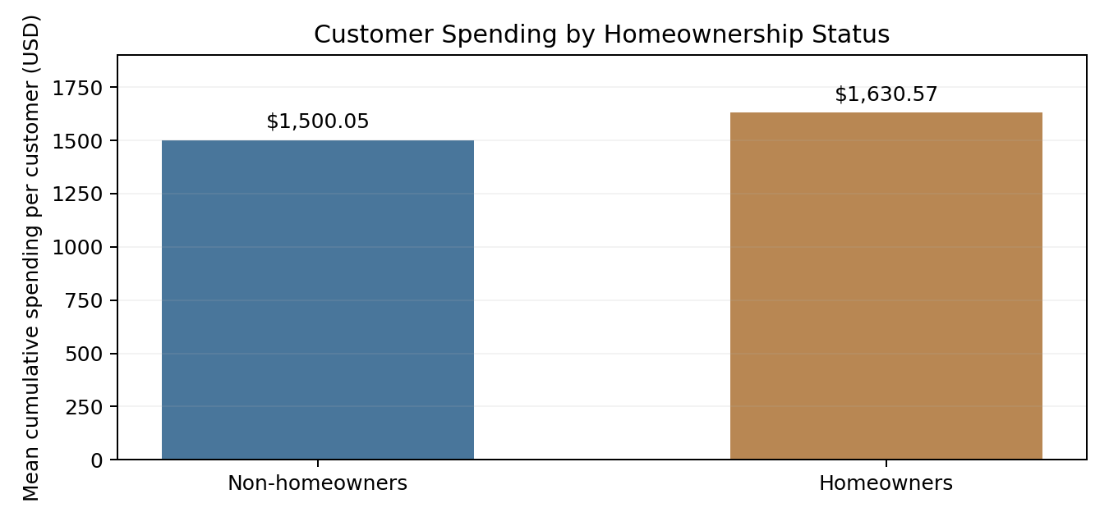
Figure D1. Mean Cumulative Spending per Customer by Homeownership Status.

Appendix E. Product Category Sales by Country
Table E1. Product Category Sales by Country Region, 2011–2013 (USD)
Country | Accessories | Bikes | Clothing
Australia | $133,337 | $8,831,140 | $67,106
Canada | $96,979 | $1,817,724 | $50,106
France | $61,042 | $2,550,176 | $26,205
Germany | $59,749 | $2,808,514 | $22,772
United Kingdom | $74,246 | $3,282,144 | $30,910
United States | $245,036 | $8,985,026 | $127,351

Note. Figures are rounded to the nearest whole dollar for display. Only complete years 2011–2013 are included.

