|  |  |
| --- | --- |
| 6. | SELECT model.make, model.model, vehicle.registration, count(trip_id) AS trips  FROM model INNER JOIN (vehicle JOIN trip ON vehicle.vehicle_id = trip.vehicle_id) ON model.model = vehicle.model  GROUP BY model.make, model.model, vehicle.registration  order by Count(trip_id)  limit 5; |

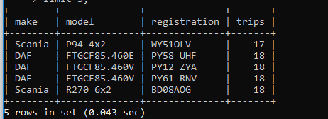

|  |  |
| --- | --- |
| 1. | SELECT COUNT(*) AS Items FROM manifest WHERE trip_id=73440; |

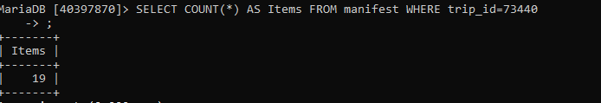

|  |  |
| --- | --- |
| 2 | SELECT trip_id FROM manifest GROUP BY trip_id HAVING COUNT(*)=1; |



    
    
    