* Python中List的四种查找方法：in , not in, count, index

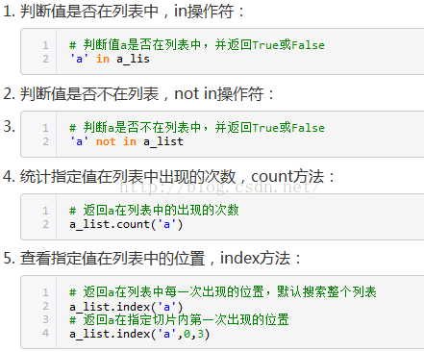

Python lambda表达式：-> map\reduce\sorted\filter

<https://blog.csdn.net/PY0312/article/details/88956795?utm_medium=distribute.pc_relevant.none-task-blog-BlogCommendFromMachineLearnPai2-1.nonecase&depth_1-utm_source=distribute.pc_relevant.none-task-blog-BlogCommendFromMachineLearnPai2-1.nonecase>