**Low-Fidelity Design**

Further Analysis

* Happy 60%
* Sad 20%
* Afraid 10%
* Angry 10%

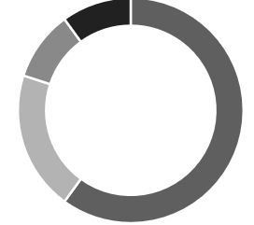

720pxx

MOOD ANALYSIS

1280px

px

Mood Analysis