HealthConnect Clinic — Week 5 Initial Analytics Report
Data Analytics Track | AnalystLab Africa Experience Lab
Project: Improving Patient Appointment Attendance and Healthcare Support Using Data and AI
Central Project Question: How can HealthConnect Clinic use data and AI to reduce missed appointments and improve the patient support experience?
Resources Used: HealthConnect_Appointment_Data.csv, HealthConnect_Data_Dictionary.xlsx, HealthConnect Clinic Knowledge Base

0. Week 4 → Week 5 Transition
- Problem defined: understand the appointment dataset and identify how it can be used to investigate appointment attendance and no-show patterns.
- Week 4 proposed approach: segment deep-dive on five candidate KPIs, statistical grounding via chi-square testing, cross-tabulation of combined effects, a slot-utilisation angle, and hand-off to Data Science.
- Key Week 4 assumptions/limitations carried forward: synthetic dataset; the Sunday-appointment flag (737 records) unresolved; distance/waiting-time missingness (<2% each) left unimputed; all relationships correlational, not causal.
- Week 5 delivers on the full Week 4 plan: this report executes every proposed step.

1. Data Preparation
The dataset was re-inspected for completeness, duplication and logical consistency ahead of deeper analysis. The original CSV was not modified; four derived columns (lead time band, prior no-show band, distance band, risk tier) were added and saved separately to HealthConnect_Appointment_Data_processed.csv.
Field / Check | Result
Duplicate rows / appointment IDs | 0 found
Logical consistency checks (negative values, date order, no-show count logic, age) | 0 violations
reminder_channel missing | 1,366 (27.3%) — structural, aligns exactly with reminder_sent = No
distance_to_clinic_km missing | 90 (1.8%) — minor, excluded row-wise where used
waiting_time_minutes missing | 60 (1.2%) — minor, excluded row-wise where used
Sunday appointment records | 737 (14.7%) — conflicts with Knowledge Base Sunday closure; unresolved, unchanged from Week 4

2. Exploratory Data Analysis

2.1 Appointment & patient characteristics
Appointment type, day of week, time of day, gender and age group all show no-show rates within a few points of the ~48% baseline — none stand out as a strong standalone driver.

2.2 Previous appointment history
A strong, statistically significant relationship (χ²=82.0, p<0.001): no-show rate rises from 43.5% (no prior no-shows) to 68.8% (3+ prior no-shows).

2.3 Reminders
The overall reminder effect is small but statistically significant (χ²=10.2, p≈0.006). Critically, the effect is far from uniform: among higher-risk patients (2+ prior no-shows), a reminder drops the no-show rate by ~10 points (68.2%→58.2%), versus only ~3 points for lower-risk patients (49.3%→46.1%).

2.4 Waiting time
Average waiting time is nearly identical across Attended, No-Show and Cancelled groups (~23-24 minutes) — no meaningful relationship with outcome was found.

2.5 Distance to clinic
Statistically significant (χ²=21.2, p≈0.0017). No-show rate is flat under 20km (~46-47%) but rises to 57.8% at 20km or more.

2.6 Cancellations vs. no-shows — slot utilisation
Over half of all scheduled slots (53.7%) are never used as originally booked. Cancellations (5.3%) are far smaller than no-shows (48.5%), but at least give advance notice for potential rebooking, unlike no-shows.

2.7 Compounding effect: lead time × prior no-show history
The two strongest drivers compound sharply: patients with 3+ prior no-shows booked 15-60 days out reach an 80-81% no-show rate — the highest-risk segment identified — while clean-history patients booked within a week sit at just 22%.

3. KPI Development
All five KPIs proposed in Week 4 were calculated and are summarised below; full definitions, business questions and interpretations follow.
# | KPI | Result
1 | Overall No-Show Rate | 48.46%
2 | No-Show Rate by Booking Lead Time | 27.8% (0-7d) → 60.5% (31-60d); χ2=339.0, p<0.001
3 | No-Show Rate by Prior No-Show Count | 43.5% (0 prior) → 68.8% (3+ prior); χ2=82.0, p<0.001
4 | Reminder Effectiveness Rate | 47.4% (reminded) vs 51.4% (not); χ2=10.2, p≈0.006. Higher-risk patients: -10pts; lower-risk: -3pts
5 | No-Show Rate by Distance Band | ~46-47% (<20km) → 57.8% (20km+); χ2=21.2, p≈0.0017

KPI 1 — Overall No-Show Rate
Business question: What is the overall scale of the no-show problem?
Why it matters: It is the single top-line measure of the scale of the problem HealthConnect is trying to solve.
Interpretation: Essentially one in two scheduled appointments is missed outright — large enough to justify dedicated intervention.

KPI 2 — No-Show Rate by Booking Lead Time Band
Business question: Does the amount of lead time between booking and the appointment affect the likelihood of a no-show?
Why it matters: It identifies whether how far in advance a patient books is itself a risk factor, independent of who the patient is.
Interpretation: The strongest single driver found. Appointments booked more than a month out are more than twice as likely to be missed as those booked within a week.

KPI 3 — No-Show Rate by Prior No-Show Count
Business question: Can a patient's appointment history be used to flag higher-risk future appointments?
Why it matters: Past behaviour is often the best available predictor of future behaviour, and this field is already captured.
Interpretation: A simple, explainable risk rule (2+ prior no-shows = higher risk) could be applied immediately, without a predictive model.

KPI 4 — Reminder Effectiveness Rate
Business question: Are reminders — and the channel used — associated with a measurable reduction in no-shows?
Why it matters: Reminders are a low-cost, easily-scaled intervention — if they work, they're one of the cheapest levers available.
Interpretation: Blanket reminders have a real but limited effect; reminders are far more valuable for higher-risk patients specifically — reframing the question from ‘do reminders work’ to ‘who should get more reminder effort.’

KPI 5 — No-Show Rate by Distance Band
Business question: Does distance to the clinic influence attendance, and could this inform outreach or scheduling decisions?
Why it matters: If distance is a real barrier, it points to structural fixes (telehealth, transport support) rather than behavioural ones (reminders).
Interpretation: Distance is a threshold effect, not a broad gradient — patients beyond ~20km face a meaningfully higher barrier.

4. Dashboard
The dashboard below brings together all five KPIs plus the compounding lead-time × prior-no-show effect.
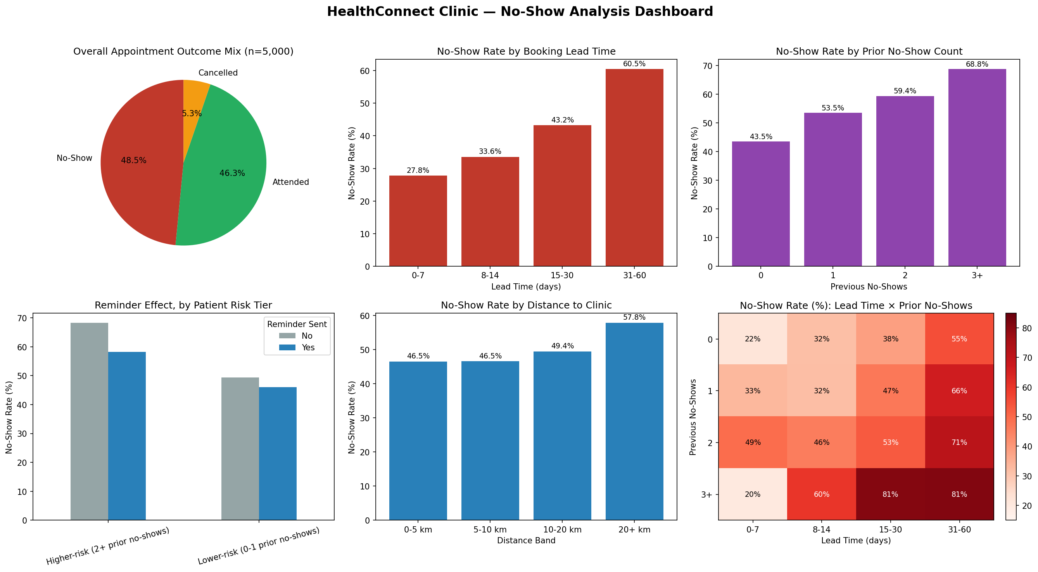

5. Business Insights
- The problem is large and material: 48.5% of appointments end in a no-show, and combined with cancellations, 53.7% of scheduled slots are never used as booked.
- Booking lead time is the single strongest, most statistically significant driver found (χ2=339.0, p<0.001): no-show rate more than doubles from 27.8% (booked within a week) to 60.5% (booked 31-60 days out).
- Patient history is a ready-made, low-cost risk signal: 3+ prior no-shows correspond to a 68.8% no-show rate vs. 43.5% for a clean record (p<0.001) — a simple rule-based flag could be deployed without any model.
- Reminders work, but disproportionately for higher-risk patients: the overall effect is modest (~4-point drop, p≈0.006), but higher-risk patients see a ~10-point drop versus ~3 points for lower-risk patients.
- Distance is a threshold effect, not a broad gradient: no-show rate is flat under 20km (~46-47%) but jumps to 57.8% at 20km+ (p≈0.0017).
- Risk factors compound sharply: patients with 3+ prior no-shows and a 15+ day lead time reach an 80-81% no-show rate — the single highest-priority segment for intervention.
- Several intuitive factors turned out not to matter much: appointment type, day of week, time of day, gender, age group and waiting time all sit within a few points of the ~48% baseline.

6. Business Recommendations
- Introduce a re-confirmation step roughly 2-3 weeks before appointments booked more than 15 days in advance, where no-show risk climbs fastest.
- Build a simple, explainable risk flag on booking history alone (2+ prior no-shows = higher-risk) to prioritise limited reminder/outreach capacity ahead of any predictive model.
- Shift reminder strategy from blanket coverage toward targeted investment in higher-risk patients, where the evidence shows the largest effect.
- Pilot a telehealth or transport-support option for patients 20km+ from the clinic, since standard reminders are unlikely to fix a genuine access barrier.
- Treat the compounding “long lead time + poor history” segment (80-81% no-show rate) as the priority group for any future intervention or model-based targeting.

7. Limitations
- All findings are correlational, from a single synthetic dataset snapshot — no causal claims are made; true experimentation would be needed to confirm intervention effectiveness.
- The Sunday-appointment inconsistency (737 records) remains unresolved and has not been corrected in this analysis.
- Distance and waiting-time missingness (under 2% each) was excluded row-wise rather than imputed.
- Statistical significance confirms an association exists, not its real-world size — several significant effects (e.g. distance, reminders) are modest in absolute terms.
- The dataset is explicitly fictional and synthetic; magnitudes should not be read as HealthConnect's literal real-world performance.

8. Cross-Track Collaboration
Track interacted with: Data Science
Information/output exchanged: The five KPI definitions, the statistically significant risk segments (lead time, prior no-show count, and their compounding effect), and the finding that reminder effectiveness varies by patient risk tier.
Why relevant: The Data Science track's Week 5 task is to prepare features and a baseline no-show prediction model; these segments directly inform which variables are worth prioritising as features.
What changed as a result: Rather than testing all variables blind, the Data Science track can prioritise lead time, prior no-show count, distance and reminder status as candidate features, and treat the lead-time × prior-no-show interaction as a feature worth engineering explicitly.

9. Assumptions, Limitations, Risks & Dependencies — Week 5 Review
- Dataset is synthetic/fictional — still relevant, unchanged.
- Sunday appointment flag (737 records) — still unresolved, no clarification received; still treated as an artifact.
- Distance/waiting-time missingness (<2% each) — still relevant, handled the same way (row-wise exclusion).
- Correlation vs. causation caveat — still relevant, reinforced by this week's statistical testing.
- Reminders assumed broadly effective — changed: Week 5 shows the effect is real but small overall, and concentrated in higher-risk patients; this refines rather than confirms the Week 4 assumption.
- New issue discovered: waiting time shows no meaningful relationship with outcome — likely a lower priority variable going forward.
- Dependency on the Knowledge Base as source of truth — still relevant; the Sunday flag conflict remains a live dependency on stakeholder input.

