LOGISTICS FLEET ANALYTICS PROJECT
Profitability, Delivery Performance, and Risk Analysis of a 120-Truck Fleet
Prepared by: Ndibueze Esther Mmesoma
Capstone Project: Finance Analytics
Tool: Microsoft Power BI

Executive Summary
This project analyzes 14 linked operational datasets from a trucking and logistics company to answer three questions raised by operations leadership: where the company makes and loses money, why delivery performance is inconsistent, and where its cost and safety risk is concentrated. The data covers 85,410 loads, 150 drivers, 120 trucks, and 170 safety incidents from January 2022 to December 2024.
The company is profitable overall, with $298.62M in revenue and a 66% profit margin after fuel and maintenance. Underneath that margin, the analysis found three problems:
- Deliveries are late more often than not. Only 44.6% of deliveries arrive on time, and the rate has not moved in three years across any terminal, facility, or customer group.
- One load in seven loses money. 11,664 loads (15.2% of loads with fuel records) cost more in fuel than they earned, a combined loss of about $8.7M.
- Safety cost is concentrated in a small group of active drivers. 10 of 150 drivers account for 30% of all claim cost, and all 10 are still active.
Key figures: $298.62M revenue, 66% margin, $95.59M fuel cost, $5.73M maintenance cost, 72,231 downtime hours, 170 safety incidents, $2.65M in claims.

1. Introduction and Background
Operations leadership holds years of data on loads, trips, drivers, trucks, maintenance, fuel, and safety, but had no single view that answered basic performance questions. This project was built around three questions:
- Is the company profitable, and where is money made or lost?
- Why is on-time delivery inconsistent, and where does it break down?
- Where is the company exposed to risk, in its trucks and in its drivers?
The third question was split in two, asset risk (maintenance and downtime) and people risk (safety incidents), because they come from different data and are handled by different teams. This is why the project has four dashboards, plus a dedicated Insight and Recommendation page summarizing the findings for leadership.

2. Data Description
The analysis uses 14 tables in two groups.

Transactional tables
- loads (85,410 rows): one row per shipment, with revenue, fuel surcharge, accessorial charges, customer, and route.
- trips (85,410 rows): one row per trip, with driver, truck, trailer, distance, duration, and MPG.
- fuel_purchases (196,442 rows): fuel transactions linked to trips.
- delivery_events (170,820 rows): pickup and delivery events with on-time flags and detention minutes.
- maintenance_records (2,920 rows): service events per truck with cost, downtime, type, and facility location.
- safety_incidents (170 rows): incidents with claim amount, preventability, and fault.

Reference tables
customers, drivers, trucks, trailers, routes, facilities, truck_utilization_metrics, and driver_monthly_metrics.

Fleet size
The trucks table lists 120 trucks: 92 Active, 15 in Maintenance, and 13 Inactive. Only 92 trucks appear in trip records. The 28 non-active trucks still carry real cost: they account for 24.1% of all downtime hours and 24.5% of all maintenance cost while hauling nothing.

Data quality notes
- About 2% of trips have no truck or driver recorded. These are most likely brokered or third-party loads and are excluded from driver and truck metrics.
- About 10% of trips have no matching fuel purchase. Their fuel cost is zero, so their margin looks better than it is. Load-level loss figures in this report use only loads that have a fuel record.
- 107 of 200 customer names repeat across multiple customer accounts (for example, "XYZ Wholesale" covers 4 separate accounts). The customer chart on the Financial page is read at the name level, not the account level; see section 4.1.

3. Methodology
All four dashboards use a star schema in Power BI. Fact tables connect to reference tables on their keys (for example, loads to customers on customer_id, trips to drivers on driver_id). A shared date table connects to every dated fact table, so one date filter controls every visual.
The main measures are written in DAX:
Measure | Logic | Purpose
Total Revenue | Revenue + fuel surcharge + accessorial charges | Full billed amount per load
Expected Revenue | Route typical distance x base rate per mile | Benchmark if priced at standard rate
Rate Variance % | (Total Revenue - Expected Revenue) / Expected Revenue | Pricing above or below benchmark
Revenue per Mile | Total Revenue / Total Miles | Compares lanes fairly across distance
Gross Margin | Revenue - Fuel Cost - Maintenance Cost | Profit after the two main costs
Maintenance Cost per Mile | Maintenance Cost / Total Miles | Cost of keeping trucks running
On-Time Delivery Rate | Average of on-time flag, Delivery events only | Customer-facing service level
Preventable Incident Rate | Preventable incidents / Total incidents | Share of risk that is controllable
Incident Rate per 1000 Trips | Incidents / Trips x 1000 | Adjusts incidents for activity

Margin in this report is revenue minus fuel and maintenance only. Driver pay, insurance, and equipment costs are not in the data, so true profit is lower than the margin shown.

4. Findings

4.1 Financial Overview
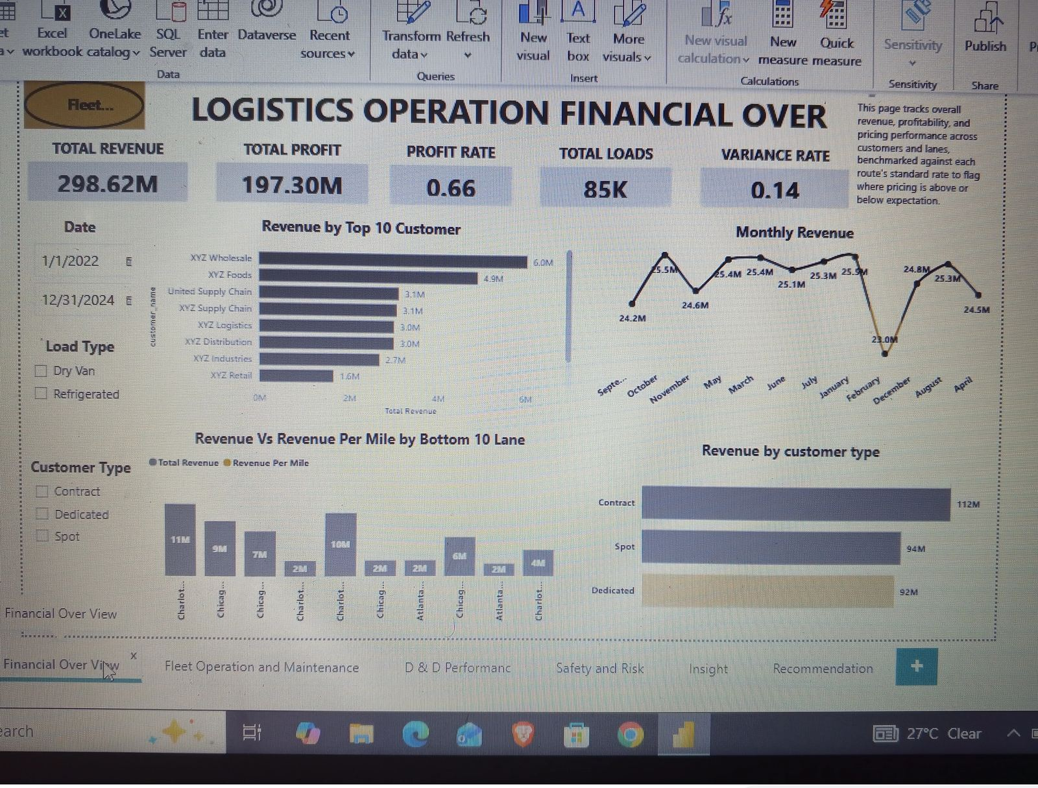
Figure 1. Financial Overview dashboard.
The fleet earned $298.62M in revenue and $197.30M in profit after fuel and maintenance, a 66% margin. Loads were billed 14% above the route benchmark on average, so pricing is above standard overall.
The "Revenue by Top 10 Customer" chart is built on customer name, and several company names are shared by multiple separate accounts (18 accounts use a name starting with "XYZ" alone). Read at the account level, the largest single customer is only 0.6% of revenue and the top 10 accounts together are 5.7%, so the company is not dependent on any one customer relationship. The chart is still useful for spotting which named accounts to review, but it should not be quoted as a concentration measure.
By customer type, revenue is close to even: Contract $112M, Spot $94M, Dedicated $92M. Revenue tied to customers with an Inactive account status is $48.5M (16% of revenue), worth a closer look since those accounts may be winding down.

Loss-making loads
Of 76,939 loads with a fuel record, 11,664 (15.2%) earned less than their fuel cost, a combined loss of about $8.7M. The rate is close to 15% for every load type and every customer type, so the problem is not tied to one segment; it looks like a pricing or acceptance issue applied load by load.

Lowest-earning lanes
The "Bottom 10 Lane" chart on this page is sorted by total revenue, so it highlights the largest low-priced lanes rather than the worst rate per mile. Measured by revenue per mile, the fleet averages $2.44, and the weakest lanes are:
Lane | Revenue per mile | Margin per mile | Loads
Charlotte, NC to Denver, CO | $1.70 | $1.01 | 1,500
Las Vegas, NV to New York, NY | $1.71 | $1.30 | 1,477
Miami, FL to Seattle, WA | $1.80 | $1.45 | 1,450
Atlanta, GA to Chicago, IL | $1.95 | $0.36 | 1,456
Phoenix, AZ to Denver, CO | $1.96 | $0.36 | 1,462
New York, NY to Columbus, OH | $2.00 | $0.01 | 1,501

Margin per mile here is revenue minus fuel only. New York to Columbus earns almost nothing per mile after fuel.

4.2 Fleet Operations and Maintenance
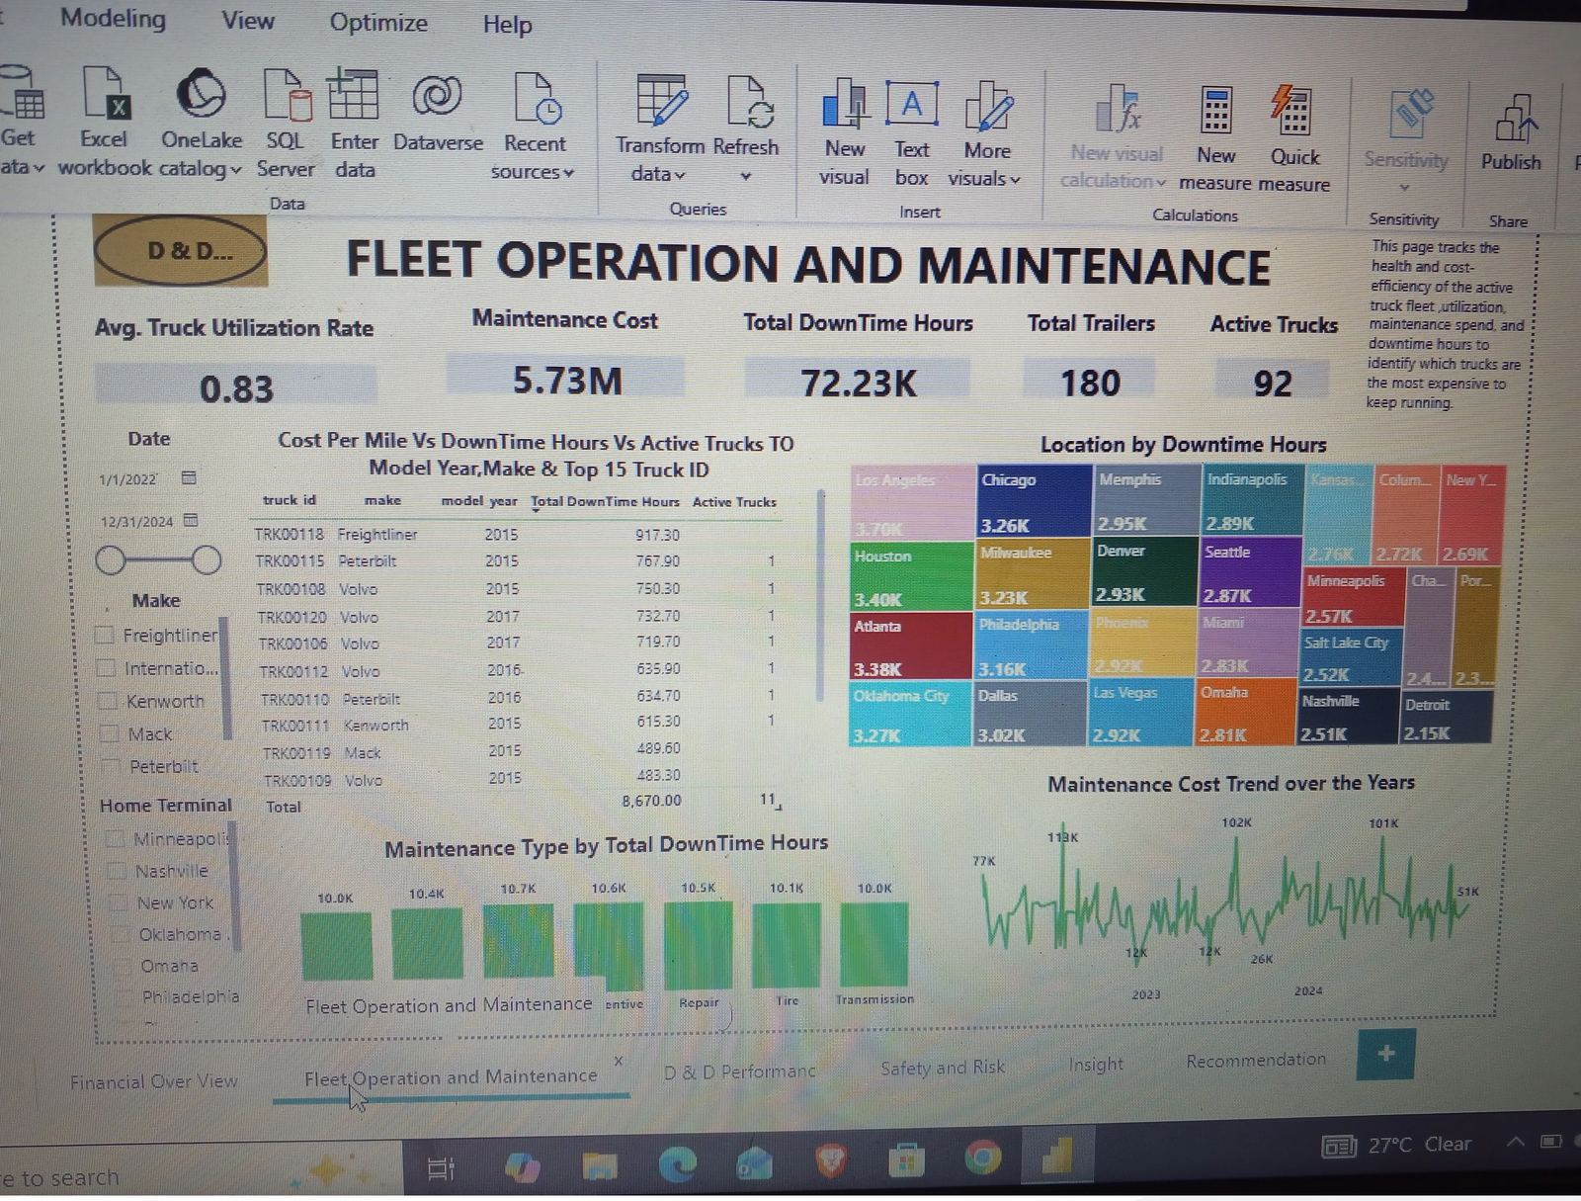
Figure 2. Fleet Operations and Maintenance dashboard.
Maintenance cost totals $5.73M and downtime totals 72,231 hours. Maintenance is a small cost compared with fuel ($95.59M): about $0.05 per mile fleet-wide.
The "Location by Downtime Hours" treemap now shows real totals per facility location (25 locations, from 2,154 to 3,697 hours), and the spread is modest: the top 5 locations hold 24% of all downtime, so no single facility is driving the cost. Maintenance type follows the same pattern, spread evenly across the seven categories at 10,000 to 10,700 hours each, with Repair and Preventive the two largest.
The truck-level table still lists TRK00118 at the top with 917 hours of downtime and a blank Active Trucks value, confirming it hauled no loads in the period. Because 28 of 120 trucks never appear in trip records yet still consume nearly a quarter of maintenance spend and downtime, the clearest opportunity here is a repair-or-retire decision on that group, not a search for one or two problem trucks.

4.3 Driver and Delivery Performance
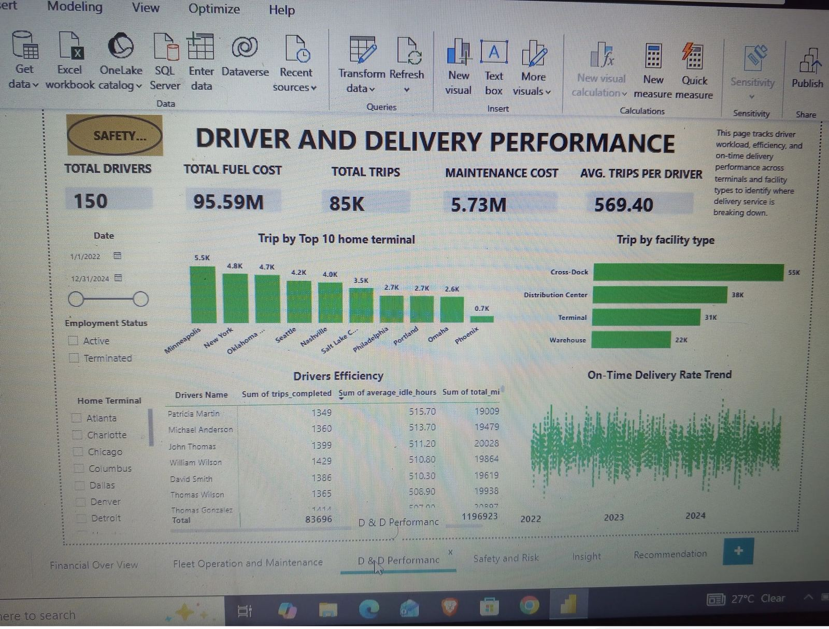
Figure 3. Driver and Delivery Performance dashboard.
Only 44.6% of deliveries arrive on time, and the trend is flat across all 36 months with no improvement. Pickups do better, at 66.7% on time, so the delay builds on the delivery side.
The rate is close to identical across every group tested: facility type (43.7% to 45.2%), customer type (44.2% to 44.9%), driver experience band (43.3% to 45.0%), and driver home terminal (43.2% to 46.9% across 25 terminals). Average detention is 107 minutes per delivery against 76 minutes per pickup, and it does not differ between on-time and late deliveries. Because no group performs meaningfully better or worse, the cause is systemic, most likely in how delivery windows are scheduled or how long trucks wait at the receiving dock, not in any one driver, terminal, or customer.
"Trip by Top 10 home terminal" now shows Dallas as the busiest terminal (6,066 trips), ahead of Minneapolis (5,498) and Las Vegas (5,370). Workload per driver is even: the 83,696 trips assigned to a driver average 558 per driver across all 150, or 675 per driver among the 124 currently active.

4.4 Safety and Risk
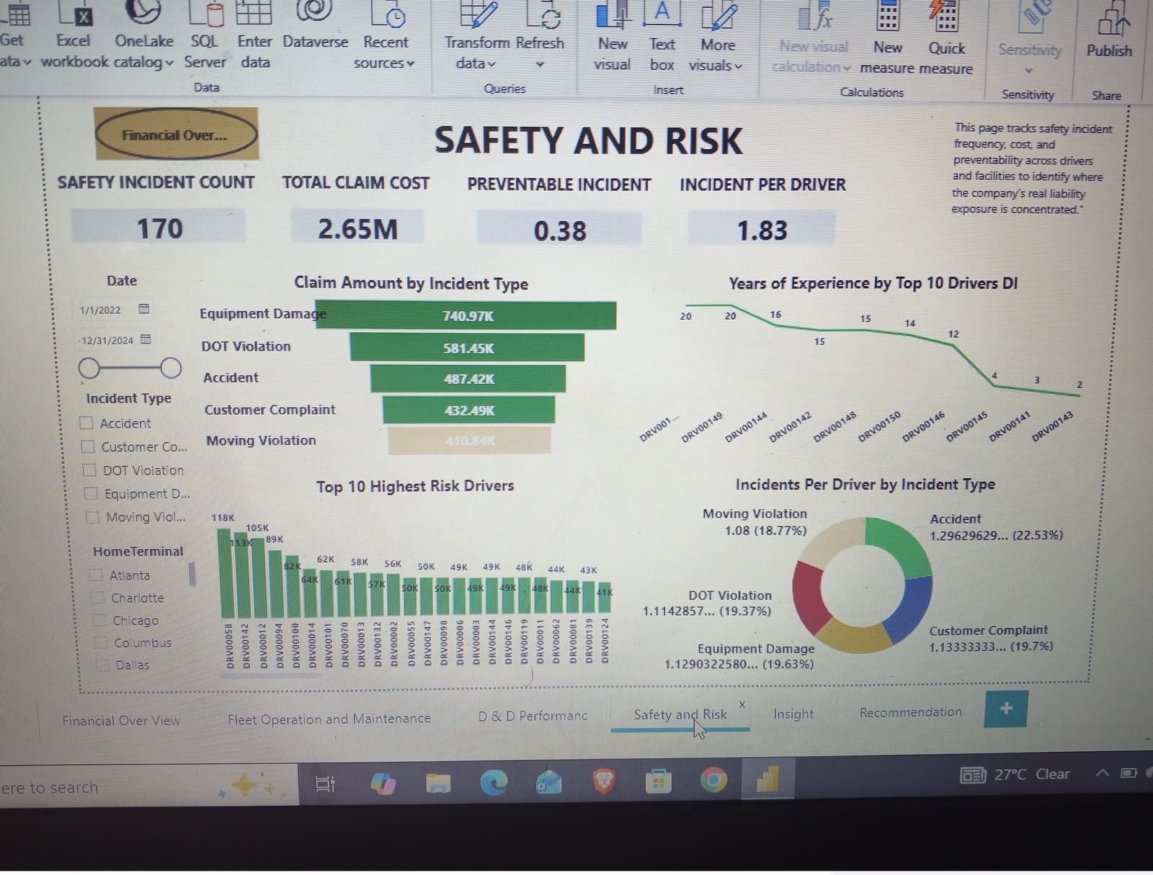
Figure 4. Safety and Risk dashboard.
There were 170 safety incidents with $2.65M in claims. 37.6% of incidents were classified as preventable, and 31.8% were the driver's fault.
Incident type | Count | Total claims | Average claim | Preventable share
Equipment Damage | 35 | $740,971 | $21,171 | 25.7%
DOT Violation | 39 | $581,447 | $14,909 | 46.2%
Accident | 35 | $487,418 | $13,926 | 40.0%
Customer Complaint | 34 | $432,492 | $12,720 | 38.2%
Moving Violation | 27 | $410,844 | $15,216 | 37.0%

Equipment Damage has the highest average claim. DOT Violations are the most preventable at 46%.
The "Top 10 Highest Risk Drivers" chart, now ranked by claim dollars, shows the concentration clearly: the top 10 drivers account for $808,905 in claims, 30% of the $2.65M total, from just 29 incidents. All 10 are currently active employees, so this is not a group that has already left the company; it is a live, addressable risk. The "Years of Experience by Top 10 Drivers" chart plots experience only for this same top-10-by-claims group, so its downward slope describes those 10 drivers, not a fleet-wide relationship between experience and safety. Across all 150 drivers, incident rate does not fall with experience (rates of 1.5 to 2.2 per 1,000 trips across experience bands, with no consistent trend), so the fleet-wide conclusion is that risk is concentrated in specific individuals rather than explained by tenure.

5. Key Insights
- Late delivery is a company-wide problem. At 44.6% on time, with almost no difference between any terminal, customer, or driver group, the cause sits in how deliveries are scheduled or received, not in one location or team.
- The margin figure hides real losses. A 66% margin coexists with $8.7M lost on 11,664 loads. Loss-making loads are equally common in every load type and customer type, which points to pricing or acceptance rules at the load level.
- Some lanes are underpriced. The lowest lanes earn $1.70 to $2.00 per mile against a fleet average of $2.44, several with almost no margin left after fuel.
- Idle trucks are a real cost, spread across the fleet. 28 of 120 trucks hauled nothing, yet still account for about a quarter of maintenance cost and downtime hours.
- Safety risk is concentrated in 10 active drivers. They account for 30% of claim cost from 29 incidents, and the experience-safety link seen in the dashboard applies only to this group, not to the driver population as a whole.

6. Recommendations
- Fix delivery reliability first. Check whether scheduled delivery windows match realistic transit times. Set up appointment scheduling with receivers to cut the 107-minute average detention. Track on-time rate monthly against a target above the current 44.6%.
- Stop loss-making loads. Set a minimum rate per mile so that no load is accepted where revenue would not cover fuel plus a margin. Review the 11,664 loss-making loads to find what they share, such as short distance or low base rate.
- Re-price the weakest lanes. Start with Charlotte to Denver, Las Vegas to New York, and Miami to Seattle. Review New York to Columbus, Atlanta to Chicago, and Phoenix to Denver, where margin per mile after fuel is $0.01 to $0.36.
- Decide what to do with idle trucks. Review the 28 trucks with no trips as a group, since they carry a quarter of maintenance cost and downtime between them. Start with TRK00118, which has both zero trips and the highest downtime in the fleet.
- Address the 10 highest-risk drivers directly. Since all 10 are active and responsible for 30% of claim cost, a targeted coaching or retraining review of this specific group will reach a disproportionate share of the company's safety exposure.
- Improve the data. Record driver and truck for brokered loads, capture fuel on every trip, standardize customer account naming so revenue concentration can be tracked by account, and add driver pay to allow a true profit calculation.

7. Limitations
- Margin excludes driver pay, insurance, tolls, and equipment cost, so it overstates true profit. Load-level losses use fuel cost only.
- About 10% of trips have no fuel record. Loss figures use only loads that have one, so the true loss could be higher or lower.
- About 2% of trips have no driver or truck and are left out of driver and truck metrics.
- Customer names are not unique identifiers; revenue concentration should be read at the account level, not the name level.
- The "Years of Experience" chart on the Safety page covers only the top 10 drivers by claim amount; it does not represent the full driver population.
- The data has no dispatch or scheduling detail, so the cause of late deliveries could be confirmed as widespread but not diagnosed down to a root cause.
- The data covers 2022 to 2024 only, and 170 safety incidents is a small sample for driver-level conclusions.

8. Conclusion
The company is profitable on paper, but three problems reduce its performance: fewer than half of deliveries arrive on time, about 15% of loads lose money after fuel, and several lanes are priced well below the fleet average. Late delivery is the most important because it is the same everywhere and has not improved in three years. Fixing it requires changes to scheduling and receiver practices, not to individual drivers or terminals. The other findings give specific starting points: named lanes to re-price, a defined group of idle trucks to evaluate, and a specific set of 10 drivers whose safety record deserves direct attention.

