**FINAL REVIEW Some Questions you should look at but please review all the lectures.**

**Logistic Regression Question Use the following data for this question:** 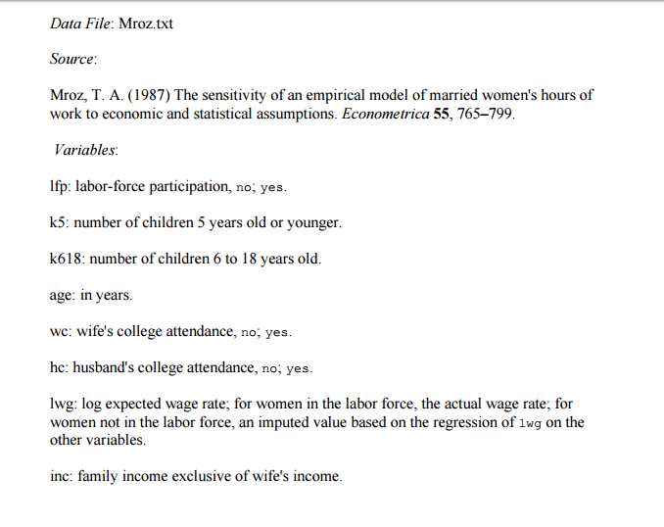

GLM model was used to conduct Logistic regression:

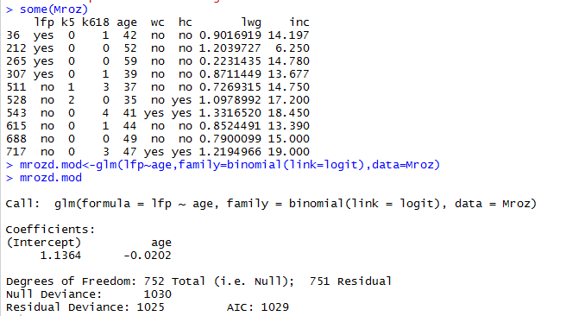

1. Write the estimated logistic regression model
2. Write the equation for fitted log odds of success
3. By increasing the age by 1 how does the odds of lfp() change?
4. Write the Expectation of Y in terms of πi
5. Write the Expectation of Y in terms of a and b
6. State the Null Hypothesis and Alternate Hypothesis
7. On obtaining the summary the following output is obtained:

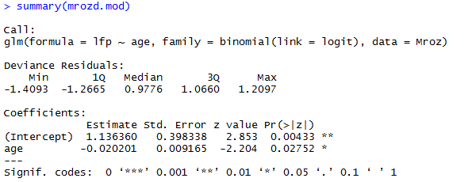

Given this will we Reject Null Hypothesis or Fail to Reject Null Hypothesis?

1. Finding the confint. Does this verify the Hypothesis test?

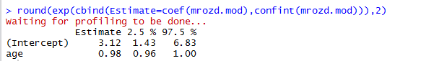

1. Look at the data and answer the questions



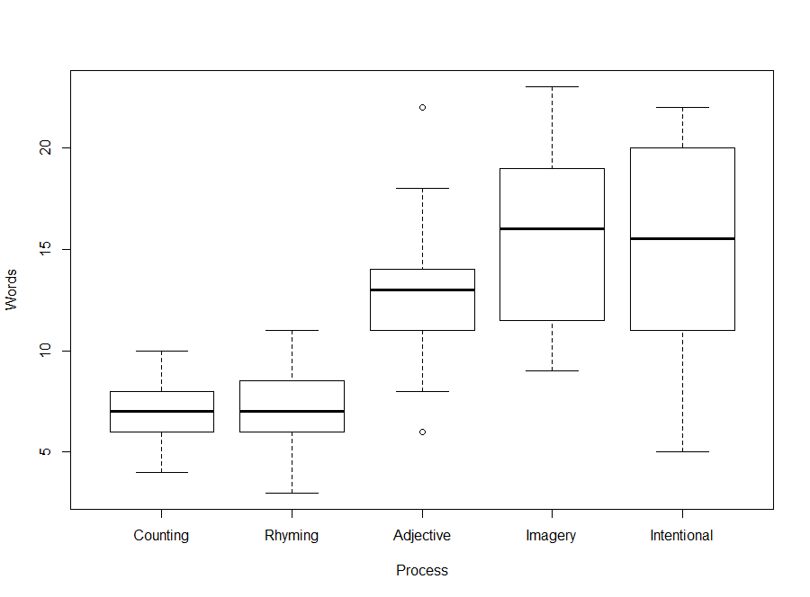

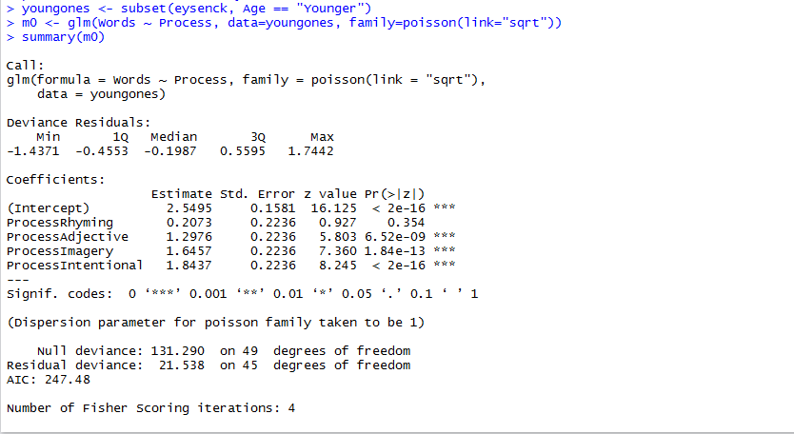

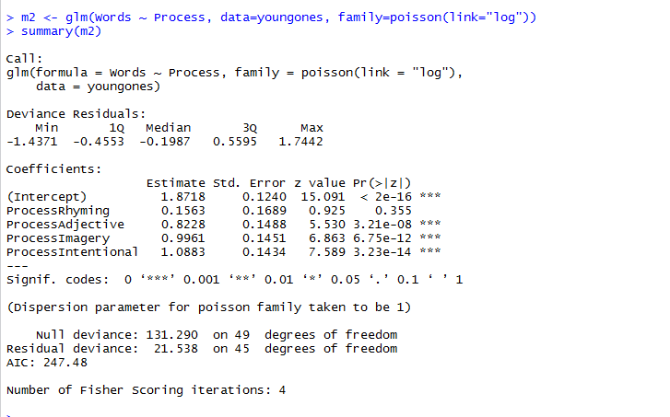

1. Is the model m0 and m2 are better than the null model
2. Compare the two models

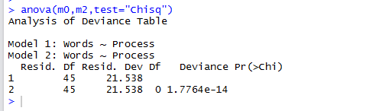

Reference web site:

http://www.theanalysisfactor.com/r-glm-model-fit/