**LAB 3**

**USE EITHER OF THE DATA and do these questions by hand. Use a calculator to complete tables and answer the following questions:**

Example Is the number of hours of work in a student life affecting the number of time spent with family in a day.

|  |  |  |  |  |  |  |
| --- | --- | --- | --- | --- | --- | --- |
| X | Y | XiYi | Xi2 |  |  |  |
| 2 | 3 |  |  |  |  |  |
| 3 | 1 |  |  |  |  |  |
| 1 | 1 |  |  |  |  |  |
| 4 | 1 |  |  |  |  |  |
| 2 | 3 |  |  |  |  |  |
| 1 | 1 |  |  |  |  |  |

**OR**

Is the number of hours/day of study affecting the GPA

|  |  |  |  |  |  |  |
| --- | --- | --- | --- | --- | --- | --- |
| X | Y | XiYi | Xi2 |  |  |  |
| 5 | 3.5 |  |  |  |  |  |
| 6 | 3.8 |  |  |  |  |  |
| 3 | 3.1 |  |  |  |  |  |
| 7 | 4 |  |  |  |  |  |
| 4 | 3.2 |  |  |  |  |  |
| 2 | 3 |  |  |  |  |  |

1. Find the Fitted Equation for Least Square estimation also is there a relationship between the two variables? Alpha=.05

STEP 1 Evaluate A and B

 and 

Then substitute to find the fitted equation 

Step 2 Find , ,  and then find  and 

Find the t test  where an easier formula for sxx is 



Step 3 Formulate the Null and Alternate Hypothesis. Find critical statistics (use degree of freedom and alpha) and observe whether the t test is in the region of rejection or acceptance.

**LAB 4 BY HAND**

Please use the ANOVA technique for testing the linear relationship between explanatory and response variable. Use alpha =.05

Steps:

1. Please use second data set provided for Lab 3. You can use numerical results from Lab 3.
2. Create the ANOVA table. 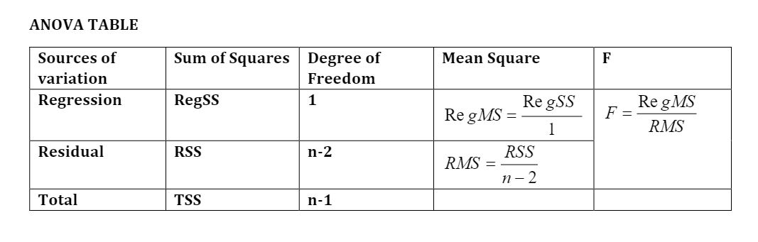
3. Find the F statistics.
4. Find the F critical statistics. Use the appropriate numerator degree of freedom and denominator degree of freedom
5. Decide whether there is a linear relationship between the response and explanatory variable.
6. If there is a linear relationship compute R2. How much of the variation in the response variable can be attributed to the explanatory variable? How much of the variation can be attributed to other variables?
7. If you did this test using the t test then did you obtain the same conclusion.
8. The instructor stated that F=t2. Can you start by using the formula of t and proving the aforementioned statement.