**MIDTERM 2 REVIEW**

Read the documentation for the file mtcars.xslx

<https://vincentarelbundock.github.io/Rdatasets/doc/datasets/mtcars.html>

The Fitted linear model:

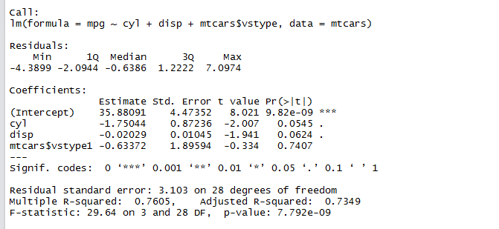

1. Write the linear least square regression equation for the full model presented above.
2. Write the linear least square regression equation for the null model corresponding to the aforementioned model
3. What is the intercept for vs=1
4. Are the regressors : cyl , disp , vs taken together significant for the linear model with the response variable write. Give your rationale
5. Are the regressors : cyl , disp , vs taken individually significant for the linear model with the response variable write. Give your rationale .

The Fitted Linear Model with interactions :

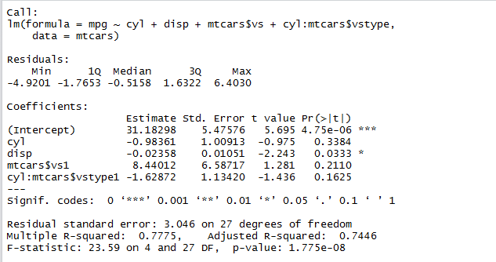

1. Write the linear least square regression equation for the model presented above.
2. What is the slope coefficient for cyl when vs=1 .
3. Write the hypothesis statement for the interactions between cyl and vs.
4. Given the above result are the interactions significant ? Give your rationale .

The Fitted Model with categorical regressors:

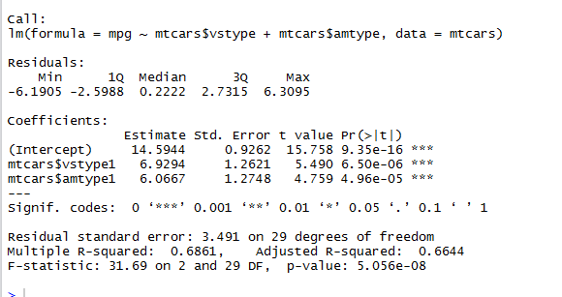

1. Write the linear least square regression equation using the traditional model presented above.
2. Write the two possible Hypothesis formulations using the traditional ANOVA model.
3. Are the regressors : am and type taken together significant for the linear model with the response variable write. Give your rationale
4. Are the regressors : am and type taken individually significant for the linear model with the response variable write. Give your rationale .

**Please Read Lectures 9-14 for Multiple choice. There will be one proof each from lectures 13 and 14 respectively.**