Misty Moon Treasure Hunt
——A Comparative Study of Multi-Algorithm Pathfinding Agents in Dynamic Grid Environments

Wenqian Qiao

20707398

Designing Intelligent Agents
School of Computer Science
University of Nottingham
Spring 2025/26

Word Count:

1 May 2026

Introduction
Path planning is one of the most fundamental capabilities for intelligent agents. Whether it's a self-driving car navigating through traffic, a warehouse robot moving between shelves, or a game AI finding its way around a map, the agent need to figure out how to get from where it is to where it wants to be — often in environments that are complex, dynamic, and only partially observable. The challenge get harder when the environment contains other moving entities like pedestrians, vehicles or patrol units, because these dynamic obstacles can block a pre-planned path at any time, and the agent has to re-plan on the fly.
This project builds a 2D grid maze environment called "Treasure Hunt in the Misty Moon", which include fixed stone walls, randomly moving guards, fog of war, and a hidden treasure. The agent must autonomously navigate from a start point to the treasure while dealing with interference from the dynamic guards.
The core question this project tries to answer is: how do four different pathfinding algorithms — DFS, BFS, A* and Genetic Algorithm — compare in terms of path quality, search efficiency and re-planning ability, across different obstacle densities and guard numbers?
To answer this question, the project introduces three main technical contributions. First, a Genetic Algorithm is added as a fourth pathfinding method alongside the three classical search algorithms, providing a comparison between traditional search and evolutionary search. Second, a predictive re-planning mechanism is implemented — the agent can predict where guards will be in the near future and re-plan its path before the guard actually blocks it. Third, the agent uses a subsumption architecture inspired by Brooks (1986), with four behaviour layers running at different priority levels.

Literature Review
  - The definition and environmental classification of intelligent agents
Wooldridge (2002) define an intelligent agent as a computer system that is situated in some environment and capable of autonomous action to achieve its design objectives. He argues that intelligent agents should have three key properties: reactivity (responding to environmental changes in a timely manner), proactiveness (goal-directed behaviour), and social ability (interacting with other agents). The agent in this project demonstrate both reactivity and proactiveness — it react to nearby guards by evading them immediately, and it proactively plan and follow paths toward the treasure.
Russell and Norvig (1995) classify environments along four dimensions: accessibility, determinism, dynamism and continuity. The maze in this project is partially accessible because the fog of war limit what the agent can see, non-deterministic because guards move randomly, dynamic because guards keep changing the environment, and discrete because the grid only have a finite number of states. In Wooldridge's terms, this is a simplified form of an open environment.
  - Subsumption Architecture
Brooks (1986) proposed the Subsumption Architecture, which take a fundamentally different approach to agent design. Instead of the traditional pipeline of "perceive → model → plan → act", Brooks decompose the system by activity — each layer is a complete sense-act loop on its own. Higher-priority layers can suppress lower ones, but lower layers never depend on higher layers being there. His key insight is that "the world is its own best model", so agents don't need to build internal representations. This project implement a four-layer Subsumption Architecture, though it depart from Brooks' purely reactive approach by introducing planning at the path-following layer, trying to strike a balance between reactivity and proactiveness.
  - Search algorithms and evolutionary methods
For the search algorithms, A* was proposed by Hart, Nilsson and Raphael (1968) and combines actual cost g(n) with a heuristic estimate h(n) to guide the search, guaranteeing an optimal solution as long as the heuristic is admissible. BFS and DFS are both uninformed search methods — BFS always find the shortest path but use more memory, while DFS is memory-efficient but don't guarantee optimality..
The Genetic Algorithm, proposed by Holland (1975), takes a completely different approach inspired by Darwinian evolution. It work by repeatedly selecting the best candidate paths, crossing them over, and introducing random mutations, gradually evolving better solutions over generations. Each chromosome encode a sequence of moves, and the algorithm evaluate candidates based on path length, distance to the goal, and whether the path is actually walkable. This idea of "keep what works, discard what doesn't" is essentially what Braitenberg (1984) described as evolutionary selection in Vehicle 6 — no deliberate design needed, just copying with occasional errors is enough to produce increasingly effective behaviour.
Finally, in dynamic environments where pre-planned paths can get blocked without warning, Koenig and Likhachev (2002) proposed D* Lite, which handle this efficiently through incremental updates rather than re-searching from scratch. This project takes a simpler but still effective approach: predictive re-planning. The agent tracks each guard's recent movement history and current direction, predict where it is likely to be in the next few steps, and trigger a re-plan before the guard actually block the path.

System Design
3.1 Environment Design
The environment is a 20×15 grid maze containing fixed stone walls (density adjustable at 15%, 25% or 35%), a starting point in the upper-left area, a treasure in the lower-right area, dynamic guards (0, 2, 4 or 6), and fog of war with a vision range of 4 grids in Manhattan distance. The map generation algorithm make sure there is always a reachable path from start to treasure.
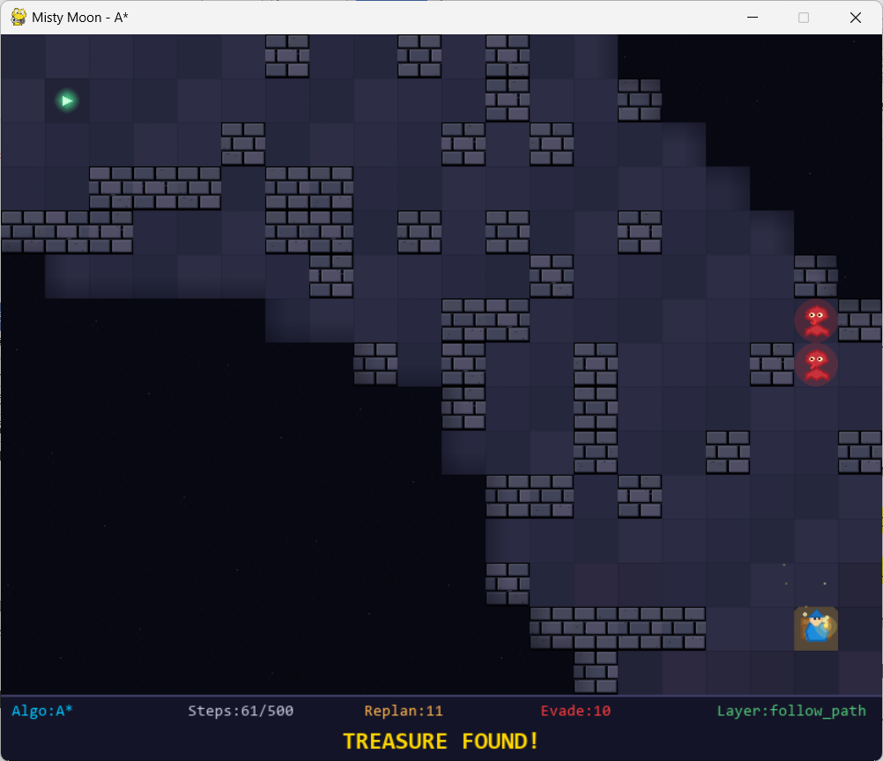

There are a few reasons why a grid maze was chosen for this project. First, grids are probably the most common testbed in path planning research (Russell & Norvig, 1995) — every step is one discrete cell movement, so path length and search nodes can be counted exactly without worrying about sampling rates or motion precision that would come with a continuous environment. Second, the difficulty of the maze can be controlled precisely just by changing the wall density parameter, which make it straightforward to study how environmental complexity affect algorithm performance in a systematic way. Third, grid environments are actually a reasonable abstraction of many real systems. Warehouse robots navigating between shelves is essentially grid pathfinding (Sartoretti et al., 2019), NPC navigation in games typically run on grids or navigation meshes (Cui et al., 2011), and even short-range obstacle avoidance in autonomous driving is basically finding a route on a discretised grid. Compared to continuous control environments like OpenAI Gym, the grid setup let us isolate the pathfinding strategy itself without the noise from continuous motion control.
3.2 Four pathfinding algorithms
This project implement four pathfinding algorithms across three categories — uninformed search (DFS, BFS), informed search (A*) and evolutionary search (GA) — so that their performance in dynamic environments can be compared from different angles.
DFS use a stack and search as deep as possible in one direction before backtracking. It's memory-efficient but don't guarantee the shortest path. BFS use a queue and expand layer by layer outward, which guarantee the shortest path but consume more memory. A* combine the actual cost with a Manhattan distance heuristic to pick the most promising node from a priority queue — it guarantee optimality like BFS but search fewer nodes. GA work differently from all three: it maintain a population of 80 candidate paths, evolve them over 150 generations with 15% mutation rate. Each chromosome encode a sequence of directional moves, and during initialisation 60% of genes are biased toward the target direction. The top 30% survive each generation (elite preservation), and new candidates are produced through single-point crossover and random mutation.
3.3 Subsumption Architecture
When a higher-priority layer activate, it suppress all the layers below it. So for example, if a guard get too close, the emergency evade layer will take over from the path-following layer — the agent prioritise staying alive over finding the treasure.

3.4 Predictive replanning mechanism
Each guard keep a record of its last 10 movement steps and its current direction. The prediction layer use this information to estimate all positions the guard might reach in the next 3 steps, including both continuing straight and possible turns. If any of these predicted positions overlap with the next 5 steps on the agent's current path, the system trigger a re-plan before the guard actually get there, and feed all predicted danger zones into the search algorithm as temporary obstacles.

Experimental Methods
  - Experimental Variable
Independent Variables
Variable | Levels
Path Search Algorithm | Depth-First Search (DFS), Breadth-First Search (BFS), A* Algorithm, Genetic Algorithm (GA)
Wall Density | 0.15, 0.25, 0.35
Number of Guards | 0, 2, 4, 6

Dependent Variables
Category | Measured Variables
Path Performance | Mean path length, Standard deviation of path length
Search Efficiency | Mean explored nodes, Standard deviation of explored nodes
Computational Cost | Mean computation time
Dynamic Decision-Making | Replanning count, Predictive replanning count, Emergency evasion count
Task Outcome | Task success rate

Control Variables
Category | Fixed Parameters
Maze Environment | Grid size: 20×15; Start position: (1,1); Goal position fixed; Cell size: 40px
Algorithm Settings | A*: Manhattan distance heuristic; GA: population size=80, generations=150, mutation rate=0.15
Agent Behavior | Vision range: 4 cells; Fixed priority of Subsumption Architecture
Guard Behavior | Random movement, step length: 2–5
Experimental Setup | Max steps: 500; 30 repetitions per condition; Headless mode; Fixed random seed

Confounding Variables & Control Measures
Confounding Factor | Control Method
Randomness of maze generation & guard placement | Fixed random seed + averaged results over repeated trials
Visual rendering interference with timing | Headless execution (no GUI rendering)
Irrelevant software warnings | Excluded from data statistics and analysis

  - experimental design
The experiment follow a three-layer structure. At the first layer, a single run is executed and its performance is measured. At the second layer, each condition is repeated 30 times to reduce the effect of randomness. At the third layer, all 48 condition combinations are run and analysed statistically, giving a total of 1440 experimental runs. Each run have a maximum of 500 steps to keep the comparison fair.

  - statistical approach
Single-factor variance analysis (ANOVA) is used to check whether there is a significant difference between the four algorithms, and pairwise t-tests are used to compare any two algorithms directly. The significance level is set at p < 0.05. Results are visualised using box-and-whisker plots, grouped bar charts, line charts and heat maps.

- Results
All results below are based on averages across 30 repetitions per condition.

  - Analysis of Task Success Rate
When there are no guards, all four algorithms achieve 100% success rate — in a purely static environment, pathfinding is straightforward regardless of algorithm choice. But as guards increase from 2 to 6, success rates start dropping across the board.
BFS and A* hold up the best, staying above 90% even with 6 guards. DFS suffer the most in high-guard, high-density scenarios, dropping as low as 73.33%. GA also struggle in complex environments, with its worst success rate at 66.67%. The pattern is clear: algorithms that find shorter paths are more likely to finish within the 500-step budget.
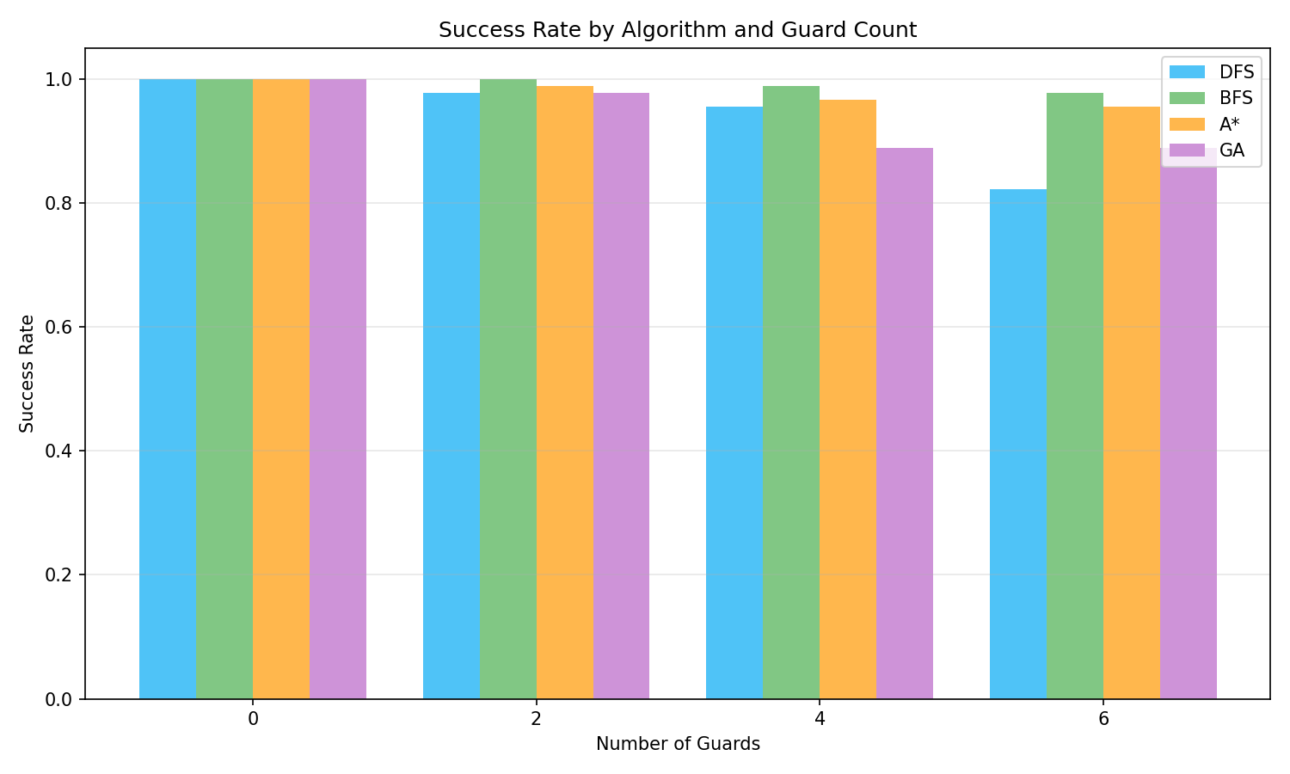
  - Path Length Performance Analysis
Looking at the box-and-whisker plots, BFS and A* have the lowest median path lengths with tight, compact distributions — they consistently find near-optimal paths. DFS sit at the other end: its median is the highest, the box is the widest, and some outliers reach close to the 500-step limit, which tell us its paths are both long and unpredictable. GA fall somewhere in between.
The line chart show that path length go up for all algorithms as wall density increase from 15% to 35%, which make sense — more walls means longer detours. A* and BFS have gentle slopes and short error bars, meaning they handle denser environments well. DFS have the longest error bars by far, reflecting huge variability in path quality from run to run. GA's path length increase sharply at high density, though it still do better than DFS overall.
The t-test confirm that A* and BFS have no significant difference in path length (p > 0.05), and both significantly outperform DFS and GA (p < 0.001).

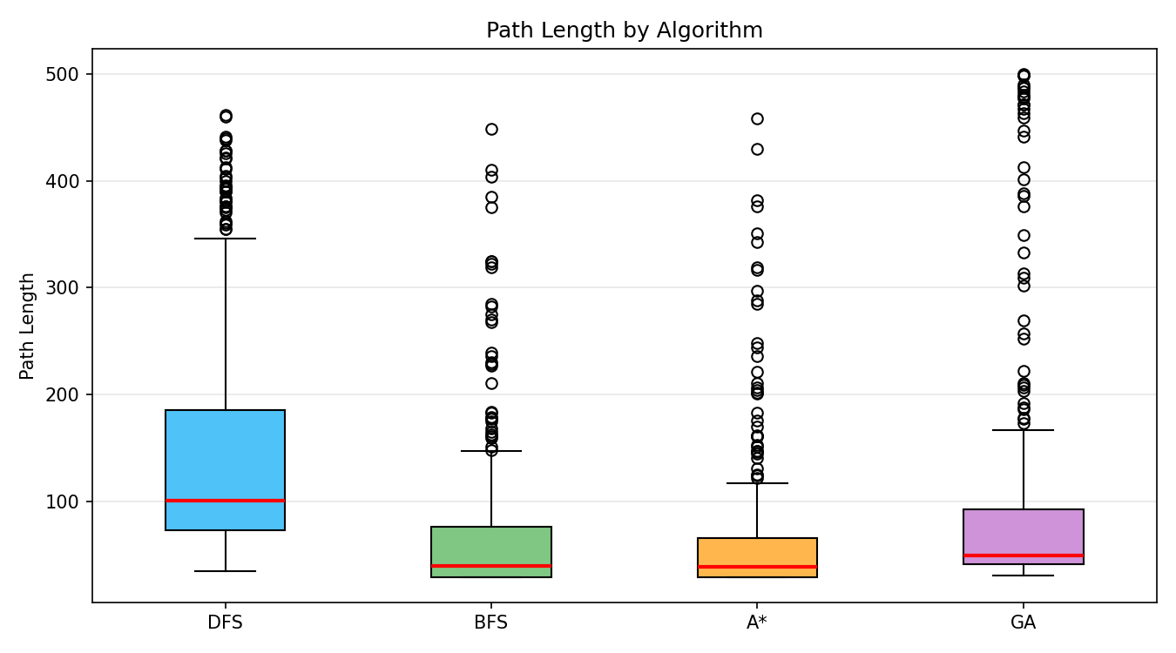
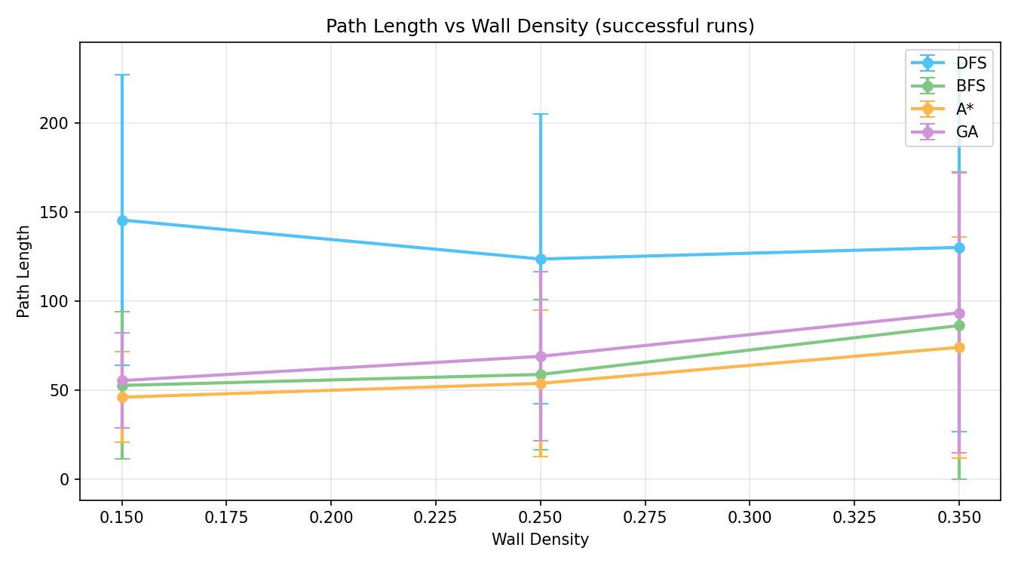
5.3 Analysis of Search Efficiency
For DFS, BFS and A*, the number of explored nodes stay in the thousands — all three are reasonably efficient. A* explore the fewest nodes thanks to its heuristic pruning, which let it skip large parts of the search space that are unlikely to contain the optimal path.
GA is on a completely different scale. Its explored nodes reach the millions, with an extremely wide distribution and lots of outliers. As environmental complexity increase, GA's search space grow exponentially. This is because every time it need to re-plan, it have to re-evolve an entire population from scratch — 80 individuals over 150 generations, multiplied by however many re-plans are needed. The box plot make this gap impossible to miss: DFS, BFS and A* are barely visible at the bottom while GA's box stretch across most of the chart.

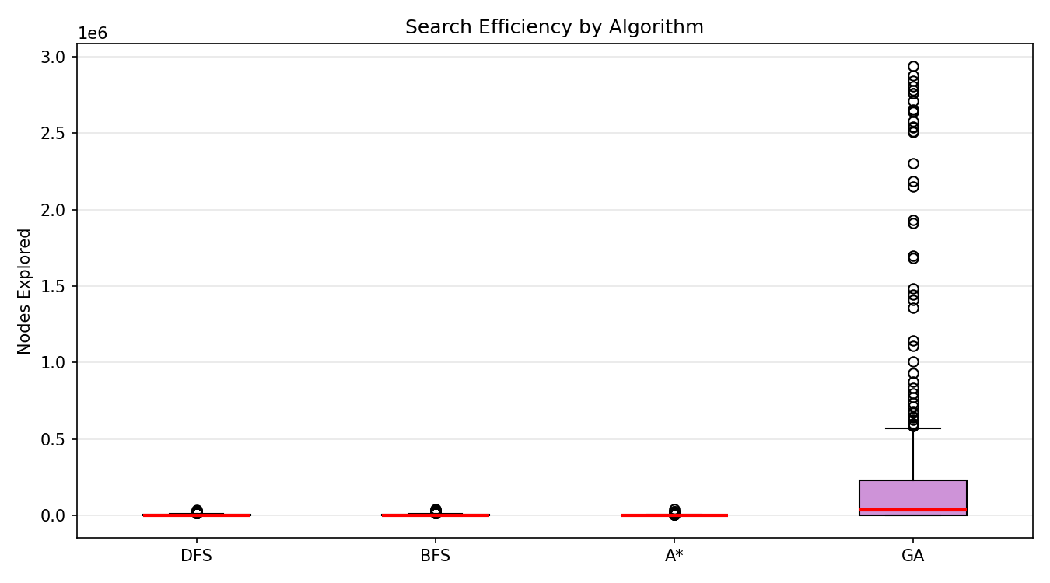

5.4Replanning Behavior Analysis
The box plot of replanning frequency show that DFS get re-planned the most often and have the most outliers, meaning its paths are frequently disrupted by guards. A* and BFS have the lowest and most consistent replanning counts. GA's replanning frequency vary a lot — in complex scenarios it need frequent forced path adjustments.
The heat map of predictive replanning tell a clear story: more guards mean more predictive replans, which make intuitive sense. With 0 guards, all algorithms have 0 predictive replans. With 6 guards, DFS trigger the most predictive replans (53.8 times on average) because its longer paths spend more time exposed to guard interference. A* keep its predictive replanning at a more manageable level (33.8 times). GA actually have the lowest predictive replan count, but this isn't because it's better at avoiding guards — it's because GA spend so long on each replan that there simply isn't enough time within the 500-step budget for many replans to happen.
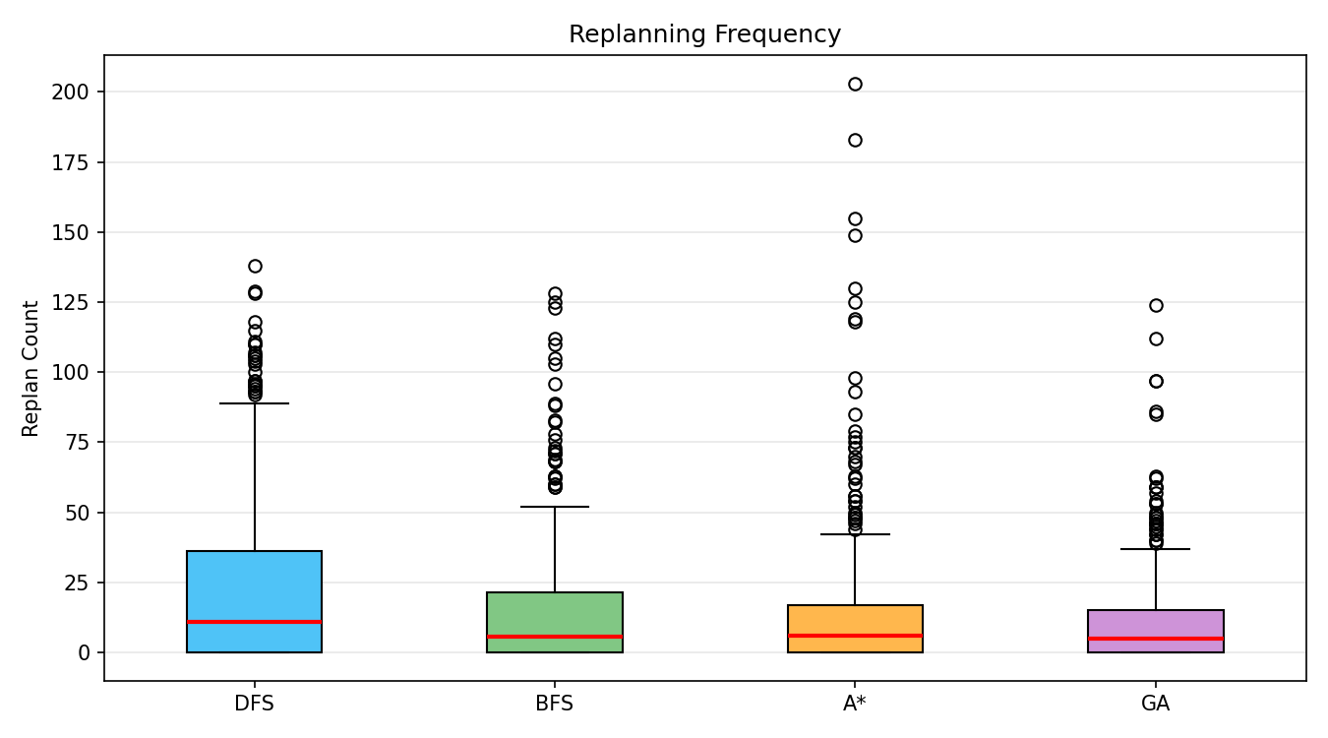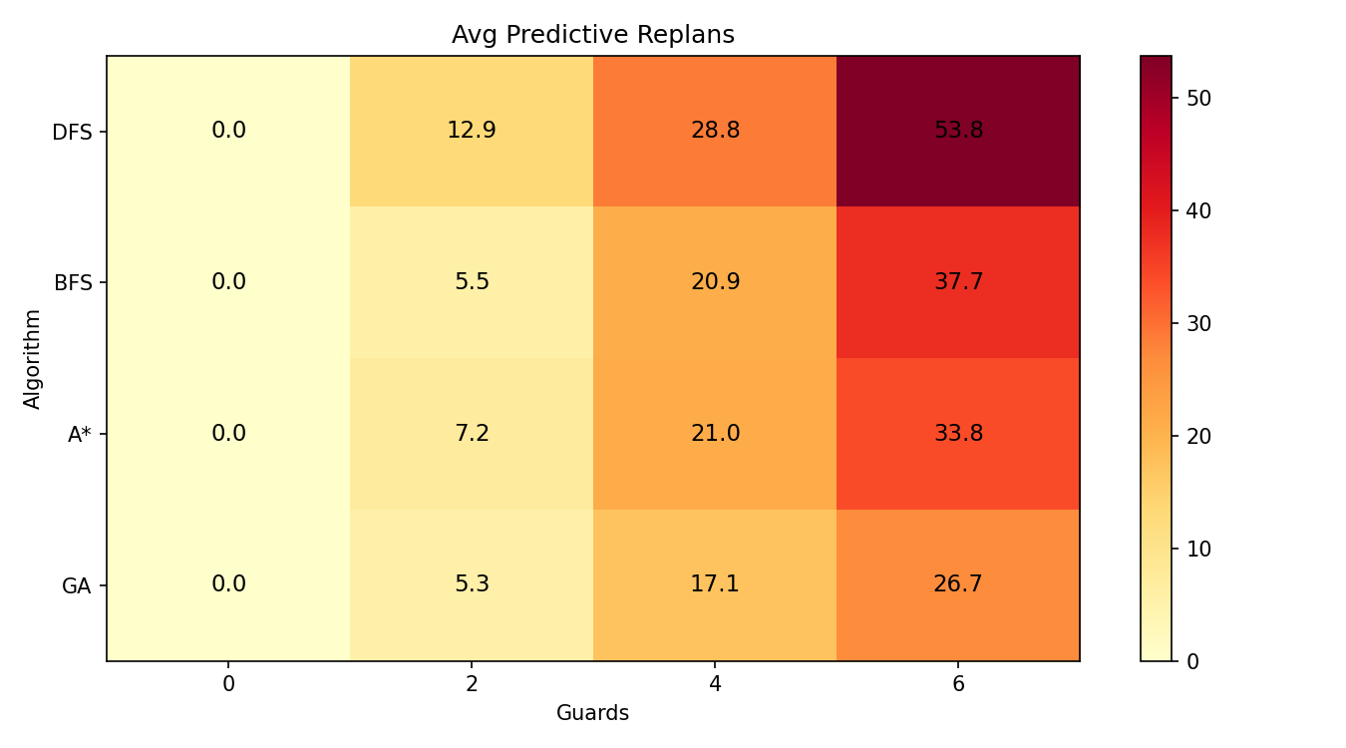

5.5 Subsumption Architecture behaviour analysis
Predictive replanning and emergency avoidance are the two core behaviours in the Subsumption Architecture for handling dynamic obstacles. The stacked bar chart show how these two behaviours are distributed across algorithms.
A* have the best ratio — most of its activations are predictive replans rather than emergency evades, which mean it usually spot threats early and deal with them through forward planning rather than last-second reactions. DFS is the opposite: it have the highest total activation count of all four algorithms, and a large chunk of that come from emergency avoidance, suggesting it's mostly reacting to guards passively rather than anticipating them. This make sense because DFS paths are longer, so the agent spend more time near guards and have less room to avoid them in advance. GA also rely heavily on emergency avoidance, not because its paths are long, but because its predictive replanning capability is limited by the computational cost of each replan.
The emergency avoidance box plot confirm this pattern. A* have the lowest median and the tightest distribution. DFS have the highest count with lots of high-value outliers. BFS and GA sit somewhere in between.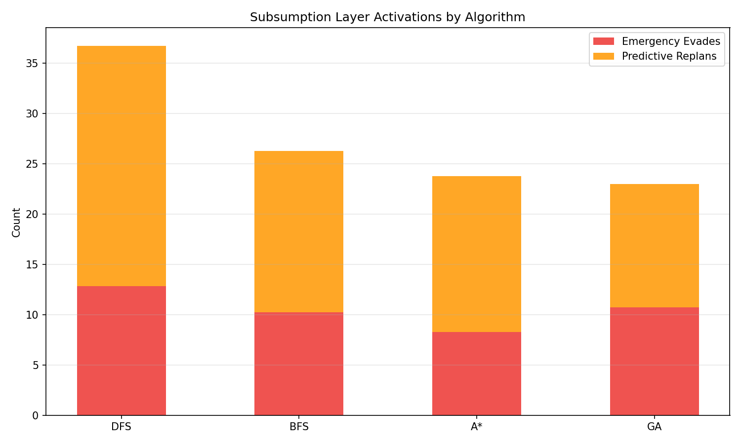

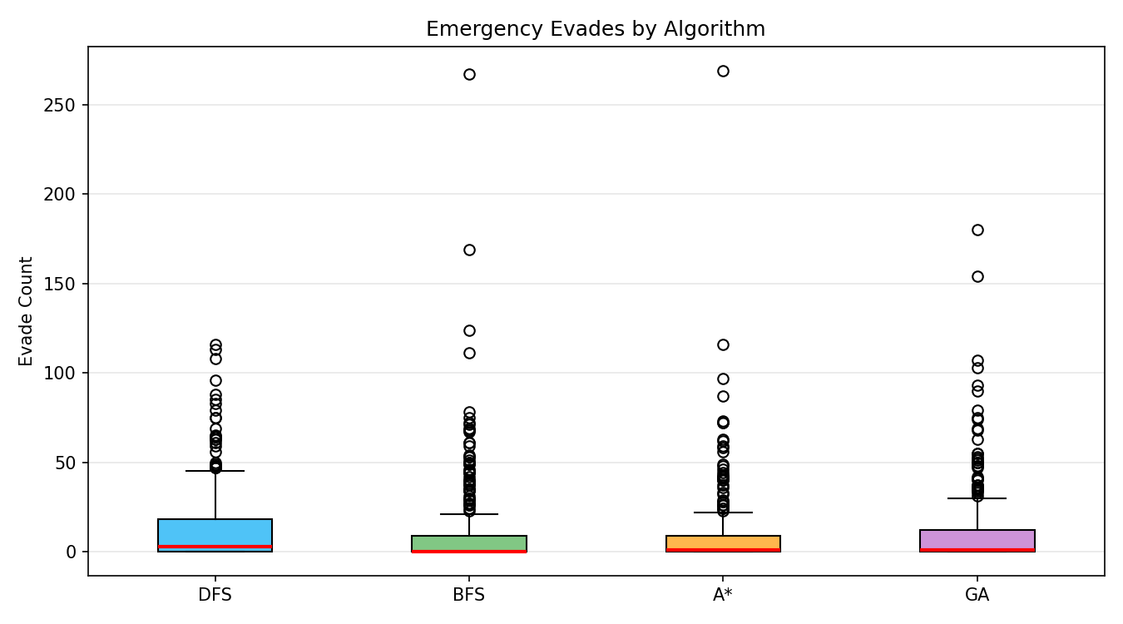
5.6 Statistical Significance Test
ANOVA on the path length of successful runs give F = 96.8413 with p < 0.001, confirming there is a statistically significant difference between the four algorithms.
The pairwise t-tests break this down further: DFS is significantly worse than all three other algorithms (p < 0.001 in each case). A* is significantly better than GA (p < 0.001). The most interesting result is that BFS and A* show no significant difference (p = 0.053) — they are essentially equal in path quality.
5.7 Result summary
Pulling everything together, A* come out as the best all-round algorithm in this experiment. It find short paths, search efficiently, and handle dynamic guards well through predictive replanning. BFS find paths that are just as short (the t-test can't tell them apart at p = 0.053), and it actually have a slightly higher success rate under heavy guard pressure (97% vs 95%). DFS is the weakest performer — its paths average more than twice the length of A* (148 steps vs 59 steps), which means it run into guards more often and spend a lot of time evading and replanning. GA can sometimes find decent paths, but every replan require re-running the entire evolutionary process from scratch, pushing its search nodes into the millions. In any scenario where the agent need to react to dynamic obstacles frequently, GA is simply not practical.

- Discussion
6.1 The trade-off in algorithm selection
Choosing an algorithm is really about balancing three things: path quality, search efficiency and computational cost. From the experimental results, A* come out best across all three — it find paths just as short as BFS, but only search about half as many nodes, and the computation time stay well within reason.
One result that stand out is that BFS and A* have no statistically significant difference in path length (p = 0.053). This basically mean A* doesn't win by finding shorter paths — both algorithms guarantee the shortest path anyway. Where A* actually win is in doing the same job with less work. In practical terms, if you're running this on an embedded system like a real robot with limited processing power, that efficiency gap matter a lot.
That said, BFS do have one advantage worth mentioning. Under the toughest conditions with the most guards, BFS have a slightly higher success rate than A* (97% vs 95%). Why? It's probably because BFS expand outward evenly in all directions, so when it need to replan it's less likely to get stuck in a dead end. A* on the other hand follow its heuristic, which sometimes lead the search straight toward an area that's actually blocked by guards — and then it have to backtrack, wasting steps.

6.2 Problems existing in genetic algorithms
The thing about GA is that the paths it find in a single search are actually not bad. The real problem is that it can't handle repeated replanning. Every time the agent need to replan, GA have to evolve a whole new population from scratch — 80 individuals for 150 generations, which mean evaluating around 12,000 candidate paths each time. When there are lots of guards, the agent end up replanning 30 to 37 times per run, and the total computation blow up to hundreds of thousands or even millions of evaluations. In practice this mean a single batch of experiments take 20 minutes for GA, while A* finish the same thing in about 1 second.
This line up pretty well with what Wooldridge (2002) say about real-time systems: in a dynamic environment, an agent can't afford to sit around thinking about the perfect answer — it need to make a "good enough" decision quickly and move on. GA fundamentally violate this principle. It's designed to find globally optimal solutions through extensive search, but in a situation where the environment keep changing and the agent need to react fast, that kind of thoroughness become a liability rather than an advantage.

6.3 Subsumption Architecture
From the data, the answer is yes. The predictive replanning layer manage to intercept roughly two-thirds of guard threats before they become a problem, leaving only about one-third for the emergency avoidance layer to deal with. This is exactly how Brooks intended the Subsumption Architecture to work — the higher-level layer (planning) handle what it can, and when something slip through, the lower-level layer (instinctive avoidance) kick in as a safety net. The lower level does not need the higher level to function; it always work on its own.
But it's not perfect. When guard density get really high (35% walls with 6 guards), the emergency avoidance layer still get activated a lot — DFS trigger it 45.6 times on average. The issue is that guard movement is inherently random and trying to predict where a guard will be more than 3 steps ahead just isn't very reliable. The prediction layer does a reasonable job within its 3-step horizon, but beyond that it's basically guessing. One way to improve this would be to use a Markov model to capture patterns in how guards move, which could extend the useful prediction range and reduce how often the agent must fall back on emergency avoidance.

6.4 The density of walls and the number of guards will mutually amplify and influence each other
One finding that was a bit surprising is that wall density and guard count don't just affect performance independently — they interact with each other and make things worse than you'd expect from either factor alone. More walls mean fewer available corridors, so guards are more likely to end up blocking the exact passages the agent need to use.
To put some numbers on this: with A* and 6 guards, increasing wall density from 15% to 35% cause the path length to jump from 65 steps to 158 steps — that's a 143% increase. If you just look at the effect of adding walls without guards, or adding guards without extra walls, neither one produce anything close to that kind of jump. The two factors clearly amplify each other.
For practical applications, this mean you can't just think about "how many obstacles there are" or "how fast do they move" in isolation. The overall congestion level of the environment — how static obstacles and dynamic obstacles combine to restrict movement — is what really determine how hard the pathfinding problem become.

- Conclusion
7.1 Main discovery
After 1440 experiments, several core conclusions are relatively clear: A* is the algorithm with the best comprehensive performance in the dynamic environment, with a short path, fast search and controllable calculation. The path found by BFS is as short as that of A* (p=0.053, no significant difference), but the number of search nodes is nearly twice as many - so the real advantage of A* is in efficiency rather than in path quality. GA is still manageable in a static environment, but once frequent replanning is required, the computational cost is completely unacceptable. The hierarchical design of the Subsumption Architecture does work. The prediction layer blocks most of the threats, and the emergency avoidance layer covers the rest. In addition, the density of walls and the number of guards will amplify each other, which is worth noting when designing an actual wayfinding system.

7.2 The boundedness
There are several obvious shortcomings in this project. At present, the guard is just a random patrol. The behaviour is too simple. In reality, dynamic obstacles often have more complex movement laws. The map is only 20×15, and the gap between algorithms may be more obvious on a larger map. Although the fog system is done, none of the four algorithms actually make use of it - assuming that the complete map is known when searching, which is not in line with the reality. Only one set of parameters such as population size, number of iterations, and mutation rate of GA has been tested. Without systematic tuning, it may not give full play to its full potential.

7.3 Future Work
If you have more time, there are several directions worth trying: add reinforcement learning algorithms such as Q-learning as the fifth comparison to see if the learning method is more advantageous than the planning method in the dynamic environment; make the guards smarter, such as tracking agents or multiple guards collaborative encirclement; change a single agent into multiple agents to collaborate in treasure hunting, and study different division of labour and communication strategies; the most interesting thing may be to really use the fog system - so that the algorithm can only see the information within the field of vision for planning, and compare the effect gap between "seeing the whole situation" and "touching walking".

