What happend : in timeline
08/2021 ~ 10/2021
We were conducting recursive meeting with your help, if this ring a bell, they merely throw a word everytime we meet. I have checked with them, and they just said they are too busy that juggling internship and work at the same time. I understood and told them they could do some easy work first (like learning how to designing the UI and learning fusion360), and I also set up modules on trello(with deadline), hoping they could provide some proof or feedback after learning. But they never uploaded anything.
Evidence: Troll board https://trello.com/b/lIQpzuUc/power-supply-main. (There are more contents in the card, all uploaded by me.)
11/2021 ~ 02/2021
(Summer vacation), right after the vacation started, I found them and set a recursive meeting on Friday every week, but they completely disappeared after one of them said he was going away on vacation for a few days. I kept updating our group chat(as well as discord), but hardly anyone reply to me.
Evidence: Chat history (The following chat history were originally linked together and not cropped in the middle)

Wechat history: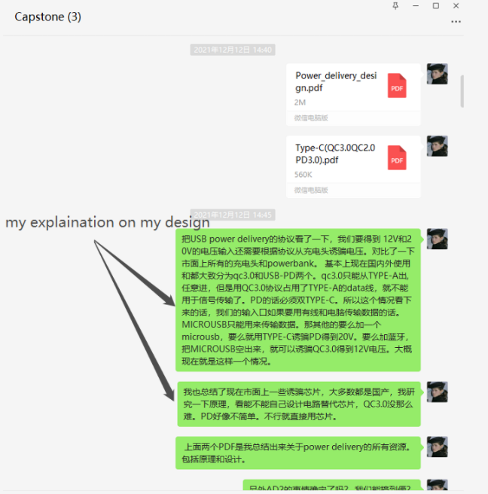
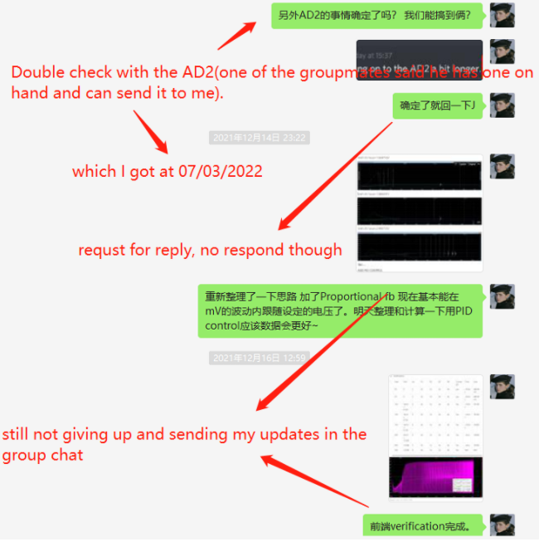
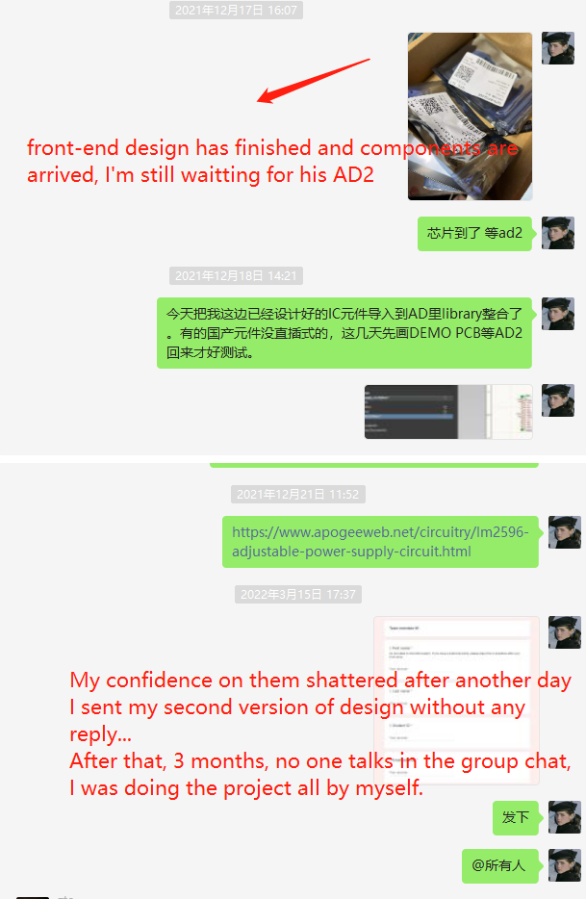
Discord history: please find the history in the capstone group chat (We are not using another one).
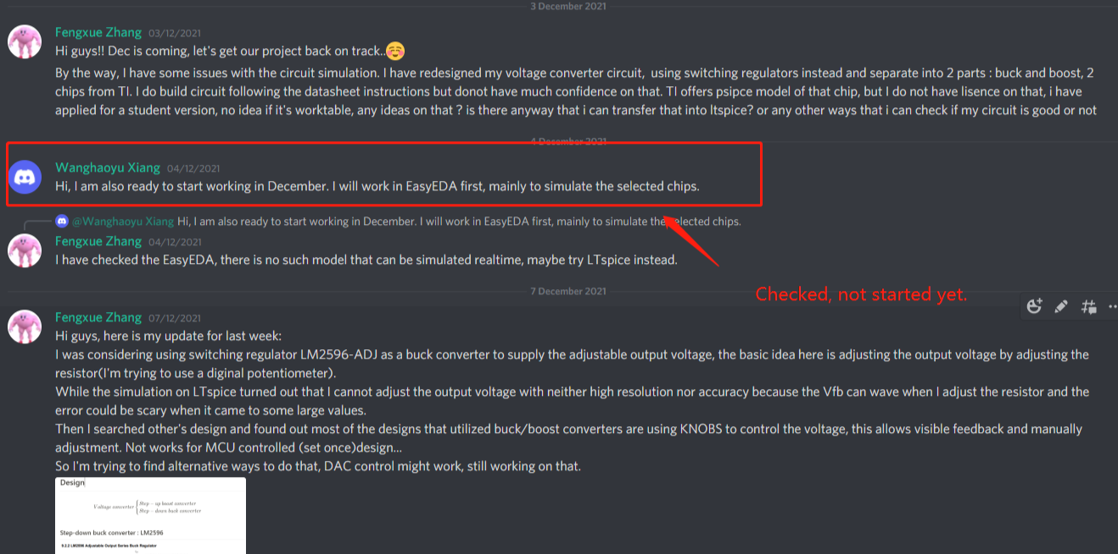

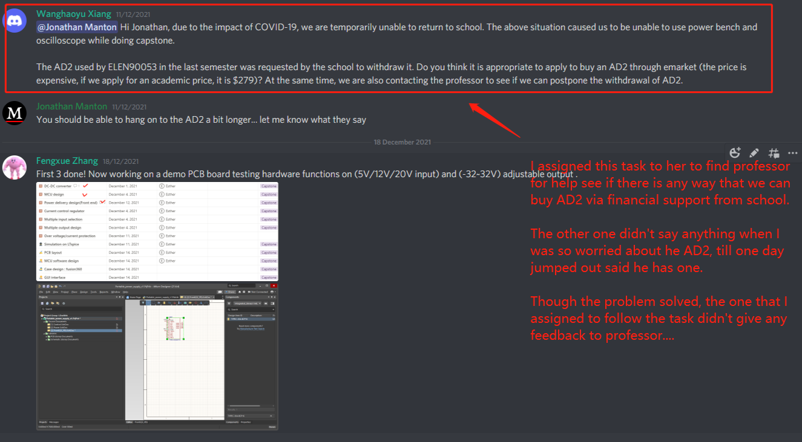

What I tried to solve problem:
- Assign non-teachnical tasks to them and set a deadline → They ignored or did some of them without following up
- Conduct them one-on-one, asking for working results → I have to take their hand and teach them how to do thing step by step, or nothing will be done.
- Provide the instructions and resources(Integrated LTspice library, IC datasheet/reference , software tutorial, etc) and assign technical tasks. → done half, pretend to ask me some conceptual questions that can be searched on Google and disappear.

Evidence that I’m continuing doing this project:
(I will add you to the notion book to see the detail if you are comfortable with this)
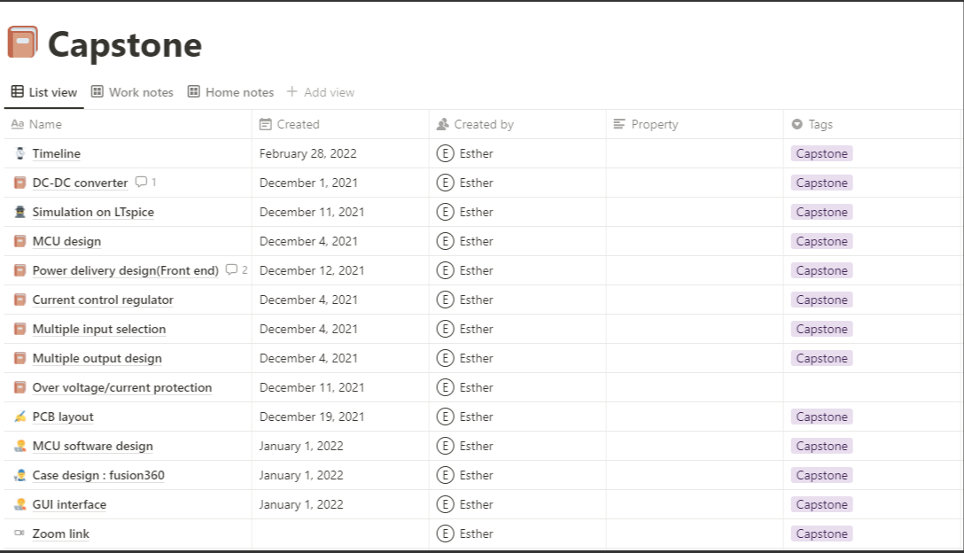

Where am I now
I have finished construct the second verison of DC-DC buck design.(The first one used LM317, which behaves not that accurate when comes to computer control.)
I did my best to push the project forward, but everytime I assigned them tasks they neither care about nor follow thing up, also ignored the deadlines I set. I caught pneumonia in the middle of Mar. and was very sick, but I still contacted them hoping they would do something and also set new a board on Teams, hoping to get through to them by uploading the working files. The deadline is Mar 27th. It's now March 26th and there's still nothing in the Teams file library.

