Used-car appraisal
Preliminary insight development
  - Teaching exemplar aligned to the supplied HD rubric · Indian used-car marketplace
SOURCE RECORDS | PRIMARY COHORT | MAIN REPORT
1,005,000 | 998,849 | 1,000 words

1. Introduction
The client operates an Indian online used-car marketplace where faster, defensible appraisals could improve cash offers and listing-price checks [1]. Overvaluation threatens purchasing margins; undervaluation risks losing sellers. This milestone examines vehicle age, usage and brand segment to prioritise subsequent analysis. It provides preliminary evidence and a development plan rather than a completed pricing model. Only the fixed randomised dataset is analysed, using the descriptive, probability and sampling concepts introduced in Weeks 1–3 [2–4]. Tables 1–4 document preparation and numerical summaries; Figures 1–4 show the observed patterns.

2. Data Summaries and Descriptive Statistics

2.1 Data definition and preparation
The dataset [6] contains 1,005,000 listings and 20 variables. Car_Price, recorded in Indian rupees, is the outcome; Registration_Age and Kms_Driven measure supplied age in years and usage in kilometres. Table 2 distinguishes nominal labels, ownership categories, numerical measurements and binary flags. In every observation, Year plus Registration_Age equals 2025. The supplied age is therefore retained as a snapshot measure, rather than recalculated using today's date; including both age and Year later would duplicate information.
Trimming Brand corrects 10,040 labels and recovers 2,334 luxury records that an uncleaned lookup would misclassify. Luxury comprises Audi, BMW and Mercedes; the other ten identified brands constitute non-luxury. Explicit spelling, case and whitespace corrections standardise 20,123 Fuel_Type entries. Unknown categories remain visible rather than being guessed. This export contains neither blank cells nor exact duplicates, including after label cleaning; those checks do not establish that the original source was complete [5]. Forty zero readings across three mechanical variables are flagged for verification, without imputing unused predictors.
Fuel type and transmission are Unknown for 7.83% and 8.00% of full-file records respectively; dropping those rows would discard usable price, age and usage observations. These unresolved categories will be reported separately when studying additional predictors.
The primary cohort provisionally screens 6,151 listings exceeding 1,000,000 kilometres, leaving 998,849 observations. This threshold follows the guide's example of implausible usage but is an appraisal-screening decision, not proof of error. All records remain in the full-sample comparison. High prices are retained: an IQR flag alone cannot establish an incorrect valuation. Table 1 records decisions and denominators.

2.2 Distribution and typical values
The primary mean price is INR 1,015,954, compared with a median of INR 673,944. The substantial gap and Figure 3's right tail indicate positive skew. The price IQR is INR 877,727 and sample SD is INR 1,141,023; dispersion is commercially material. The median is preferable for describing a typical listing because extreme prices pull the mean upward [2]. However, it is not a vehicle-specific appraisal, and the mean remains informative for portfolio averages.
Average age is 13.00 years and median usage is 152,632 kilometres. Table 3 includes means, medians, modes, sample SDs, quartiles and ranges for the full file and screened groups. Repeated price and usage values produce many tied modes, so a single modal benchmark would be misleading.

Analysis, conclusions and next steps

2.3 Relationships with age and usage
Figures 1–2 use the same reproducible random sample of 5,000 screened listings to limit overplotting. A logarithmic price axis displays the full sampled range; reported correlations use original prices and every eligible record. Figure 1 shows broad price variation at each age. Pearson's age–price correlation is −0.0012 overall and similarly negligible within both segments. Figure 4a's approximately flat age means offer no clear depreciation pattern in this randomised version.
Usage has a weak negative linear association with price: r = −0.0509 overall, −0.0521 for luxury and −0.0505 for non-luxury. Figure 4b shows declining mean prices across usage deciles, while Figure 2 shows substantial overlap. Hence usage may inform further investigation but cannot support precise offers alone. Restoring high-usage records changes the overall correlation to −0.0499; the interpretation survives this sensitivity check. Pearson correlation describes linear association, not causation or all possible nonlinear structure [2].
An additional diagnostic removes prices above the upper IQR fence of INR 2,560,035. Usage correlation remains weak at −0.0516, so the principal conclusion is not driven solely by unusually expensive listings; this diagnostic is not the adopted sample.

2.4 Brand-segment comparison
The screened cohort contains 230,761 luxury and 768,088 non-luxury listings. Their mean prices are INR 1,014,112 and INR 1,016,508 respectively: a luxury difference of −0.236%. Medians differ by only INR −435, or −0.065%. Figure 3's distributions overlap almost completely, and both groups have comparable ages and usage. These summaries provide no commercially substantial unconditional luxury premium in this version. They neither establish equality in the population nor rule out differences conditional on other characteristics. Empirical segment shares describe these listings, not India's market composition [3].

3. Conclusion and Development Plan
The useful preliminary findings are strong price skew, considerable dispersion, negligible age association and a weak usage association. The evidence supports cautious investigation, not automatic depreciation deductions or a fixed luxury surcharge. Listing prices are not verified transaction prices; city coverage, Unknown labels and unresolved measurements limit generalisation. Randomisation may weaken real-world relationships. A million observations can improve precision without removing selection bias: the Central Limit Theorem concerns sample means, not a normal distribution of individual prices or representative sampling [4].
A useful Milestone 2 comparison is whether the population mean price differs between the two segments, with the null hypothesis of equal means. Practical difference sizes should accompany uncertainty estimates; a statistically detectable gap could still be too small to guide offers.
For Milestone 2, formulate explicit questions about mean-price differences between segments and age or usage associations, selecting inferential procedures as taught later. Compare within-segment patterns and document sample availability before testing. For the final report, assess the remaining supplied predictors and compare pooled versus segment-specific approaches using subsequent course methods. Evaluate prediction errors on reserved observations, particularly expensive listings and each segment, rather than judging usefulness from sample size or significance alone. Revisit the mileage screen and investigate flagged records before operational deployment. Improving transaction-price verification and measurement consistency would be useful future data collection, without introducing external observations into this project. A future pricing system should also flag uncertain appraisals for human review rather than force precision.

Evidence A · Preparation and audit

Table 1a. Observed issues and documented decisions
Audit item | Observed count | Treatment / rationale
Source rows | 1,005,000 | Complete supplied CSV; source hash verified.
Blank cells | 0 | 0 in this export; not proof the original source was always complete.
Exact duplicate rows | 0 | Compared all 20 supplied fields; keep first rule would apply only if found.
Duplicates after label cleaning | 0 | Rechecked all supplied fields after canonicalisation.
Brand labels corrected | 10,040 | Trim leading/trailing spaces; 26 labels become 13.
Luxury records recovered by Brand trimming | 2,334 | 2,334 records otherwise misclassified by an exact uncleaned lookup.
Fuel labels corrected | 20,123 | Case/space correction and explicit hybridd/electrik mappings; 12 labels become 6.
Kms_Driven > 1,000,000 | 6,151 (0.612%) | Flag and screen provisionally; retained in full-sample sensitivity analysis.
Primary cohort rows | 998,849 | No other record exclusions; all key variables valid in this cohort.
Zero Mileage_kmpl / Engine_CC / Horsepower | 5 / 12 / 23 | Flag unresolved auxiliary readings; do not call them blanks or impute them.
High price IQR flags in primary cohort | 70,457 | Diagnostic only; no price-based exclusion in primary results.

Table 1b. Unknown categories retained in the full file
Variable | Unknown entries | Share of 1,005,000
Fuel_Type | 78,733 | 7.83%
Transmission | 80,385 | 8.00%
Color | 80,419 | 8.00%
City | 80,430 | 8.00%

Table 1c. Cohort reconciliation after Brand normalisation
Stage | All | Luxury | Non-luxury
Full supplied file | 1,005,000 | 232,172 | 772,828
High-usage screen | 6,151 | 1,411 | 4,740
Primary cohort | 998,849 | 230,761 | 768,088

Evidence B · Variables and units

Table 2. Definitions, measurement types and analytical roles
Variable | Type / unit | Meaning and treatment
Brand | Nominal | Vehicle manufacturer; cleaned before segment construction.
Model | Nominal | Model name; 39 observed labels.
Year | Integer / year | Manufacturing year, 2000–2024. Age + Year = 2025 in every row.
Mileage_kmpl | Continuous / km per litre | Fuel efficiency; five zero values flagged.
Engine_CC | Continuous / cm³ | Engine displacement; twelve zeros require contextual checking.
Horsepower | Continuous / reported horsepower | Engine power output; twenty-three zero readings flagged.
Fuel_Type | Nominal | Petrol, Diesel, CNG, Electric, Hybrid, Unknown after correction.
Transmission | Nominal | Manual, Automatic, Unknown.
Owner_Type | Ordinal category | First, Second, Third, Fourth+ owner category.
Color | Nominal | Vehicle colour; Unknown preserved as an unresolved label.
City | Nominal | Registration city; eight named cities and Unknown.
Kms_Driven | Continuous / km | Total distance travelled; key usage variable.
Insurance_Valid | Binary / 0 or 1 | Recorded insurance-status flag; 1 indicates valid insurance.
Service_History | Binary / 0 or 1 | Recorded service-history availability flag.
Accidents | Integer / count | Number of reported accidents, 0–5.
Tax_Paid | Binary / 0 or 1 | Recorded road-tax-payment flag.
Number_of_Doors | Integer / count | Door count; observed values 2, 4, 5.
Seats | Integer / count | Seating capacity; observed values 2, 4, 5, 7.
Registration_Age | Integer / supplied years | Key age measure, 1–25; retain the supplied snapshot definition.
Car_Price | Continuous / INR | Reported price in rupees; outcome, not verified transaction proceeds.

Source: course dataset description shown in [5, PDF p. 8] and the user’s Dataset worksheet screenshot [6]. INR denotes Indian rupees. Age uses the supplied year units and snapshot; the exact Year + Registration_Age = 2025 identity is an observed data check, not a recalculation. Auxiliary zero measurements are flagged but retained; the companion workbook reports their recorded-value summaries.

Evidence C · Numerical summaries

Table 3. Full file and primary cohort, overall and by segment
F = full supplied file (labels standardised). S = primary cohort (Kms_Driven ≤ 1,000,000). Price and usage are scaled by 1,000; sample SD uses n − 1. All calculations use unrounded original values.

Table 3a. Car_Price (INR thousands)
Cohort | Valid n | Mean | Median | SD | Min | Max | Mode†
F: All | 1,005,000 | 1,014.8 | 673.1 | 1,140.1 | 10.4 | 46,802.5 | 53 ties
F: Luxury | 232,172 | 1,013.0 | 672.8 | 1,129.1 | 11.5 | 46,802.5 | 5 ties
F: Non-luxury | 772,828 | 1,015.3 | 673.2 | 1,143.4 | 10.4 | 38,036.4 | 23 ties
S: All | 998,849 | 1,016.0 | 673.9 | 1,141.0 | 10.4 | 46,802.5 | 51 ties
S: Luxury | 230,761 | 1,014.1 | 673.6 | 1,130.3 | 11.5 | 46,802.5 | 5 ties
S: Non-luxury | 768,088 | 1,016.5 | 674.0 | 1,144.2 | 10.4 | 38,036.4 | 22 ties

Table 3b. Registration_Age (years)
Cohort | Valid n | Mean | Median | SD | Min | Max | Mode†
F: All | 1,005,000 | 13.00 | 13.00 | 7.21 | 1.00 | 25.00 | 6
F: Luxury | 232,172 | 13.02 | 13.00 | 7.21 | 1.00 | 25.00 | 18
F: Non-luxury | 772,828 | 13.00 | 13.00 | 7.21 | 1.00 | 25.00 | 19
S: All | 998,849 | 13.00 | 13.00 | 7.21 | 1.00 | 25.00 | 6
S: Luxury | 230,761 | 13.02 | 13.00 | 7.21 | 1.00 | 25.00 | 18
S: Non-luxury | 768,088 | 13.00 | 13.00 | 7.21 | 1.00 | 25.00 | 19

Table 3c. Kms_Driven (thousand km)
Cohort | Valid n | Mean | Median | SD | Min | Max | Mode†
F: All | 1,005,000 | 203.0 | 153.5 | 175.9 | 4.5 | 6,259.5 | 96 ties
F: Luxury | 232,172 | 202.9 | 153.2 | 175.7 | 4.5 | 4,129.8 | 5 ties
F: Non-luxury | 772,828 | 203.1 | 153.6 | 175.9 | 4.7 | 6,259.5 | 43 ties
S: All | 998,849 | 196.2 | 152.6 | 150.7 | 4.5 | 999.9 | 96 ties
S: Luxury | 230,761 | 196.1 | 152.4 | 150.9 | 4.5 | 999.5 | 5 ties
S: Non-luxury | 768,088 | 196.2 | 152.7 | 150.6 | 4.7 | 999.9 | 43 ties

† Price and usage modes are tied at the exported precision; every tied modal value appears twice. Ties are not a unique central benchmark. Age has a unique modal value in each displayed group.

Table 3d. Primary-cohort quartiles and interquartile ranges
Variable / unit | All: Q1 / Q3 / IQR | Luxury: Q1 / Q3 / IQR | Non-luxury: Q1 / Q3 / IQR
Price / INR thousands | 365.7 / 1,243.4 / 877.7 | 365.0 / 1,246.6 / 881.5 | 365.9 / 1,242.6 / 876.6
Age / years | 7.0 / 19.0 / 12.0 | 7.0 / 19.0 / 12.0 | 7.0 / 19.0 / 12.0
Usage / thousand km | 92.4 / 251.7 / 159.3 | 92.4 / 251.4 / 158.9 | 92.4 / 251.8 / 159.4

Quartiles use linear interpolation, equivalent to Excel QUARTILE.INC / PERCENTILE.INC. Extended summaries for all 13 numerical variables and category frequencies are included in the companion Excel evidence workbook.

Evidence D · Relationships

Table 4. Pearson correlations with Car_Price
Cohort / segment | Eligible pairs | r: age–price | r: usage–price
F: All | 1,005,000 | -0.0012 | -0.0499
F: Luxury | 232,172 | -0.0009 | -0.0508
F: Non-luxury | 772,828 | -0.0013 | -0.0497
S: All | 998,849 | -0.0012 | -0.0509
S: Luxury | 230,761 | -0.0008 | -0.0521
S: Non-luxury | 768,088 | -0.0013 | -0.0505
Extra price screen* | 928,392 | -0.0005 | -0.0516

* Diagnostic only: additionally omit 70,457 prices above INR 2,560,035 (Q3 + 1.5 × IQR). Primary estimates retain those prices. No hypothesis tests are performed.
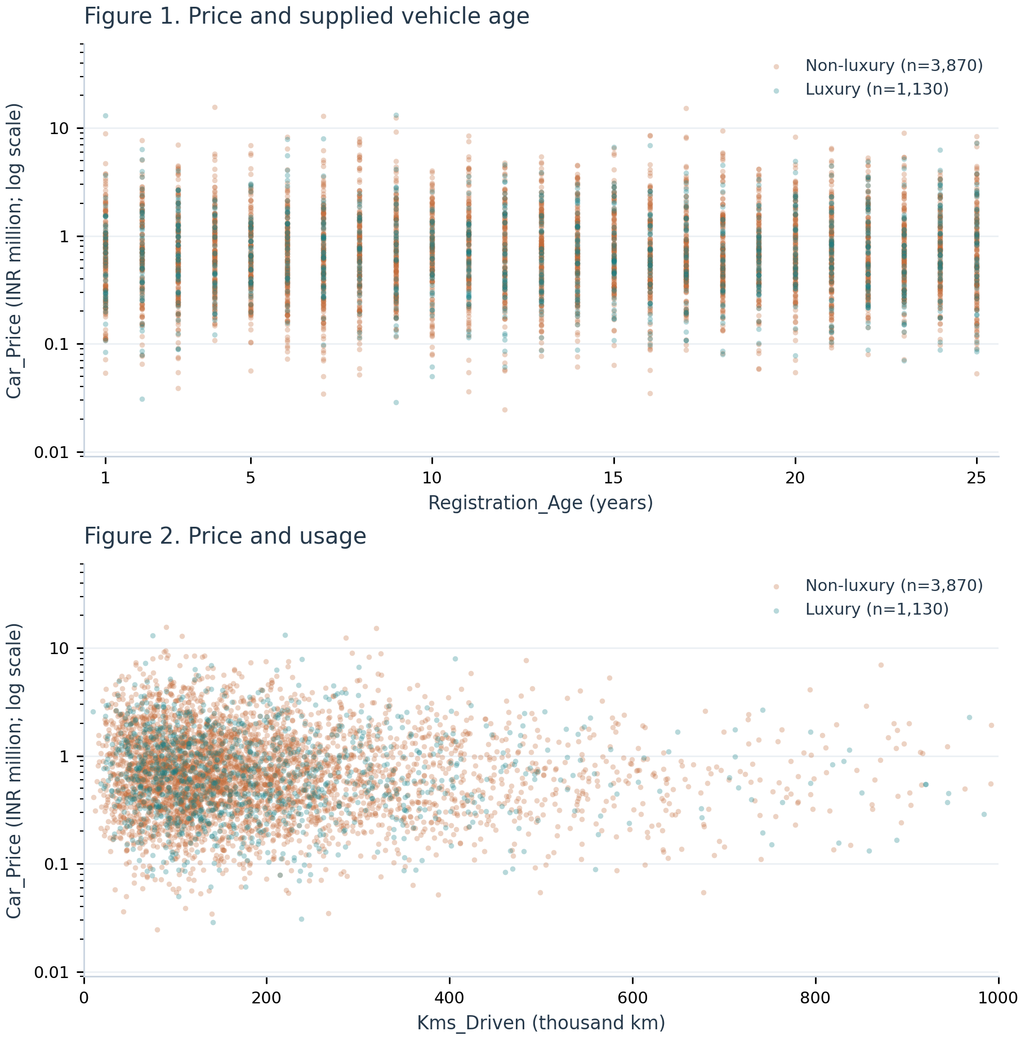

Figures 1–2: simple random sample of 5,000 primary-cohort rows; pandas random_state = 5000. Sample: luxury 1,130; non-luxury 3,870. Logarithmic price axes are display choices only; Table 4 uses original-scale prices and all eligible pairs. All sampled points are displayed; no fitted regression is shown.

Evidence E · Shape and grouped patterns
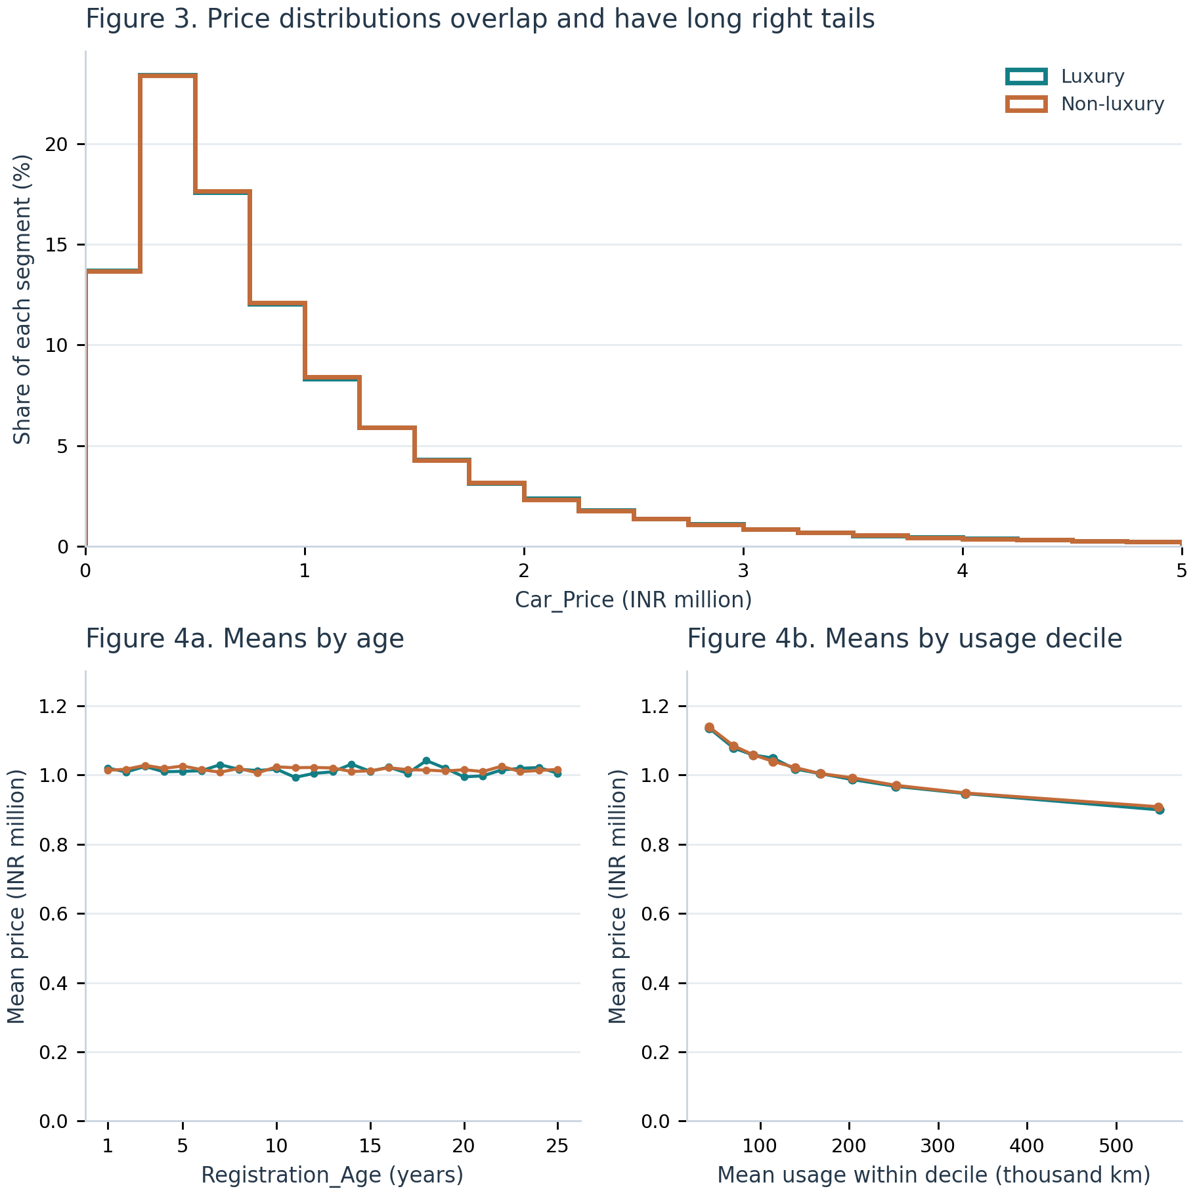

Figure | Calculation and display scope
Figure 3 | Full primary cohort; equal-width INR 250,000 bins. Percentages use each entire segment as denominator, not just displayed records. Prices above INR 5 million are outside the display: luxury 2,969 (1.29%); non-luxury 10,418 (1.36%). These observations remain in all primary statistics. Overall maximum: INR 46,802,453.
Figure 4a | Arithmetic mean price at each of the 25 supplied integer ages, separately by segment; all primary-cohort observations used. Lines join group summaries, not fitted values.
Figure 4b | Ten usage deciles defined on the pooled primary cohort. For each segment within each decile, plot mean kilometres against mean price. All primary observations used. Aggregation reveals a modest trend but suppresses substantial individual variation.

References and teaching alignment
[1] UNSW Business School (2026). COMM5000 T3 2026 Assessment Guide Milestone 1 – Used Cars. PDF pp. 6, 8–11: business scenario, M1 tasks, structure, submission requirements and marking rubric.
[2] UNSW Business School (2026). COMM5000–Week 1–T326. PDF pp. 27–55: data quality, sampling, graphical and numerical summaries, dispersion and Pearson correlation.
[3] UNSW Business School (n.d.). COMM5000 W2 Lecture. PDF pp. 10, 17–22, 32–34: empirical and conditional probability; probability distributions.
[4] UNSW Business School (n.d.). COMM5000 W3 Lecture. PDF pp. 4–11: descriptive/inferential statistics, estimators, sampling distributions and the Central Limit Theorem. Historical administrative dates are not used.
[5] UNSW Business School (2026). COMM5000_Course-Dataset-M1-intro-T326. PDF pp. 2–8: project scope, workbook use, dataset-description screenshot and randomisation guidance.
[6] COMM5000 course dataset (2026). COMM5000-Used_Car_Price_Prediction.xlsm; user-supplied fixed CSV export, 1,005,000 rows × 20 variables, and Dataset worksheet screenshot. B6 confirms randomisation applied on 2026-10-07 at 06:20:30; the message does not specify a timezone.
Course-material access: https://moodle.telt.unsw.edu.au/ (login required). Exact file names and physical PDF page locations are given above. Individual Moodle resource URLs were not provided. The original publisher address is recorded in the supplied dataset description; no external observations or market reports were used.

HD rubric coverage — evidence locations
Criterion / weighting | Evidence in this example
Business context / 10% | Page 1: appraisal decision, margin and seller-offer implications; explicit preliminary scope.
Data processing / 30% | Tables 1–2: actual audit counts, category correction, denominators, units and justified screening.
Exploratory analysis / 40% | Tables 3–4 and Figures 1–4: full-file/segment statistics, shape, correlations and sensitivity checks.
Conclusions and plan / 10% | Page 2: evidence-linked recommendations, limitations and concrete M2/final-report steps.
Professional presentation / 10% | Numbered sources, labelled units/scales, reproducible graphics and consistent cross-references.

Verification | Record
Fixed-source SHA256 | 6c129c0fad2d907b559d5d44baf6af29c71f4c46b80227a976ec44ecbdabc610
Main-report word count | 1,000 words including section headings; excludes title/metadata, tables, figures/captions and references.
Teaching use | Illustrative HD-rubric alignment, not an awarded grade. The guide limits students’ own assessment use of AI to simple editing assistance; this document is a teaching reference.

