Polarity
The output signal produce by the et232 is biphasic. This means that each impulsion is composed of two phases of opposite polarities. The shape of each impulsion is controlled by the four least significant bits at address 0x0C for channel A, and at address 0x12 for channel B.

bit 3 | bit 2 | bit 1 | bit 0 | Signal
X | X | X | 0 | 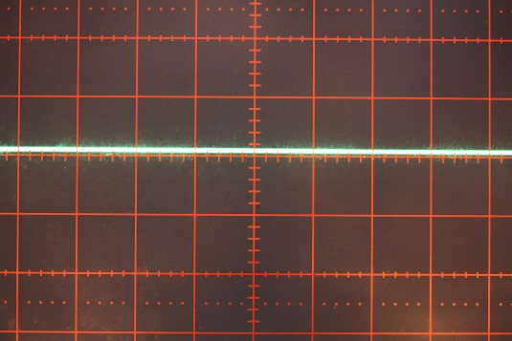  No signal
0 | 0 | 0 | 1

bit 3 | bit 2 | bit 1 | bit 0 | Signal without charge | Signal with charge
0 | 0 | 1 | 1 | 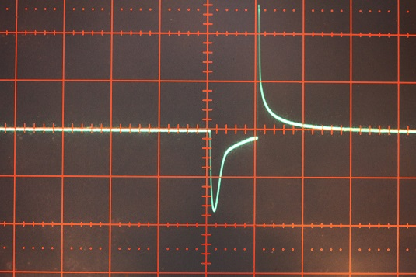 | 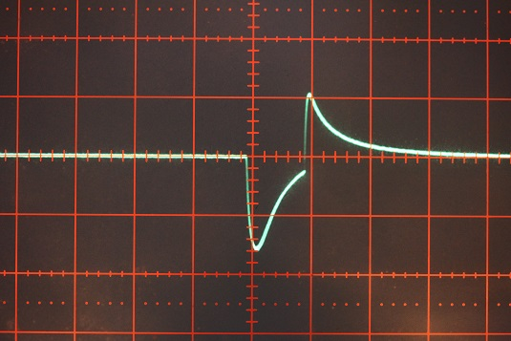
0 | 1 | 0 | 1 | 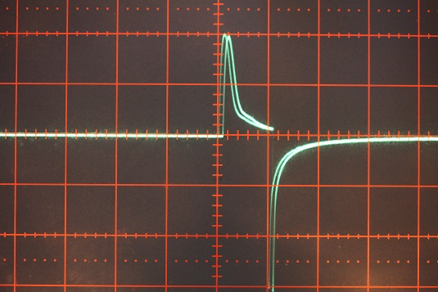 | 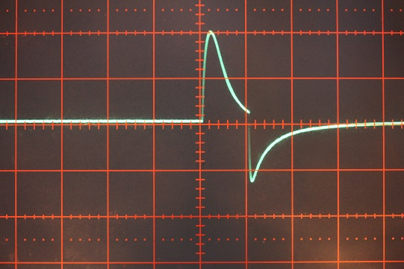
0 | 1 | 1 | 1 | 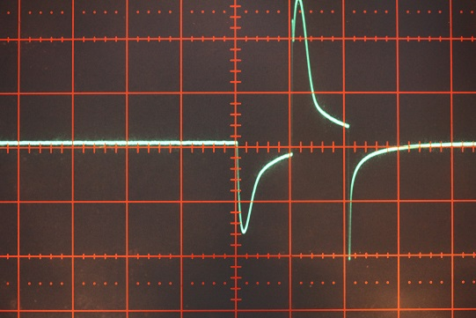 | 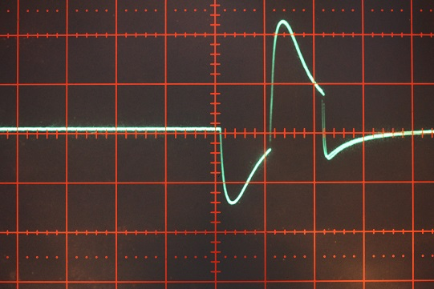

bit 3 | bit 2 | bit 1 | bit 0 | Signal
1 | a | b | 1 | When bit 3 is set, it alternates the effects of [ 0 a b 1 ] and [ 0 A B 1 ],  where a=not A, b=not B.
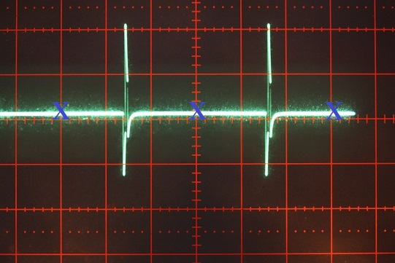

… [1 0 0 1] → [1 1 1 1] → [1 0 0 1] → [1 1 1 1] → [1 0 0 1] ...
The blue X shows the missing impulsion when [1 0 0 1] is executed.

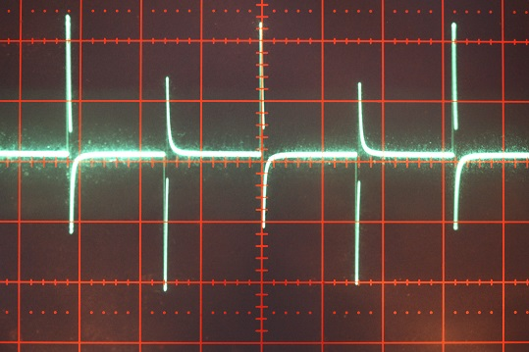

… [1 1 0 1] → [1 0 1 1] → [1 1 0 1] → [1 0 1 1] → [1 1 0 1] ...

The signal generated by value 7 [0 1 1 1] has the strongest effect. Excepted Stroke, all modes use the value 7 [0 1 1 1], some time alternately with 6 [0 1 1 0 ] (no signal). Stroke uses the values 3 [0 0 1 1] and 5 [0 1 0 1].

