Connection ET232 / computer

Cable DB9/Jack-3.5 | Adapter USB/RS-232
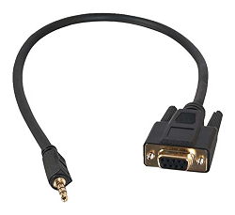 | 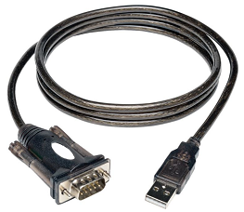

Cable DB9/Jack-3.5

If you have an old computer you may have an RS-232 port using a DB9 connector. In this case you only need a simple cable to convert DB9 to Jack 3.5 mm. This kind of cable is easy to make.

ET232 | Cable |  | Computer
Jack 3.5 mm  female | Jack 3.5mm  male | DB9  female | DB9  male
Tip (Tx) |  |  | (Rx) Pin 2
Ring (Rx) |  |  | (Tx) Pin 3
Sleeve (Ground) |  |  | (Ground) Pin 5

In this configuration the name of the port is COM1 or COM2 (sometime COM3 or COM4) and there is no driver to install.
Note: When the RS-232 port is on the mother board it can be enabled/disabled in the bios.

Cable DB9/Jack and Adapter USB/RS-232

But, modern computers don’t have RS-232 port. In addition to the cable DB9/Jack you have to use an USB to RS-232 adapter. This adapter contains electronic and requires a driver. When you buy it make sure it is supported by your OS version.

ET232 | Cable |  | Adapter |  |  | Computer
Jack 3.5mm female | Jack 3.5mm male | DB9 female | DB9  male | Active electronic.  Usually included in the DB9 connector | USB Type A male | USB Type A  female
Tip (Tx) |  |  | (Rx) Pin 2 | Active electronic.  Usually included in the DB9 connector | 1 (VCC) | 1 (VCC)
Ring (Rx) |  |  | (Tx) Pin 3 | Active electronic.  Usually included in the DB9 connector | 2 (Data -) | 2 (Data -)
Sleeve (Ground) |  |  | (Ground) Pin 5 | Active electronic.  Usually included in the DB9 connector | 3 (Data +) | 3 (Data +)
 |  |  |  |  | 4 (Ground) | 4 (Ground)

A driver is required. This driver depends on the chip-set used inside the adapter. Some chip-sets are supported natively by Windows, some require to install a driver provided by the vendor.

Check the device manager to see if the adapter is detected by Windows and if the drivers is loaded without error. The name (COM3, COM4 …) of the RS-232 port provided by the adapter depends on the USB port used.

