MODULE 1: Introduction

What is a client-server model?
In computing:
- client can be a web browser or desktop application that a person interacts with to make request to computer servers.
- server can be services, such as Amazon Elastic Compute Cloud (Amazon EC2) – a type of virtual server

What is cloud computing?
The on-demand delivery of IT resources (compute power, database, storage, application and other) over the internet with pay-as-you-go pricing

Six Advantage of Cloud Computing
- Trade capital expense for variable expense
You can Pay On-Demand meaning there is no upfront costs, and you pay for only what you consume or pay by the hour, minute, or seconds.
- Benefits from massive economics of scale
You are sharing the cost with other customers to get unbeatable savings. Hundreds of thousands of customers utilize a fraction of a server.
- Stop guessing capacity
Scale it up or down to meet the current need. Launch and destroy services whenever possible. You can launch Amazon EC2 instances when needed and pay only for the computer time you use.
- Increase speed and agility
Launch resources within a few clicks in minutes.
- Stop spending money to run and maintain data centers
Focus on your own customers, developing and configuring your application.
- Go global in minutes
Deploy your app in multiple regions around the world with a few clicks.

Type of Cloud Computing
Cloud Computing Models
- Infrastructure as a Service (IaaS)
Most basic building blocks of cloud IT infrastructure. It has the most flexibility and management control of all the different cloud computing models. It is the closes to having a traditional on-premises data center
e.g. Amazon Web Services, Microsoft Azure, Google Cloud

- Platform as a Service (PaaS)
Provides a platform allowing customers to develop, run and manage applications without complexity of building and maintaining the infrastructure typically associated with developing and launching an app. Less flexibility than IaaS because of pre-constructed packages.
e.g. AWS Elastic Beanstalk, Windows Azure, Heroku, Google App Engine.

- Software as a Service (SaaS)
Completed projects managed by a service provider. Easy to use and comes complete with the user interface. Least flexibility.
e.g. GMAIL, Adobe Creative Cloud, Office 365
Cloud Computing Deployment Models
- Cloud-based deployment
  - 100% of IT infrastructure is on the cloud
  - All of the companies’ applications were migrated to or created on the cloud
  - Helps to remove roadblocks of costly and time-consuming procurement processes for on-premises infrastructure (big servers and data centers)
  - Great for small businesses and start-ups.

- On-Premises deployment
  - Think of a large old company that is beholden to Government Regulations.
  - Use virtualization to deploy resources in their on-premises data centers.
  - Resembles traditional IT infrastructure (big servers and data centers)

- Hybrid deployment
  - Think of FinTech Companies
  - Connects on-premises technology with cloud-based resources
  - Great for established companies that had a dedicated data center but also wants to migrate processes over the cloud
  - Data is partially on the cloud and partially in the on-premises

MODULE 2: Global infrastructure and reliability

Global infrastructure
The AWS Global infrastructure is globally distributed hardware and data centers that are physically networked together to act as one large resource for the end customer.
The AWS Global Infrastructure is made up of the following resources
- 33 Launched Regions
- 105 Availability Zones
- 135 Direct Connection Locations
- 600+ Points of Presence
- 41 Local Zones
- 29 Wavelength Zones

Regions
An AWS region is a geographically distinct location, which has multiple datacenters (AZ’s). Every region is physically isolated and independent of every other region in terms of locations, power, water supply.
- Each region has at least two Availability Zones
  - AWS US-EAST-1 (North Virginia) is the largest region
- New services almost always become available first in US-EAST
- Not all AWS Services are available in all regions
- All your billing information appears in US-EAST-1 (North Virginia)
- When you choose a region, there are 4 factors you need to consider:
  - Compliance with data governance and legal requirements:
What Regulatory Compliance does this region meet?
  - Pricing
What is the cost of the AWS services in this region?
  - Available services within a region
What AWS services are available in this region?
  - Proximity to your costumer
What is the distance or latency to my end-users?

Availability Zones
Availability Zones are often referred to as AZ’s. It is a physical location made up of one or more datacenters. A datacenter is a secure building that contains hundreds of thousands of computers. Datacenters within a region will be isolated from each other. But they will be close enough to provide low latency (< 10ms).
- A region will generally contain 3 availability zones.
- The use of AZ’s gives customers the ability to operate production applications and databases that are more highly available, fault tolerant and scalable.
- Its common practice to run workloads in at least 3 AZs to ensure services remain available in case one or two datacenters fail (High Availability)
- A subnet is associated with an Availability Zone. So, to launch an AWS resource into an specific AZ you need to launch it in a subnet that resided in that AZ.
- All AZs in an AWS region are interconnected with high-bandwidth, low latency networking.
- All traffic between AZ is encrypted
- AZs are within 100km of each other.

Fault Tolerance
It is the ability to withstand subsystem failure and maintain availability
Multi-AZ for High Availability
Deploying your application across multiple AZs can be better to isolate and protect from issues such power outages, lightning strikes, tornadoes, and more.

Global Network
The global network represents the interconnections between AWS Global Infrastructure. Commonly referred to as the “The Backbone of AWS”

Point of Presence (PoP)
Point of presence are intermediate locations between an AWS Region and the end-user, and these locations could be a datacenter or collection of hardware.
For AWS Point of presence is a datacenter owned by AWS or a trusted partner that is utilized by AWS Services related for content delivery or expediated upload.
Point of presence resources are:
- Edge Locations: Are datacenters that hold cached(copy) on the most popular files (e.g. Web pages, images and videos) so that the delivery of distance to the end user is reduced.
- Regional Edge Cache: Are datacenters that hold much larger caches of less-popular files to reduce a full round trip and to reduce the cost of transfer fees.
The following AWS Service use PoPs for content delivery or expediated upload:
- AWS CloudFront: It is a web service that speeds up distribution of your static and dynamic web content, such as .html, .css, .js, and image files, to your users. CloudFront delivers your content through a worldwide network of data centers called edge locations.
- AWS S3 Transfer Location: It is effective at minimizing or eliminating the latency caused by geographic distance between globally dispersed clients and a regional application using Amazon S3. Transfer Acceleration uses the globally distributed edge locations in CloudFront for data transport.
- AWS Global accelerator: It can find the optimal path from the end-user to your webservers. They are deployed within Edge Locations to send user traffic to an Edge Location instead of directly to your web application.
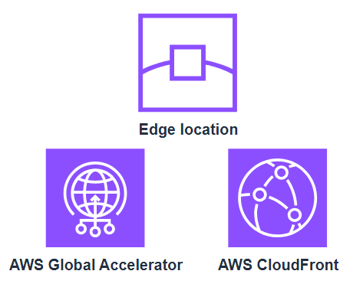

AWS Outpost
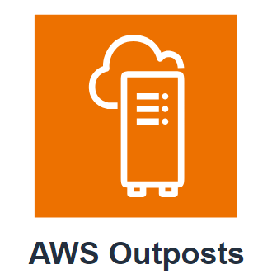
It is a physical rack of servers that you can put in your data center. Your data will reside whenever the Outpost Physically resides.

AWS Direct Connect
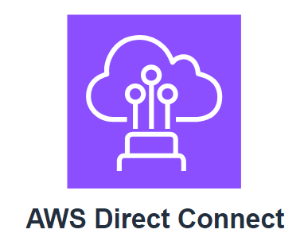
AWS Direct Connect is a networking service that provides an alternative to using the internet to connect to AWS. Using AWS Direct Connect, data that would have previously been transported over the internet is delivered through a private network connection between your facilities and AWS.

AWS Local Zones
AWS Local Zones are a type of AWS infrastructure deployment that place compute, storage, database, and other select services closer to large population, industry, and IT centers, enabling you to deliver applications that require single-digit millisecond latency to end users.
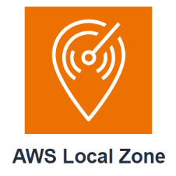
The purpose of Local Zones is to support high-demanding applications sensitive to latency: Media & Entertainment, Electronic Design Automation, Ad-tech, Machine Learning.

AWS Wavelength Zone
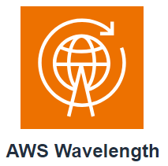
AWS Wavelength enables developers to build applications that require edge computing infrastructure to deliver low latency to mobile devices and end users or increase the resiliency of their existing edge applications. (5G Network)

AWS Ground Station
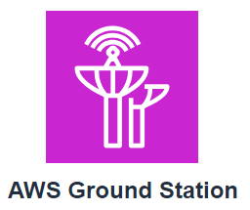
It is a fully managed service that lets you control satellite communications, process data, and scale your operations without having to worry about building or managing your own ground station infrastructure. Satellites are used for a wide variety of use cases, including weather forecasting, surface imaging, communications, and video broadcasts.

MODULE 3: Management and Development tools

Provisioning AWS resources

AWS Management Console
It is a web-based interface for accessing and managing AWS services. You can use it to perform tasks such as monitoring resources, viewing alarms, and accessing billing information.

AWS Command line interface (AWS CLI)
To save time when making API requests, you can use the AWS CLI, that enables you to control multiple AWS services directly from command line within one tool. Available for users on Windows, macOS and Linux

AWS software development kits (AWS SDKs)
SDKs make it easier for you to use AWS services through an API designed for your programming language or platform. Supported languages include C++, Java, .NET and more.

AWS Elastic Beanstalk
With AWS Elastic Beanstalk, you provide code and configuration settings, and deploy the resources necessary to perform the following tasks: Adjust capacity, load balancing, automatic scaling, application health monitoring.
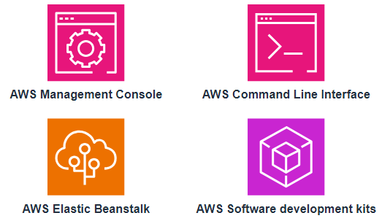

Infrastructure as a Code (IaC)

AWS CloudFormation
AWS CloudFormation allows you to write IaC as either a JSON or YAML file. CloudFormation provides your resources in a safe, repeatable manner, enabling you to frequently build your infrastructure and applications without having to perform manual actions.

AWS Cloud Development Kit (CDK)
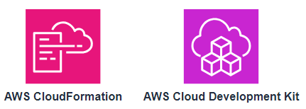
AWS CDK allows you to use your favorite programming language to write Infrastructure as a Code (TypeScript, NodeJS, Python, Java, ASP .NET). CDK is powered by CloudFormation

MODULE 4: Storage and Database

Instance Stores and Amazon Elastic Block Store (EBS)

Instance Stores
Block-level storage volume behaves like physical hard drives.
An instance store provides temporary block-level storage for an Amazon EC2 instance. An instance store is a disk storage that is physically attached to the host computer for an EC2 instance, and therefore has the same lifespan as the instance. When the instance is terminated, you lose any data in the instance store.

Amazon Elastic Block Store (AWS EBS)
It is a service that provides block-level storage volumes that you can use with Amazon EC2 instance. If you terminate and EC2, all data on the attached EBS volume remains available. (When you need a virtual hard drive attached to a VM).
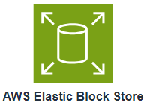
- Volumes attach to EC2 instances
- AZ level resources
- Need to be in the same AZ to attach EC2 instance
- Volume do not automatically scale
To create an EBS volume, you define the configuration (size (16TiB) and type) and provision it. After you create an EBS volume, it can attach to and EC2.
Because EBS volumes are for data that need to persist, it’s important to back up the data. You can take incremental backups of EBPS volumes by creating Amazon EBS snapshots.
Amazon EBS Snapshots
It is an incremental backup. This means that the first backup taken of a volume copies all the data. For subsequent backups, only the block of data that has changed since the most recent snapshots are saved.
It is different from a full backup, that includes data thar has not changed since the most recent backup.

Amazon Simple Storage Service (Amazon S3)
It is a service that provides object-level storage. Amazon S3 stores data as objects in buckets. The maximum file size for an object in Amazon S3 is 5TB.
- Web enabled
- Regionally distributed
- Unlimited storage
- serverless

Object Storage

In object storage, each object consists of data, metadata, and a key.
- Data: video, image, text document, or any other type of file
- Metadata: Information about the data, how it is used, object size, and so on.
- Key: It is the unique identifies

S3 Storage Classes
You can choose from a range of stage classes to select a fit for your business and cost needs. When selecting a storage class consider 2 factors:
- How often you plan to retrieve your data
- How available you need your data to be

>> S3 Standard (default)
- 99.9% Availability
- Designed for frequently accessed data
- Stores data in a minimum of 3 AZ
- Objects: Websites, content distribution and data analytics.
- It has a higher cost than other storage classes

>> S3 Standard-Infrequent Access (S3 Standard-IA)
- Ideal for infrequently accessed data
- Similar to standard but has a lower storage price and higher retrieval price.
- Minimum of 3 AZ
- The same level of availability as Standard
- Objects: Back up

>> S3 One-Zone-Infrequent Access (S3 One-Zone-IA)
- Store data in a single AZ
- Has a lower storage price than Standard-IA
- You want to save cost on storage and can easily reproduce your data in the event of an AZ failure.

>> S3 Intelligent Tiering
- Ideal for data with unknown or changing access patterns
- Requires a small monthly monitoring and automation fee per object
- When you have not accessed an object for 30 consecutive days, S3 automatically move it to the infrequent access tier (Standard-IA and Standard)

>> S3 Glacier Instant Retrieval
- Works well for archived data that required immediate access
- Can retrieve objects within a few milliseconds.
- Lower cost, optimized for data that is rarely accessed but requires instant retrieval when needed.

>> S3 Glacier Flexible Retrieval
- Able to retrieve objects within a few minutes to hours.
- Low-cost storage designed for data archiving

>> S3 Glacier Deep Archive
- Low-cost object storage class ideal for archiving
- Data that might be accessed once or twice in a year.
- Able to retrieve object withing 12 hours - 48 hours.
- Replicated and stored across at least 3 geographically dispersed AZ

>> S3 Outpost
- Create S3 buckets on Amazon S3 Outposts
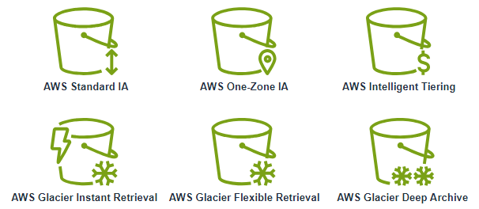
- Makes it easier to retrieve, store and access data on AWS Outposts

Amazon Elastic File System (EFS)
Amazon EFS is a scalable file system used with AWS Cloud services and on-premises resources. As you add and remove files, Amazon EFS grows and shrinks automatically. It can scale on-demand to petabytes without disrupting applications.
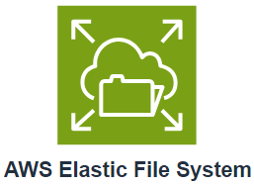
It is ideal for use cases in which a large number of services and resources need access the same data at the same time.
- Multiple instances reading and writing simultaneously
- Linux file system
- Multiple AZ
- Regional resource
- Automatically scale

Amazon Relational Database Service (Amazon RDS)
It is a service that enables you to run relational databases in the AWS Cloud.
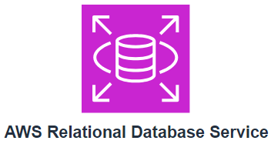
It is a managed service that automates tasks such as hardware provisioning, database setup, patching, and backups. Many Amazon RDS database engines offer encryption at rest (protecting data while it is stored) and encryption in transit (protecting data while it is being sent and received)
- Automatic high availability, recovery provides
- Customer ownership of data and schema
- Customer control of network
AWS supported databases: MySQL, PostgreSQL, Oracle, Microsoft SQL Server, Maria DB, Amazon Aurora

Amazon Aurora
It is an enterprise-class relational database. It is compatible with MySQL and PostgreSQL relational databases. It is up five time faster than standard MYSQL databases and up to 3 time faster than standard PostgreSQL databases
Consider Amazon Aurora if your workloads require high availability. It replicated 6 copies of your data across 3 AZ and continuously backs up data in S3.

Amazon DynamoDB
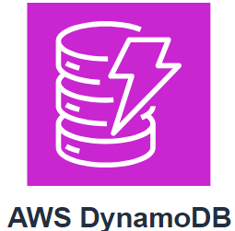
It is a serverless NoSQL key-value database service. It delivers single-digit millisecond
- Non-relational, NoSQL database
- Millisecond response time
- Fully managed
- Granular API access
- Autoscaling

Amazon Redshift
It is a petabyte-size data warehousing service that you can use for big data analytics. It offers the ability to collect data from many sources and helps you to understand relationships and trends across your data.
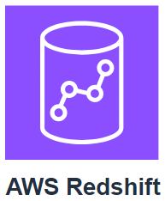

Amazon Database Migration Service
It is a database migration service.
- The source database remains fully operational during migration
- Downtime is minimized for applications that rely on that database
- The source and target databases don’t have to be of the same type.
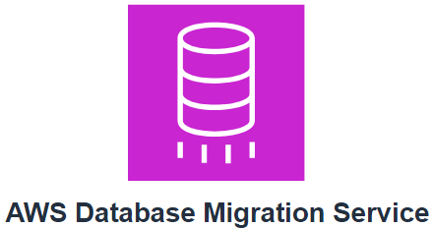
You can migrate from:
- On premise database to AWS
- From 2 database in different or same AWS account using different SQL engines
- From an SQL to NoSQL database
Use cases:
- Development and test database migration
Enables developers to test applications against production data without affecting production users

- Database consolidation
Combining several databases into a single database

- Continuous replication
Sending ingoing copies of your data to other target sources instead of doing a one-time migration.

Additional Database Services

Amazon DocumentDB
It is a document database service that supports MongoDB workloads

Amazon Neptune
It is a graph database service. Data is represented as interconnected node You can use Amazon Neptune to build and run applications that work with highly connected datasets, such as fraud detection and knowledge graphs.

Amazon Quantum Ledger Database (Amazon QLDB)
It is a ledger database service. You can use it to review a complete history of all the changes that have been made to you application data (Record history of financial activities)

Amazon Managed Blockchain
It is a service that you can use to create and manage blockchain networks with open-source frameworks

Amazon ElastiCache
It is a service that adds caching layers on top of your databases to help improve the read times of common requests.

Amazon DynamoDB Accelerator
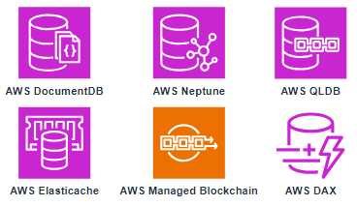
It is an in-memory cache for DynamoDB. It helps improve response times from single-digit milliseconds to microseconds.

MODULE 5: Networking

Conectivity to AWS

Amazon Virtual private Cloud (VPC)
Amazon VPC enables you to provision an isolated section of the AWS Cloud. In this isolated section, you can launch resources in a virtual network that you define. You choose a range of Ips using CIDR Range. Within a VPC, you can organize your resources into subnets
Subnets: It is a section of a VPC that can contains resources such as EC2 instance

Internet Gateway
To allow public traffic from the internet to access your VPS, you attach an internet gateway to the VPC. An internet gateway is a connection between a VPC and the internet.
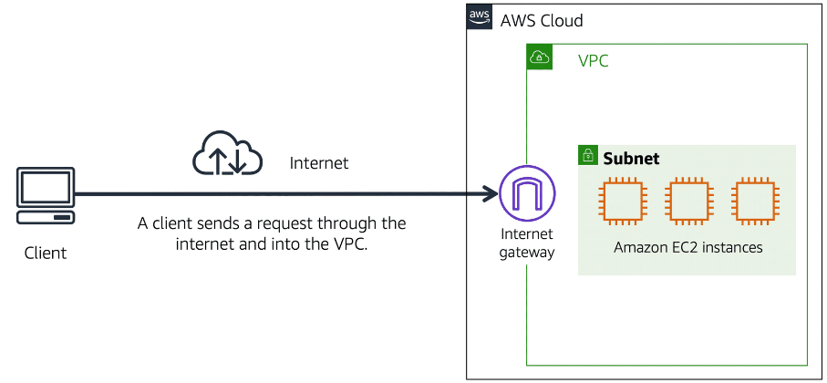

Virtual private Gateway
The virtual private gateway is the component that allows protected internet traffic to enter to the VPC. A virtual private gateway enables toy to establish a virtual private network (VPN) connection between your VPC and a private network, such as an on-premises data center.
A virtual private gateway allows traffic into the VPC only if it is coming from an approved network.
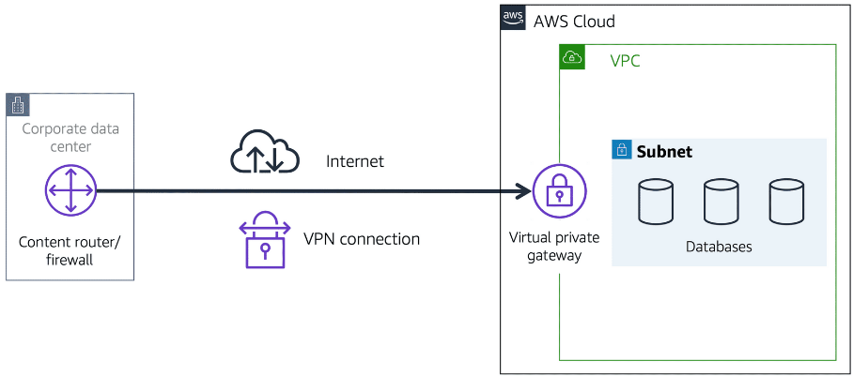

AWS Direct Connect
It is a service that lets you establish a dedicated private connection between your data center and a VPC. The private connection that AWS Direct Connect provides helps you to reduce network costs and increase the amount of bandwidth that can travel through your network.
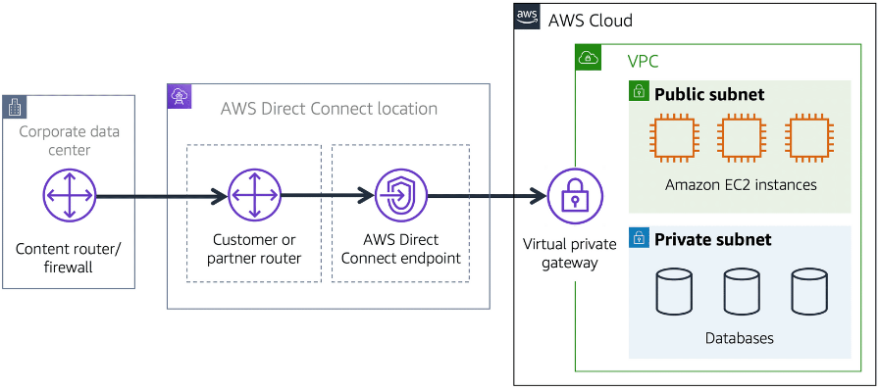

Subnets and Network Access Control Lists

Subnets
A subnet is a section of a VPC in which you can group resources based on security or operational needs. Subnets can be public or private.
Public subnets contain resources that net to be accessible by the public, such as an online store’s website.
Private subnets contain resources that should be accessible only through your private network, such as a database that contains customers’ personal information.

Network traffic in a VPC
When a customer request data from an application hosted in the AWS Cloud, this request is sent as a packet. A packet is a unit of data sent over the internet or a network.
Before a packet can enter a subnet or exit from a subnet, it checks for permissions. These permissions indicate who sent the packet and how the packet is trying to communicate with the resources in a subnet.

Network ACLs
It is a virtual firewall that controls inbound and outbound traffic at the subnet level.
By default, your account’s default network ACL allows all inbound and outbound traffic, but you can modify it by adding your own rules.
All inbound and outbound traffic is denied until you add rules to specify which traffic to allow.
Stateless packet filtering
Network ACLs perform stateless packet filtering. They check packets that cross the subnet border each way: inbound and outbound

Security groups
It is a virtual firewall that controls inbound and outbound traffic for an Amazon EC2 instance
By default, a security group denies all inbound traffic and allows all outbound traffic. You can add custom rules to configure which traffic should be allowed; any other traffic would then be denied.
Stateful packet filtering
Security groups perform stateful packet filtering. They remember previous decisions made for incoming packets.

With both network ACLs and security groups, you can configure rules for the traffic in your vpc.
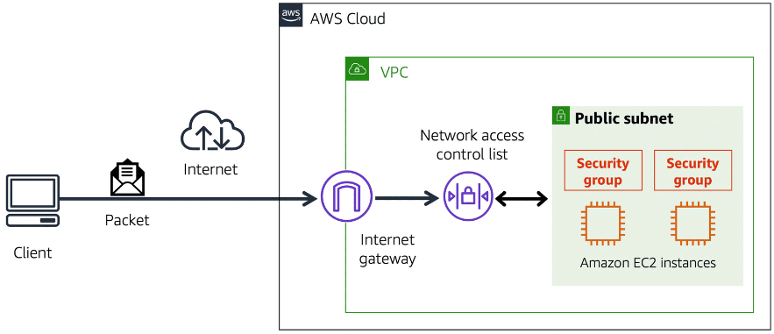

Global Networking

Domain Name System
DNS resolution is the process of translating a domain name to an IP address

Amazon Route 53
It is a DNS web service. It gives developers and businesses a reliable way to route end users to internet applications hosted in AWS.
Amazon Route 53 connects user request to infrastructure running in AWS. Another feature is the ability to manage DNS records for domain named. You can register new domain names directly in Route 53
Routing policies:
- Latency-based routing
- Geolocation DNS
- Geoproximity routing
- Weighted round robin
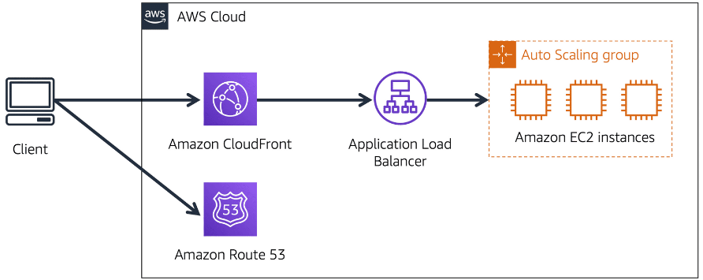

MODULE 6: Compute in the cloud

Amazon Elastic Compute Cloud (Amazon EC2)
Amazon EC2 provides secure, resizable compute capacity in the cloud as Amazon EC2 Instances
- You can provision and launch an Amazon EC2 instance within minutes.
- You can stop using it when you have finished running the workload.
- You pay only for the compute time you use when an instance is running, not when it is stopped or terminated.
- You can save costs by paying only for server capacity that you need or want.
How it works:
- Launch
- Begin by selecting a template with basic configurations for your instance, that includes operating system, application server or application. You also select the instance type, that is the specific hardware configuration of your instance.
- As you are preparing to launch an instance, you specify security settings to control the network traffic.
- Connect
- You can connect to the instance in several ways:
  - Your programs and applications have multiple different methods to connect directly to the instance and exchange data.
  - By logging in and accessing the computer desktop
- Use
- You can run commands to install software, add storage, copy and organize files, and more.

Amazon EC2 Instance Types
Amazon EC2 Instance Types are optimized for different tasks. When selecting an instance type, consider the specific needs of your workloads and applications. This might include requirements for compute, memory, or storage capabilities.

General purpose instances
It provides a balance of compute, memory, and networking resources. You can use them for a variety of workloads, such as:
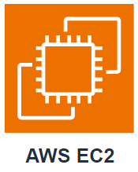
- Application servers
- Gaming servers
- Backend servers for enterprise applications
- Small and medium databases

Compute optimized instances
It is ideal for compute-bound applications that benefit from high-performance processors. Like general purpose, you can use it for web, application and gaming servers.
However, the difference is compute optimized applications are ideal for high-performance web servers, compute-intensive applications servers and dedicated gaming servers.

Memory optimized instances
It is designed to deliver fast performance for workloads that process large datasets in memory. In computing, memory es a temporary storage area. It holds all the data and instructions that a CPU needs to be able to complete actions. Memory optimized instance enables you to run workloads with high memory needs and receive great performance.

Accelerated computing instances
It uses hardware accelerators, or coprocessors, to perform some functions more efficiently than is possible in software running on CPUs. Example of these functions include floating-point number calculations, graphics processing and data pattern matching.
It ideal for workloads such as graphics applications, game streaming and application streaming

Storage optimized instances
It is designed for workloads that require high, sequential read and write access to large datasets on local storage. It is designed to deliver tens of thousands of low-latency, random IOPS (input/output operations per second) to applications. Example for workloads: distributed file systems, data warehousing applications, and high frequency online transaction processing (OLTP) system.

Amazon EC2 Pricing
With Amazon EC2 you pay for the compute time that you use. It offers a variety of pricing options for different use cases.

On-Demand
It is ideal for short-term, irregular workloads that cannot be interrupted. No upfront cost or minimum contracts apply. The instances run continuously until you stop them, and you pay for only the compute time you use. It is not recommended for workloads that last a year or longer.

Example: Developing and testing applications and running applications that have unpredictable usage patterns.

Reserved Instances
It is a billing discount applied to the use of On-Demand instances in your account. There are 2 types of Reserved Instances:
You can purchase the 2 types for a 1-year or 3-year term. You realize cost savings with the 3-year option.
- Standard Reserved Instances
It is a good fit if you know the EC2 instance type and size you need for your steady-state application and in which AWS region you plan to run them.
Reserved Instance require you to state the following qualifications:
- Instance type and size (m5.xlarge)
- Platform description (OS – Microsoft Windows Server or Red Hat Enterprise Linux)
- Tenancy (Default or dedicated)
You have the option to specify an Availability Zone for your EC2 RI.

- Convertible Reserved Instances
If you run your instances in a different AZ or different instance types, then Convertible Reserved might be right for you.

Savings Plans
It reduces your EC2 instance cost when you make and hourly spend commitment to an instance family and region for 1-year or 3-year term. This term includes savings of up to 72% compared to On-Demand rate.
It is ideal when you need flexibility in your Amazon EC2 usage over the duration of the commitment term.

Spot Instances
It is ideal for workloads with flexible start and end time, or that can withstand interruptions. It uses unused EC2 computing capacity and offers you cost savings at up you 90% of On-Demand prices.

Dedicated Hosts
It is a physical server with Amazon EC2 instance capacity that is fully dedicated to your use. It is the most expensive

Scaling Amazon EC2

Amazon EC2 Auto Scaling
It enabled you to automatically add or remove Amazon EC2 instances in response to changing application demand. By automatically scaling your instances in and out as needed, you can maintain a greater sense of application availability. You can use two approaches.
- Dynamic scaling responds to changing demand
- Predictive scaling automatically scheduled the right number of EC2 instances based on predicted demand.
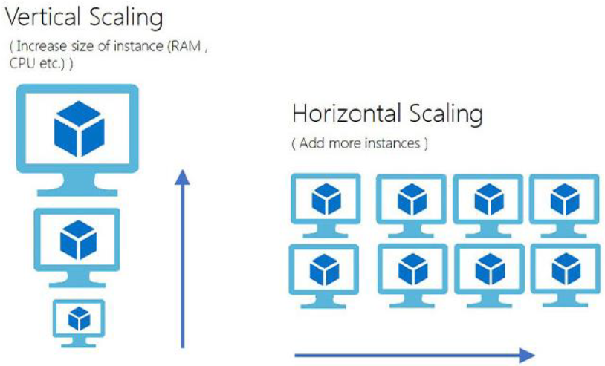

Directing traffic with elastic load balancing

Elastic Load Balancing
It is the AWS service that automatically distributes incoming application traffic across multiple resources, such as AWS EC2 instance.
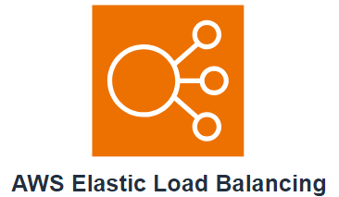
A load balancer acts as a single point of contact for all incoming web traffic to your Auto Scaling group. This means that as you add or remove EC2 instances in response to the amount for incoming traffic, these request route to the load balancer first.

Messaging and Queuing

Amazon SNS
It is a publish/subscribe service. Using Amazon SNS topics, a publisher messages to subscribers. Subscribers can be web servers, email addresses, AWS lambda functions or several other options.

Amazon SQS
In Amazon SQS you can send, store, and receive messages between software components without losing messages or requiring other services to be available.
- Send message
- Store messages
- Receive messages
- Between software components
- At any volume

Additional Compute Services

AWS Lambda
It is a server that lets you code without needing to provision or manage servers. While using lambda you pay only for the compute time that you consume. Charges apply only when your code is running.
How it works:
- Upload code to lambda
- Set code to trigger from an event source
- Code runs only when triggered
- Pay only for the compute time

Amazon Elastic Container Service (Amazon ECS)
It is a highly scalable, high performance container management system that enables you to run and scale containerized applications on AWS. Amazon EC2 supports Docker containers.
Dockers is a software platform that enables you to build, test and deploy applications quickly.

Amazon Elastic Kubernetes Service (Amazon EKS)
It is a fully managed service that you can use to run Kubernetes on AWS
Kubernetes is open-source software that enables you to deploy and manage containerized applications at scale.

AWS Fargate
It is a serverless compute engine for containers. It works with both Amazon ECS and Amazon EKS. When using fargate, you don’t need to provision or manager server, fargate it manages it for you.

MODULE 7: Security

AWS Shared Responsability Model

Customers: Security in the cloud
Customers are responsible for the security of everything that they create and put in in the AWS Cloud.
When using AWS services, you, the customer, maintain complete control over your content. You are responsible for managing security requirements for your content, including which content you choose to store on AWS, which AWS services you use, and who has access to that content.

AWS: Security of the Cloud
AWS is responsible for the security of the cloud.
AWS operates, manages, and controls the components at all layers of infrastructure. This includes areas such as the host operating system, the virtualization layer, and even the physical security of the data centers from which services operate. It is responsible for protecting the global infrastructure, the physical infrastructure that host your resources.
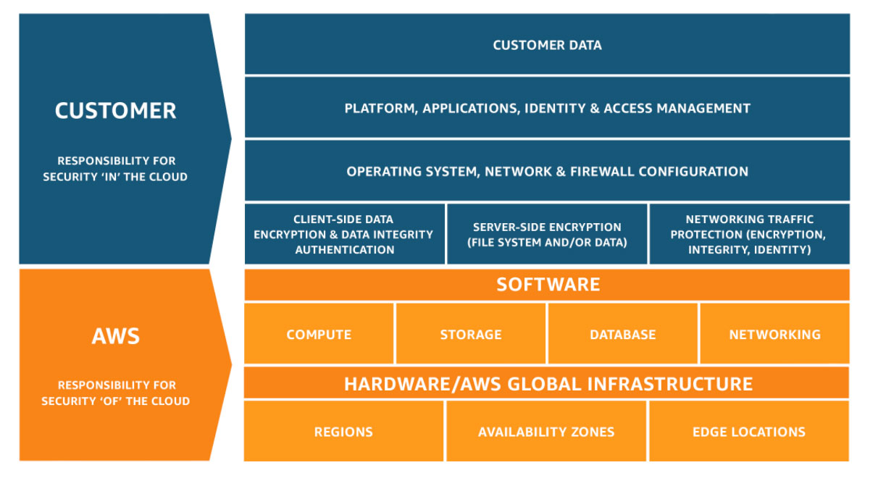

User Permissions and Access

AWS Identify and Access Management (IAM)
It enables you to manage access to AWS services and resources securely. It gives you the flexibility to configure access bases on your company’s specific operational and security needs.
- IAM users, groups and roles
- IAM policies
- Multi-factor authentication

AWS Account root user
When you create an AWS account, you begin with an identity known as the root user.
The root user is accessed by signing in with the email address and password that you used to create your AWS account.
- Best Practice: Do not use the root user for everyday tasks, instead use it to create your first IAM user and assign permissions to create another user.

IAM users
It is an identity that you create in AWS. It represents the person or application that interacts with AWS services and resources. It consists of a name and credentials. By default, it has no permissions associated with it.
- Best Practice: Create individual IAM users for each person who needs to access AWS, even if you have multiple people who require the same level of access.

IAM Policies
It is a document that allows or denies permissions to AWS services and resources.
IAM Policies enable you to customize the user’s level of access to resources.
- Best Practice: Follow the security principle of least privilege when granting permissions.

IAM Groups
It is a collection of IAM users. When you assign an IAM policy to a group, all users in the group are granted permissions specified by the policy.

IAM Roles
It is an identity thar you can assume to gain temporary access to permissions
- Best Practice: IAM roles are ideal for situations in which access to services or resources needs to be granted temporarily, instead of long-term.

AWS Organizations
In AWS Organizations, you can centrally control permissions for the accounts in your organization by using service control policies (SCPs). SCPs enable you to place restrictions on the AWS services, resources, and individual API actions that users and roles in each account can access.
- Centralized management
- Consolidated billing
- Hierarchical grouping of accounts
- AWS services and API actions access control

Organizational Units
In AWS organizations, you can group accounts into organization units (Ous) to make it easier to manage accounts with similar business or security requirements. When you apply a policy to an OU, all the accounts in the OU automatically inherit the permissions specified in the policy.

Compliance

AWS Artifact
It is a service that provides on-demand access to AWS Security and compliance reports and select online agreements. AWS Artifact consists of two main sections:

AWS Artifacts Agreements
In AWS Artifacts Agreements, you can review, accept, and manage agreements for an individual account and for and for all your accounts in AWS Organizations. (Health Insurance Portability and Accountability Act – HIPAA)

AWS Artifacts Report
It provides compliance reports from third-party auditors. These auditors have tested and verified that AWS is compliant with a variety of global, regional and industry-specific security standards and regulations.

Customer Compliance Center
It contains resources to help you learn more about AWS compliance

Denial-of-Service Attacks
A denial-of-service (DoS) attack is a deliberate attempt to make a website or application unavailable to user.

AWS Shield
It is a service that protect application against DDoS attacks. It provides two levels of protection Standard and Advanced.

AWS Shield Standard
It automatically protects all AWS customers at no cost. It protects your AWS resources from the most common, frequently occurring types of DDoS attacks. It uses a variety of analysis techniques to detect malicious traffic in real time and automatically mitigates it.

AWS Shield Advanced
It is a paid service that provides detailed attack diagnostics and the ability to detect and mitigate sophisticated DDoS attacks. It also integrates with other services such as AWS CloudFront, AWS Route 73 and Elastic Load Balancing. Additionally, you can integrate AWS Shield with AWS WAF by writing custom rules to mitigate complex DDoS attacks

Additional Security Services:

AWS Key Management Service (KMS)
It enables you to perform encryption operations using cryptographic keys. A cryptographic key is a random string of digits used for locking (encrypting) and unlocking (decryption). You can use KMS to create, manage and use the keys.

AWS WAF
It is a web application firewall that lets you monitor network requests that come into your web application. It works together with AWS CloudFront and an Application Load Balancer. AWS WAF works in a similar way to block or allow traffic by using a web access control list(ACL) to protect your AWS resources.

AWS Inspector
It helps you to improve the security and compliance of applications by running automated security assessments. It checks applications for security vulnerabilities and deviations from security best practices. After has perform the inspection, it provides you with a list of security findings.

AWS GuardDuty
It is a service that provides intelligent threat detection for your AWS infrastructure and resources. It identifies threats by continuously monitoring network activity and account behavior within your AWS environment

MODULE 8: Monitoring and Analytics

Amazon CloudWatch
It is a web service that enables you to monitor and manage various metrics and configure alarm actions based on data from those metrics. CloudWatch uses metrics to represent the data points for your resources. AWS services send metrics to CloudWatch. CloudWatch then uses these metrics to create graphs automatically that show performance has changed over time.
- Access all your metrics from a central location
- Gain visibility into your applications, infrastructure, and services
- Reduce mean time to resolution (MTTR) and improve total cost of ownership (TCO)
- Drive insights to optimize applications and operational resources

CloudWatch Alarms
You can create alarms that automatically perform actions if the value of your metrics has gone above or below a predefined threshold.

CloudWatch dashboard
It is a feature that enables you to access all the metrics for your resources from a single location. (CPU utilization of EC2 instance, total number of requests made to an AWS S3 and more)

Amazon CloudTrail
AWS CoudTrail records API calls for your account. The recorded information includes the identity of the API caller, the time of the API call, the source of the IP address of the API caller, and more. (Actions that someone has left behind. With this service you can view a complete history of user activity and API calls for your application and resources. Events are typically updated in CloudTrail within 15 min after an API call
Filter logs to assist with operational analysis and troubleshooting

CloudTrail Insights
This optional feature allows CloudTrail to automatically detect unusual API activities in your AWS Account.

Amazon Trusted Advisor
It is a web service that inspects your AWS environment and provides real-time recommendations in accordance with AWS best practices.
It compares its finding to AWS best practices in five categories:
- Cost optimization
- Performance
- Security
- Faul tolerance
- Service limits

AWS Truested Advisor Dashboard
When you access the trust advisor dashboard on the AWS Management Console, you can review completed checks for the 5 categories.

AWS Config
AWS Config is a service provided by Amazon Web Services (AWS) that allows you to assess, audit, and evaluate the configurations of your AWS resources. It helps you monitor and record your AWS resource configurations and automate the evaluation of recorded configurations against desired configurations.

MODULE 9: Pricing and Support

AWS Free Tier
It enables you to begin using certain services without having to worry about incurring costs for the specific period.
- Always free
These offers do not expire and are available to all AWS customers.
- 12 Months Free
Those offers are free for 12 months following your initial sign-up date to AWS
- Trials
Short-term free trial offers start from the date you activate a particular service. The length of each trail might vary by number of days or the amount of usage in the service.

AWS Pricing Concepts
AWS offers a range of cloud computing services with pay-as-you-go pricing.
- Pay for what you use
- Pay less when you reserve
- Pay less with volume-based discounts when you use more

AWS Pricing Calculator
It let you explore AWS services and create an estimate for the cost of your use cases on AWS.

Billing Dashboard
Use the AWS Billing & Cost Management dashboard to pay your AWS bill, monitor your usage, and analyze and control your costs.
- Compare your current month-to-date balance with the previous month, and get a forecast of the next month based on current usage
- View month-to-date spend by service
- View Free Tier usage by service
- Access Cost Explorer and create budgets
- Purchase and manage Savings Plans
- Publish AWS Cost and Usage Reports

Consolidated Billing
AWS Organizations also provides the option for consolidated billing. The consolidated billing feature enables you to receive a single bill for all AWS Accounts in your organization. By consolidating, you can easily track the combined costs of all the linked accounts in your organization. The default number of account allowed for an organization is 4, but you can contact AWS Support to increase your quota.

AWS Budgets
You can create budgets to plan your service usage, service costs, and instance reservation.
The information in AWS Budgets is updated 3 times a day. This helps you to accurately determine how close your usage is to your budgeted amounts or the AWS Free Tier limits

AWS Cost Explorer
It is a tool that lets you visualize, understand and manage your AWS costs and usage over time. It includes a default report of the costs and usage of your top five cost-accruing AWS Services.

AWS Support Plans
AWS offers 4 different support plans to help you troubleshoot issues, lower costs, and efficiently use AWS services
- Basic
- Developer
- Business
- Enterprise On-Ramp
- Enterprise

Basic Support
- It is free for all AWS customers.
- Access to whitepapers, documents and support communities
- Billing questions and service limit increases
- AWS Personal Health Dashboard It is a tool that provides alert and remediation guidance when AWS is experiencing events that may affect you
The next support plants have pay-by-the-months pricing and require no long-term contracts

Developer Support
- Basic
- Client-side diagnostic tools
- Email access to customer support
- Building-block architecture support, which consists of guidance for how to use AWS offering, feature and services together-

Business Support
- Basic and developer support
- AWS trusted advisor provides full set of best practice checks
- Direct phone access to cloud support engineers
- Infrastructure event management
- Limited support for third-party software, such as common operating systems and applications stack components.

Enterprise On-Ramp Support
- Basic, developer and business support
- Cost Optimization Workshop (One per year)
- Infrastructure Event Management support (One per year)
- 30-minute response time for business-critical workloads
- Access to a pool of Technical Account Managers (TAMs)

Enterprise Support
- Basic, developer and business support
- A concierge support team for billing and account assistance
- 15-minute response time for business-critical workloads
- Designated Technical Account Managers (TAMs)

Technical Account Managers (TAMs)
It is your primary point of contact at AWS. If your company subscribes to Enterprise support, your TAM educates and evolves your cloud journey across the full range of AWS range. It provides expert engineering guidance, help you design solutions that efficiently integrate AWS services, assist with cost-effective and resilient architectures.

AWS Marketplace
It is a digital catalog that includes thousands of software listings from independent software vendors. You can use it to find, test, and buy software that runs on AWS.
Categories: Infrastructure software, DevOps, Data Products, Professional Services, Business Applications, Machine Learning, Industries, IoT.

MODULE 10: Migration and innovation

AWS Cloud Adoption Framework (AWS CAF)
The AWS CAF organizes guidance into 6 areas of focus, called Perspective. Each perspective addresses distinct responsibilities. The planning process helps the right people across the organization prepare for the changes ahead.
- Business, People and Governance perspectives focus on business capabilities
- Platform, Security and Operations perspectives focus on technical capabilities

Business Perspective
- It ensures that IT aligns with business needs and the IT investments link to key business results.
- Use it to create a strong business case for cloud adoption and prioritize cloud adoption initiative.
- Includes: Business and finance managers, Budget owners and strategy stakeholders.

People Perspective
- It supports development of an organization-wide change management strategy for successful cloud adoption.
- Use it to evaluate organizational structures and roles, new skill and process requirements and identify gaps
- Includes: Huma Resources, Staffing, People managers

Governance Perspective
- It focuses on the skills and processes to align IT strategy with business strategy. This ensures that you maximize the business value and minimize risks.
- Use it to understand how to update the staff skills and processes necessary to ensure business governance in the cloud.
- Include: Chief Information Officer, Program manager, Enterprise architect, Business analytics and Portfolio manager.

Platform Perspective
- It includes principles and patters form implementing new solutions on the cloud, and migration on-premises workloads to the cloud
- Use a variety of architecture models to understand and communicate the structure of IT systems.
- Include: Chief Technology Officer, IT Managers and Solutions architects

Security Perspective
- Ensures that the organization meets security objectives for visibility, auditability, control, and agility.
- Use the AWS CAF to structure the selection and implementation of security controls that meet the organization’s needs
- Include: Chief Information Security Officer, IT security managers, IT security analysts

Operations Perspective
- It helps you to enable, run, use, operate and recover IT workloads to the level agreed upon with your business stakeholders.
- Includes: IT operations managers, IT support managers

Migration Strategies
When migration applications to the cloud, six of the most common migration strategies that you can implement are:

Rehosting
- It is also known as “lift-and-shift”
- Involves moving applications without changes

Replatforming
- It is also known as “lift, tinker, and shift”
- Involves making a few cloud optimizations to realize tangible benefits.
- Optimization is achieved without changing the core architecture of the applications

Refactoring/re-architecting
- It is also known as “re-architecting”
- Involves reimagining how an application is architected and developed by using cloud-native features.
- It is driven by a strong business need to add feature, scale, or performance that would otherwise be difficult to achieve in the application’s existing environment

Repurchasing
- Involves moving from a traditional license to a software-as-a-service model

Retaining
- It consists of keeping applications that are critical for the business in the source environment. This might include applications that require major refactoring before they can be migrated, or work that can be postponed until a later time

Retiring
- It is the process of removing applications that are no longer needed

AWS Snow Family members
The AWS Snow Family is a collection of physical devices that help to physically transport up to exabytes of data into and out of AWS.

AWS Snowcone
- It is a small, rugged, and secure edge computing and data transfer device
- It features 2 CPUs, 4GB of memory, and up to 14 TB of usable storage

AWS Snowball

Snowball Edge Storage Optimized
  - The devices are well suited for large-scale data migrations and recurring transfer workloads, in addition to local computing with higher capacity needs
    - Storage: 80 TB (HDD) capacity for block volumes and Amazon S3 compatible object storage, and 1TB of SATA (SSD) for block volumes
    - Compute: 40 vCPUs and 80 GiB of memory to support EC2

Snowball Edge Compute Optimized
  - It provides powerful computing resources for use cases such as machine learning, full motion video analysis, analytics, and local computing stacks
    - Storage: 80 TB (HDD) Amazon S3 compatible object storage
    - Compute: 104 vCPUs, 416 GiB of memory and an optional NVIDE Tesla V100 GPU

AWS Snowmobile
- It is an exabyte-scale data transfers service used to move large amounts of data to AWS
- You can transfer up to 100 petabytes of data per Snowmobile

MODULE 11: The cloud journey

The AWS Well-Architected Framework
It helps you to understand how to design and operate reliable, secure, efficient and cost-effective systems in the AWS Cloude

Operational Excellence
- It is the ability to run and monitor systems to delivery business value and to continually improve supporting processes and procedures

Security
- It is the pillar is the ability to protect information, systems and assets while delivering business value through risk assessments and mitigation strategies

Reliability
- It is the ability to recover from infrastructure or service disruptions
- Dynamically acquire computing resources to meet demand
- Mitigate disruptions such as misconfigurations or transient network issues
- Include testing recovery procedures, scaling horizontally to increase aggregate system availability, and automatically recovering from failure.

Performance efficiency
- It is the ability to use computing resources efficiently to meet system requirements and to maintain the efficiency as demand changes and technologies evolves

Cost Optimizations
- It is the ability to run system to deliver business value at the lowest price point

Sustainability
- It is the ability to continually improve sustainability impacts by reducing energy consumption and increasing efficiency across all components of a workload.

Benefits of the AWS Cloud

