Using NuGet

1. Create a local folder where the package files will be copied to. In this example X:\Nuget. Copy the RawFIleReader NuGet file to this folder.
2. In Visual Studio open the Tools | Options dialog and select NuGet Package Manager | Package Sources (Figure 1).

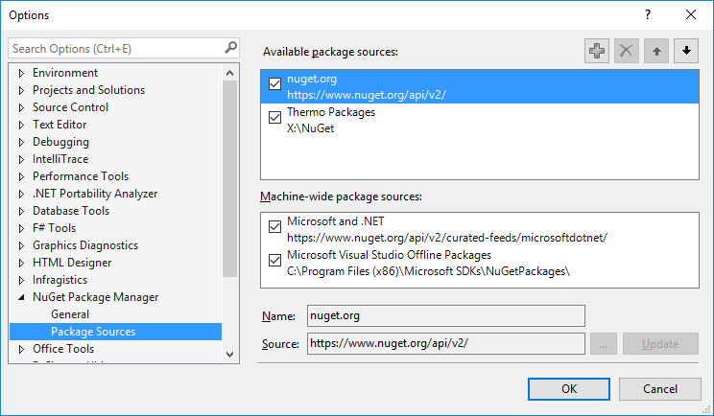

Figure 1.

1. Click on the plus sign to add a new source. Select the ... button to the right of Source. In the dialog select he folder created in step 1. Assign a name to this item. I choose Thermo Packages.
2. Click OK.
3. In a project, such as the RawFileReader example program, select the Solution Explorer tab and make sure that the project doesn’t contain any references to the ThermoFisher.CommonCore libraries. If they are present, then delete them.
4. Right click on References and select Manage NuGet Packages. In the Nuget Package Consolde click on the Thermo Packages item on the left (Figure 2). The package files in the folder created in step 1 will be displayed. Select Thermo Scientific Raw File Reader and install it. Since our NuGet package contains the Windows and MacOS assemblies, an extra step of manually browsing in the Add References dialog is necessary. The assemblies will be in packages/ThermoFisher.CommonCoreRawFileReader.4.0.26/lib/Windows.

(Note - The dialog shown is from Visual Studio 2015, Microsoft has updated it for Visual Studio 2017.)

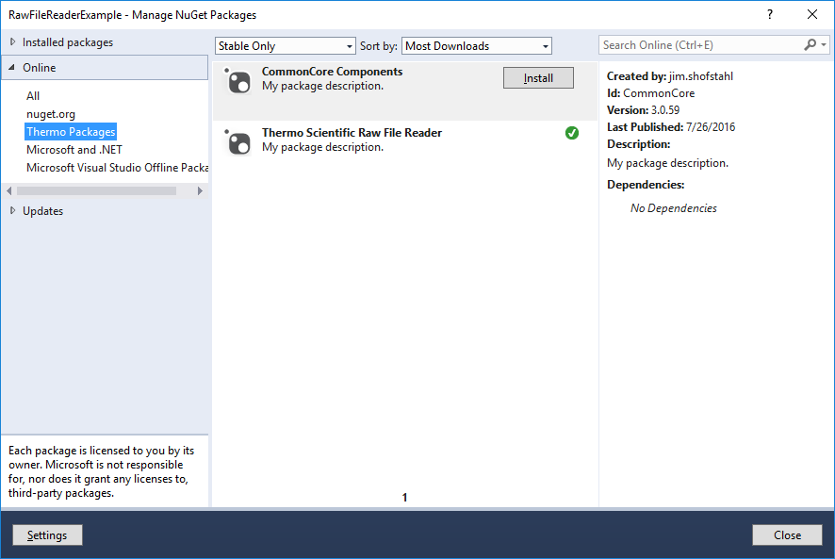

Figure 2.

1. Rebuild the project
2. The project should look similar to this if the package installed in step 6 (Figure 3). The XML files may or may not be present in the project.

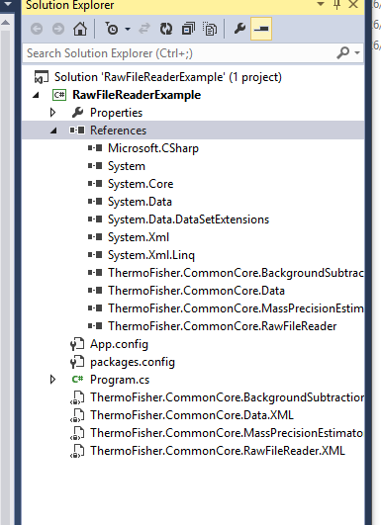

Figure 3.