Riyadh Mobility Dashboard Team Runbook
atomcamp Arabia and Microsoft Riyadh Urban Hackathon
This guide is for a mixed team. A manager can lead the session, a runtime owner can run the dashboard on one laptop, a change owner can make small edits, and an Azure owner can handle cloud resources. You do not need to understand the whole codebase before you start.
Public dashboard: Open the deployed application
The local path is the safe starting point. It uses bundled sample data, needs no Azure login, and creates no Azure costs.
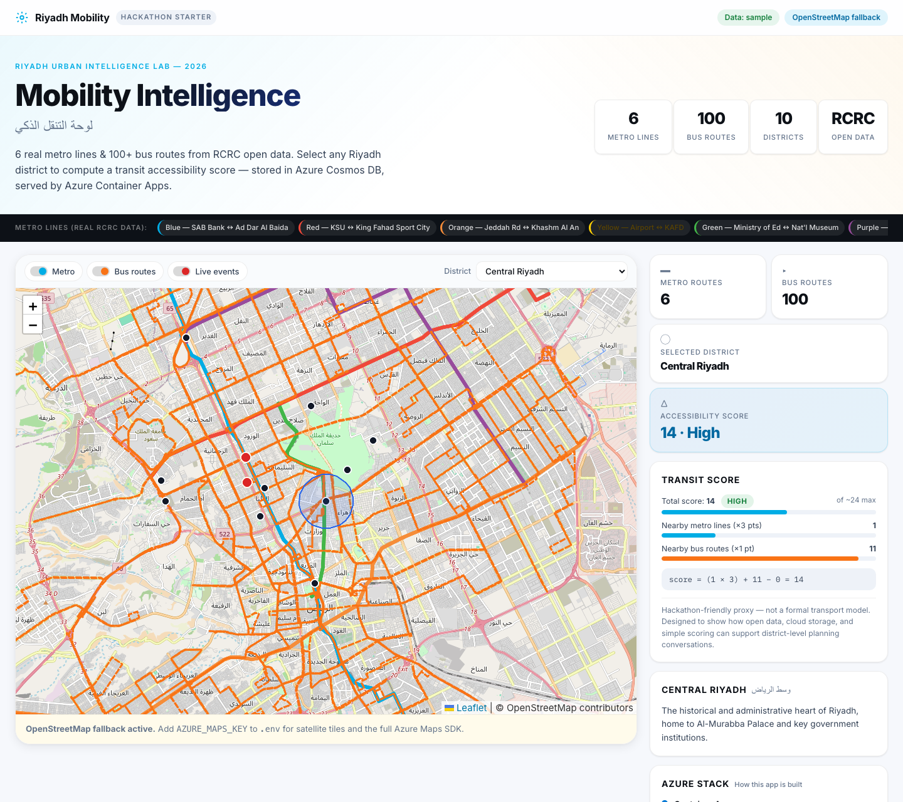
Local dashboard showing Riyadh map routes and district score
The local dashboard: transport routes, district selection, and a transparent accessibility score.
<!-- pagebreak -->

1 Pick the route and assign people
Start by deciding what the team actually needs. Do not install tools or touch Azure if the goal is only to show the existing dashboard.
If your goal is | Do this | Stop when
Show the existing app | Open the public dashboard | The demo is complete
Change the app locally | Assign a runtime owner and follow Sections 2–8 | The local checks pass
Publish a changed app | Ask the Azure owner to follow Section 10 | The deployed smoke test passes
Give each job to a named person before anyone starts. One person may fill more than one role on a small team.
Role | Owns | Does not need to do
Manager or facilitator | Goal, demo flow, decisions, and handoff notes | Edit code or Azure resources
Runtime owner | Installs the local tools, runs the dashboard, and completes checks | Deploy to Azure
Change owner | Makes one small code or data change at a time and retests | Approve cloud spending
Azure owner | Subscription, resource group, cloud deployment, and cost controls | Change the product story
Follow this order every time:
1. The manager chooses the route above and names the owners.
2. The runtime owner follows Sections 2–5 until the local dashboard works.
3. The change owner follows Sections 6–8 for one small change.
4. The manager repeats the checks and records the result.
5. Only then does the Azure owner use Section 10.
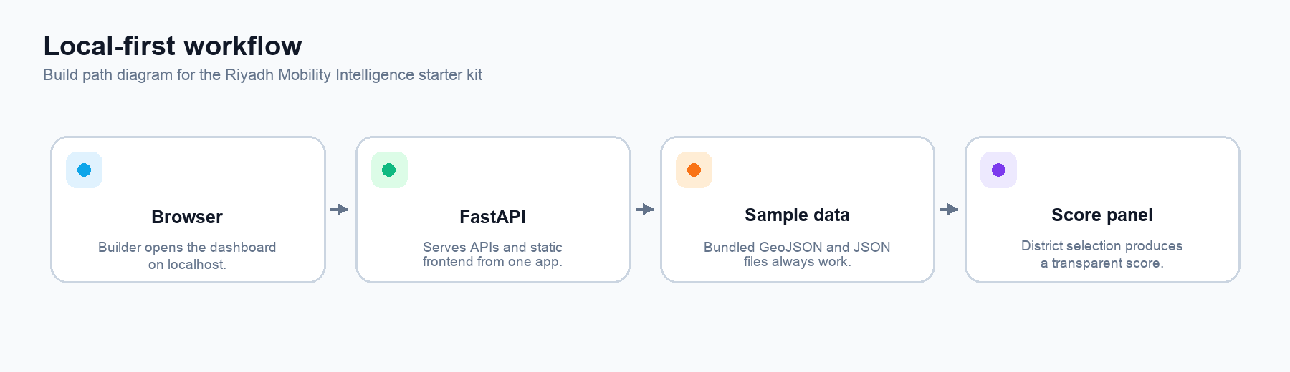
Local first workflow from browser to API to sample data to score panel
The same workflow works locally before any cloud services are introduced.
Success in the first 20 minutes: the dashboard opens at http://127.0.0.1:8000; Metro and Bus layers can be toggled; selecting a district updates the score; /health returns {"status":"ok"}.
If nobody on the team writes code: use the public dashboard for the demo, then ask a runtime owner or mentor to perform the local setup. The manager does not need to edit files, install Azure tools, or run cleanup commands.
Manager fast lane: if the goal is a demo, open the public dashboard and stop. If local setup fails once, stop repeating commands and send the support note in Section 6.
<!-- pagebreak -->

2 Get the computer ready
This section explains the few computer concepts used later. Read it once before copying commands.

Words you need
Word | Plain meaning
Terminal | The app where you type commands. On macOS it is Terminal; on Windows it is PowerShell.
Repository | The project folder downloaded from GitHub.
Command | A short instruction typed into the terminal, then confirmed with Enter.
Virtual environment | A private project toolbox named .venv; it keeps this app’s Python packages separate.
Localhost | This laptop. 127.0.0.1:8000 means the browser is talking to the app on this laptop.

Install the two required tools
You need Git, Python 3.11 or newer, an internet connection for the one-time download, and a terminal. If the laptop is managed by an organisation, ask IT or the runtime owner to install them.
- Install Git
- Install Python
- Optional plain-text editor: Visual Studio Code
On Windows, select Add Python to PATH in the Python installer if that option appears. After installing, close and reopen PowerShell.
Use a plain-text editor for code and data files. Do not open Python, JSON, or GeoJSON files in Word or Pages.

Check the tools
macOS Terminal
git --version
python3 --version
Windows PowerShell
git --version
py --version
Pass result: both commands print a version number, and Python is 3.11 or newer. If a command is not found, install the missing tool, reopen the terminal, and run the check again. If Windows says py is not recognised, type python instead in every command; Command Prompt works as well as PowerShell.

Terminal habits that prevent mistakes
1. Copy one command at a time.
2. Paste it into the terminal and press Enter.
3. Wait for it to finish before running the next command.
4. Keep the terminal visible when the server is running; it is the app’s status window.
5. If a command prints a red error, stop and capture the full error before trying random fixes.
AI Pro Tip: Ask Copilot or ChatGPT: “Explain this command in plain English, tell me what success looks like, and give me only the next action. Do not change files.” Never paste passwords, keys, or the contents of .env.
<!-- pagebreak -->

3 Start on macOS
The runtime owner should do these steps in order. The first run downloads Python packages and may take a few minutes.

Step 1 Open Terminal
Open Applications → Utilities → Terminal. A prompt appears. The prompt is where you type; do not type the prompt characters themselves.

Step 2 Download the project
git clone https://github.com/Esturban/microsoft-hackathon-riyadh-mobility.git
cd microsoft-hackathon-riyadh-mobility
Pass result: the prompt is now inside the project folder. If cd says the folder does not exist, run ls and check the spelling.

Step 3 Create the private Python toolbox
python3 -m venv .venv
source .venv/bin/activate
Pass result: (.venv) appears at the start of the terminal prompt. You must repeat the source command each time you open a new terminal for this project.

Step 4 Install the app packages
python -m pip install -r requirements.txt
Pass result: the command finishes without a red error. Warnings are usually okay; copy them to the handoff note if the app does not start.

Step 5 Create the local settings file
cp .env.example .env
The copied file uses DATA_MODE=sample. That is the correct setting for a workshop. Do not add Azure keys to this file unless the Azure owner tells you to.

Step 6 Start the dashboard
python -m uvicorn app.main:app --reload
Pass result: the terminal says Uvicorn running on http://127.0.0.1:8000. Leave this terminal open.

Step 7 Open the browser
Open http://127.0.0.1:8000. If the page loads, continue to Section 5. To stop the server, return to Terminal and press Ctrl+C.
<!-- pagebreak -->

4 Start on Windows
Use PowerShell, not the browser address bar. The runtime owner should copy one command at a time.

Step 1 Open PowerShell
Open the Windows Start menu, search for PowerShell, and open it. A blue or black terminal window appears.

Step 2 Download the project
git clone https://github.com/Esturban/microsoft-hackathon-riyadh-mobility.git
cd microsoft-hackathon-riyadh-mobility
Pass result: the prompt is now inside the project folder. If cd says the folder does not exist, run dir and check the spelling.

Step 3 Create and activate the private Python toolbox
py -3 -m venv .venv
.venv\Scripts\Activate.ps1
Pass result: (.venv) appears at the start of the PowerShell prompt. You must repeat the activation command each time you open a new PowerShell window for this project.
If PowerShell says that running scripts is disabled, run this one-time command for the current window, then activate again:
Set-ExecutionPolicy -Scope Process -ExecutionPolicy Bypass
.venv\Scripts\Activate.ps1

Step 4 Install the app packages
python -m pip install -r requirements.txt
Pass result: the command finishes without a red error. Warnings are usually okay; capture them if the app does not start.

Step 5 Create the local settings file
Copy-Item .env.example .env
The copied file uses DATA_MODE=sample. Do not add Azure keys to this file unless the Azure owner tells you to.

Step 6 Start and open the dashboard
python -m uvicorn app.main:app --reload
Leave the PowerShell window open. Open http://127.0.0.1:8000 in a browser. To stop the server, return to PowerShell and press Ctrl+C.
<!-- pagebreak -->

5 Prove the local app works
Do not change code until these checks pass. A manager can perform the browser checks while the runtime owner watches the terminal.
Check | What to do | Pass result
Dashboard | Open http://127.0.0.1:8000 | Riyadh map and controls appear
Map layers | Turn Metro and Bus off, then on | Route overlays disappear and return
District score | Choose a district | Rating and explanation update
Health | Open http://127.0.0.1:8000/health | {"status":"ok"}
Data source | Open http://127.0.0.1:8000/api/data-status | activeMode is sample
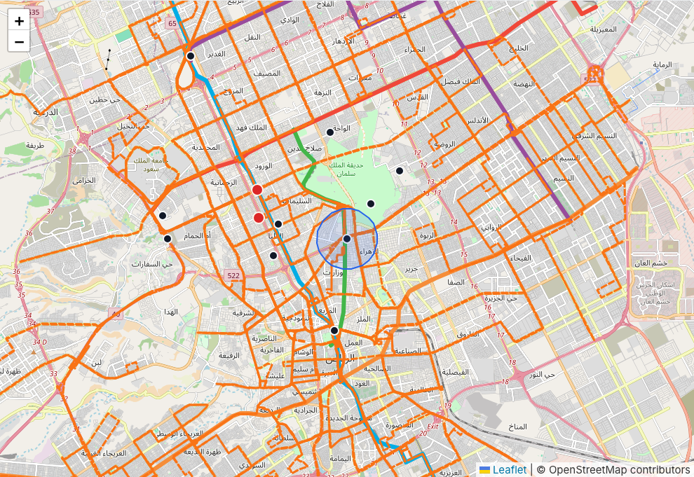
Map layers showing metro bus routes and district markers
The local map remains useful when Azure Maps is not configured because it falls back to OpenStreetMap tiles.

What the browser pages mean
- /health answers one question: is the API alive?
- /api/data-status answers: which data source is active? sample is expected locally.
- /api/districts lists the districts available to the selector.
- /api/routes lists the route summary used by the dashboard.
Use this short demonstration flow:
1. Show the dashboard landing page.
2. Toggle Metro and Bus layers to explain the two transport views.
3. Select a district and read the score explanation.
4. Open /api/data-status and explain that sample data keeps the app working without cloud credentials.
<!-- pagebreak -->

6 Recover when something goes wrong
Most first-run problems are a missing tool, the wrong folder, an inactive .venv, or a server that is not running. Use the first matching row and stop if the fix does not work.
What you see | First action | If it still fails
command not found or not recognized | Install the named tool, reopen the terminal, and rerun the version check | Ask IT or the runtime owner
destination path already exists during git clone | Run ls or dir, then cd into the existing project folder | Ask the runtime owner before cloning a second copy
No such file or directory after cd | Run ls on macOS or dir on Windows and check the folder name | Re-run the git clone step in a known folder
ModuleNotFoundError | Activate .venv, then rerun python -m pip install -r requirements.txt | Capture the full error
Browser says it cannot connect | Check that the Uvicorn terminal is still open and use port 8000 | Restart the server
Address already in use | Run python -m uvicorn app.main:app --reload --port 8001 and open port 8001 | Tell the manager which port you used
PowerShell blocks Activate.ps1 | Run the process-scoped policy command in Section 4 | Ask the runtime owner; do not change organisation-wide policy
Map is blank | Set AZURE_MAPS_KEY= in .env, save, and restart | Check whether the OpenStreetMap fallback appears
A code or data edit breaks the page | Stop the server and undo only the last edit in the editor | Ask the change owner to review the diff
A cloud command asks for a subscription or deletes resources | Stop immediately | Give the command and full output to the Azure owner

The support note to send
When asking for help, send these five lines. Do not send passwords, keys, or the contents of .env.
Computer: macOS or Windows
Step I was on:
Command I ran:
What I expected:
What actually happened and the full error:
AI Pro Tip: Paste only the support note into Copilot or ChatGPT and ask: “I am new to Python. Identify the likely cause, give me one safe next step, and tell me what result to expect.” If the first fix fails, stop and ask the runtime owner.
<!-- pagebreak -->

7 Make one safe change
Make only one change at a time. Keep the local app working before and after the change. Do not deploy a change that has not passed the local checks.
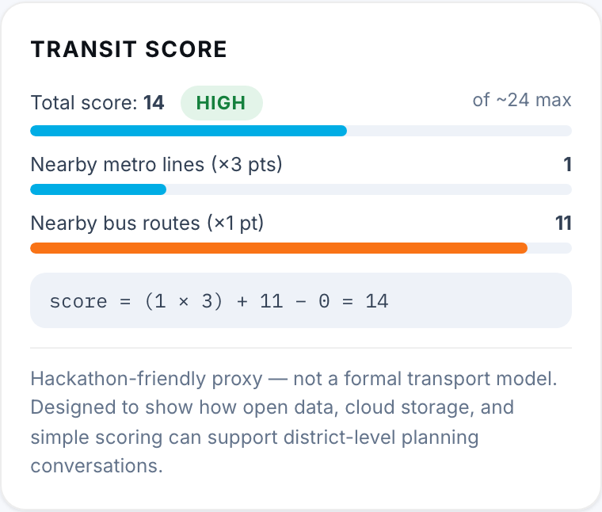
Transit score panel showing the simple scoring formula
The score is intentionally transparent so teams can discuss and adapt the rule.

First change the score weighting
1. Stop the server with Ctrl+C.
2. Open app/scoring.py in Visual Studio Code (File, Open Folder, pick the project folder, then click the file). Notepad on Windows or TextEdit in plain text mode on macOS also work.
3. Find this line:
`python
score = (nearby_metro_count * 3) + nearby_bus_count - live_delay_penalty
`
1. Change only the 3 if you want metro access to count more or less. For example, change it to 2. The tests expect the weight 3, so python -m pytest now fails on the scoring test on purpose; that is the check working. Put the 3 back, or change the expected value in the test, before you hand off.
2. Save the file.
3. Start the server again and select a district.
4. Repeat every check in Section 5.

Record the change
git diff -- app/scoring.py
python -m pytest
Pass result: the diff shows only the intended line and the tests pass. If the result is wrong, undo the last edit in the text editor, save, and repeat Section 5.

Rules for a first change
- Change one file, not five files.
- Do not change .env to a cloud mode.
- Do not paste secret values into a document or chat.
- Do not ask the Azure owner to deploy until the manager has seen the local result.
AI Pro Tip: Before editing, ask Copilot: “Explain this scoring line in plain English and show a small example.” After editing, ask: “Review this diff for accidental changes; do not rewrite it.” A human still decides whether the change matches the workshop goal.
<!-- pagebreak -->

8 Change sample data safely
Sample data is the workshop safety net. It lives in app/static/sample-data/ and keeps the app useful without cloud credentials.
File | Contains | Beginner guidance
riyadh_metro_lines_sample.geojson | Six metro line features | Ask a technical reviewer before changing geometry
riyadh_bus_routes_sample.geojson | Bus route features | Preserve valid GeoJSON structure
district_centers_sample.geojson | Ten district points and names | Change one district record at a time
mock_live_events_sample.json | Example delay or incident markers | Keep the JSON commas and quotes valid

Safe data workflow
1. In Finder or File Explorer, duplicate the original file and put the copy outside the project folder.
2. Change one record in the sample file.
3. Save the file.
4. Run the validator:
`bash
python scripts/validate_data.py
`
1. Start the local server and repeat Section 5.
2. Run the tests:
`bash
python -m pytest
`
1. Show the changed file and the command results to the manager.
If validation fails, stop. The error names the file or property that needs review. Do not switch to blob, cosmos, or auto to hide a sample-data problem.

Files technical owners may need
Goal | Start here
Run the app | app/main.py
Change the API | app/routes.py
Change data fallback | app/data_access.py
Change the score | app/scoring.py
Change page or map interaction | app/static/index.html and app/static/src/
Replace sample data | app/static/sample-data/
Review Azure infrastructure | azure.yaml and infra/
<!-- pagebreak -->

9 Run the demo and hand off
The manager can lead this section without opening the code editor.

Five minute demo
1. Open the public dashboard or the verified local URL.
2. Introduce the Riyadh map and the Metro and Bus layers.
3. Select one district and explain that the score is a transparent workshop proxy, not a formal transport model.
4. Open /api/data-status and show that the local demo uses bundled sample data.
5. If the team changed anything, show the one changed file and the passing checks.

Names and ownership
Write these down before the session ends.
Role | Name | Last confirmed
Manager or facilitator | ____________________ | ____________________
Runtime owner | ____________________ | ____________________
Change owner | ____________________ | ____________________
Azure owner | ____________________ | ____________________

Handoff checklist
- Last successful local URL and the computer used.
- Date and time of the last successful run.
- DATA_MODE value in .env (sample for workshops).
- Changed files and the result of python -m pytest plus python scripts/validate_data.py.
- Public URL, target subscription, resource group, region, and cost owner if Azure is in use.
- The full support note if a check failed.
<!-- pagebreak -->

10 Azure owner only
This is the only section that can create billable cloud resources. A beginner should not run it alone. If the team only needs a demo, stop at Section 9.

Current shared deployment
The verified public dashboard is running on the Riyadh Urban Hackathon subscription. The target resource group is rg-riyadh-ud-uae-north in UAE North. The Bicep deployment keeps Azure Maps global; its account is maps-riyadh-mobility-riyadh-ud-uae-north. The West US 2 source group has been decommissioned after the replacement health and data-status checks passed.
https://ca-rmd-api-riyadh-ud-ua-aesdq5.jollyplant-57daa6ab.uaenorth.azurecontainerapps.io/
Its health endpoint is:
https://ca-rmd-api-riyadh-ud-ua-aesdq5.jollyplant-57daa6ab.uaenorth.azurecontainerapps.io/health
Use the public dashboard for sharing and the local dashboard for making changes safely.

Before deployment
1. Confirm the local checks in Section 5 pass.
2. Confirm the target subscription is Riyadh Urban Hackathon.
3. Confirm the target resource group and region with the budget owner.
4. Confirm that the person running the commands has the required Azure role.
5. Record the expected deployment owner and teardown date.
az login
azd auth login
az account set --subscription "Riyadh Urban Hackathon"
az account show --output table
azd env select riyadh-ud-uae-north
azd env get-values
Stop if az account show displays the wrong subscription or if the resource group is not the agreed target.
AI Pro Tip: AI can translate Azure CLI output into plain language. Ask: “Compare this account output with the target subscription and resource group. Tell me what looks wrong; do not run commands.” The Azure owner must make the decision and approve every deploy or teardown action.

Deploy and verify
bash scripts/deploy_azure.sh uaenorth rg-riyadh-ud-uae-north
After deployment, open the URL printed as WEB_APP_URL, then check:
- the dashboard loads;
- /health returns {"status":"ok"};
- /api/data-status shows the intended active mode;
- the Azure owner records the URL and deployment time.
Do not create duplicate resource groups just to retry a failed deployment. Do not run a cleanup or destroy command from a beginner laptop. Teardown belongs to the Azure owner and budget owner; use docs/azure_deployment.md for the controlled process.
<!-- pagebreak -->

Appendix Command cheat sheet and help

Start again later
macOS
cd microsoft-hackathon-riyadh-mobility
source .venv/bin/activate
python -m uvicorn app.main:app --reload
Windows PowerShell
cd microsoft-hackathon-riyadh-mobility
.venv\Scripts\Activate.ps1
python -m uvicorn app.main:app --reload

Stop the local server
Return to the terminal that shows Uvicorn and press Ctrl+C. Closing the browser does not stop the server; closing the terminal does.

Run the two project checks
python -m pytest
python scripts/validate_data.py

What not to do
- Do not put secrets in the repository or the runbook.
- Do not change cloud settings while trying to fix a local sample-data problem.
- Do not delete a resource group to solve a code error.
- Do not deploy until the local browser checks pass.
- Do not report success based only on a command finishing; open the URL and check the result.

Safe AI prompts
Need | Prompt to copy
Understand a command | “Explain this command for a non-technical manager. What does it change, and what should I see if it worked?”
Understand an error | “Here is the red error text. Give me one safe next step and the expected result. Do not suggest deleting files or cloud resources.”
Understand a code change | “Explain this diff in plain English. List any unintended changes. Do not rewrite the code.”
Prepare a handoff | “Turn these non-secret test results into a five-line handoff note with owner, URL, change, checks, and next action.”
AI is a reading and explanation aid. It is not the approval path for Azure subscriptions, deployments, secrets, or resource deletion.

Where to look next
Use docs/local_setup.md for the short technical setup, docs/troubleshooting.md for deeper diagnostics, docs/azure_deployment.md for controlled cloud operations, and docs/data_sources.md for data provenance.

