Eswara Raj M
CB.SC.U4CSE23022

Gopher AI XAI Report
  - Gopher AI road damage detection project
Evaluation date 15 October 2026
This report explains the observed behaviour of gopher-ai_v1.pt through a local occlusion experiment, confidence reliability analysis and country subgroup results. The occlusion study identified a region whose removal suppressed a selected pothole detection. It supports local interpretation, but does not establish a complete explanation of the model.

Model and explanation objective
Gopher AI uses a supervised YOLO11n detector with 2,590,815 unfused parameters. It predicts bounding boxes, class labels and confidence scores for longitudinal crack, transverse crack, alligator crack, other corruption and pothole. The explanation objective is to make a road inspection prediction easier to review, especially when confidence alone could be misleading.

Local occlusion method
A reproducible random sample of 300 test images was selected with seed 23022. Among correctly matched pothole detections at confidence at least 0.25 and intersection over union at least 0.50, the highest-confidence detection was chosen. Its image was resized to a 512-pixel longest side and divided into a 6 by 6 grid.
Each of the 36 grid cells was replaced with gray pixel value 114 in a separate inference run. The tracked score was the highest remaining pothole confidence whose box overlapped the original predicted box at IoU at least 0.50; the score was zero if no qualifying box remained. Sensitivity equals original confidence minus the score after masking.
Measurement | Value
Selected image | Japan_003154.jpg
Original confidence | 0.7391
Occlusion runs | 36
Maximum confidence decrease | 0.7391
Mean signed decrease | 0.0393
Minimum signed decrease | -0.0174

The maximum decrease equals the original score: at least one mask eliminated the tracked detection under the matching rule. A negative decrease means the mask increased confidence. A score decrease can also reflect a localization change, not only weaker classification.

Visual explanation and its limits
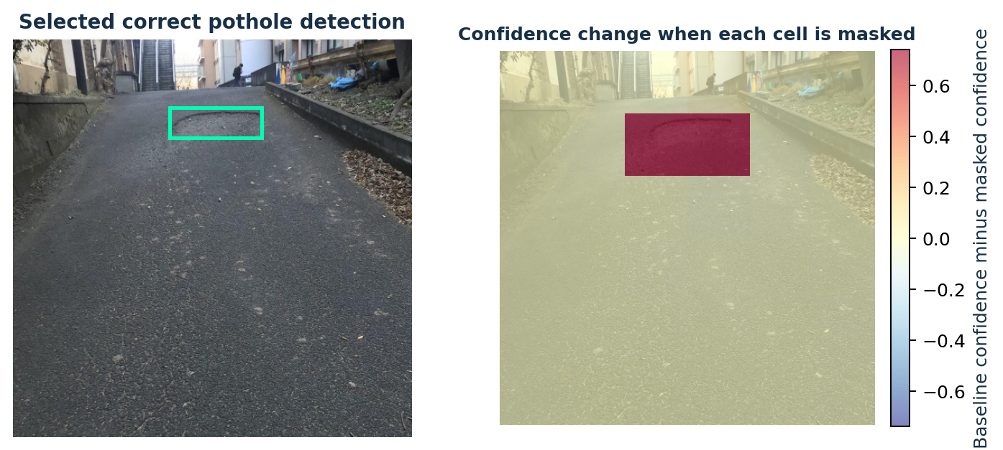
Figure 1. Left: the selected correctly matched pothole prediction. Right: the confidence decrease when each cell is masked. Red indicates a larger decrease; blue indicates an increase. The colours show responses to separate masking experiments, not an attention map from the network.

Interpretation
The largest response lies around the selected detection region. Removing information there makes the tracked pothole detection disappear. This is evidence of local sensitivity to the displayed road region for this image and model configuration. It does not prove that all predictions rely on meaningful road-damage features.

Scope of the explanation
Occlusion is a post-hoc, model-agnostic technique. A gray patch can itself create an unfamiliar input, and a 6 by 6 grid provides coarse spatial resolution. The selected example is a strong correct prediction, so it cannot represent missed detections or typical explanation quality across the dataset.
No SHAP, LIME, Grad-CAM, causal attribution study or human explanation-usability assessment was performed. Those methods must not be inferred from this visualization. A broader explanation study should sample correct detections, false alarms and missed objects across classes and countries, using a selection rule fixed before reviewing the outputs.

Confidence reliability and subgroup evidence
Across 7,070 detections retained at confidence 0.25, expected calibration error was 0.0908 and Brier score was 0.2111. Correctness required one-to-one same-class matching at IoU 0.50. Ten equal-width confidence bins were used, with empty bins contributing no weight.
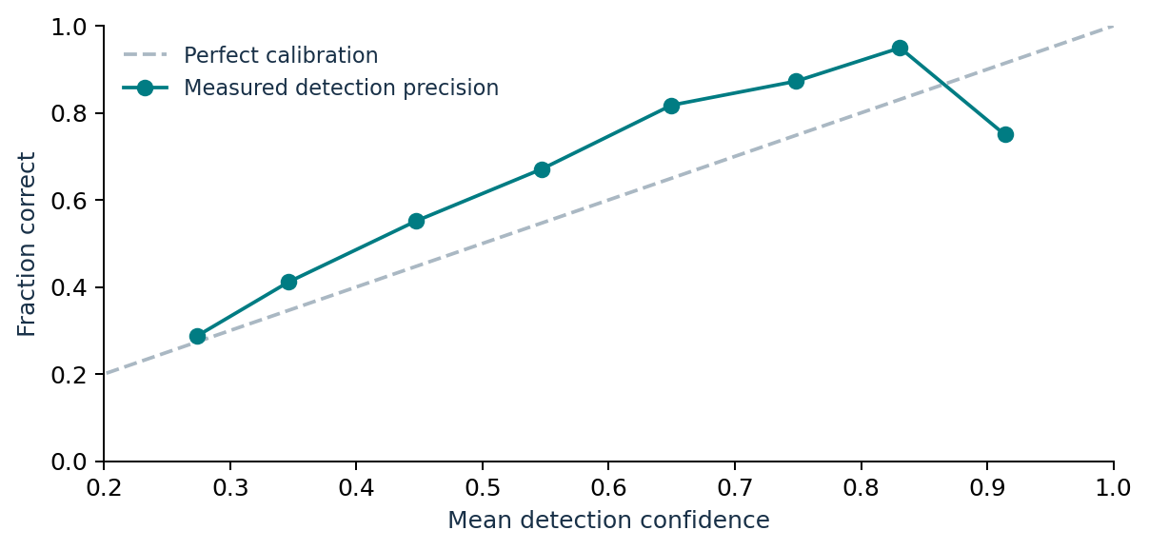
Figure 2. Average confidence compared with observed precision. The 0.90 to 1.00 bin contains only four detections, so the final downward point is highly uncertain. This analysis is conditional on retained detections and does not include the uncertainty of missed objects.
Country prefix | Recall | F1
Czech Republic | 25.47% | 33.01%
India | 37.67% | 40.65%
Japan | 57.84% | 59.20%
Norway | 16.68% | 25.05%
United States | 66.87% | 61.89%

The country recall gap is 50.19 percentage points. Filename-derived country groups indicate possible domain differences, but class mix, scene conditions and annotation practices may also explain the gap. These results do not establish demographic fairness or a causal geographic effect.

References and evidence
[1] CDAO Assessment and Assurance. Test and Evaluation of Artificial Intelligence Models. April 2024. Printed pages 10 11 and 14; the PDF page number is one greater than the printed number.
[2] Gopher AI evaluation executed on 15 October 2026. Evidence files: extended_results.json, analysis.json and the occlusion and calibration figures. The Testing Methodology report provides dataset and metric definitions.

