**Ex no.: Working with Image Editing Tools Date:**

**Install tools like GIMP / Inkscape /Krita / Pencil and perform editing operations:**

★**Use different selection and transform tools to modify or improve n image**

★**Create logos and banners for the home pages of websites.**

**Creating a Logo:**

* Open GIMP: Launch the GIMP software on your computer.
* Create a new canvas: Go to "File" in the menu bar and select "New." Set the dimensions for your logo canvas by entering the desired width and height. Choose the resolution and click "OK" to create a new canvas.
* Design your logo:
  1. Text: Select the "Text Tool" from the Toolbox on the left side. Click on the canvas and type in your logo text. You can choose the font, size, color, and other formatting options from the text tool options at the bottom of the Toolbox.
  2. Shapes: Use the "Shape Tool" to create shapes like circles, rectangles, or custom shapes for your logo. Select the desired shape from the Toolbox, click and drag on the canvas to draw the shape, and adjust its properties from the tool options.
  3. Drawing: You can use various drawing tools, such as the "Paintbrush Tool,""Pencil Tool," or "Eraser Tool," to create freehand or pixel-based elements for your logo. Experiment with different brushes, colors, and sizes to achieve the desired effect.
  4. Layers: Utilize layers to separate and organize different elements of your logo. Each element, such as text or shapes, can be placed on separate layers. To create a new layer, click

the "New Layer" button at the bottom of the Layers dialogue (Windows

→ Dockable Dialogs → Layers).

* Fine-tune your logo:
  1. Alignment and spacing: Use the alignment tools (found in the Toolbox) to align and distribute elements evenly. You can also adjust the spacing between letters or shapes by selectingthem and using the "Move Tool" to move them closer or further apart.
  2. Effects and filters: GIMP offers a wide range of effects and filters to enhance your logo. You can access these options through the "Filters" menu. Experiment with effects like blurs, shadows, gradients, or angles to give your logo a unique look.
* Save your logo:
  1. Save your work in GIMP's native format to preserve the layers and editing capabilities. Go to "File" and select "Save" or "Save As." Choose a location and provide a name for your file. Click "Save."
  2. Export your logo in a suitable file format (e.g., PNG, JPEG) for use in different applications. Goto "File" and select "Export As." Choose the desired file format, provide a name, and click "Export."

**Creating a Banner:**

* Open GIMP: Launch the GIMP software on your computer.
* Create a new canvas: Go to "File" in the menu bar and select "New." Set the dimensions for your banner canvas by entering the desired width and height. Choose the resolution and click "OK" to create a new canvas.
* Design your banner:
  1. Background: Use the "Bucket Fill Tool" or the "Gradient Tool" to fill the canvas with a suitable background color or gradient. Select the tool from the Toolbox, choose the color or gradient from the tool options, and click on the canvas to apply.
  2. Text: Add text to your banner using the "Text Tool." Click on the canvas, type in your desired text, and adjust the font, size, color, and other formatting options from the text tool options.
  3. Images and graphics: Import images or graphics to include in your banner. Go to "File" and select "Open." Locate the image file on your computer and click "Open." Use the "Move Tool" to position the image on the canvas.

**Output:**

**LOGO:**



**BANNER:**



**Result:**

Thus the banner and logo has been created successfully using GIMP.

**Ex No. : Working with Audio Editing Tools Date:**

★**Install tools like, Audacity/Ardour for audio editing, and sound mixing, and add special effects like fade-in or fade-out, etc.,**

★**Perform audio compression by choosing a proper codec.**

**Installation:**

* Visit the Audacity website: Go to the Audacity website at https://[www.audacityteam.org/.](http://www.audacityteam.org/)
* Download the installer: On the Audacity website, click on the "Download" button to access the downloads page. Choose the appropriate installer for your operating system (Windows, macOS, or Linux).
* Run the installer: Once the installer file is downloaded, run it by double- clicking on the file.
* Accept the terms and conditions: Read and accept the terms and conditions of the software.
* Choose installation options: During the installation process, you may be prompted to choose additional components to install. Select the options you desire, such as optional plug-ins or language packs.
* Complete the installation: Follow the on-screen instructions to complete the installation process. The installer will create shortcuts or icons as necessary.
* Launch Audacity: After installation, launch Audacity by locating its shortcut or searching for it in the Start menu (Windows) or Applications folder (macOS).

**Audio Editing and Applying Special Effects Fade In / Fade Out:**

* Import audio: Open Audacity and import the audio file you want to edit by going to File > Import > Audio.
* Select the portion to fade: Use the selection tool (I-beam icon) to highlight the section of the audio where you want to apply the fade-in or fade-out effect.
* Apply fade-in effect: To apply a fade-in effect, go to Effect > Fade In. Audacity will gradually increase the volume from silence to the desired level.
* Apply fade-out effect: To apply a fade-out effect, go to Effect > Fade Out. Audacity will gradually decrease the volume from the desired level to silence.
* Adjust fade duration: By default, the fade duration is relatively short, but you can adjust it by selecting the fade-in or fade-out portion of the audio and dragging its edges to lengthen or shorten it.
* Preview and save: To preview the audio with the fade effects, click the Play button. If you're satisfied with the result, save the edited audio by going to File > Export > Export Audio.

**Perform Sound Mixing:**

* Import audio tracks: Open Audacity and import the audio tracks you want to mix by going to File > Import > Audio. Select the files you want to include in the mix and click "Open.”
* Arrange tracks: By default, the imported tracks will appear as separate tracks stacked vertically. Drag and drop the tracks to arrange them in the desired order for mixing. You can also use the Time Shift Tool (double-headed arrow) to adjust the timing of individual tracks.
* Adjust volume levels: To adjust the volume levels of individual tracks, use the Envelope Tool (the icon that looks like a line with small dots). Click and drag the dots to create volume envelopes for each track. For example, you can create a gradual increase or decrease in volume over time.
* Apply effects: If you want to apply effects to individual tracks or the entire mix, select the portion of the audio you want to affect and goto Effect > Apply. Choose the desired effect from the list, such as EQ, reverb, or compression.
* Mix and balance tracks: To balance the overall sound of the mix, adjust the volume levels of each track relative to one another. Use the slider controls on each track to increase or decrease the volume.
* Preview the mix: To preview the mix, click the Play button in Audacity's transport toolbar. Listen carefully to the levels and adjust as needed to achieve the desired balance and sound.
* Export the mix: Once you're satisfied with the sound mix, gotoFile> Export > Export Audio. Choose the desired file format, name the file, and select the location where you want to save it. Click "Save" to export the mixed audio.

**Perform Audio Compression by choosing a proper codec:**

* Understand audio codecs: An audio codec is a technology that compresses and decompresses audio data. Different codecs have varying compression algorithms and settings, which affect the quality and file size of the compressed audio. It's important to consider your requirements, such as desired audio quality and file size, when selecting a codec.
* Identify available codecs: Audacity supports a variety of audio codecs. Some popular options include MP3, AAC, Ogg Vorbis, and FLAC. Research and understand the features, compression ratios, and compatibility of different codecs to determine the one that best suits your needs.
* Choose the codec: Once you have a clear understanding of the available codecs, select the one that aligns with your requirements. Consider factors such as the intended use of the compressed audio, target playback devices, and desired balance between audio quality and file size.
* Configure codec settings (if applicable): Some codecs offer configurable settings that allow you to fine-tune the compression process. For example, you may be able to adjust bit rate, sample rate, channel settings, and other parameters. Consult the documentation or specifications of the chosen codec to understand its available settings and adjust them as desired.
* Export audio with the selected codec: In Audacity, goto File>Export

> Export Audio. Choose the desired file format associated with the selected codec(e.g.,MP3,AAC,Ogg,FLAC) from the "Save as type" or "Format" drop down menu. Configure any additional settings

specific to the chosen codec if available. Provide an a mean dlocation for the exported audio file, and click "Save" or "Export" to initiate the compression process.

* Monitor the compression progress: Depending on the size of the audio file and the codec's compression algorithm, the compression process may take some time. Audacity will display a progress bar indicating the status of the compression. Wait for the process to complete.
* Review and verify the compressed audio: Once the compression process is finished, verify the compressed audio file to ensure it meets your requirements. Play the file in a compatible audio player or import it back into Audacity for further analysis if needed.

**Output:**

**FADE IN and OUT:**

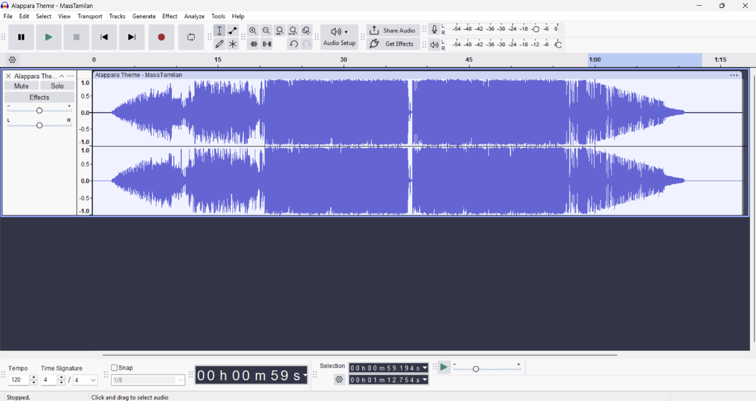

**AUDIO MIX:**

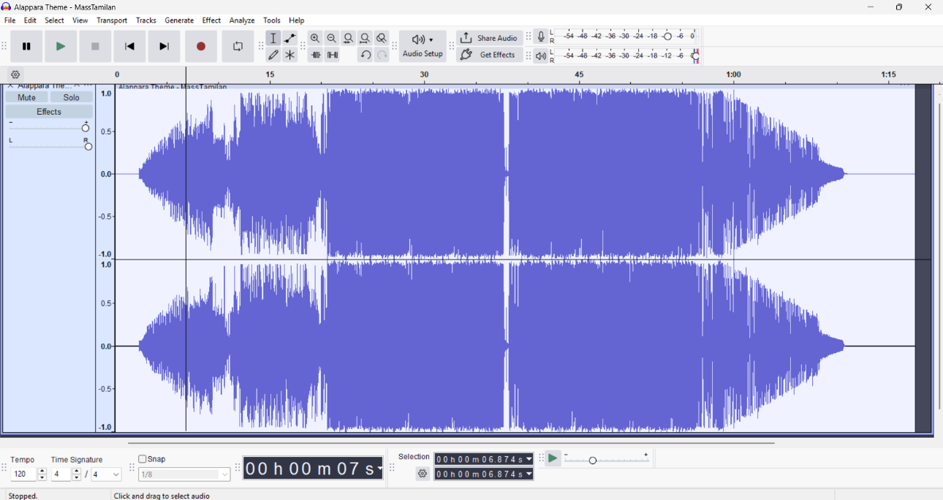

**AUDIO COMPRESSION:**

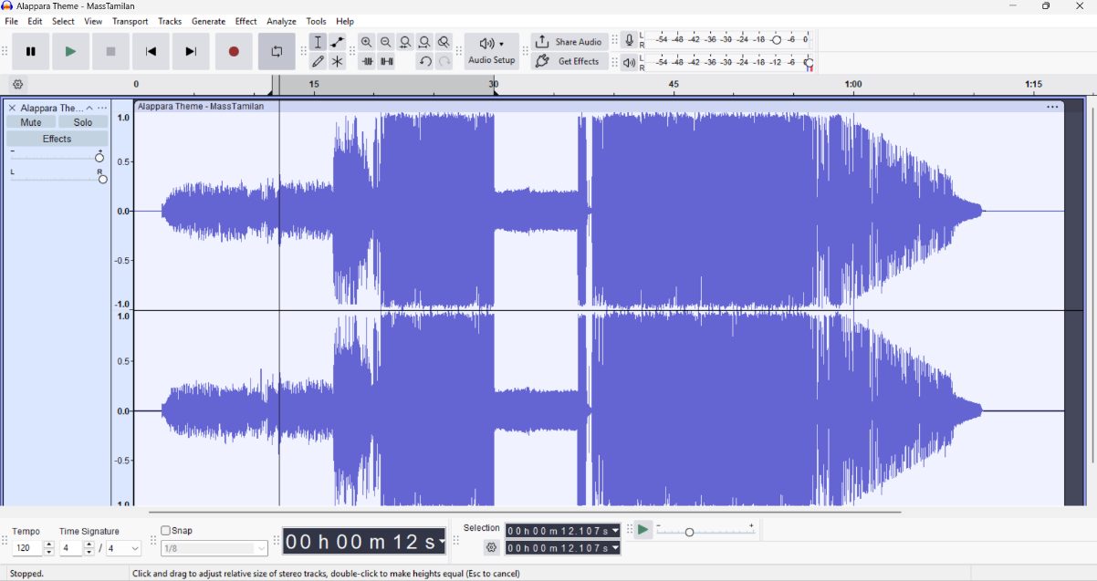

**Result:**

Thus the audio editing, sound mixing and compression has been done successfully using Audacity.