**Announcement: Credit Application Process Changes!**

**In our ongoing effort to enhance the Partner experience, we are pleased to announce major improvements in the SunPower credit application process.**

***Summary of Changes***

1. Partners can now view and submit credit applications via the Salesforce Partner Portal. This feature also simplifies attaching documents with your application such as financial statements.
2. Easy to read layout changes includes additional Status field values as well as Credit Application update controls based on Status value.

***Details of Changes***

**Salesforce Partner Portal**

* New Tab “Credit Applications” added to Salesforce Partner Portal

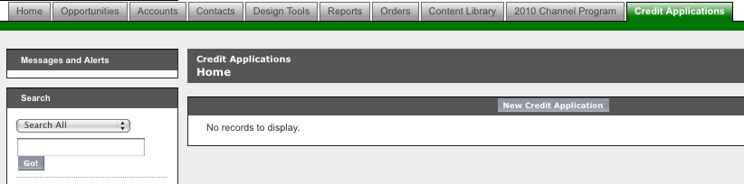

* Partner Users with login access to Salesforce Partner Portal can go to Credit Applications tab to Create, Edit and Submit a New Credit Application
* Partner Users can View their Credit Applications and Status of each Credit Application
* Partner Users can add Notes and Attachments to a Credit Application
* Partner User can set Status of Credit Application to Withdrawn

**These changes will allow Partners to have more hands on control of the credit granting process as well as allowing greater communication in regard to application status. Please feel free to contact your PSR, AR Analyst or Credit Team at 1-800-SUNPOWER (786-7693) if you have any questions or if we can be of further assistance.**

**Regards,**

**Evan Colin Popaduke, CCE, CICP**

**Sr. Global Credit Manager**

**SunPower Corporation**

**1414 Harbour Way South**

**Richmond, CA 94804 USA**

**Phone: 510-439-4633**

**Fax: 408-608-2034**

[**evan.popaduke@sunpowercorp.com**](mailto:evan.popaduke@sunpowercorp.com)

