Experiment 1: Linear Search (Iterative)

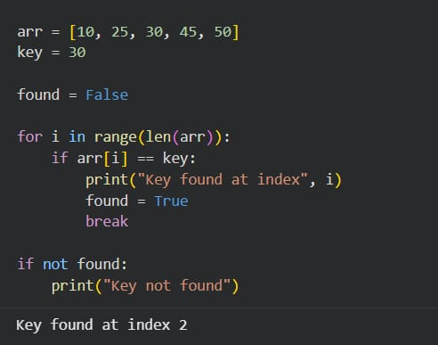

Experiment-2: Binary Search
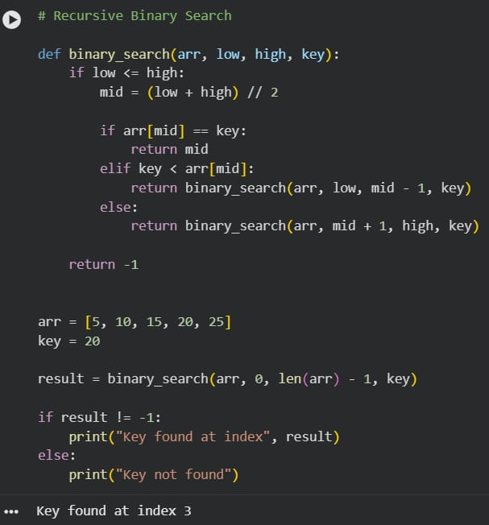
Experiment-3: Factorial
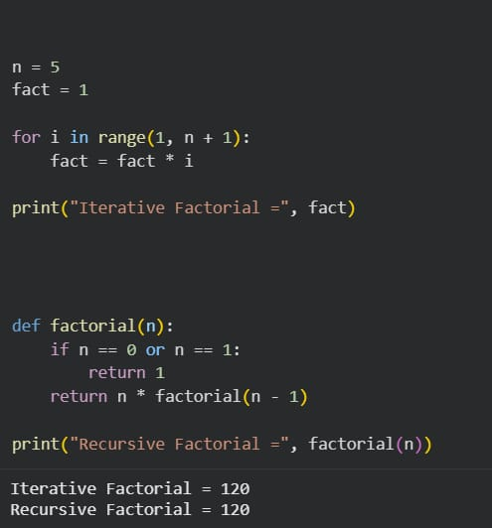
Experiment -4: Fibonacci series
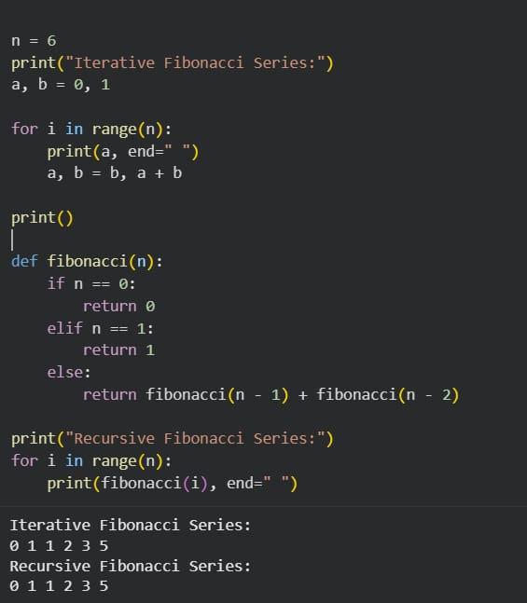
Experiment-5: Matrix Multiplication
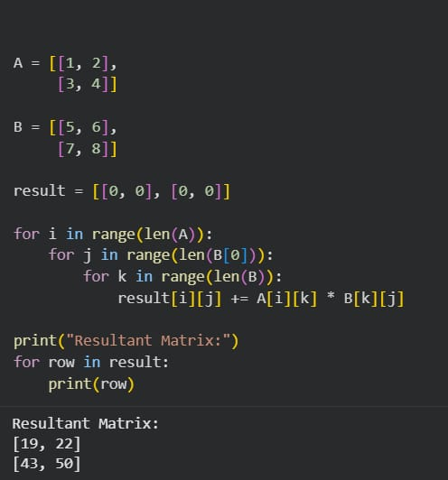

Experiment-6: Merge sort
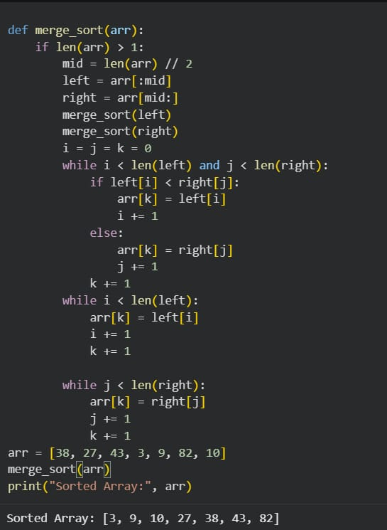
Experiment -7: Quick Sort
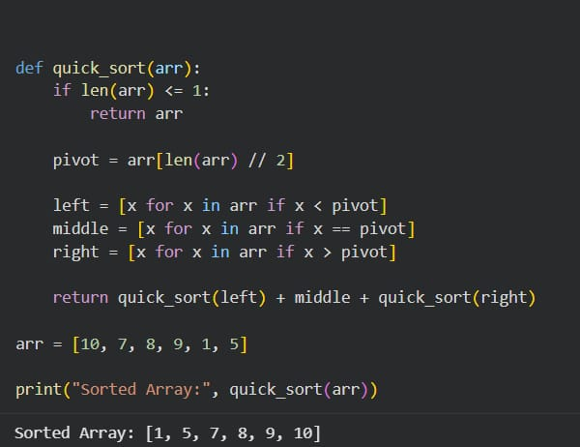

Experiment-8: Tower Of Hanoi
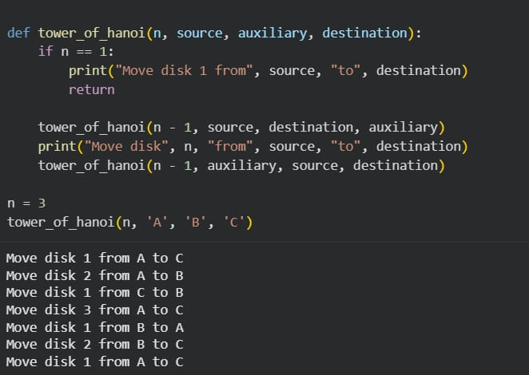

Experiment-9: GCD (Euclidean Algorithm)
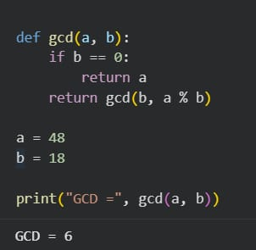

Experiment-10: Insertion Sort
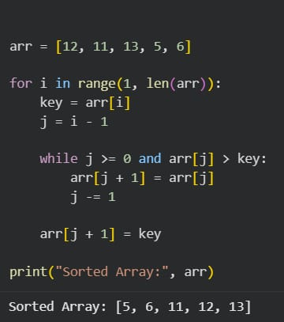

Experiment -11: Heap sort
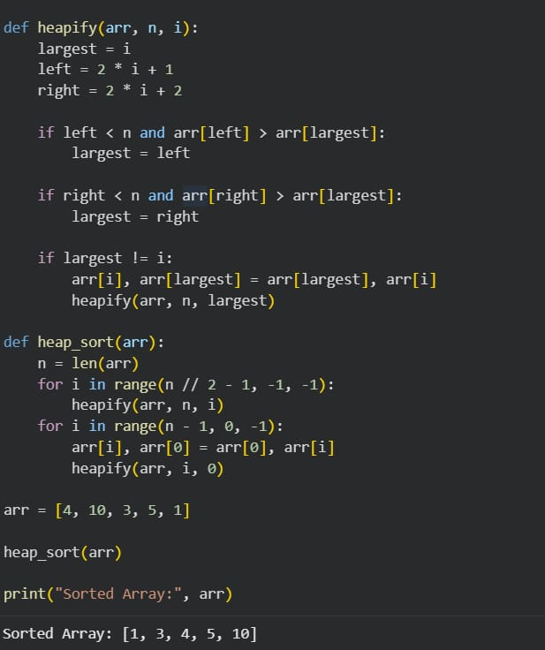

Experiment-12: Counting Inversions
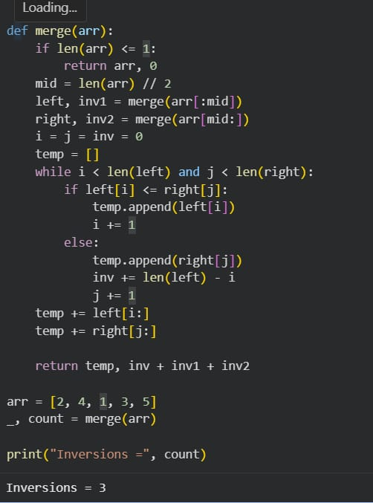

Experiment-13: Maximum Subarray Sum
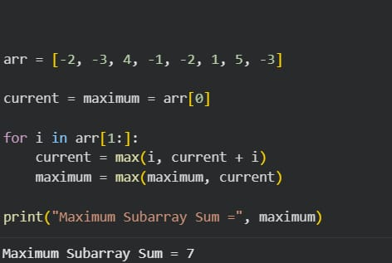

Experiment-14: Exponentiation
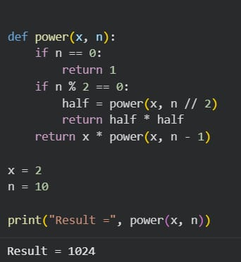

Experiment-15: Closest pair of points
