K.Eswar
192411176
INTERNET PROGRAMING-CSA4308

36)
<!DOCTYPE html>
<html>
<head>
<title>BookHaven</title>

<style>
body {
margin: 0;
font-family: Arial;
background: #f5f0e8;
}

header {
background: #4b2e2e;
color: white;
text-align: center;
padding: 25px;
}

nav {
background: #222;
padding: 15px;
text-align: center;
}

nav a {
color: white;
text-decoration: none;
margin: 20px;
}

.hero {
text-align: center;
padding: 50px;
background: #ead8c0;
}

.search {
width: 60%;
padding: 12px;
border-radius: 20px;
border: 1px solid gray;
}

.books {
display: flex;
justify-content: center;
gap: 25px;
padding: 30px;
}

.book {
background: white;
width: 200px;
padding: 20px;
text-align: center;
border-radius: 10px;
box-shadow: 0 3px 10px gray;
}

.book img {
width: 150px;
height: 200px;
object-fit: cover;
}

button {
background: #4b2e2e;
color: white;
padding: 10px 20px;
border: none;
border-radius: 5px;
}

section {
padding: 30px;
text-align: center;
}

footer {
background: #222;
color: white;
text-align: center;
padding: 20px;
}
</style>
</head>

<body>

<header>
<h1>📚 BookHaven</h1>
<p>Your Online Bookstore</p>
</header>

<nav>
<a href="#">Home</a>
<a href="#about">About</a>
<a href="#catalog">Catalog</a>
<a href="#contact">Contact</a>
<a href="#faq">FAQs</a>
</nav>

<div class="hero">
<h1>Discover Your Next Great Book</h1>
<input class="search" type="text" placeholder="Search books...">
</div>

<section>
<h2>Featured Books</h2>

<div class="books">

<div class="book">
<img src="https://images.unsplash.com/photo-1544947950-fa07a98d237f">
<h3>The Great Adventure</h3>
<p>By John Smith</p>
<p>₹499</p>
<button>Add to Cart</button>
</div>

<div class="book">
<img src="https://images.unsplash.com/photo-1512820790803-83ca734da794">
<h3>Learning Python</h3>
<p>By David Brown</p>
<p>₹699</p>
<button>Add to Cart</button>
</div>

<div class="book">
<img src="https://images.unsplash.com/photo-1495446815901-a7297e633e8d">
<h3>Modern Fiction</h3>
<p>By Sarah Lee</p>
<p>₹399</p>
<button>Add to Cart</button>
</div>

</div>
</section>

<section id="about">
<h2>About Us</h2>
<p>BookHaven provides quality books for students and book lovers.</p>
</section>

<section id="catalog">
<h2>Categories</h2>
<p>Fiction | Non-Fiction | Academic | Science | Technology</p>
</section>

<section id="contact">
<h2>Contact Us</h2>
<p>Email: bookhaven@gmail.com</p>
<p>Phone: +91 9876543210</p>
</section>

<section id="faq">
<h2>FAQs</h2>
<p>Shipping takes 3–7 working days.</p>
<p>Books can be returned within 7 days.</p>
</section>

<footer>
<p>© 2026 BookHaven</p>
</footer>

</body>
</html>

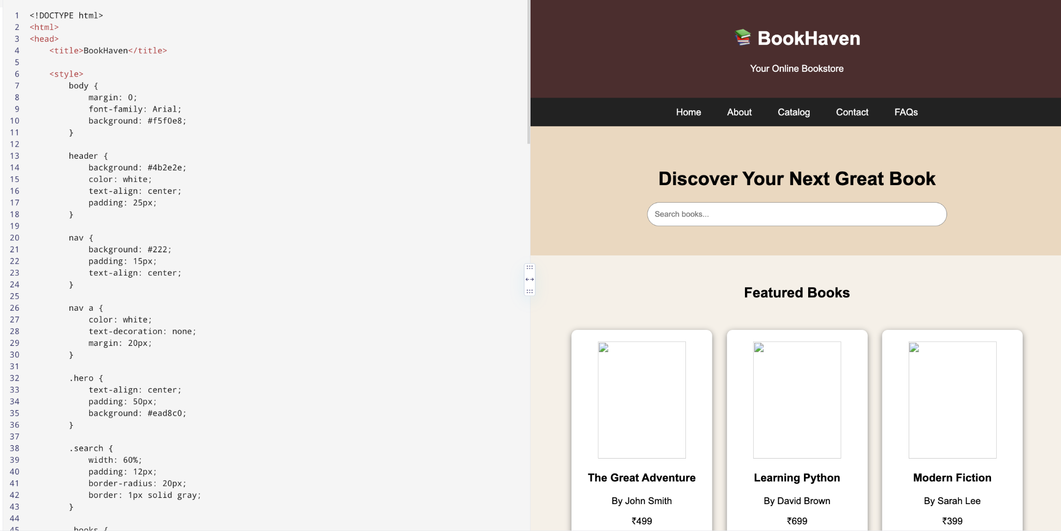

37)

<!DOCTYPE html>
<html>
<head>
<title>MyProfessionalShowcase</title>

<style>
body {
margin: 0;
font-family: Arial;
background: #f4f4f4;
}

header {
background: #111827;
color: white;
text-align: center;
padding: 50px;
}

header h1 {
font-size: 45px;
}

nav {
background: #1f2937;
padding: 15px;
text-align: center;
}

nav a {
color: white;
text-decoration: none;
margin: 20px;
}

section {
padding: 40px;
text-align: center;
}

.skills span {
display: inline-block;
background: #2563eb;
color: white;
padding: 10px 20px;
margin: 5px;
border-radius: 20px;
}

.projects {
display: flex;
justify-content: center;
gap: 25px;
flex-wrap: wrap;
}

.card {
width: 250px;
padding: 25px;
background: white;
border-radius: 10px;
box-shadow: 0 3px 10px gray;
}

button {
background: #2563eb;
color: white;
border: none;
padding: 12px 25px;
border-radius: 5px;
}

input, textarea {
padding: 12px;
width: 300px;
}

footer {
background: #111827;
color: white;
text-align: center;
padding: 20px;
}
</style>
</head>

<body>

<header>
<h1>My Professional Showcase</h1>
<p>Web Developer | Python Programmer | AI Enthusiast</p>
<button>Download Resume</button>
</header>

<nav>
<a href="#">Home</a>
<a href="#about">About Me</a>
<a href="#portfolio">Portfolio</a>
<a href="#resume">Resume</a>
<a href="#blog">Blog</a>
<a href="#contact">Contact</a>
</nav>

<section id="about">
<h2>About Me</h2>
<p>I am passionate about software development and modern technologies.</p>

<div class="skills">
<span>HTML</span>
<span>CSS</span>
<span>JavaScript</span>
<span>Python</span>
<span>C++</span>
<span>SQL</span>
</div>
</section>

<section id="portfolio">
<h2>My Projects</h2>

<div class="projects">

<div class="card">
<h3>Farming App</h3>
<p>Smart agriculture application.</p>
<button>View Project</button>
</div>

<div class="card">
<h3>Book Store</h3>
<p>Online bookstore website.</p>
<button>View Project</button>
</div>

<div class="card">
<h3>AI Project</h3>
<p>Machine learning application.</p>
<button>View Project</button>
</div>

</div>
</section>

<section id="resume">
<h2>Resume</h2>
<p>Education | Skills | Projects | Achievements</p>
<button>Download Resume</button>
</section>

<section id="blog">
<h2>Blog</h2>
<p>Articles about programming and technology.</p>
</section>

<section id="contact">
<h2>Contact Me</h2>

<input type="text" placeholder="Your Name"><br><br>
<input type="email" placeholder="Email"><br><br>
<textarea placeholder="Message"></textarea><br><br>
<button>Send Message</button>
</section>

<footer>
<p>© 2026 MyProfessionalShowcase</p>
</footer>

</body>
</html>

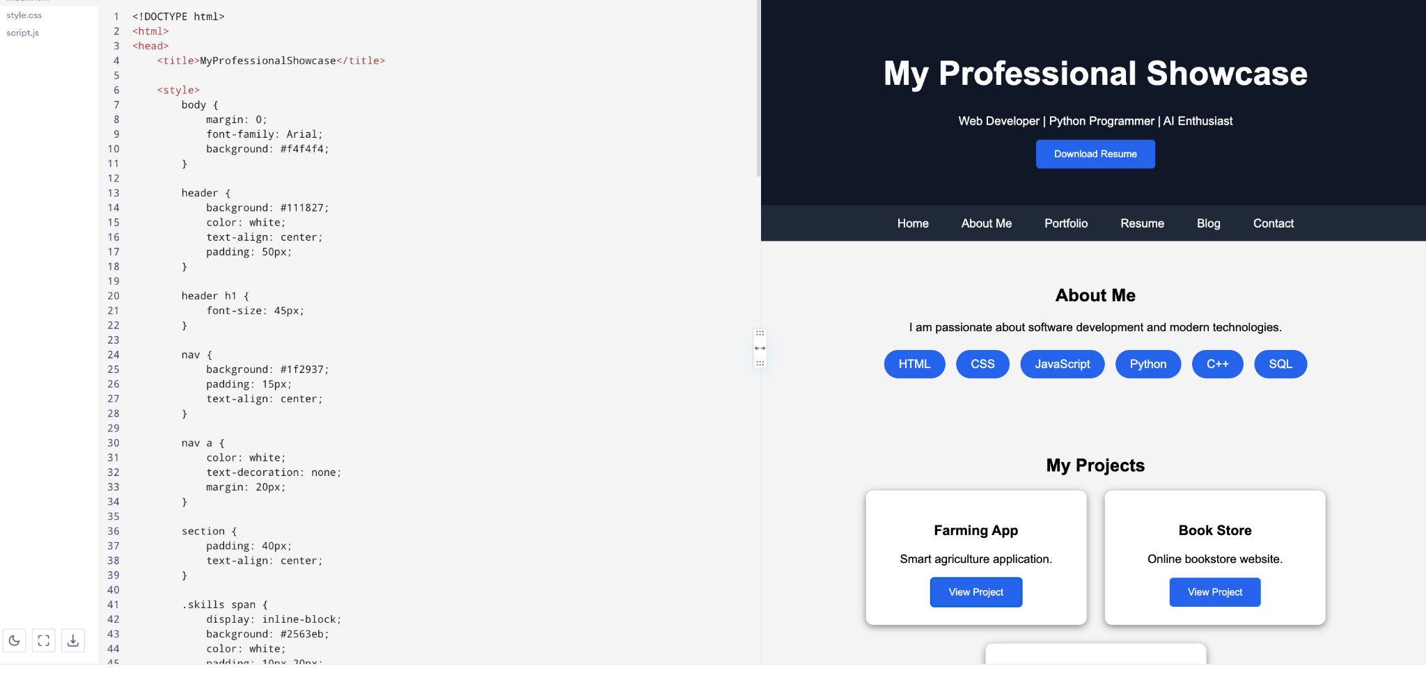

38)
<!DOCTYPE html>
<html>
<head>
<title>Gourmet Haven</title>

<style>
body {
margin: 0;
font-family: Arial;
background: #111;
color: white;
}

header {
height: 400px;
text-align: center;
padding-top: 150px;
background: url("https://images.unsplash.com/photo-1515003197210-e0cd71810b5f") center/cover;
}

header h1 {
font-size: 55px;
}

nav {
background: black;
padding: 20px;
text-align: center;
}

nav a {
color: white;
text-decoration: none;
margin: 20px;
}

section {
padding: 40px;
text-align: center;
}

.menu {
display: flex;
justify-content: center;
gap: 25px;
flex-wrap: wrap;
}

.item {
width: 250px;
background: #222;
padding: 20px;
border-radius: 10px;
}

.item img {
width: 100%;
height: 160px;
object-fit: cover;
}

.price {
color: #facc15;
font-size: 20px;
}

button {
background: #facc15;
border: none;
padding: 12px 25px;
}

input, textarea {
padding: 12px;
margin: 5px;
}

footer {
background: black;
text-align: center;
padding: 20px;
}
</style>
</head>

<body>

<header>
<h1>Gourmet Haven</h1>
<p>Fine Dining. Extraordinary Experience.</p>
<button>Reserve a Table</button>
</header>

<nav>
<a href="#">Home</a>
<a href="#menu">Menu</a>
<a href="#about">About</a>
<a href="#reservation">Reservation</a>
<a href="#contact">Contact</a>
</nav>

<section id="menu">
<h2>Our Menu</h2>

<div class="menu">

<div class="item">
<img src="https://images.unsplash.com/photo-1547592180-85f173990554">
<h3>Italian Pasta</h3>
<p>Fresh pasta with creamy sauce.</p>
<p class="price">₹450</p>
</div>

<div class="item">
<img src="https://images.unsplash.com/photo-1544025162-d76694265947">
<h3>Grilled Steak</h3>
<p>Premium grilled steak.</p>
<p class="price">₹850</p>
</div>

<div class="item">
<img src="https://images.unsplash.com/photo-1551024506-0bccd828d307">
<h3>Chocolate Dessert</h3>
<p>Rich chocolate dessert.</p>
<p class="price">₹300</p>
</div>

</div>
</section>

<section id="about">
<h2>About Us</h2>
<p>Gourmet Haven offers delicious food and excellent dining experiences.</p>
</section>

<section id="reservation">
<h2>Reservation</h2>
<input type="date">
<input type="time">
<input type="number" placeholder="Number of Guests">
<br><br>
<button>Book Table</button>
</section>

<section id="contact">
<h2>Contact Us</h2>
<p>📍 Chennai, Tamil Nadu</p>
<p>📞 +91 9876543210</p>
<p>✉ gourmet@gmail.com</p>
</section>

<footer>
<p>© 2026 Gourmet Haven</p>
</footer>

</body>
</html>

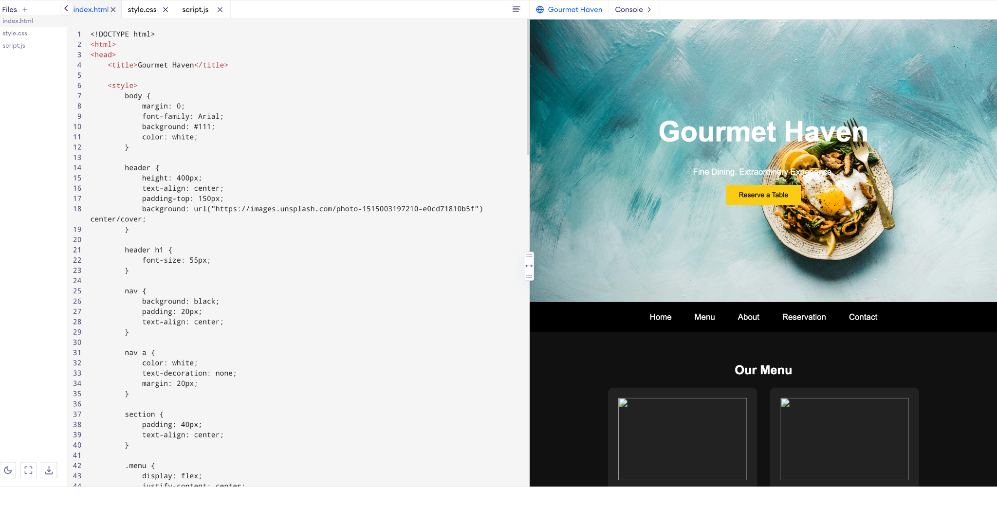

39)<!DOCTYPE html>
<html>
<head>
<title>Online Store</title>

<style>
body {
margin: 0;
font-family: Arial;
background: #f5f5f5;
}

header {
background: #2563eb;
color: white;
text-align: center;
padding: 30px;
}

.search {
width: 60%;
padding: 12px;
border-radius: 20px;
border: none;
}

nav {
background: #111827;
padding: 15px;
text-align: center;
}

nav a {
color: white;
text-decoration: none;
margin: 20px;
}

.products {
display: flex;
justify-content: center;
gap: 25px;
flex-wrap: wrap;
padding: 40px;
}

.product {
width: 220px;
background: white;
padding: 20px;
text-align: center;
border-radius: 10px;
box-shadow: 0 3px 10px gray;
}

.product img {
width: 180px;
height: 180px;
object-fit: cover;
}

.price {
font-size: 20px;
font-weight: bold;
}

button {
background: #2563eb;
color: white;
border: none;
padding: 10px 20px;
border-radius: 5px;
}

.checkout {
background: white;
padding: 30px;
text-align: center;
}

.checkout input {
padding: 12px;
width: 300px;
margin: 5px;
}
</style>
</head>

<body>

<header>
<h1>🛍️ SmartStore</h1>
<input class="search" placeholder="Search products...">
</header>

<nav>
<a href="#">Home</a>
<a href="#">Electronics</a>
<a href="#">Clothing</a>
<a href="#">Accessories</a>
<a href="#">Cart 🛒</a>
</nav>

<h2 style="text-align:center;">Featured Products</h2>

<div class="products">

<div class="product">
<img src="https://images.unsplash.com/photo-1505740420928-5e560c06d30e">
<h3>Headphones</h3>
<p>Wireless headphones</p>
<p class="price">₹1,999</p>
<button>Add to Cart</button>
</div>

<div class="product">
<img src="https://images.unsplash.com/photo-1523275335684-37898b6baf30">
<h3>Smart Watch</h3>
<p>Fitness smart watch</p>
<p class="price">₹2,499</p>
<button>Add to Cart</button>
</div>

<div class="product">
<img src="https://images.unsplash.com/photo-1521572163474-6864f9cf17ab">
<h3>T-Shirt</h3>
<p>Cotton T-Shirt</p>
<p class="price">₹599</p>
<button>Add to Cart</button>
</div>

</div>

<div class="checkout">
<h2>Checkout</h2>
<input placeholder="Name"><br>
<input placeholder="Address"><br>
<input placeholder="Payment Details"><br><br>
<button>Place Order</button>
</div>

</body>
</html>

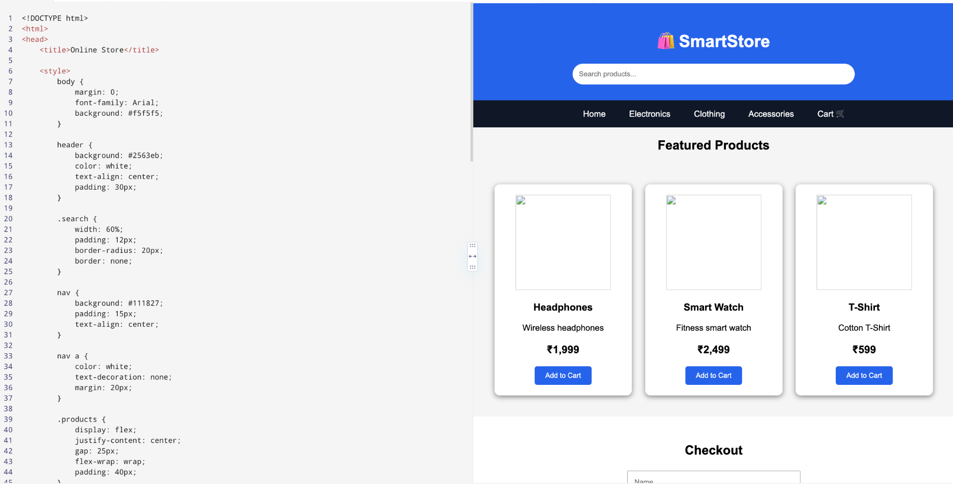
40)
<!DOCTYPE html>
<html>
<head>
<title>WanderWorld Travel Blog</title>

<style>
body {
margin: 0;
font-family: Arial;
background: #eff6ff;
}

header {
padding: 80px;
text-align: center;
color: white;
background: url("https://images.unsplash.com/photo-1500530855697-b586d89ba3ee") center/cover;
}

header h1 {
font-size: 50px;
}

nav {
background: #0369a1;
padding: 15px;
text-align: center;
}

nav a {
color: white;
text-decoration: none;
margin: 20px;
}

section {
padding: 30px;
text-align: center;
}

.posts {
display: flex;
justify-content: center;
gap: 25px;
flex-wrap: wrap;
}

.post {
width: 280px;
background: white;
padding: 15px;
border-radius: 10px;
box-shadow: 0 3px 10px gray;
}

.post img {
width: 100%;
height: 180px;
object-fit: cover;
}

.map {
background: #bae6fd;
padding: 50px;
margin: 20px;
}

footer {
background: #075985;
color: white;
text-align: center;
padding: 20px;
}
</style>
</head>

<body>

<header>
<h1>🌍 WanderWorld</h1>
<p>Explore. Travel. Discover.</p>
</header>

<nav>
<a href="#">Home</a>
<a href="#destinations">Destinations</a>
<a href="#blog">Blog</a>
<a href="#gallery">Gallery</a>
<a href="#about">About</a>
</nav>

<section id="blog">
<h2>Latest Travel Stories</h2>

<div class="posts">

<div class="post">
<img src="https://images.unsplash.com/photo-1524492412937-b28074a5d7da">
<h3>Exploring India</h3>
<p>Discover the beauty and culture of India.</p>
</div>

<div class="post">
<img src="https://images.unsplash.com/photo-1507525428034-b723cf961d3e">
<h3>Beautiful Beaches</h3>
<p>A relaxing journey through tropical beaches.</p>
</div>

<div class="post">
<img src="https://images.unsplash.com/photo-1501785888041-af3ef285b470">
<h3>Mountain Adventure</h3>
<p>An exciting mountain trekking experience.</p>
</div>

</div>
</section>

<section id="destinations">
<h2>Travel Destinations</h2>

<div class="map">
<h2>🗺️ Interactive Map</h2>
<p>📍 India &nbsp;&nbsp; 📍 Europe &nbsp;&nbsp; 📍 Asia</p>
</div>
</section>

<section id="gallery">
<h2>Photo Gallery</h2>
<p>🏔️ Mountains &nbsp; 🏖️ Beaches &nbsp; 🌆 Cities</p>
</section>

<section id="about">
<h2>About the Traveler</h2>
<p>I am a travel enthusiast sharing my adventures and travel tips.</p>
</section>

<footer>
<p>© 2026 WanderWorld</p>
</footer>

</body>
</html>
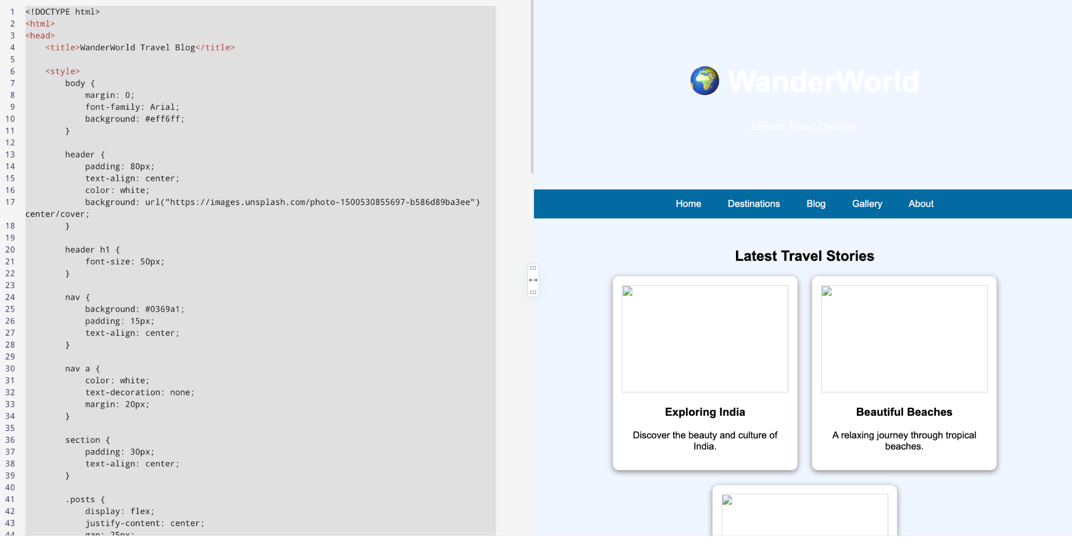

41)
<!DOCTYPE html>
<html>
<head>
<title>Digital Recipe Book</title>

<style>
body {
margin: 0;
font-family: Arial;
background: #fff7ed;
}

header {
background: #ea580c;
color: white;
text-align: center;
padding: 35px;
}

.search {
width: 60%;
padding: 12px;
border-radius: 20px;
border: none;
}

nav {
background: #7c2d12;
padding: 15px;
text-align: center;
}

nav a {
color: white;
text-decoration: none;
margin: 20px;
}

.recipes {
display: flex;
justify-content: center;
gap: 25px;
flex-wrap: wrap;
padding: 40px;
}

.recipe {
width: 280px;
background: white;
border-radius: 10px;
overflow: hidden;
box-shadow: 0 3px 10px gray;
}

.recipe img {
width: 100%;
height: 180px;
object-fit: cover;
}

.recipe-content {
padding: 20px;
}

button {
background: #ea580c;
color: white;
border: none;
padding: 10px 20px;
}

.instructions {
background: white;
margin: 20px;
padding: 30px;
}
</style>
</head>

<body>

<header>
<h1>🍳 Digital Recipe Book</h1>
<input class="search" placeholder="Search recipes...">
</header>

<nav>
<a href="#">Home</a>
<a href="#">Breakfast</a>
<a href="#">Main Course</a>
<a href="#">Desserts</a>
<a href="#">Vegetarian</a>
</nav>

<div class="recipes">

<div class="recipe">
<img src="https://images.unsplash.com/photo-1565299624946-b28f40a0ae38">
<div class="recipe-content">
<h2>Pizza</h2>
<p>Cheese, tomato and vegetables.</p>
<p>⏱ 30 Minutes | 👥 4 Servings</p>
<button>View Recipe</button>
</div>
</div>

<div class="recipe">
<img src="https://images.unsplash.com/photo-1512058564366-18510be2db19">
<div class="recipe-content">
<h2>Fried Rice</h2>
<p>Rice with vegetables and spices.</p>
<p>⏱ 20 Minutes | 👥 3 Servings</p>
<button>View Recipe</button>
</div>
</div>

<div class="recipe">
<img src="https://images.unsplash.com/photo-1551024506-0bccd828d307">
<div class="recipe-content">
<h2>Chocolate Cake</h2>
<p>Soft and delicious chocolate cake.</p>
<p>⏱ 45 Minutes | 👥 6 Servings</p>
<button>View Recipe</button>
</div>
</div>

</div>

<div class="instructions">
<h2>Pizza Recipe</h2>

<h3>Ingredients</h3>

<ul>
<li>2 cups flour</li>
<li>1 cup cheese</li>
<li>Tomato sauce</li>
<li>Vegetables</li>
<li>Oregano</li>
</ul>

<h3>Instructions</h3>

<ol>
<li>Prepare the dough.</li>
<li>Add tomato sauce.</li>
<li>Add vegetables and cheese.</li>
<li>Bake for 20 minutes.</li>
</ol>
</div>

</body>
</html>
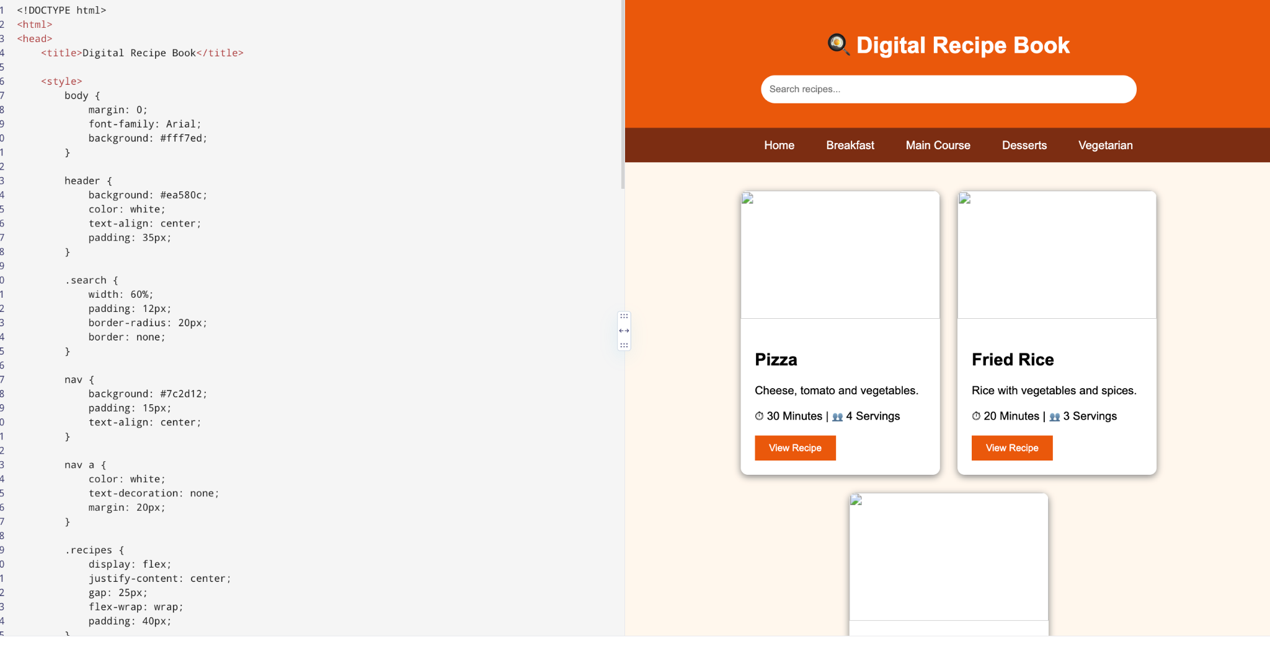

42)
<!DOCTYPE html>
<html>
<head>
<title>Electricity Bill Payment</title>

<style>
body {
margin: 0;
font-family: Arial;
background: #eff6ff;
}

header {
background: #075985;
color: white;
text-align: center;
padding: 30px;
}

.container {
width: 450px;
margin: 40px auto;
background: white;
padding: 30px;
border-radius: 10px;
box-shadow: 0 3px 10px gray;
}

input, select {
width: 100%;
padding: 12px;
margin: 8px 0;
}

button {
width: 100%;
padding: 12px;
background: #0284c7;
color: white;
border: none;
}

.bill {
background: #e0f2fe;
padding: 20px;
margin: 20px 0;
}

h2 {
color: #075985;
}
</style>
</head>

<body>

<header>
<h1>⚡ Electricity Bill Payment</h1>
</header>

<div class="container">

<h2>Customer Login</h2>

<input type="email" placeholder="Email">
<input type="password" placeholder="Password">

<button>Login</button>

<hr>

<h2>Bill Details</h2>

<input placeholder="Consumer Number">

<select>
<option>Domestic</option>
<option>Commercial</option>
</select>

<input type="number" placeholder="Units Consumed">

<div class="bill">
<h3>Domestic Tariff</h3>
<p>First 100 Units - ₹1/unit</p>
<p>101–200 Units - ₹2.50/unit</p>
<p>201–500 Units - ₹4/unit</p>
<p>501+ Units - ₹6/unit</p>

<h3>Commercial Tariff</h3>
<p>First 100 Units - ₹2/unit</p>
<p>101–200 Units - ₹4.50/unit</p>
<p>201–500 Units - ₹6/unit</p>
<p>501+ Units - ₹7/unit</p>

<h3>Late Fine</h3>
<p>₹10 for each day after due date.</p>
</div>

<select>
<option>Credit Card</option>
<option>Debit Card</option>
<option>Net Banking</option>
<option>Digital Wallet</option>
</select>

<button>Pay Bill</button>

</div>

</body>
</html>
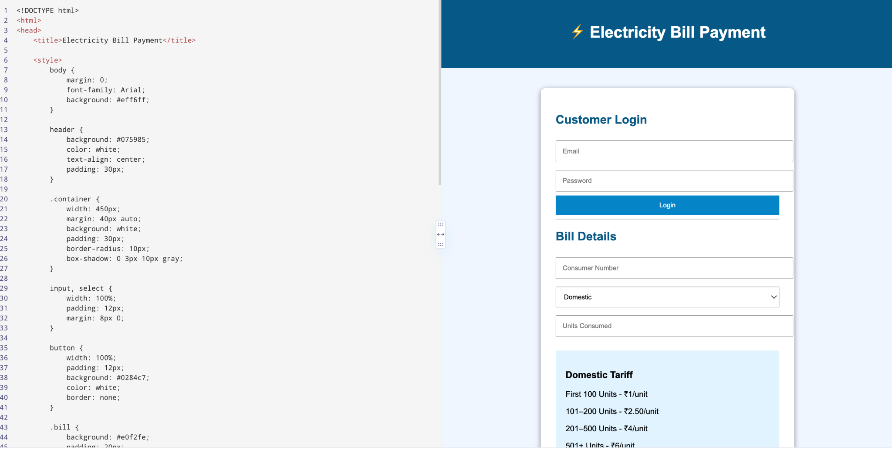

43)
<!DOCTYPE html>
<html>
<head>
<title>Online Placement Examination</title>

<style>
body {
margin: 0;
font-family: Arial;
background: #f1f5f9;
}

header {
background: #1e3a8a;
color: white;
text-align: center;
padding: 30px;
}

.container {
max-width: 800px;
margin: 30px auto;
background: white;
padding: 30px;
border-radius: 10px;
}

input {
padding: 12px;
width: 90%;
margin: 8px;
}

.question {
background: #f8fafc;
padding: 20px;
margin: 15px 0;
border-radius: 8px;
}

button {
background: #1e3a8a;
color: white;
padding: 12px 25px;
border: none;
border-radius: 5px;
}

.result {
background: #dcfce7;
padding: 20px;
margin-top: 20px;
}
</style>
</head>

<body>

<header>
<h1>Online Placement Examination</h1>
</header>

<div class="container">

<h2>Candidate Login</h2>

<input placeholder="Candidate ID">
<input type="password" placeholder="Password">
<button>Login</button>

<hr>

<h2>Placement Test</h2>

<div class="question">
<p><b>1. Which language is used to create web page structure?</b></p>

<input type="radio" name="q1"> Python<br>
<input type="radio" name="q1"> HTML<br>
<input type="radio" name="q1"> SQL<br>
<input type="radio" name="q1"> C++
</div>

<div class="question">
<p><b>2. What does CSS stand for?</b></p>

<input type="radio" name="q2"> Computer Style Sheet<br>
<input type="radio" name="q2"> Cascading Style Sheets<br>
<input type="radio" name="q2"> Creative Style System<br>
<input type="radio" name="q2"> Colorful Style Sheet
</div>

<div class="question">
<p><b>3. Which is a programming language?</b></p>

<input type="radio" name="q3"> HTML<br>
<input type="radio" name="q3"> CSS<br>
<input type="radio" name="q3"> Python<br>
<input type="radio" name="q3"> XML
</div>

<button>Submit Exam</button>

<div class="result">
<h2>Result</h2>
<p>Score: 85%</p>
<p>Rank: 12</p>
<p>Status: <b>PASS</b></p>
</div>

</div>

</body>
</html>
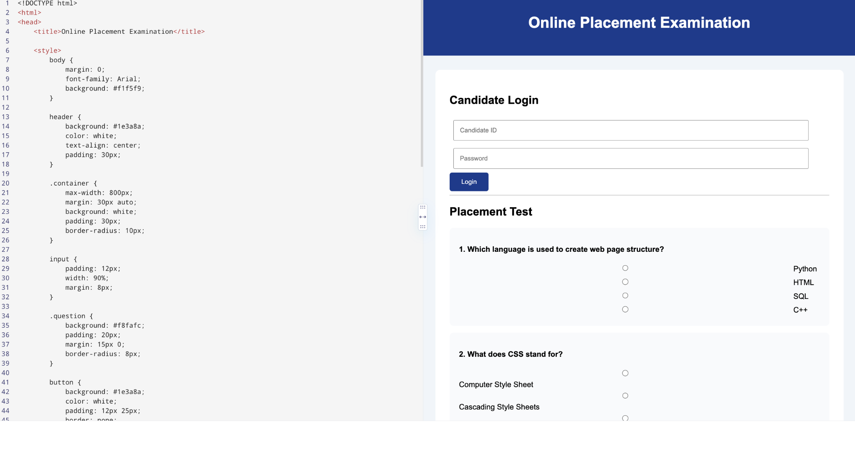

44)
<!DOCTYPE html>
<html>
<head>
<title>Painting Rating and Review</title>

<style>
body {
margin: 0;
font-family: Arial;
background: #f5f3ff;
}

header {
background: #581c87;
color: white;
text-align: center;
padding: 30px;
}

.container {
width: 800px;
max-width: 90%;
margin: 30px auto;
}

.painting, .review {
background: white;
padding: 25px;
margin: 20px 0;
border-radius: 10px;
box-shadow: 0 3px 10px gray;
}

.painting {
text-align: center;
}

.painting img {
width: 400px;
max-width: 100%;
height: 300px;
object-fit: cover;
}

.stars {
color: #eab308;
font-size: 30px;
}

input, textarea, select {
width: 90%;
padding: 12px;
margin: 8px;
}

button {
background: #7e22ce;
color: white;
border: none;
padding: 12px 25px;
}
</style>
</head>

<body>

<header>
<h1>🎨 Painting Rating & Review</h1>
</header>

<div class="container">

<div class="painting">

<h2>Sunset Beauty</h2>

<img src="https://images.unsplash.com/photo-1549490349-8643362247b5">

<p>Beautiful artistic painting.</p>

<div class="stars">★★★★★</div>

<p>Average Rating: 4.5 / 5</p>

</div>

<div class="review">

<h2>Submit Your Review</h2>

<input type="text" placeholder="Your Name">

<textarea rows="5" placeholder="Write your review"></textarea>

<select>
<option>★★★★★</option>
<option>★★★★</option>
<option>★★★</option>
<option>★★</option>
<option>★</option>
</select>

<br>

<button>Submit Review</button>

</div>

<div class="review">

<h2>Customer Reviews</h2>

<p>👍 Beautiful painting and excellent colours.</p>

<p>👍 Very creative artwork.</p>

<p>👎 Packaging could be improved.</p>

</div>

</div>

</body>
</html>

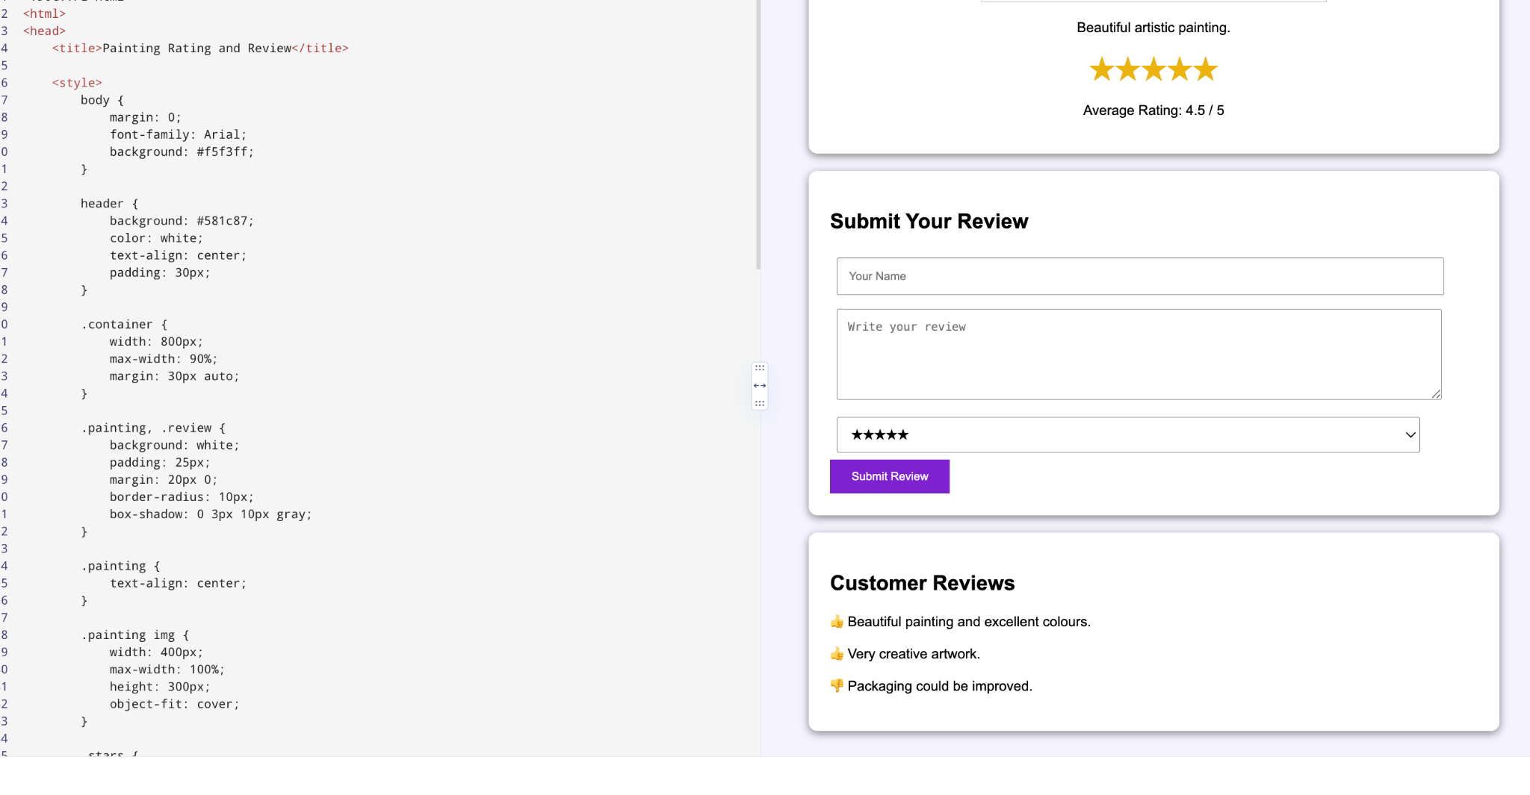

45)
<!DOCTYPE html>
<html>
<head>
<title>Income Tax Calculator</title>

<style>
body {
margin: 0;
font-family: Arial;
background: #f0fdf4;
}

header {
background: #166534;
color: white;
text-align: center;
padding: 30px;
}

.container {
width: 500px;
max-width: 90%;
margin: 30px auto;
background: white;
padding: 30px;
border-radius: 10px;
box-shadow: 0 3px 10px gray;
}

input {
width: 100%;
padding: 12px;
margin: 8px 0;
}

button {
width: 100%;
padding: 12px;
background: #15803d;
color: white;
border: none;
}

.result {
background: #dcfce7;
padding: 20px;
margin-top: 20px;
}
</style>
</head>

<body>

<header>
<h1>Income Tax Calculator</h1>
</header>

<div class="container">

<h2>Employee Details</h2>

<input type="number" placeholder="Monthly Gross Pay">

<input type="number" placeholder="Monthly HRA">

<input type="number" placeholder="Monthly Pension">

<input type="number" placeholder="Monthly Health Insurance">

<button>Calculate Tax</button>

<div class="result">

<h3>Tax Calculation</h3>

<p>Gross Pay = Monthly Gross Pay × 12</p>

<p>Standard Deduction = ₹50,000</p>

<p>Pension Maximum Deduction = ₹1,50,000</p>

<h3>Tax Slabs</h3>

<p>₹0 – ₹2,50,000 → 0%</p>

<p>₹2,50,001 – ₹5,00,000 → 5%</p>

<p>₹5,00,001 – ₹10,00,000 → ₹12,500 + 20%</p>

<p>Above ₹10,00,000 → ₹1,12,500 + 30%</p>

<h3>Tax Payable: ₹0</h3>

</div>

</div>

</body>
</html>
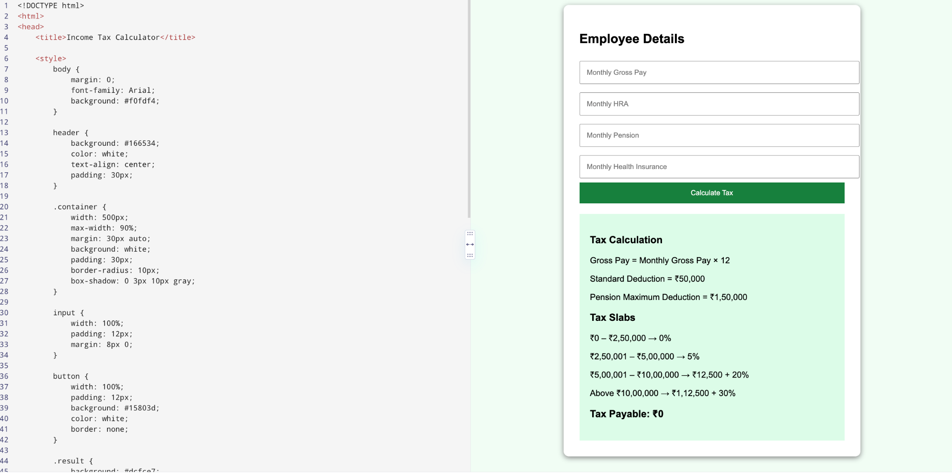

45)
<!DOCTYPE html>
<html>
<head>
<title>Phone Bill Payment</title>

<style>
body {
margin: 0;
font-family: Arial;
background: #eff6ff;
}

header {
background: #1d4ed8;
color: white;
text-align: center;
padding: 30px;
}

.container {
width: 500px;
max-width: 90%;
margin: 30px auto;
background: white;
padding: 30px;
border-radius: 10px;
box-shadow: 0 3px 10px gray;
}

input, select {
width: 100%;
padding: 12px;
margin: 8px 0;
}

button {
width: 100%;
padding: 12px;
background: #2563eb;
color: white;
border: none;
border-radius: 5px;
}

.bill {
background: #dbeafe;
padding: 20px;
margin: 20px 0;
}

.history {
background: #f8fafc;
padding: 20px;
margin-top: 20px;
}
</style>
</head>

<body>

<header>
<h1>📱 Phone Bill Payment</h1>
</header>

<div class="container">

<h2>Customer Login</h2>

<input type="email" placeholder="Email">

<input type="password" placeholder="Password">

<button>Login</button>

<hr>

<h2>Bill Details</h2>

<input placeholder="Mobile Number">

<div class="bill">

<h3>Current Bill</h3>

<p>Billing Period: August 2026</p>

<p>Due Date: 30 August 2026</p>

<h2>Amount: ₹599</h2>

<p>Late Fine: ₹10 per day after due date</p>

</div>

<h3>Payment Amount</h3>

<input type="number" placeholder="Enter Amount">

<h3>Payment Method</h3>

<select>
<option>Credit Card</option>
<option>Debit Card</option>
<option>Net Banking</option>
<option>Mobile Wallet</option>
</select>

<button>Pay Bill</button>

<div class="history">

<h3>Payment History</h3>

<p>July 2026 - ₹599 - Paid</p>

<p>June 2026 - ₹599 - Paid</p>

<p>May 2026 - ₹549 - Paid</p>

</div>

</div>

</body>
</html>
