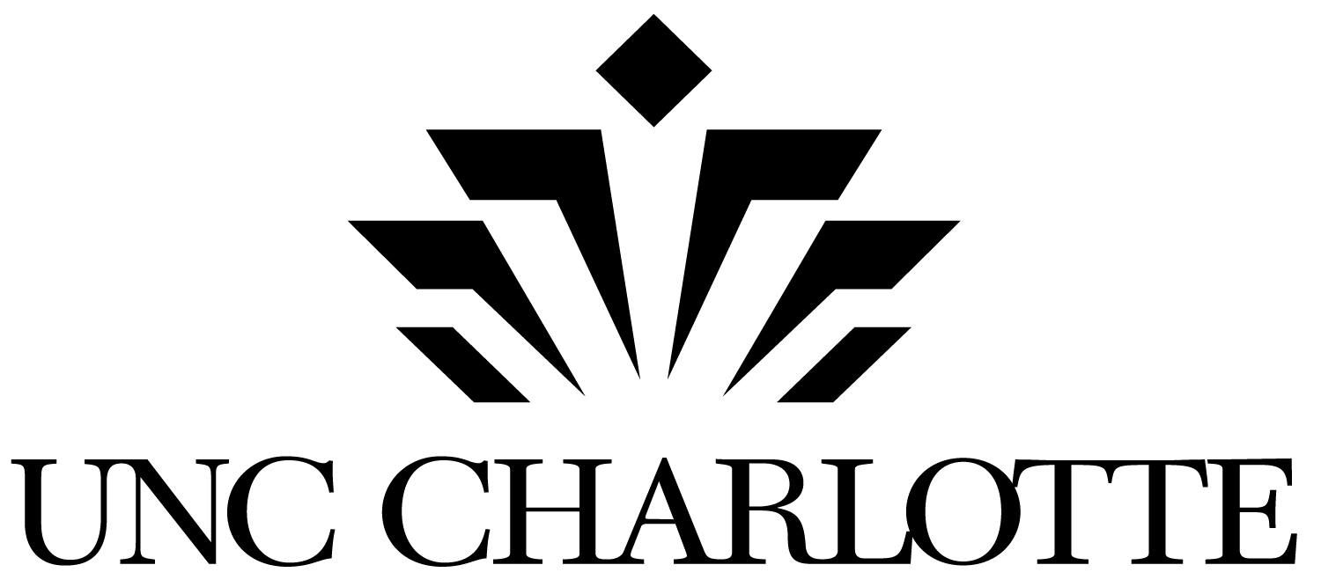

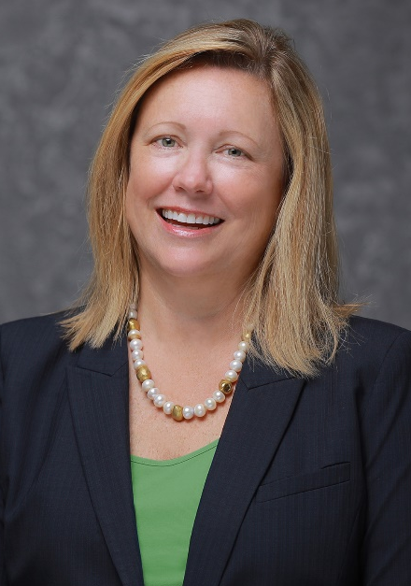
Welcome to UNC Charlotte, North Carolina’s urban research university. As you work toward your undergraduate or graduate degree program, please think of UNC Charlotte’s dedicated faculty and staff as your partners in your success. Their expertise and support, along with the many University resources and services available to you, will enable you to meet your academic, personal, and professional aspirations.

This is an exciting year in Niner Nation for a few reasons. First, you are back on campus! It’s also a big year because we are commemorating the 75th anniversary of our founding. We’ll have opportunities throughout the year to celebrate this milestone and the many accomplishments we’ve enjoyed during our first 75 years.

I’m sure you join with me in wishing a speedy “good riddance” to the pandemic that we all have had to navigate since Spring 2020. None of us could have ever imagined the set of challenges that it presented. Even so, I am proud of how the members of Niner Nation have come together in the face of these difficulties and worked to provide the safest environment possible for all of us, while also implementing creative measures that allowed for a flexible and robust learning environment.

I do appreciate that we have learned some lessons through these trying months about how to keep each other safe and how we can accomplish great things while using methods that look a bit different from what we’ve always done. You should know that, while we are back on campus together in Fall 2021, UNC Charlotte remains committed to providing a safe environment that is conducive to learning and enjoying all that a college experience entails.

One service that I believe you will find especially helpful in navigating your college experience is Niner Central, which is a one-stop shop for nearly any college-related issue that you can imagine. The physical location for Niner Central is at the front entrance of the Cone University Center. There you will find experts ready to assist with questions related to financial aid, billing/payments, course registration, transcripts, student records, etc. The Niner Central website (ninercentral.uncc.edu) also contains loads of information in one place to help you get the answers you need as quickly and easily as possible.

In joining the UNC Charlotte community—Niner Nation—you become part of a community in which students, faculty, and staff work collaboratively to identify and address the needs of the greater Charlotte region. We have a stake in the quality of life of the citizens of the communities we serve, so we constantly are pioneering new ways to drive economic growth and to meet the region’s environmental, health, and social needs.

We know that college is more than textbooks and classes, so we encourage you to become actively engaged on campus. Explore all the possibilities available – take advantage of leadership and volunteer opportunities; attend cultural events and lectures; participate in intramural sports; and, of course, we want to see you cheering on your Charlotte 49er athletic teams wherever they might be competing.

The light rail service on campus connects Niner Nation to Uptown Charlotte and all that it has to offer. And that includes quick and convenient access to the Dubois Center, UNC Charlotte’s campus in Center City, which is a hub for a number of our graduate programs. Its prime location also provides the University a place to convene civic, business, and community leaders around thought-provoking topics. Access to these leaders, and connections you may establish with them, could prove valuable to your educational pursuits and career prospects. Part of the transportation fee that you pay ensures your unlimited access to light rail, any city bus or shuttle, the Uptown trolley, and the campus shuttle system, “Niner Transit.”

Recent additions to our ever-growing campus include the University Recreation Center (UREC), the UNC Charlotte Marriott Hotel & Conference Center, and a brand new state-of-the-art science building.

I am beyond thrilled to be a part of Niner Nation, and I hope you feel the same way. So once again, welcome! I’m delighted that you’ve made UNC Charlotte your university of choice. Go Niners!


Sincerely,

Sharon L. Gaber
Chancellor

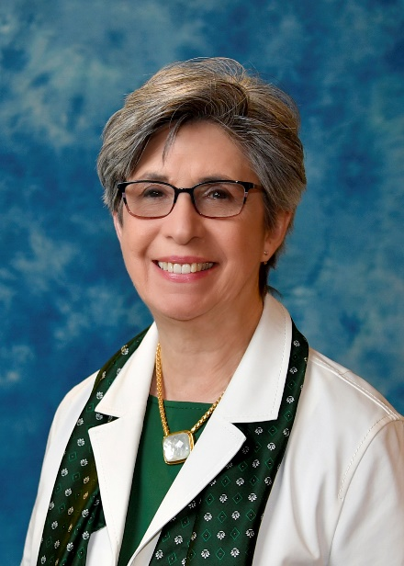
If this is your first year at UNC Charlotte, welcome to our dynamic community! If you are returning, we are pleased to welcome you back.

You are part of an engaged and enterprising university that is interconnected with North Carolina’s largest city. Because we are situated in a diverse, progressive city, our institution is alive with possibilities to learn and grow. Our distinguished faculty are here to provide you with a quality education that will open doors for you. Over the past few years, Niner Nation has proven itself to be a resilient and resourceful community. We have learned how to adjust and adapt. So, no matter what comes our way, we are dedicated to your education and are offering resources through college advising centers and the University Center for Academic Excellence to help you succeed. Please reach out to your academic advisor early and often, as they are here to help you stay on track to meet your goals.

Remember, too, that there is more to the collegiate experience than coursework. I encourage you to become involved in some of the many activities or student organizations. By getting involved, you will build relationships with both your fellow students and our faculty that you will cherish as you move on through the years.

I hope you will take advantage of the excellent resources available here, and explore all that our University has to offer. But don’t stop there – explore research, community engagement, and professional development opportunities in the greater Charlotte area and in the world beyond. We’re here to help you get started.

We are pleased that you have chosen UNC Charlotte. As our University continues to grow, we look forward to you continuing to grow with us as a person, a scholar, and a future alum.

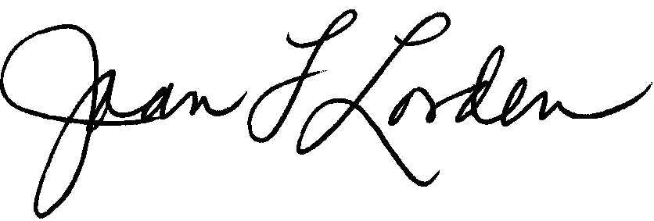
Sincerely,

Joan F. Lorden
Provost and Vice Chancellor for Academic Affairs

