University Regulation

of Student Conduct

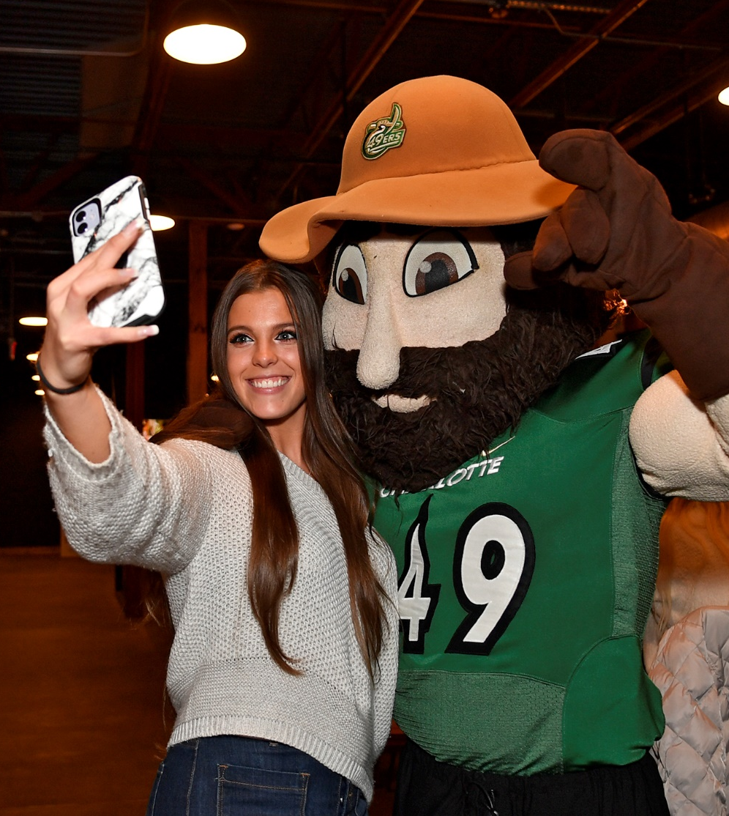

University Regulation
of Student Conduct

As students willingly accept the benefits of membership in the UNC Charlotte community, they also commit to obligations to observe and uphold the principles and standards of conduct that reflect the values of the UNC Charlotte community.

At UNC Charlotte, University Policy 406, The Code of Student Responsibility, fulfills the duty of the Chancellor to regulate matters of student conduct in the University community. University Policy 407, The Code of Student Academic Integrity, governs student behavior relating to academic work. All UNC Charlotte students are expected to be familiar with both Codes and to conduct themselves in accordance with these requirements. Any person may report an alleged violation(s) of the Code online at incidentreport.uncc.edu. Individuals may report crimes or incidents involving imminent threat of harm to Police and Public Safety at 704-687-2200.

The University has also established a program for the prevention of the use of illegal drugs and alcohol abuse (University Policy 711), as well as a policy regulating smoking and tobacco product use on campus (University Policy 707). All UNC Charlotte students are obligated to be familiar with and to conduct themselves in accordance with the standards set forth in these policies.

Additionally, the Student Government Association has created a code called The Noble Niner that solidifies the high standard of morals, principles, and integrity that all students should strive to uphold the reputation of excellence at UNC Charlotte.

The Code of
Student Academic Integrity
legal.uncc.edu/policies/up-407

The Code of Student Academic Integrity governs the responsibility of students to maintain integrity in academic work, defines violations of the standards, describes procedures for handling alleged violations of the standards, and lists applicable penalties. Except in cases of Research Misconduct, as set forth in Chapter 3, Section III.2 of the Code, the following conduct, or complicity in the following conduct, is considered Academic Misconduct under the Code:

- Cheating means using or attempting to use materials, or giving assistance or materials without Authorization to another in any academic exercise that could result in gaining or helping another to gain academic advantage. See examples.
- Fabrication means providing fabricated information, including inventing or counterfeiting information, in any form in an academic exercise. See examples.
- Falsification means altering without Authorization any data or information, regardless of communication method (e.g., e-mail or other electronic communication), in an academic exercise. See examples.
- Misuse of Academic Materials means sharing, distributing, altering, acquiring, damaging, or making inaccessible academic materials without Authorization, that could result in gaining or helping another to gain an academic advantage. See examples.
- Multiple Submission means submitting academic work or substantial portions of the same academic work (including oral reports) in more than one academic exercise without Authorization. See examples.
- Plagiarism means presenting the words or ideas of another as one’s own words or ideas, including failing to properly acknowledge a source, unless the ideas or information are common knowledge. Plagiarism includes self-plagiarism, which is the use of one's own previous work in another context without indicating that it was used previously. See examples.
- Unauthorized Collaboration means sharing the work or effort in an academic exercise with another individual or individuals without Authorization. See examples.
- Research Misconduct means a determination that Research Misconduct has occurred under University Policy 309, Responding to Allegations of Misconduct in Research and Scholarship and its Supplemental Procedures. (See Chapter 3, Section III of the Code.)

A full explanation of these definitions, and a description of procedures used in cases where student violations are alleged, is found in the complete text of University Policy 407, The Code of Student Academic Integrity, as it may be modified from time to time. Students are advised to contact the Dean of Students Office or visit legal.uncc.edu/policies/up-407 to ensure they consult the most recent edition.

The Code of
Student Responsibility
legal.uncc.edu/policies/up-406

Philosophy and Purpose
The purpose of the Code is to uphold academic and community standards; encourage personal accountability and responsible decision making; promote student learning; and reduce and prevent behavior that undermines student success and community safety.

The University is committed to providing a fair, impartial, and efficient process facilitated through compassionate conversations in which students are heard, respected, and treated with dignity. All students are responsible for conducting themselves in a manner that helps enhance an environment of learning in which the rights, dignity, value, and freedom of each member of the academic community are respected.

The University works to create and sustain an environment where freedom of speech and expression are supported and honored. The University has the discretion to regulate the time, place, and manner of exercising these and other Constitutionally protected rights. In administering this Code, the University will exercise care to preserve the freedom of speech and expression for all in the campus community.

As with the scales of justice, the University’s work in the area of student conduct is about balance. The University must balance students’ free speech rights with the desire to protect the Campus community from discriminatory words and actions. The University acknowledges that higher education student conduct and disciplinary systems have, historically, contributed to systemic racism. Therefore, the University must balance its commitment to preserving student rights, encouraging responsible growth and development of its students, protecting the rights of those targeted by student actions, and holding students accountable for their actions.

Prohibited Conduct, Procedures, and Sanctions
Chapter 5 of the Code (legal.uncc.edu/policies/up-406#ch5) includes a list of behaviors that are prohibited by the Code, including, but not limited to, acts of harm (injury, harassment, relationship violence, etc.), weapons violations, disruption of University activities, drug violations, fire safety, misrepresentation, false identification, theft, vandalism, alcohol violations, sexual misconduct, trespassing, disorderly conduct, hazing, and retaliation. For a full explanation of all conduct prohibited under the Code, consult Chapter 5 of the Code at legal.uncc.edu/policies/up-406#ch5.

Important Note: Any alleged conduct occurring on or after August 14, 2020 that meets the definition of one or more of the Title IX Violations (legal.uncc.edu/policies/up-406#TIXViolations) is not considered Sexual and Interpersonal Misconduct under University Policy 406, Code of Student Responsibility. Alleged Title IX Violations occurring on or after August 14, 2020, are processed according to University Policy 504, Title IX Grievance Policy (legal.uncc.edu/policies/up-504).

Chapter 6 of the Code (legal.uncc.edu/policies/up-406#ch6) provides the process for case referrals and adjudication methods.

Chapter 7 of the Code (legal.uncc.edu/policies/up-406#ch7) provides Conduct Procedures applicable for Formal Charge(s) adjudicated by a Hearing Panel or Administrative Hearing Officer under the Code.

Chapter 8 of the Code (legal.uncc.edu/policies/up-406#ch8) provides additional Conduct Procedures applicable to alleged Sexual and Interpersonal Misconduct.

Chapter 10 of the Code (legal.uncc.edu/policies/up-406#ch10) details possible sanctions imposed on Students or Student Organizations found responsible for violating the Code.

Chapter 11 of the Code (legal.uncc.edu/policies/up-406#ch11) provides information on appeals.

A full explanation of prohibited conduct, and a description of procedures used in cases where violations are alleged, including appeals processes, are found in the complete text of The Code of Student Responsibility, as it may be modified from time to time. Students are advised to contact the Office of Student Conduct and Academic Integrity or visit legal.uncc.edu/policies/up-406 to ensure they consult the most recent edition.

The Program to Prevent Use of
Illegal Drugs and Alcohol Abuse
legal.uncc.edu/policies/up-711

Below is a brief summary of University Policy 711, Program to Prevent Use of Illegal Drugs and Alcohol Abuse. Visit legal.uncc.edu/policies/up-711 for a full version of that policy.

In keeping with efforts to maintain an environment that supports and encourages the pursuit and dissemination of knowledge, it is the policy of The University of North Carolina at Charlotte to consider the use of illegal drugs or alcohol abuse by students, faculty and staff or by others on premises under University control to be unacceptable conduct that adversely affects the educational environment.

To remind students, faculty, and staff of their responsibilities for maintaining a drug-free environment, this Policy will be distributed throughout the University community each year. Further, the University considers a sound awareness, education, and training program indispensable in combating illegal use of drugs and alcohol abuse, both as a preventive measure and as a remedy. The scope of the University program addresses the awareness needs of students, faculty, administrators, and other staff members and includes the following minimum components.

- The health hazards associated with the use of illegal drugs and alcohol abuse.
- The incompatibility of the use of illegal drugs or abuse of alcohol with maximum achievement of personal, social, and educational goals.
- The potential legal consequences (including both criminal law and University discipline) of illegal drug use and alcohol abuse.
- The effective use of available campus and community resources in dealing with illegal drug use and alcohol abuse problems.

The University's program emphasizes collaboration with local resources, including the Center for Prevention Services, Dilworth Center for Chemical Dependency, Anuvia Prevention and Recovery Center, McLeod Addictive Disease Center, Carolinas Medical Center Behavioral Health Services, Eastover Psychological and Psychiatric Group, The Insight Program, Alcoholics Anonymous, Narcotics Anonymous, Al-Anon, and Nar-Anon. To this end, the University shall participate in the Charlotte-Mecklenburg Drug Free Coalition and will work with local advisory boards to further collaborate between the University and the Charlotte community.

The University's awareness, education, and training efforts stress prevention. The goal of these efforts is (1) to encourage non-users of illegal drugs and alcohol to continue to be non-users, (2) to encourage users of alcohol to do so safely and responsibly, and (3) to encourage users of illegal drugs to stop such use.

The use of illegal drugs and the abuse of alcohol are considered by the University to be problems that can be overcome. Therefore, the educational and rehabilitative services cited above are available on a confidential basis. However, the possession, sale, delivery, or manufacture of illegal drugs will not be tolerated on campus or off campus in the event that the interests of the University may be affected.

The University will cooperate fully with law enforcement agencies and will apply appropriate disciplinary procedures should a student violate criminal statutes with regard to illegal drugs or alcohol abuse. Violations may subject a student to prosecution and punishment by civil authorities and to disciplinary action by the University.

Upon receiving notice of a student’s violation of this Policy, the University will initiate disciplinary procedures under the Code of Student Responsibility.

Smoking and Use of Tobacco Products
on University Property
legal.uncc.edu/policies/up-707

Below is a brief summary of University Policy 707, Smoking and Use of Tobacco Products on University Property. Visit legal.uncc.edu/policies/up-707 for a full version of that policy.

The University of North Carolina at Charlotte has a vital interest in maintaining a healthy and safe environment for its students, faculty, staff and visitors while respecting individual choice about smoking and use of tobacco products. Consistent with these concerns and with North Carolina law, the following Policy establishes restrictions on smoking and use of tobacco products on University Property and provides procedures for accommodating the preferences of both smokers and non-smokers.

For the purposes of this Policy:

- "Smoking" is defined as the use or possession of a lighted cigarette, lighted cigar, lighted pipe, or any other lighted tobacco product, or the use of an electronic inhaler that employs a mechanical heating element, battery, or electronic circuit to heat a liquid nicotine solution contained in a vapor cartridge, such as an electronic cigarette, electronic cigar, electronic cigarillo, or an electronic pipe.
- “Tobacco product” means a cigarette, a cigar, chewing tobacco, vapor product, or any other product that contains tobacco and is intended for inhalation, oral use, or nasal use. The term does not include nicotine patches, nicotine gum, nicotine lozenges, or other tobacco cessation products.
- A "Building" is defined as any permanent or temporary structure utilized for the support, shelter or enclosure of people, animals, or property. "Buildings" include, but are not limited to: residence halls; classroom and office buildings; workshops; shuttle, light rail, and bus stops; all recreational and athletic facilities, including athletic fields, gymnasiums, and stadiums; parking decks; stairwells; inside and outside dining areas; vending areas; breezeways; and connectors.
- A "University Building" is defined as any Building owned, leased as lessor, or the area leased as lessee and occupied by UNC Charlotte.
- "University Property" means University Buildings and grounds owned, leased, operated, controlled, or supervised by UNC Charlotte.
- A "University Vehicle" is defined as a vehicle owned or leased by UNC Charlotte.
- A "Designated Smoking Area" is defined as an exterior area on the UNC Charlotte campus designated by the Chancellor or the Chancellor's designee as a place for smoking. Designated Smoking Areas will be marked by proper signage, and are subject to the provisions in Section III of this Policy.

The following restrictions apply to smoking and use of tobacco products on University Property:
- Smoking and use of tobacco products is prohibited within all University Buildings.
- Smoking is prohibited within 100 linear feet of any University Building unless otherwise allowed under subsection III. D.
- Smoking and use of tobacco products in University Vehicles is prohibited.
- Smoking is permitted on University Property in Designated Smoking Areas. See the Smoking Policy Map at facilities.uncc.edu/our-services/maps/printable-campus-maps.

Additional restrictions on smoking or use of tobacco products required for safety reasons may be imposed by the University on a case-by-case basis. Areas with such restrictions will be identified by signage.

Cooperation and consideration between smokers and non-smokers, and between users and non-users of tobacco products is necessary to ensure the successful implementation of this Policy. Effective implementation of this Policy depends upon the courtesy, respect, and cooperation of all members of the University community.

Violation of this Policy may subject a student to conduct action under the Code of Student Responsibility.

Noble Niner Code
dso.uncc.edu/rights-responsibilities/noble-niner

The Noble Niner Code was authored by the Student Government Association and describes the ideals which every Charlotte 49er student can ideally reach as he or she becomes a fully actualized individual.

It was approved by the UNC Charlotte Board of Trustees on April 20, 2007, and is now adopted as an official document of the University.

Scholarship
A Niner shall strive for academic excellence in and out of the classroom while maintaining academic honesty and ethical values.

Integrity
A Niner shall act to uphold and improve one’s self, the community, and the high standards of the institution.

Respect
A Niner shall welcome all aspects of individuality and self-worth while embracing the learning opportunities that diversity provides.

Accountability
A Niner shall hold others responsible for their actions while accepting responsibility for one’s own.

Dignity
A Niner shall appreciate the intrinsic value of the institution and work to preserve the 49er environment.

Honor
A Niner shall appreciate students, faculty, administration, and staff as contributing members of the University community.

Compassion
A Niner shall demonstrate genuine consideration and concern for the needs, feelings, ideas, and well-being of others.

Character
A Niner shall exemplify all qualities and traits that promote fellowship and camaraderie among the student body, faculty, staff, and administration.

Nobility
A Niner shall exhibit the virtues and values listed above which befit all members of our Niner Nation.

