School of

Professional Studies



School of
Professional Studies
professional.charlotte.edu

Undergraduate Programs
- B.S. in Professional Studies

The UNC Charlotte School of Professional Studies ensures that all learners, regardless of age, level of experience, or previous education, have opportunities to learn, grow, and achieve their personal and professional goals with a UNC Charlotte education. We believe that everyone deserves lifetime access to education that enables a lifelong journey of personal and professional growth.



Bachelor of Science in Professional Studies
The multi/interdisciplinary major in Professional Studies is intentionally designed to allow transfer and returning students to build on past educational and professional experiences and work with faculty and professional staff to grow knowledge and skills needed to secure employment in a desired field. Students complete a plan of study that includes a core of applied professional skills, an exploration of human social relationships and institutions, two concentrations, and culminates in a capstone project.

Admission Requirements
Transfers
The Professional Studies degree is available to transfer students and returning degree-seeking UNC Charlotte undergraduate students who have not enrolled in the last 12 months.

Prospective students interested in the Professional Studies degree should have at least 75 transferable credit hours. This requirement may be met with (1) transferable associate's degree and additional college coursework to meet 75 credit hours (2) 75 college credits that fulfill the UNC Charlotte general education requirements. Students who apply as transfer students without the approved Associate of Arts (AA), Associate of Science (AS) or Associate of Fine Arts (AFA) degree from a North Carolina community college that results in General Education exemption at UNC Charlotte will have their prior coursework evaluated upon application and may qualify for admission directly to the Professional Studies degree. Prospective and newly admitted students will consult with the Office of Adult Students and Evening Services (OASES) for advising. Students who have the 75 transferable credit hours but do not otherwise meet the criteria for admission directly to the Professional Studies major can be admitted to UNC Charlotte as an undecided major where they will work with an OASES advisor to secure admission to the Professional Studies program. All 49er Finish Program students are advised by OASES staff.

In addition to the online application and required fee, official transcripts from every college attended, and an official high school transcript, the following requirements apply:

- Applicants must present an overall 2.0 grade point average according to calculations performed by the Undergraduate Admissions office.
- Internationally‐educated students must have their foreign credentials translated and evaluated by an accredited credential evaluation service. Transfer applicants must have a "course by course report" completed by the service, and they must present the equivalent of a high school diploma in addition to college‐transferable coursework.
- Applicants must be in good standing and eligible to return to the last institution attended.

Degree Requirements
General Education Courses (37-43 credit hours)
For details on required courses, refer to the General Education Program.

Credit for Prior Learning (optional)
Up to 23 credit hours (see policy for transfer credit).

Major Core Courses (12 credit hours)
Sociology Courses (6 credit hours)
SOCY 2115 - Introduction to Organizations (3)
SOCY 4111 - Social Inequality (3)
or SOCY 4112 - Sociology of Work (3)
or SOCY 4115 - Organizational Sociology (3)

Professional Studies Courses (6 credit hours)
Professional Competency Courses (3 credit hours)
Select one of the following Professional Competency series. The three credit hours may be completed in a consecutive course series or selected from a different professional competency. Special topics (PROS 3000) may also be used to satisfy the professional competency requirement.

Project Management Series
PROS 3101 - Project Management: Foundations (1)
PROS 3102 - Project Management: Practitioner (1)
PROS 3103 - Project Management: Specialist (1)

Leadership Essentials Series
PROS 3201 - Leadership Essentials: Foundations (1)
PROS 3202 - Leadership Essentials: Practitioner (1)
PROS 3203 - Leadership Essentials: Specialist (1)

Human Resource Management Series
PROS 3301 - Human Resource Management: Foundations (1)
PROS 3302 - Human Resource Management: Practitioner (1)
PROS 3303 - Human Resource Management: Specialist (1)

Capstone Course (3 credit hours)
PROS 4600 - Professional Studies Capstone (1 to 3)

Area Courses or Optional Minor (18 credit hours)
Complete at least nine credit hours in two areas. Only three credit hours from the 1000-level may be counted toward the area. A minor of 18 credit hours may be substituted for the two areas. Appropriate courses in the area may be substituted with advisor approval.

Area Courses (18 credit hours)
Political Science and Public Administration Area (9 credit hours)
Select from the following:
POLS 1110 - American Politics (3)
POLS 2120 - Introduction to Public Policy (3)
POLS 3119 - State and Local Government (3)
POLS 3126 - Introduction to Public Administration (3)

Information Technology Area (9 credit hours)
Select from the following:
ITSC 3xxx - Information Technology Elective (3)
ITSC 3xxx - Information Technology Elective (3)
ITSC 3xxx - Information Technology Elective (3)

Optional Minor (18 credit hours)
Select any 18 credit hour minor approved in consultation with advisor.

Unrestricted Elective Courses (0-30 credit hours)
As needed to complete the credit hours required for graduation.

Degree Total = 120 Credit Hours

Grade Requirements
A GPA of 2.0 in the major is required for graduation, as well as grades of C or above in all courses.

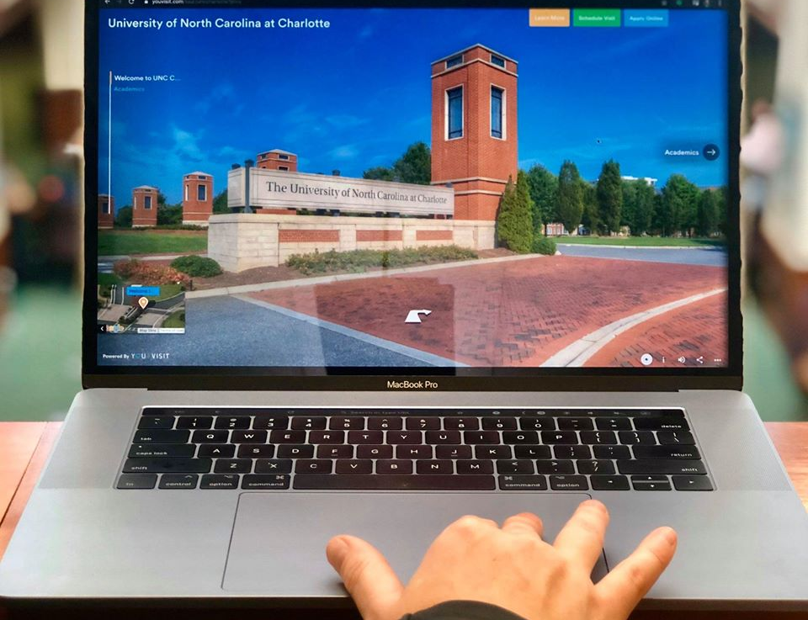
Online Academic Programs

Charlotte Online extends learning opportunities to professionals hoping to advance their careers on their own time. Our growing selection of online and distance education programs are taught by award-winning faculty and are nationally recognized for quality. Students can connect to campus from anywhere in the U.S. and enroll in undergraduate and graduate programs to fit their needs in industries like healthcare, education, engineering, data and computing, and more.

Options for delivery include sending a UNC Charlotte faculty member to an off-campus location to teach a course in person, delivering courses completely online or via Hybrid delivery combining face-to-face and online delivery of instruction. Visit professional.charlotte.edu/online for more details.

Professional Credit

Professional credit is a term used for the University’s non-academic-credit programs within the School of Professional Studies. These programs provide upskilling and reskilling opportunities in short-format options that are convenient for adults’ busy schedules. Many of these programs also allow professionals to maintain their license in their profession. A professional-credit course can provide fresh material and insight as well as feedback and direction from industry leaders and instructors. Learners can earn continuing education credits in some courses and complete a professional certificate to add to one’s resume or use toward certifications.

Employer Solutions

UNC Charlotte's Employer Solutions provides a wide range of world-class training and development solutions to meet the needs of businesses and organizations. As a leading provider in end-to-end learning solutions, Employer Solutions creates and customizes strategically-designed training programs for organizations that create skill-centered results and a lasting impact. Training and executive education opportunities are conveniently offered both onsite and online.

But Employer Solutions is so much more than just training and executive education. We strive to provide support for every aspect of an organization’s talent development journey including group and 1:1 coaching, advising services, assessments, materials licensing, instructional design, and train-the-trainer. Visit professional.charlotte.edu/employer-solutions for more details.

