Honors

College

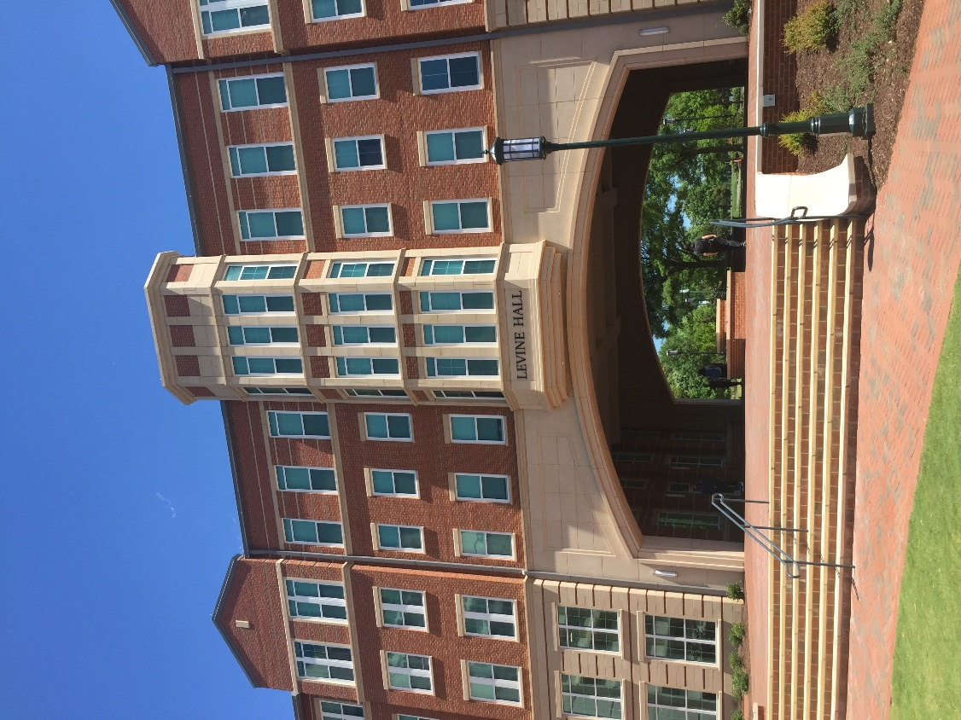

Honors
College
honorscollege.charlotte.edu

The Honors College offers academically motivated, high-potential learners from all communities access to opportunities for intellectual breadth, undergraduate research, service learning, and a community feeling within the context of a large public research university. Comprised of several distinct honors programs, each with its own admission and graduation requirements, the Honors College is a campus hub for undergraduate honors courses, enrichment opportunities, merit scholars programs, honors scholarships, study abroad, community service, faculty lectures, and University-wide advising for pre-health professions and competitive national awards like the Rhodes, Truman, and Goldwater. An honors residence option in Levine Hall is also available for all students in the Honors College.

The University Honors Program in the Honors College
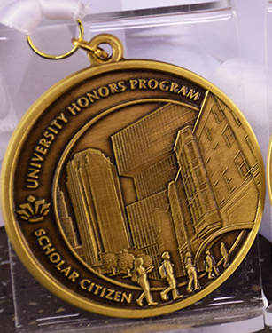
The University Honors Program (UHP) in the Honors College offers a unique, interdisciplinary undergraduate experience. The program centers around honors coursework, community engagement, and leadership opportunities. In addition to academic and professional development, UHP offers a supportive community of students and faculty who mutually invest to help members develop to their fullest potential as scholar citizens. Students are encouraged to participate in varied enrichment activities, internships, research, and Education Abroad programs with the goal of broadening perspectives.

The UHP curriculum requires successful completion of HONR 1700, LBST 2301 (honors sections only), 12 credit hours of honors electives, and completion of an honors senior capstone project. An Advanced Entry option is available for students coming in with substantial early college or transfer credit. Students in UHP also may join one or more disciplinary honors programs during their time at UNC Charlotte. The Honors College website maintains a current listing of all honors programs available at UNC Charlotte. Credit for certain honors courses in disciplinary honors programs may count toward UHP requirements. During the senior year, UHP students complete a senior capstone project through UHP or through their disciplinary honors program.

Admission Requirements
Entering freshmen, transfer and continuing students in any major who: expect to be at UNC Charlotte for at least two years to complete their degree program, have a strong record of academic success, and feel they are a good fit with the UHP mission may apply to UHP. Continuing students must have a GPA of 3.4 to apply. All members of UHP must maintain a 3.0 overall GPA, a 3.2 GPA in honors courses, and meet extra-curricular expectations each semester.

Course Requirements
To graduate with University Honors distinction noted on the transcript, students must satisfy the following course requirements:

Required Courses
HONR 1700 - University Honors Program Colloquium (1) (with a grade of B or above)
LBST 2301 - Critical Thinking and Communication (3) (Honors sections only) (taken in the Sophomore year)
HONR 3790 - University Honors Program Senior Seminar (1) (with a grade of A)
HONR 3791 - University Honors Program Senior Project (3) (W) (with a grade of A)

Elective Courses
Select 12 credit hours of HONR courses and/or Honors sections of LBST courses. At least 6 credit hours of honors elective courses should be at the 3000 level or higher. Students accepted as Advanced Entry may be exempted from 6 credit hours of LBST Honors coursework if they enter with 60+ credit hours, and may be exempted from 3 credit hours LBST Honors coursework if they enter with 30-59 credit hours.

Other Requirements
- Complete the Application to Candidacy process for graduating with Honors, as directed by the Honors College
- Maintain a minimum overall GPA of 3.0, and a 3.2 GPA in honors coursework
- Maintain good standing through participation in UHP

Dual Honors
Students may graduate with dual honors by completing all departmental/college honors requirements, in addition to UHP requirements. In this case, the departmental thesis or capstone experience will satisfy the UHP project requirement, exempting the student from HONR 3790 and HONR 3791.

Students in dual honors programs may count one 3000 or 4000-level honors course toward their honors electives.

Study Abroad
Students studying abroad may request equivalency credits for one honors elective coursework from the Associate Director of Curriculum for the Honors College.

Residence
University Honors Program students are encouraged to live in the Honors College residence, Levine Hall, which provides an environment especially conducive to study and cooperative learning.

Student Association
Students in the University Honors Program are also part of the University Honors Program Student Association (UHPSA). The student-led organization coordinates social events, special discussions, student mentoring, and community service projects.

Merit Scholars Programs
The Albert Engineering Leadership Scholars Program, Crown Scholars Program, Freeman Scholars Program, Johnson Scholars Program, and Martin Scholars Program are housed in the Honors College; Albert and Crown Scholars are members of the University Honors Program; Freeman, Johnson, and Martin Scholars are members of any honors program.

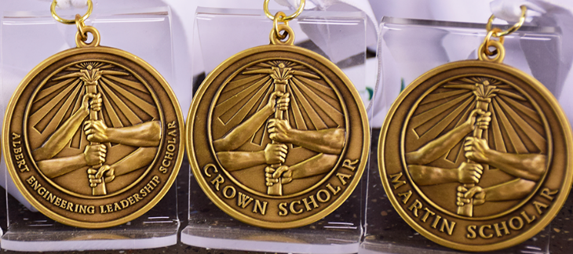

Honors Programs in Academic Departments and Colleges
Many academic departments and colleges have honors programs enabling students to graduate with honors distinction in their academic discipline or college. This recognition will appear on students’ official academic transcripts.

Honors programs in colleges include:
- College of Arts + Architecture
- College of Business
- College of Computing and Informatics
- College of Education
- College of Engineering

Honors programs in academic departments and interdisciplinary programs include:
- Africana Studies
- Anthropology
- Applied Physiology, Health, and Clinical Sciences
- Art History
- Biological Sciences
- Chemistry
- Communication Studies
- Criminal Justice and Criminology
- English
- Geography and Earth Sciences
- Global Studies
- Health Systems Management
- History
- Languages and Culture Studies
- Latin American Studies
- Mathematics and Statistics
- Nursing
- Philosophy
- Physics and Optical Science
- Political Science and Public Administration
- Psychological Science
- Religious Studies
- Social Work
- Sociology

Information on how to apply and graduate with honors from a college or a specific academic discipline can be found in this Catalog under each academic discipline with an honors program.



Preparation for Professional Schools

Pre-Health Professions and Pre-Medical School Advising
UNC Charlotte offers pre-professional preparation for undergraduate, graduate, and post-baccalaureate students interested in pursuing a career in medicine, dentistry, veterinary medicine, pharmacy, optometry, physician assistant, physical therapy, podiatry, and related healthcare careers. Opportunities and services available to students include:

- Strong academic preparation in the required prerequisite core of science and math courses
- Broad selection of recommended non-science courses
- Pre-Health Professions Advising for academic and nonacademic requirements for professional school admission
- Assistance with the application process, including essay preparation and interviews
- Pre-Professional Faculty Evaluation Committee that prepares composite recommendation letters on the student’s behalf
- Opportunities to participate in research
- Student clubs that offer guest speakers, community service, and peer support

Like most universities, UNC Charlotte does not offer a formal pre-health major, minor, or program. Students must select a major and are responsible for completing the prerequisites for their chosen professional school in addition to courses for their major. There is no requirement to major in science, but strong preparation in science and math must be demonstrated, regardless of the major. A Pre-Health Advisor will assist the student with identifying the appropriate pre-professional courses and formulating a timeline for their completion.

All pre-health students are encouraged to consult with a Pre-Health Advisor to plan and review their course of study and other requirements necessary for admission into professional schools. Additional information may be found on the Honors College website at honorscollege.charlotte.edu, including prerequisite course lists for various professions.

For health-related student organizations, visit studentorgs.charlotte.edu.

Prerequisite Core Courses
The basic minimum requirements for entrance to most health professions schools are as follows:

Biology (with labs) 8 credit hours
General Chemistry (with labs) 8 credit hours
Organic Chemistry (with labs) 8 credit hours
Physics (with labs) 8 credit hours
English 6 credit hours

Note: These are the common minimum requirements; additional courses may be required at the discretion of the professional school. Most students will need additional coursework and healthcare-related extracurricular activities to be competitive for admission. Community service is also highly desirable.

Faculty Evaluation Committee for Pre-Health Professions
The UNC Charlotte Pre-Health Professions Faculty Evaluation Committee consists of faculty members from the University and serves as the main recommending body for UNC Charlotte students seeking entrance to medical, dental, veterinary, and optometry schools. Students must have competitive credentials to qualify for a committee letter. In order to obtain a recommendation from the committee, the student must schedule an appointment with the Pre-Health Professions Advising Office during the year in which applications are being submitted.

Pre-Law Advising

Admission to law school is determined mainly by undergraduate grade point average and the score on the Law School Admissions Test (LSAT). Applicants must also submit letters of recommendation and a recitation of extracurricular activities, and personal statement, but those items are secondary to the GPA and LSAT. There is no defined program of pre-law courses, and law schools do not favor or require a specific major. Law schools look for students who have taken courses that are academically rigorous, including writing intensive and research oriented courses.

To learn more about law school, please visit the UNC Charlotte Pre-Law Society website at unccprelaw.com or contact the Department of Criminal Justice and Criminology. For law-related student organizations, please visit the Student Organizations website at studentorgs.charlotte.edu.

Scholarships for Advanced Undergraduate and Graduate Study
The Honors College, working with the University Endorsement Committee, supports applications and nominations for many national and international scholarships for advanced undergraduate and graduate study. These scholarships, from a number of foundations and national organizations including Rhodes, Marshall, James Madison, Barry M. Goldwater, Jack Kent Cooke, Phi Kappa Phi, and National Science Foundation, require extensive application procedures and are awarded only to the most outstanding applicants. Students with exemplary academic records—combined with service and leadership—may be nominated for these highly selective graduate and, in some cases, advanced undergraduate awards. Most require an on-campus review and institutional endorsement of completed applications.

The Honors College also coordinates UNC Charlotte Alumni Association Scholarships, which preference students in honors programs, as well as scholarships for honors students: the Delbridge E. Narron Scholarship and Travel Award, and the Al Maisto Honors College Scholarship.

