Office of

Undergraduate Education

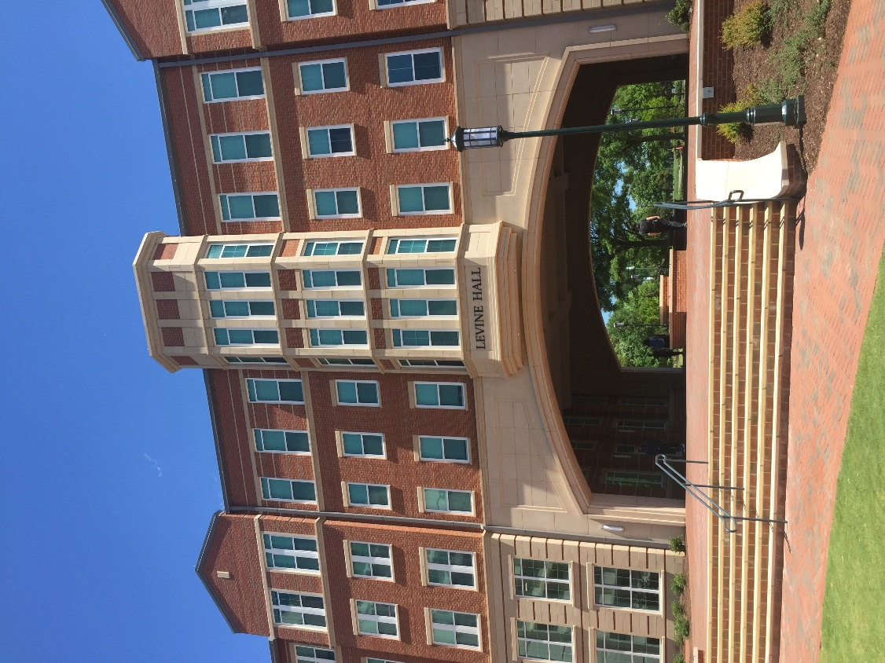

Office of
Undergraduate Education
uge.charlotte.edu


The Office of Undergraduate Education at UNC Charlotte enriches the academic community by offering a broad range of initiatives promoting student success, ensuring access, and enhancing the educational experience of all students. Broadly speaking, the Office of Undergraduate Education’s responsibilities fall in two areas: (1) curriculum and integrated learning, and (2) advising and experiential learning. Through transition programs, learning communities, support for student-athletes, career services, experiential learning, disability services, initiatives for underrepresented students, tutorial programs and other success services, the Office of Undergraduate Education supports students in cultivating life skills critical to successful graduation and global citizenship. In addition, through its faculty development programs, curriculum improvement and innovation initiatives, leadership on advising, and community outreach, the Office of Undergraduate Education engages the University’s academic units, faculty, and staff in efforts to enhance and improve both the quality and effectiveness of our academic programs. Working with students and stakeholders to address the needs of a diverse student population, the Office of Undergraduate Education utilizes an integrated student-centered approach that reinforces rigorous academic expectations and encourages student engagement from the time of enrollment through graduation.

The Office of Undergraduate Education consists of the following:

- Advising Systems
- Athletic Academic Center
- Communication Across the Curriculum
- Disability Services
- First-Year Experience (Prospect for Success, Common Reading Experience, and Learning Communities)
- Office of Academic Diversity and Inclusion
- Office of Undergraduate Research
- University Advising Center
- University Career Center
- University Center for Academic Excellence
- University College
- University Transfer Center

Advising Systems
advising.charlotte.edu/students/academic-support/advising-systems

The Advising Systems Team works with the campus community in supporting student success by utilizing academic software systems for early alerts, appointments, notifications, notes, and student progression/performance tracking. These systems include CONNECT, Navigate Student, and DegreeWorks. Faculty in 1000- and 2000-level courses report early alerts by the fourth week in the semester using CONNECT. An early alert triggers an email sent to a student’s UNC Charlotte email account. This email contains information related to missing assignments, missing classes, or demonstrating low performance. Students are able to make appointments with academic advisors and other academic support services, such as tutoring and academic consultations, to improve performance in their courses. Navigate Student is a mobile app that allows students to be able to keep track of university deadlines, provides tips to success, and links to CONNECT. DegreeWorks, managed by the Office of the Registrar, is the official degree audit system to track progress towards degree completion.

Athletic Academic Center
charlotte49ers.com/sports/academic_center

The Charlotte 49ers Athletic Academic Center (AAC) is committed to empowering all Charlotte varsity student-athletes to take ownership of their personal academic experience. The center provides a framework of support services designed to meet the unique needs of student-athletes, assisting them to achieve academic and personal success at the University while ensuring the student athlete’s compliance with all National Collegiate Athletic Association (NCAA), Conference and University regulations.

The Athletic Academic Center operates dual centers: the ATAC AAC located in the Miltimore-Wallis Athletics Training and Academic Center adjacent to the Barnhardt Student Activity Center and the Board of Trustees (BOT) AAC is located in the Rose Football Center adjacent to McColl-Richardson Field. The academic facilities have study areas, computer labs, private tutor rooms, and offices.

Communication Across the Curriculum
cxc.charlotte.edu

Communication Across the Curriculum (CxC) supports student success through programs designed to integrate writing and speaking into disciplinary curricula and general education. CxC’s vision is that all students have multiple, high quality opportunities throughout their academic careers to develop their communication skills. CxC staff partner with academic colleges, departments, and individual faculty to facilitate curricular transformations that broaden and deepen student learning and engagement. The following programs are offered on a regular basis by CxC:

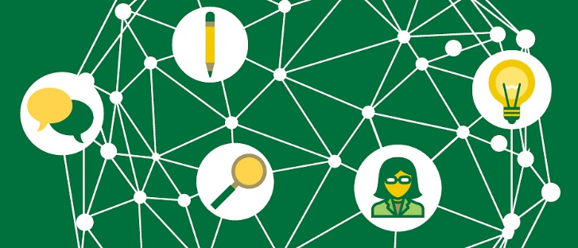

Curriculum Consultation
CxC offers a comprehensive approach to curriculum mapping that identifies areas of strength and opportunities for growth in teaching and evaluating writing and speaking. On a smaller scale, CxC facilitates group discussions about communication in the curriculum. Also, CxC works with faculty in small groups and individually to consult on specific course and assignment design.

Professional Development
CxC facilitates various professional development opportunities for faculty throughout the year, including:

- CxC Webinar Series
- LBST 2301 Teaching Academy
- W/O Teaching Academy
- Workshops (customized to group needs, upon request)

Student Communication Consultants
CxC administers a student peer-mentoring program, providing opportunities for students to work as Communication Consultants with faculty who develop a communication-enhanced curriculum. The consultant’s role when working with students is to act as an engaged reader/listener, providing informed, constructive criticism directed toward the focus, scope, evidence, analysis, organization, clarity, and style of papers and presentations. Consultants also provide faculty with constructive feedback on how students are experiencing writing and speaking assignments.

Disability Services
ds.charlotte.edu

UNC Charlotte is committed to access to education for all students. The Office of Disability Services is the University office designated to determine reasonable accommodations for students with disabilities. Their mission is to provide access to education and campus life at the University and to support a culturally rich, inclusive, and accessible campus environment. They work with undergraduate, graduate, and continuing education students to help ensure that programs, services, and the campus are accessible in accordance with Section 504 of the Rehabilitation Act of 1973, the Americans with Disability Act, and the ADA Amendments Act. Students who plan to request accommodations must submit documentation of their disability to Disability Services for review. Appropriate forms can be found on the Documentation webpage at ds.charlotte.edu/students/how-register-services/documentation. Once documentation is reviewed and a determination is made, students are notified via their University email regarding eligibility status and next steps. Once eligible for services, students must schedule a Registration appointment with a DS counselor to establish accommodations through an interactive process. Students with documented disabilities may be eligible for a variety of reasonable accommodations and services.

The Disability Services staff recognize there are often differences in services and accommodations between high school and college, and services can even vary from university to university. Students are encouraged to contact Disability Services with questions about eligibility, services, and accommodations at UNC Charlotte.

First-Year Experience

Recognizing the importance of the first year in shaping a student’s college experience, the First-Year Experience initiative works across the University to develop and coordinate programs that support new students. These include:

Prospect for Success

The Office of Undergraduate Education coordinates the University's Prospect for Success program. Prospect for Success is a campus-wide academic engagement initiative for all incoming first-year students. Students engage with the Prospect for Success program during their first semester at UNC Charlotte.

Through carefully designed courses and out-of-class experiences, every first-year student at UNC Charlotte develops their own commitment to success, inquiry skills, and cultural awareness as a participant in Prospect for Success. While this may look different for each student, depending on the coursework and requirements for their particular college, the commitment to seeing students thrive at UNC Charlotte remains the same.

Each college at UNC Charlotte has a carefully designed Prospect for Success curriculum that fits the needs of students in their programs. The Prospect course that all new students take addresses three learning outcomes: commitment to success, inquiry, and cultural awareness. Prospect for Success also provides structured activities that engage students with their advisors, campus resources, and co-curricular opportunities.

Common Reading Experience

The Common Reading Experience at UNC Charlotte is designed to provide a shared academic experience, which serves to assist first-year students in their transition to UNC Charlotte. This program offers unique opportunities for self-reflection, critical thinking, student interaction, and understanding of diverse perspectives. For details, visit the Common Reading Experience webpage at ucol.charlotte.edu/cre.

Learning Communities
UNC Charlotte's Learning Communities Program is transforming the way students live, learn, and succeed in their academic endeavors. Learning communities help new students transition through academic and social challenges by providing small, supportive learning environments. Students who participate in a learning community interact closely with UNC Charlotte faculty, staff, and peer mentors through areas of common interest, enroll in two or three of the same courses, and -- in many cases -- live together in the same residence hall. Students in the year-long learning communities make friends and develop close relationships.

While some learning communities are residentially based, most do not require living on campus. Additionally, while most learning communities are designed for first-year students, some are specifically designed for new transfer students.

Contact and application information for UNC Charlotte's Learning Communities can be found online at lc.charlotte.edu.

Office of
Academic Diversity and Inclusion
oadi.charlotte.edu

While open to all students, The Office of Academic Diversity and Inclusion (OADI) emphasizes the student success and academic support of students from the following populations: African American, Asian American, Hispanic/Latinx, Pacific Islander, Native American, Multi-racial, LGBTQ, first-generation, students from rural communities, and students who have a reported disability.

Services rendered include, but are not limited to, academic advising, transition programs, academic support workshops, peer counseling and tutoring, and personal counseling. Moreover, the office serves as a clearinghouse for information and referrals to other University resources and academic support services. While the focus remains on student success, OADI supports/assists in organizing the creation of curricular and co-curricular academic activities within the academic colleges and units of academic affairs. Additionally, faculty are supported in expanding their understanding of DEI to strengthen the curriculum, classroom environment, and UNC Charlotte community.

Transition programs led by OADI include the University Opportunities Transition Program (UTOP), the 49er Intensive Transition Program (FIT) and the Spring to Academic Readiness (STAR) programs. These are cohort-based programs that serve as academic bridge programs for incoming students that connect them with campus resources, offer course credit, and provide a solid foundation as they begin their experience as Niner.

Retention and Navigation programs that OADI offers are Building Better Brothers (B3) and Instilling Girls with Nobility and Integrity: Thriving Toward Empowerment (IGNITE). These are identity-based programs that support student retention and graduation efforts; including but not limited to; research, connection to faculty, educational and social support. Collaborative support programs offered to students include the North Carolina Louis Stokes Alliance for Minority Participation (NC-LSAMP) program. This program, funded by the National Science Foundation, is a partnership with the College of Liberal Arts and Sciences to support underrepresented students in STEM majors to gain experience with research and be prepared to move to graduate level education. The Student Advising for Freshman Excellence program (SAFE), co-sponsored by the Office of the Dean of Students is a first-year peer-mentoring program. OADI works with a variety of offices to support first generation students through the 49er First program.

OADI offers faculty education and curricular support for diversity, equity, and inclusion within Academic Affairs. Working with faculty, departments, identity-based caucuses, and the Office of Diversity and Inclusion; OADI supports the mission of student success in Undergraduate Education by supporting and implementing initiatives that help to create and sustain an equitable and inclusive environment. This includes education through the Diversity Peer Educator program, the convening of the Academic Affairs Diversity Consortium, and analyzing assessment data related to student achievement, and serving on research/grant teams to fund new initiatives.

Office of
Undergraduate Research
our.charlotte.edu

The Office of Undergraduate Research (OUR) assists students in identifying mentors and exciting research opportunities in their field, and offers support to the student through undergraduate research grants and opportunities to communicate their research to others through multiple research symposium, a research journal, funding to national conferences to present their research, and research exploration events.

A key aspect of fulfilling this vision rests in removing financial, social, and/or cultural barriers, so research can become a central feature of the undergraduate experience for all students at UNC Charlotte.

Our mission focuses on supporting undergraduates, graduate students, post-doctoral scholars, and faculty involved in undergraduate research by administering programs that facilitate, fund, and recognize their undergraduate research efforts.

University
Advising Center
ucol.charlotte.edu/advising/academic-advising

The University Advising Center provides academic advising services to students who are undeclared, exploring, or transitioning between majors.

Academic Advisors in the Advising Center collaborate with faculty Academic Advisors from each of the Colleges to support students in making decisions regarding major declaration and to ensure smooth transitions to and from majors. The Academic Advisors, in collaboration with many campus partners, work to provide new and creative opportunities for students to explore majors and careers that align with their abilities, interests, and strengths. The University Advising Center works closely with other services within the Office of Undergraduate Education to ensure consistent and frequent referrals to academic enrichment and support services.

University Career Center
career.charlotte.edu

The University Career Center (UCC) offers comprehensive career services designed to assist undergraduate and graduate students in all stages of career development. Each student has a specific career advisor (based on the student’s major and including undeclared majors). Career advisors assist students with exploring majors and careers, gaining experience, conducting job and internship searches, and transitioning after graduation. In addition to individual appointments and group workshops, the UCC hosts career fairs and events throughout the year and provides a host of resources online at career.charlotte.edu. UCC staff collaborate with academic colleges to coordinate experiential learning, and career advisors teach career-related sections of freshman and transfer seminars. The UCC offers the following programs.

Preparation for Professional Schools
An education at UNC Charlotte can prepare students for a number of professional careers. Students who plan to enter a professional school are advised to plan their program of study so that general requirements for their degree are met in addition to the requirements for the professional program being considered. This can begin with a discussion with an academic advisor as soon as a student starts to explore professional schools. Students should become familiar with the requirements of the professional schools of interest. That school, not UNC Charlotte, will determine which UNC Charlotte credits will be accepted.

Professional school entrance requires an extensive commitment and focused career choice. Certain careers require an advanced degree, and the University Career Center (UCC) can help students identify what kind of graduate study will best prepare them for the specific career of interest. In addition, the career resource collection in the UCC contains information on preparing for professional school exams, select fellowships and grants, and in-depth career information. Hire-A-Niner, the UCC’s online job and internship database, includes relevant job shadowing, internship, and work opportunities. Résumé critique sessions, application essay reviews, and mock interviews offered by the UCC can be geared toward professional school admissions, based on student need. Professional programs recruit on campus career fairs that happen throughout the academic year.

It is important to note that there are more application requirements for professional programs than for undergraduate programs. Application is often an extensive and in-depth process. The UCC can help students plan the application and career development processes, which includes career exploration through job shadowing, self-assessment, career research, and internships.

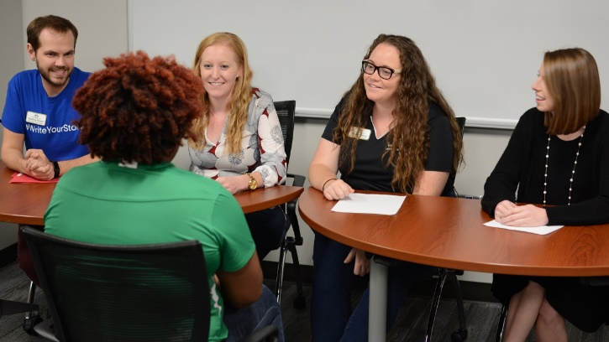

Part-Time Employment On/Off-Campus
The UCC’s Job Location and Development (JLD) Program assists students in obtaining off-campus jobs including part-time, summer, temporary/seasonal, and full-time (non-degree). Job listings may be viewed online in Hire-A-Niner at hireaniner.charlotte.edu and often include career-related positions in various fields. In addition, all on-campus jobs can be found in Hire-A-Niner (both Federal Work Study eligible and non-Federal Work Study).

Experiential Learning Programs
The majority of UNC Charlotte students are expected to and do participate in University-sanctioned experiential learning programs. Opportunities are available for both undergraduate and graduate students to receive course credit, or other recognition for supervised experiences in public and private agencies within the community, nationally, and internationally. These opportunities are offered through experiential learning programs including over 670 courses involving clinical rotations, cooperative education, internships, and practicums. For full description of related courses, see the Course Descriptions section of this Catalog.

Cooperative Education
This career-related professional program is available to students in the College of Computing and Informatics and College of Engineering. Participants must be enrolled full-time in an undergraduate degree program, and have a cumulative GPA of at least 2.5, and complete course requirements specified by their department. Transfer students must complete 12 hours at UNC Charlotte before applying to the program. Co-op students work two to three semesters either part-time or full-time (depending on college requirements) with an employer in a paid work experience. Participants receive transcript notation, not academic credit.

Academic Internships
Some academic departments award students credit for completing relevant internships. Students are encouraged to check with their academic department for further information and academic eligibility requirements.

University Professional Internship Program
The University Professional Internship Program (UPIP) offers paid on-campus internships to full-time sophomores, juniors, and seniors. Internships are designed to provide professional knowledge and skill development consistent with the student’s major/career goals. Students work through their home academic department for approval of academic credit for their internship. UNC Charlotte faculty and administrators serve as mentors to interns, with each internship paying $10 per hour for 10-15 hours per week during the Fall and Spring semesters.

University Center for Academic Excellence
ucae.charlotte.edu

The University Center for Academic Excellence (UCAE) provides academic support services and resources that increase learning effectiveness, enhance student success, and promote academic excellence. All services are free to enrolled UNC Charlotte students. For additional information on any of the programs and services offered by the UCAE, visit ucae.charlotte.edu. The UCAE offers the following programs and services:

Academic Skill Development Instruction
A wide variety of workshops and presentations are offered each semester on topics that help students achieve academic success. These interactive workshops are led by staff and graduate students on-site and across campus. Topics include: Test Prep, Time Management, Goal Setting, Effective Note Taking, Motivation, the Science of Learning, and more.

Learning Commons
The Learning Commons is a place where students can come to study in a welcoming environment with academic support only a few steps away. They can make use of computers and pay-for-print services, as well as a library of resources including books and study guides.

Peer-Assisted Learning
The Peer-Assisted Learning (PAL) program assists students in historically difficult courses such as biology, chemistry, physics, engineering, mathematics, business, and the social sciences. In weekly scheduled group study sessions, trained peer leaders help students refine the unique skills necessary for succeeding in the target course. Peer leaders are embedded in classes and collaborate with faculty members to offer additional support to students in an active learning environment. Data show that students regularly participating in Peer-Assisted Learning sessions average significantly higher final course grades compared to non-participants. The program has been nationally certified through the College Reading and Learning Association (CRLA) at Level I.

Personal Academic Consultations
Personal Academic Consultations (PACs) are one-on-one meetings tailored to the academic needs of the student. They are designed to help students discover more about themselves and develop personalized strategies for comprehensive collegiate success. Assessments of study habits/attitudes can also be administered and interpreted during PACs. Students may sign up for one-time or ongoing appointments to address their academic success goals.

49er Connect
49er Connect links UNC Charlotte students to trained Success Guides who provide academic support and accountability. Success Guides are there to help their peers strengthen academic skills like time management and note-taking. They work with students to troubleshoot issues in classes or to navigate campus resources. In addition to regular email check-ins, they provide reminders about University deadlines and share study tips throughout the semester.

Students Obtaining Success
Students Obtaining Success (SOS) is a peer-mentoring program for students experiencing academic difficulty at UNC Charlotte. SOS is a semester-long program that is individually tailored to help students overcome their unique challenges, improve academic performance, and return to good academic standing. SOS empowers students to identify strengths, develop academic and personal strategies to be successful, and connect with appropriate campus resources. Any student experiencing academic difficulty is eligible to register for SOS, though priority is given to students participating in 49er Rebound. Each participant meets weekly with a well-trained undergraduate peer mentor for support and guidance. The SOS program has been nationally certified through the College Reading and Learning Association (CRLA) at Level II, Advanced Mentor.

Tutorial Services
Serving all UNC Charlotte undergraduate students, the Tutorial Services Program provides free tutoring by appointment and drop-in sessions. Recurring and online appointments are available. Tutoring is offered for courses in various subjects including mathematics, science, business, engineering, health and human services, foreign languages and others as needed. Peer tutors emphasize learning skill development and content mastery. UCAE Peer Tutors are selected based on expertise in their area of academic discipline and faculty endorsements. Along with tutor professional development and tutee learning facilitation, Tutorial Services progressively updates its practices and policies as a nationally certified program through the College Reading and Learning Association (CRLA) at Level III.

49er Rebound
49er Rebound is a program to assist students who are on academic probation at the end of their first year of enrollment at UNC Charlotte. New freshmen and transfer students from all colleges participate in the program. The UCAE collaborates with all eight colleges, secondary advising centers, and staff members across campus to offer a range of options for participating students. These options include both a credit and a non-credit bearing academic success course, a discussion group experience, or peer mentoring for more individualized support. 49er Rebound works! Students who complete 49er Rebound have significant GPA improvement and return to good academic standing at higher rates than those who do not complete the program.

University College
ucol.charlotte.edu

University College serves all undergraduate students at UNC Charlotte through the General Education Program, which it coordinates on behalf of and with the support of all of the academic colleges that make up the campus community. This curriculum reflects this university's commitment to the principles of a liberal arts education, a broad training that develops analytic, problem solving, and communications skills and also awareness of bodies of knowledge and new perspectives that prepare students for success in their careers and communities in the 21st century.

In addition, the populations of students that form the University College include undergraduate students who are exploring their options before choosing a major or transitioning between majors. Students within the University College will have several Meta-Major options to choose from. Meta-Majors provide a clear pathway to declaring a major and help make connections between academics and different career tracks. Before students declare a major, they are advised in the University Advising Center. The professional advisors in the Advising Center are specially trained to work with students to assess their interest and likelihood of success in possible majors. The Advising Center staff are also able to refer students to a variety of support offices available to assist students.

See the “Degree Requirements and Academic Policies” section of this Catalog for details on the General Education Program at UNC Charlotte.

University Transfer Center
transfercenter.charlotte.edu

The University Transfer Center supports and advocates for transfer students through a variety of programs and services, including advising, peer mentoring, outreach, and collaboration with stakeholders. The center provides primary advising to transfer students in University College and secondary advising to transfer students in other colleges, as needed. Advisors within the University Transfer Center utilize a developmental advising model that assists transfer students in academic exploration, teaches them registration and degree audit skills, and helps them negotiate academic policies and resources.

